US military draft records are potentially untapped sources of information on male ancestors and sometimes their female family members. Even men who didn’t serve in the military may have had to register under one of the conscription acts for the Civil War, World War I, or World War II.
Online resources make it easy for today’s savvy researcher to find and use draft records as a springboard for family history discoveries. We’ll give you an overview of registration records created between 1862 and 1945, identify where to find them, and explain how to expand on the information they provide. We’ll also give your skills a boost with more resources to explore, a bit of practice interpreting these records, and a worksheet to chart your searches.

Clues in Draft Records
Local districts or boards conducted draft registrations to identify men eligible for service in times of war—specifically, the Civil War and World Wars. Many of the registration lists and cards these boards created survive, providing a deep well of data on several generations of American men. Those born as early as 1816 and as late as 1920 could’ve been eligible to be drafted for one or more of these three wars.
Questions the draft boards asked registrants varied from war to war, and even from one registration to the next. Typically, you’ll find information about the registrant’s name, residence, age, date and place of birth, race, US citizenship and occupation.
Depending on the registration, you also may discover details about your ancestor’s previous or current military service, his marital status, the name and address of a relative or contact person, a physical description, and his signature.
These findings can move your research forward in many ways. Birth information can tell you about births that occurred long before a state began keeping vital records. A woman named as a man’s nearest relative might narrow your search for a marriage record. An immigrant’s claim to be a US citizen could lead to naturalization papers.
Draft information is also useful in combination with other evidence. Residence and occupation details can distinguish your relative from others with the same name. If you’re “missing” a person in census records, a draft registration can indicate where he lived. Descriptions of height, build, hair and eye color can help you visualize your ancestor.

Civil War
Prior to the Civil War, the federal and state governments relied on offering free public land to attract volunteer soldiers in wartime. These bounty land incentives were discontinued by 1855. The Civil War brought an unprecedented need for troops on both the Union and Confederate sides. Governors from Maine to Mississippi issued calls for volunteers beginning in 1861. As the war escalated, the need for men reached crucial heights.
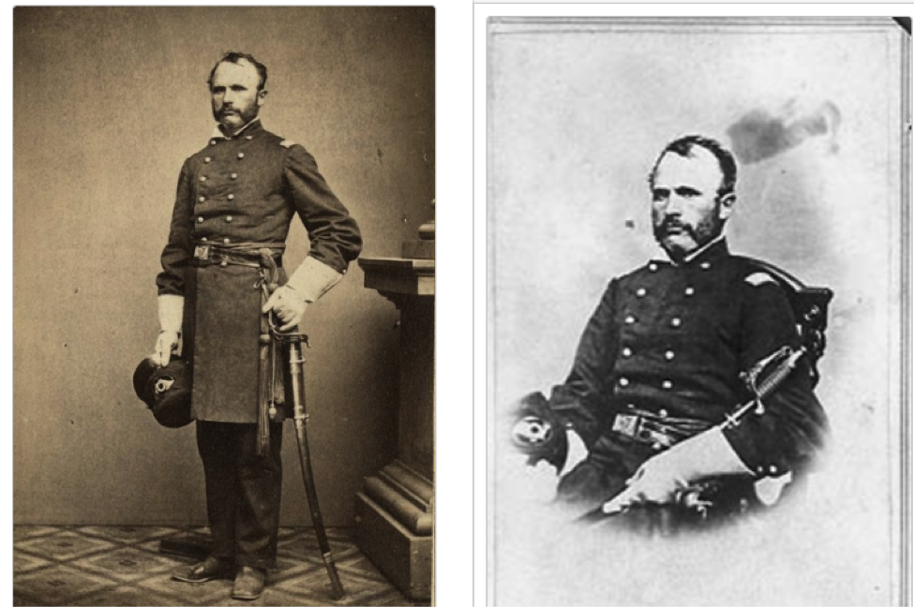Portrait of a Civil War solider in uniform.
Without the promise of free land to spur recruits (an incentive in previous wars), how could this demand be met?
Although the idea of a national draft faced considerable opposition in the North, it seemed the only viable solution. The Enrollment Act of 1863 required all men age 20 to 45 to register within their Congressional District, which often covered several counties.
The first Union registration took place July 1, 1863. Three smaller enrollments followed. For eligibility purposes, men were divided into classes. Those age 20 to 35 years, plus unmarried men age 36 to 45, were designated Class I. Nearly everyone else was Class II. In addition to name and residence, Northern draft registers typically show:
- age on the registration date
- whether white or colored
- occupation or trade
- whether married
- state or country of birth
The registrations were assembled into consolidated lists, many of which survive. You can find digital images of existing consolidated lists on subscription site Ancestry.com (which you can use free at libraries offering Ancestry Library Edition). For more-focused results, search within the site’s US Military Records collection. As a starting point, enter your ancestor’s name and where you think he lived in 1863.
The original consolidated lists are in Record Group 110 (Records of the Provost Marshal General) at the National Archives and Records Administration (NARA) in Washington, DC. The registration books from which they were compiled, which sometimes contain additional information, haven’t been microfilmed or digitized. They’re held at NARA’s regional branches.
If your ancestor registered, does that mean he served in the war? Not necessarily. Those in Class II were rarely made to serve. Each community and state was responsible for filling a quota of men. If they could raise that number with volunteers, no one needed to be drafted, so volunteers were heavily encouraged. Some states, like Massachusetts and Ohio, never had to call up draftees. Even if they were drafted, men could be exempted from service if they were:
- physically or mentally impaired
- only sons of dependent widows or infirm parents
- widowers or orphans supporting young children
- non-citizens who hadn’t declared intent to naturalize
- convicted of a felony
- able to furnish a substitute or pay a $300 fee
Let’s take a closer look at the information available in a draft record. The citation for this image can be found in the caption below. Look at the entry for each number to see where each piece of information appears on the record.
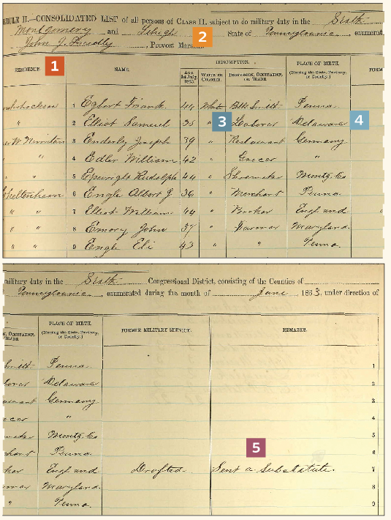U.S. Civil War Draft Registration Record
Citation for this record: “U.S. Civil War Draft Registrations Records, 1863-1865,” digital image, Ancestry.com (http://www.ancestry.com : accessed 10 March 2015), entry for Samuel Elliot in list for 6th Congressional District, Class II: Montgomery and Lehigh, Pennsylvania (June 1863).
1. This list (which is shown split into halves for larger viewing) was compiled in Pennsylvania’s Montgomery and Lehigh counties in June 1863. Registrants’ names are grouped by township.
2. Class II lists named primarily married men between ages 35 and 45. Younger and unmarried men were in Class I.
3. Occupation can help identify ancestors. Compare this listing of Samuel Elliot, laborer, to 1860 and other census records.
4. Place of birth offers clues to where men came from. Samuel Elliot may appear in Delaware records.
5. Union Civil War draftees could pay a $300 commutation fee or send a substitute in their place, as William Elliot did.
The South also instituted a draft. The Confederate Conscription Act of 1862 required all white males age 18 to 35 years to register. This was extended to ages 17 to 50 by early 1864. Ministers, teachers, civil officials, tradesmen, railroad workers and plantation owners were typically exempt. Initially, a man could hire a substitute and pay up to $1,000 to avoid service, but that allowance was scrapped in late 1863 due to bitter opposition. Men already enlisted for one-year terms automatically saw their service extended to three years.
Now What: Understanding Confederate Discharge Papers
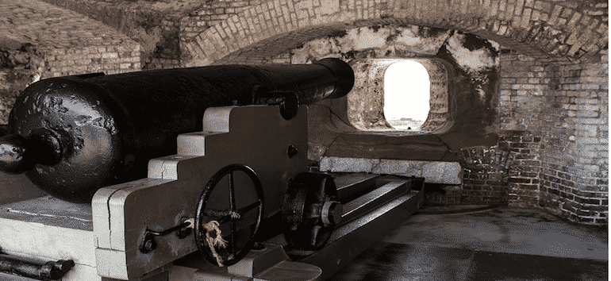
Do you have questions about your ancestors military discharge form? David A. Fryxell answers your genealogy research questions in Now What.
Family Tree Magazine
There are no consolidated lists of Confederate registrations. Each Southern state conducted its own drafts. Many times, troops raised by conscript were merged with existing units. Relatively few Confederate conscription registers survive today, and those that do can be difficult to find.
The best place to begin your search for any existing Southern conscription records is in the state adjutant general’s records. Some states compiled and published adjutant general records after the war. Georgia, for instance, published six volumes of The Confederate Records of the State of Georgia, which are available free on Google Books.
If your ancestors lived in Tennessee, search the Civil War Sourcebook, a digital collection of official records, diaries, letters and newspaper articles. South Carolina Archives offers information about its Confederate Military Records as well. Learn more about Civil War records for individual states, North or South on FamilySearch.org.

Draft Records Toolkit

Websites
- Ancestry.com: Draft, Enlistment and Service records
- Cyndi’s List: US Military Records
- FamilySearch Wiki: US Military Draft Records
- FamilySearch.org
- Findmypast.com
- Fold3
- Linkpendium: Click links for the place you’re interested in, then look for a military records section.
- Military Classifications for Draftees
- National Archives: Military Records
- National Archives Regional Record Centers
- National Personnel Records Center
- Online Military Indexes & Records
- Selective Service Records

Publications and Resources
- Guide to Genealogical Research in the National Archives of the United States, 3rd Edition, by Anne Bruner Eales and Robert M. Kvasnicka (NARA)
- One Million Men: The Civil War Draft in the North by Eugene Murdock (State Historical Society of Wisconsin)
- Uncle, We Are Ready! Registering America’s Men, 1917-1918 by John J. Newman (Heritage Quest)
- US Military Records by James C. Neagles (Ancestry)

Put It Into Practice Quiz
1. True or False: Only men who were US citizens were required to register for the draft.
2. The first draft registrations in the United States occurred during the:
a. War of 1812
b. Civil War
c. World War I
3. WWI draft registrations covered nearly what percent of males between 18 and 45 years old?
Exercise A: Go to the United States WWII Draft Registration Cards, 1942 collection on FamilySearch.org <www.familysearch.org/search/collection/1861144>. Enter the name Roy Eberhard in the name search box. Select the first result, Roy David Eberhard of Columbus, Franklin County, Ohio. View the document and answer the following:
1. Where and when was Roy born?
2. What company did he work for?
3. Who was named as the person who would always know his whereabouts?
4. How tall was Roy? (Hint: click the Image arrow button to advance to the next image.)
Exercise B: Choose an ancestor who was of age to be registered for the draft during the Civil War, World War I or World War II. Search for him in the databases on Ancestry.com, FamilySearch.org, Findmypast.com, or Fold3, as discussed in this article. What did you find?
Answers: 1. False 2. b 3. 98 percent Exercise A: 1. Allentown, Pa., March 9, 1894 2. Pennsylvania Railroad 3. Mrs. Roy D. Eberhard 4. 5 feet, 5 inches
From the July/August 2015 issue of Family Tree Magazine.

Related Reads
10 Top Civil War Websites for Genealogy Research

Explore Civil War genealogy records and history at these top 10 online destinations. Plus: State-by-state Civil War websites and resources for offline research.
Family Tree Magazine
How to Read WWI Draft Registration Cards
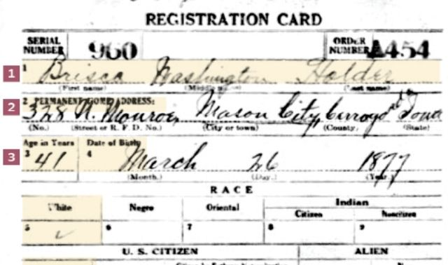
Learn how to genealogy clues in WWI draft registrations.
Family Tree Magazine
Unusual Records: State-Specific Military Records
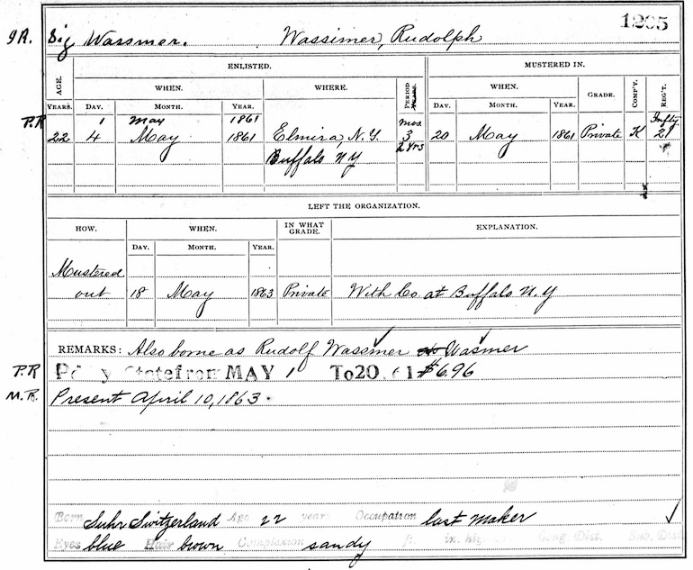
Family Tree Magazine

Get Your Free Essential Genealogy Research Forms
Sign up for the Family Tree Newsletter and receive 10 research forms as a special thank you!

Email*

CAPTCHA

Military

Author
Shelley K. Bishop


relatedarticles

Civil War Genealogy Research Guide

Military
Researching your Civil War ancestors? Learn everything you need to know with our Civil War Genealogy Research and Records Guide!

Genealogy Q&A: Researching Civil War Ancestors

Military
Are you trying to trace your Civil War ancestors? Out experts answer some of your toughest questions to help you…

Using World War II Draft Registrations for Genealogy Research

Military
Millions of WWII draft registration cards are available online. Read about draft registrations and what they may teach you about…

21 Most Important Civil War Records
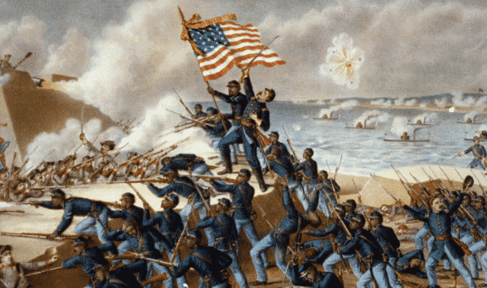

Military
Document if—and where—your ancestor served with these with these Civil War service records, pensions, and other documents.

Civil War Genealogy Research Guide
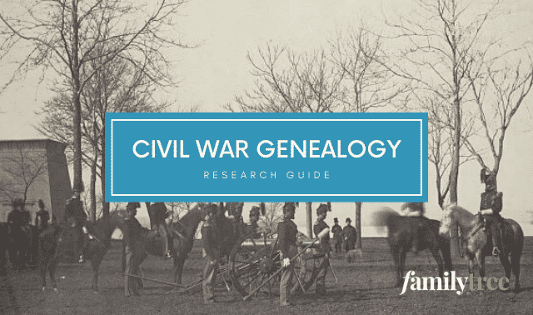

Military
Researching your Civil War ancestors? Learn everything you need to know with our Civil War Genealogy Research and Records Guide!

Genealogy Q&A: Researching Civil War Ancestors
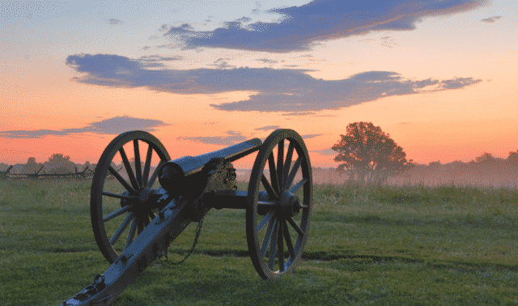

Military
Are you trying to trace your Civil War ancestors? Out experts answer some of your toughest questions to help you…

Using World War II Draft Registrations for Genealogy Research
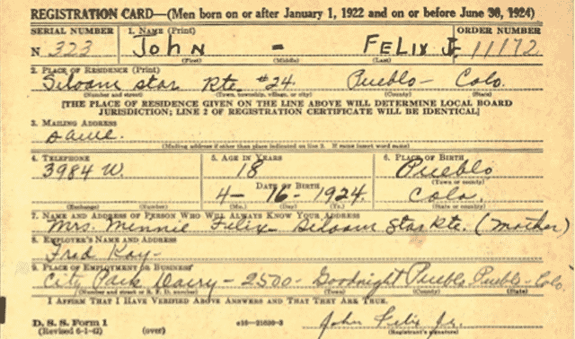

Military
Millions of WWII draft registration cards are available online. Read about draft registrations and what they may teach you about…

21 Most Important Civil War Records

Military
Document if—and where—your ancestor served with these with these Civil War service records, pensions, and other documents.

Civil War Genealogy Research Guide

Military
Researching your Civil War ancestors? Learn everything you need to know with our Civil War Genealogy Research and Records Guide!

Genealogy Q&A: Researching Civil War Ancestors

Military
Are you trying to trace your Civil War ancestors? Out experts answer some of your toughest questions to help you…

