找所有三角形

找整数点

简化分数

[Section 5 (bridgew.edu)](http://webhost.bridgew.edu/hburgiel/MATH130/prob16.html)

斐波那契

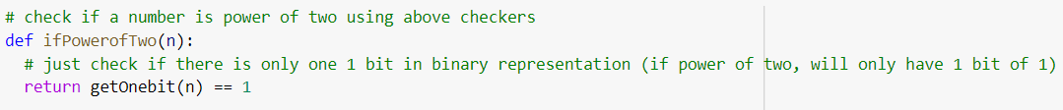

Reverse LinkedList

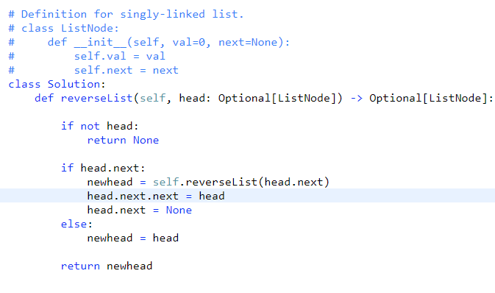

Reverse LinkedList

