MACHINE PROBLEM

MATLAB SOLUTION PROBLEM # 2

Aguinaldo, Kurt 2ECE – A

Sales, Ace Lawrence

**SCRIPT FILE:**

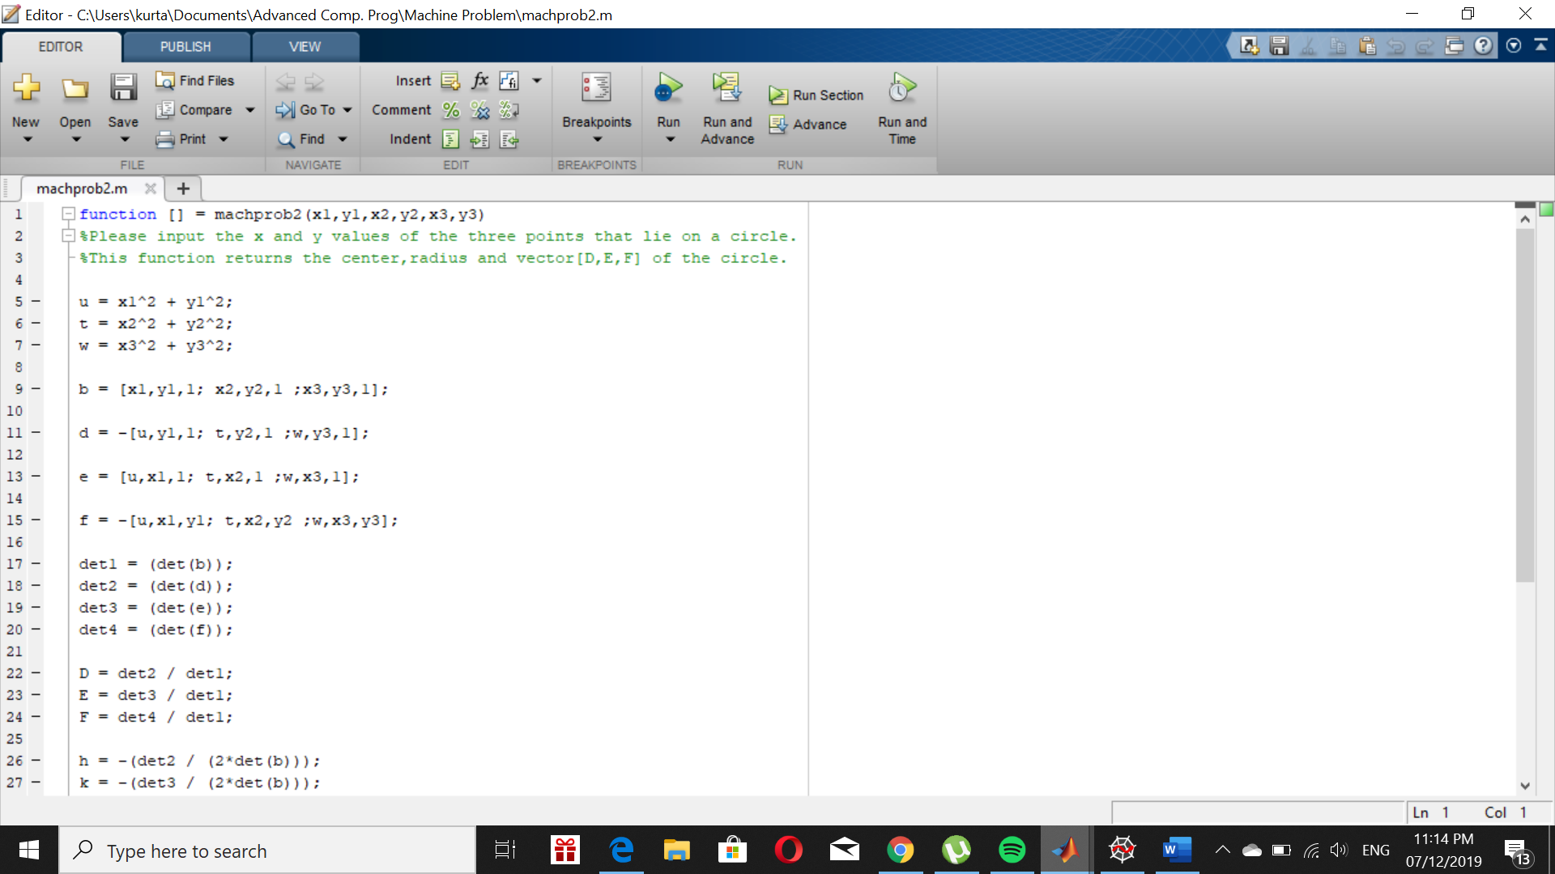

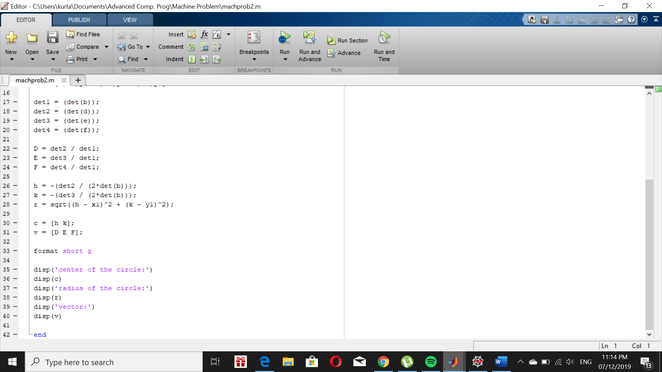

Using input problem2 (3,4,5,6,7,9)

**OUTPUT:**

