MACHINE PROBLEM

MATLAB SOLUTION PROBLEM # 3

Aguinaldo, Kurt 2ECE – A

Sales, Ace Lawrence

**SCRIPT FILE:**

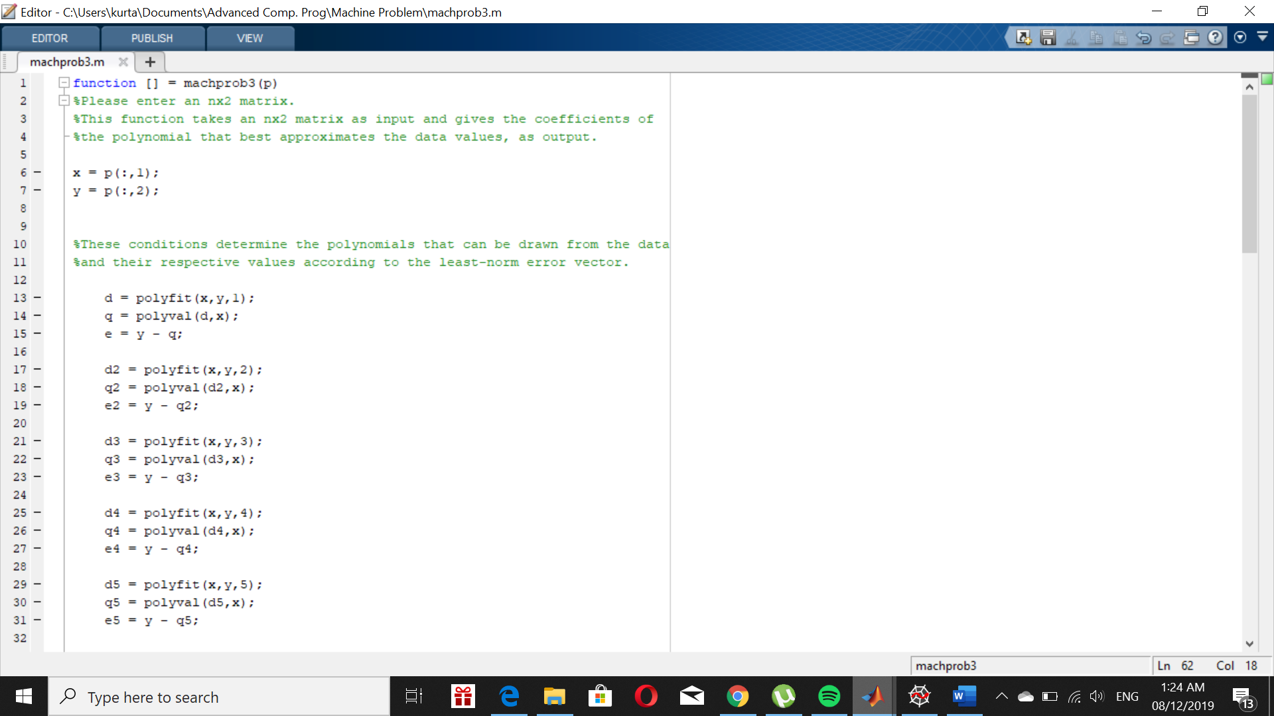

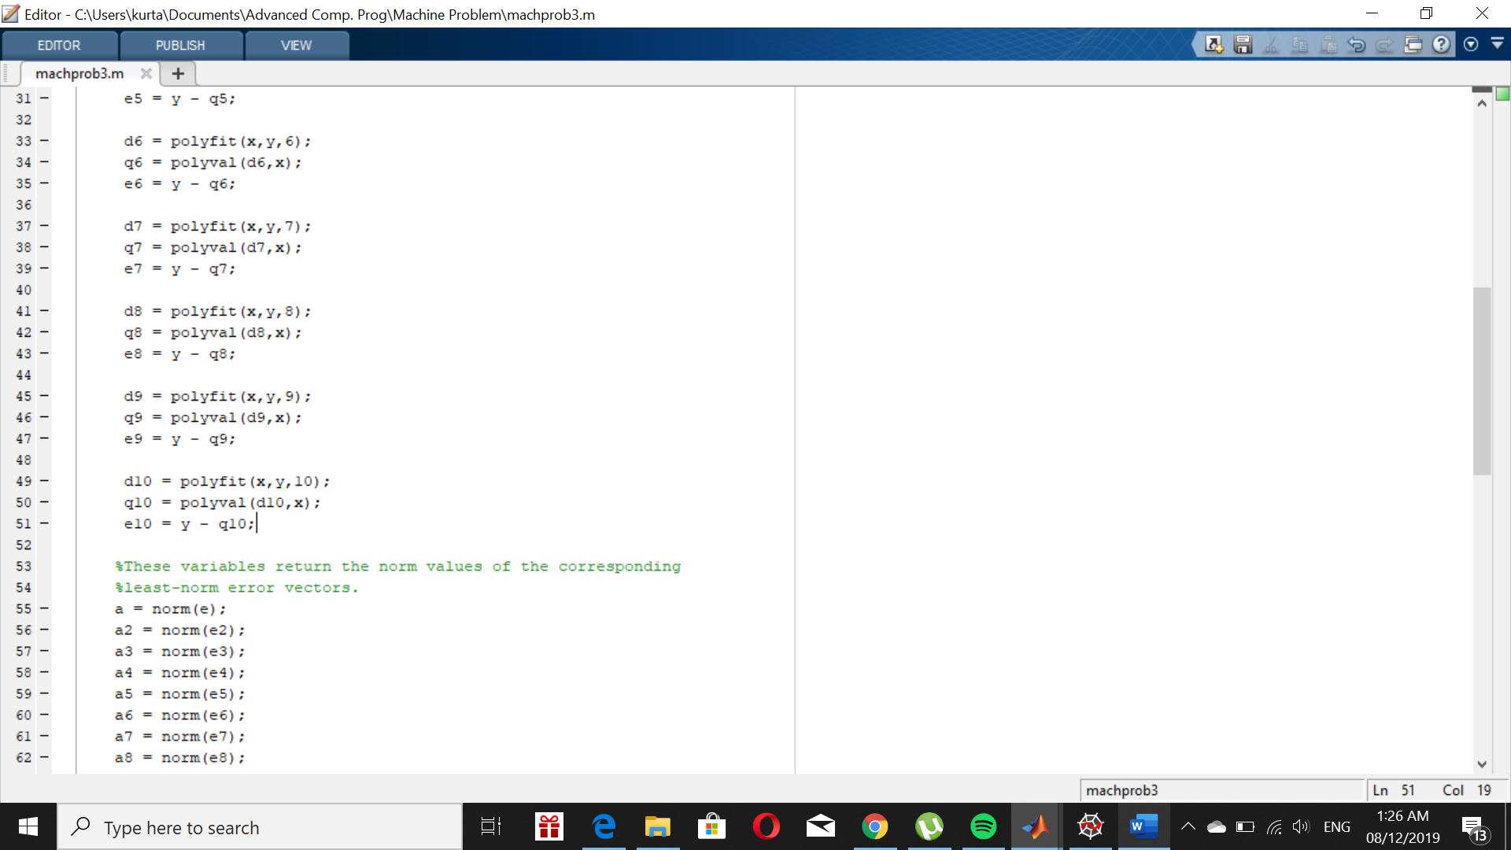

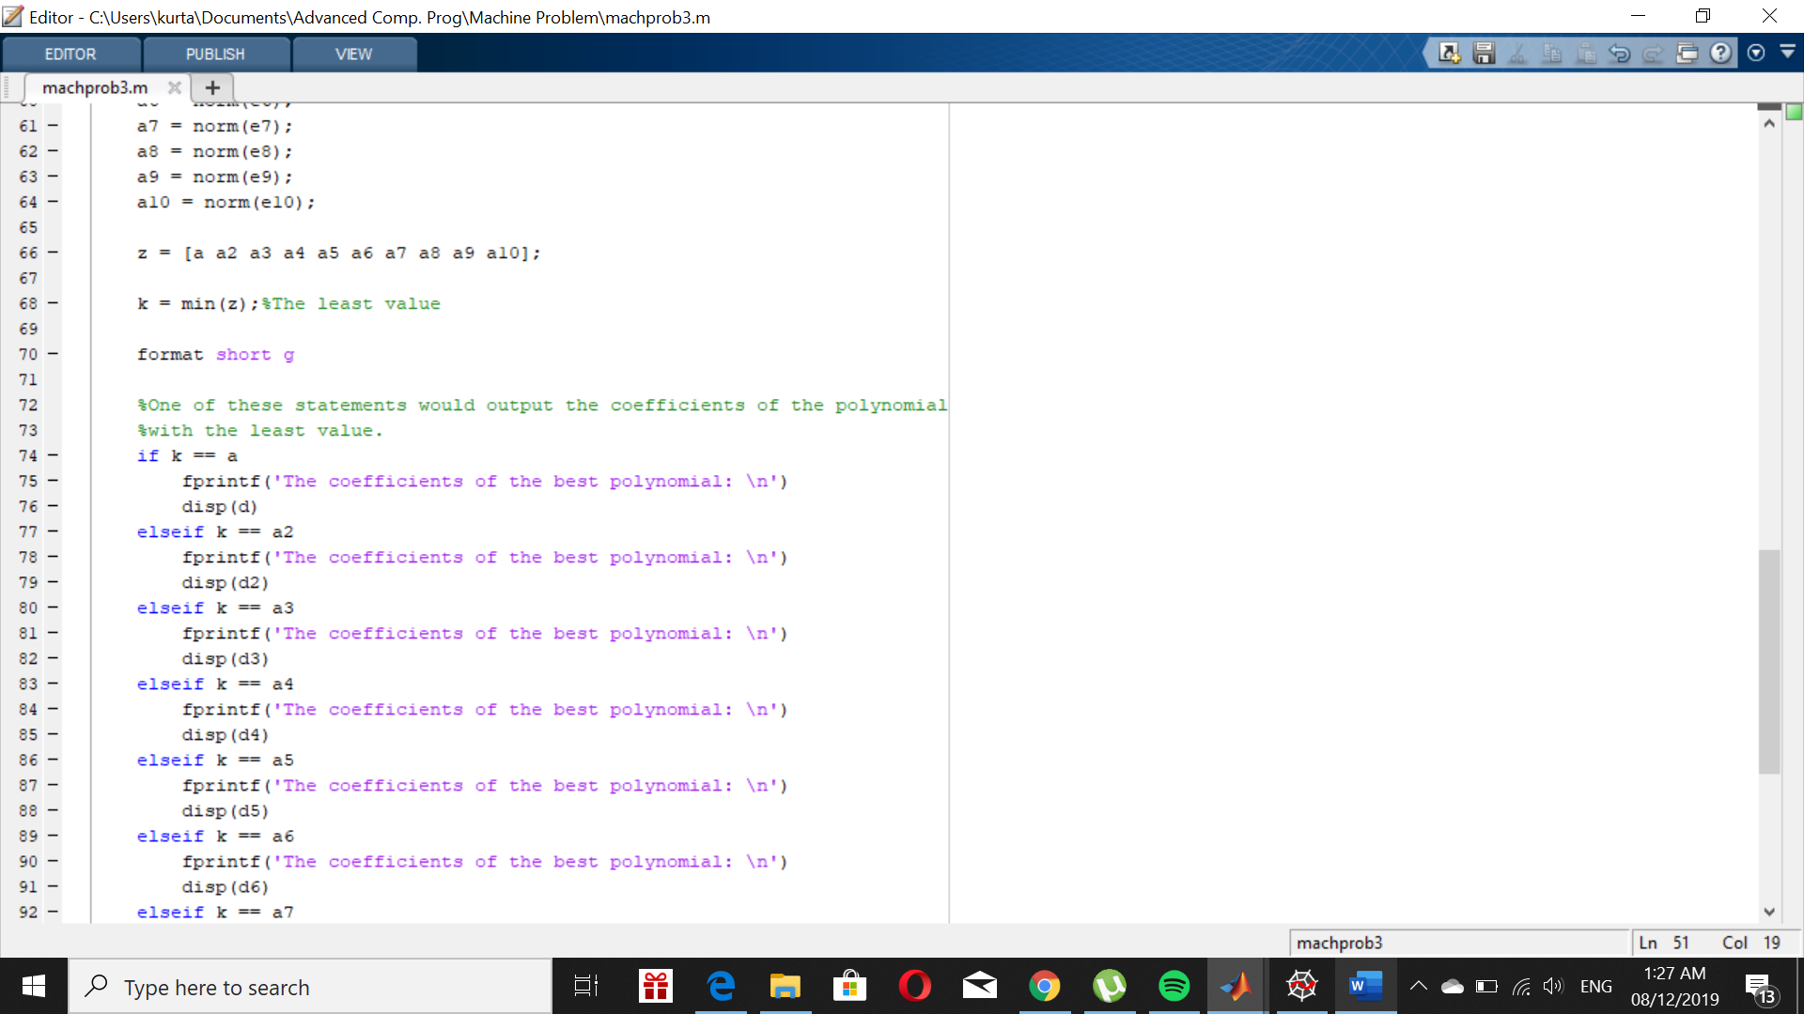

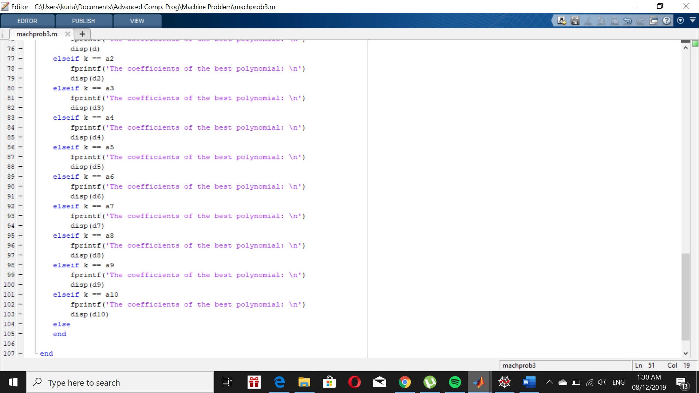

Using input problem3([(-3,174;-2,41;-1,4;0,0;1,-7;2,-29;3, -52;4, -41;5, 60])

**OUTPUT:**

