MACHINE PROBLEM

MATLAB SOLUTION PROBLEM # 4

Aguinaldo, Kurt 2ECE – A

Sales, Ace Lawrence

**SCRIPT FILE:**

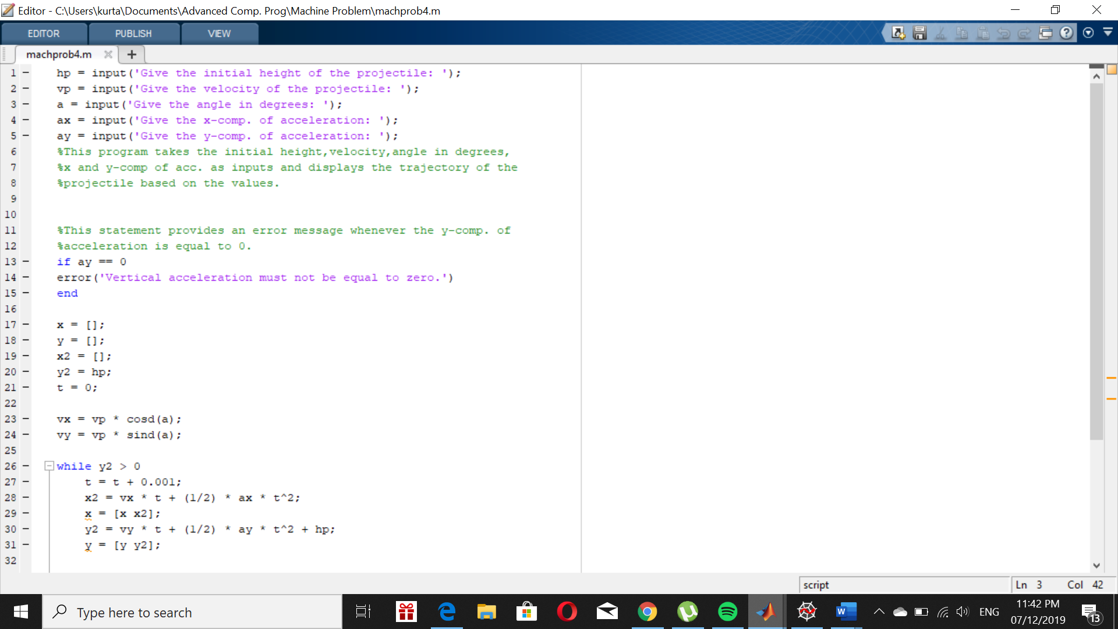

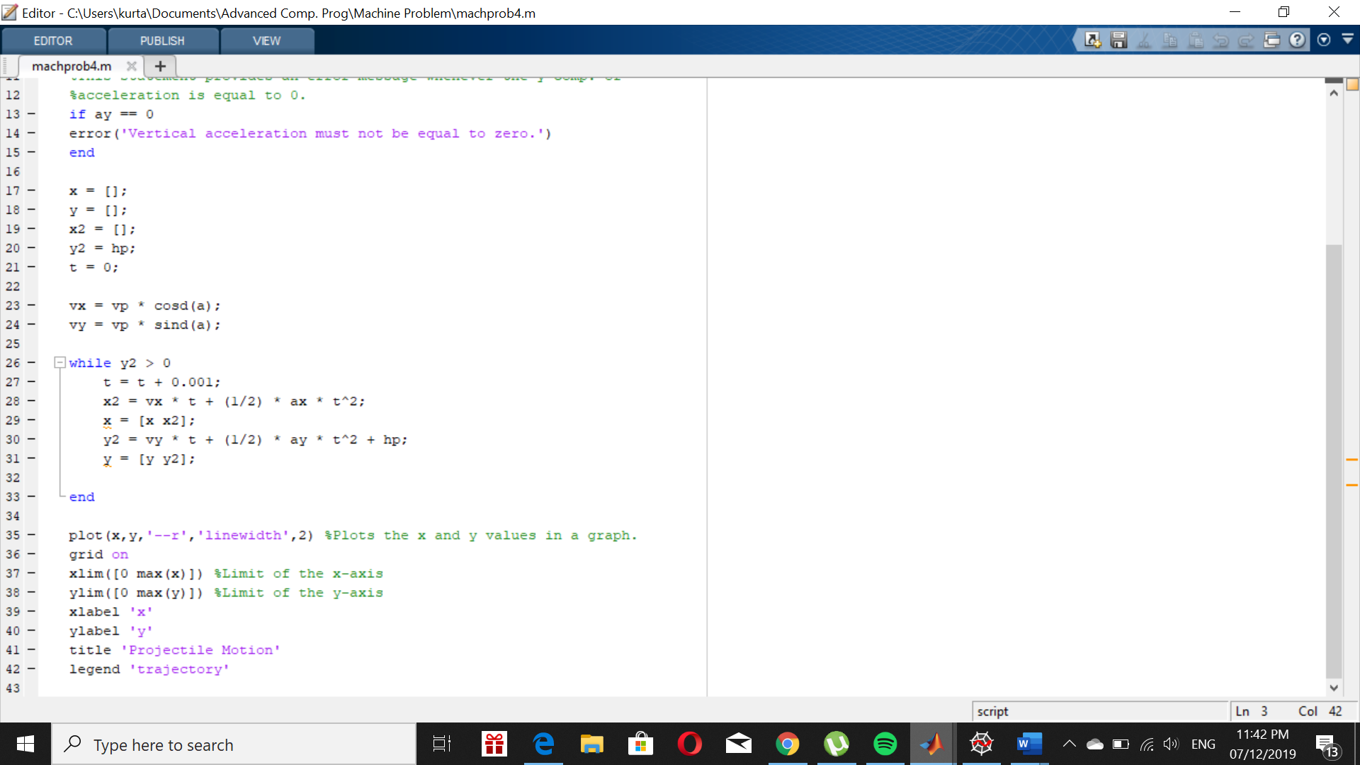

Using input problem4(10,15,45,20,-10)

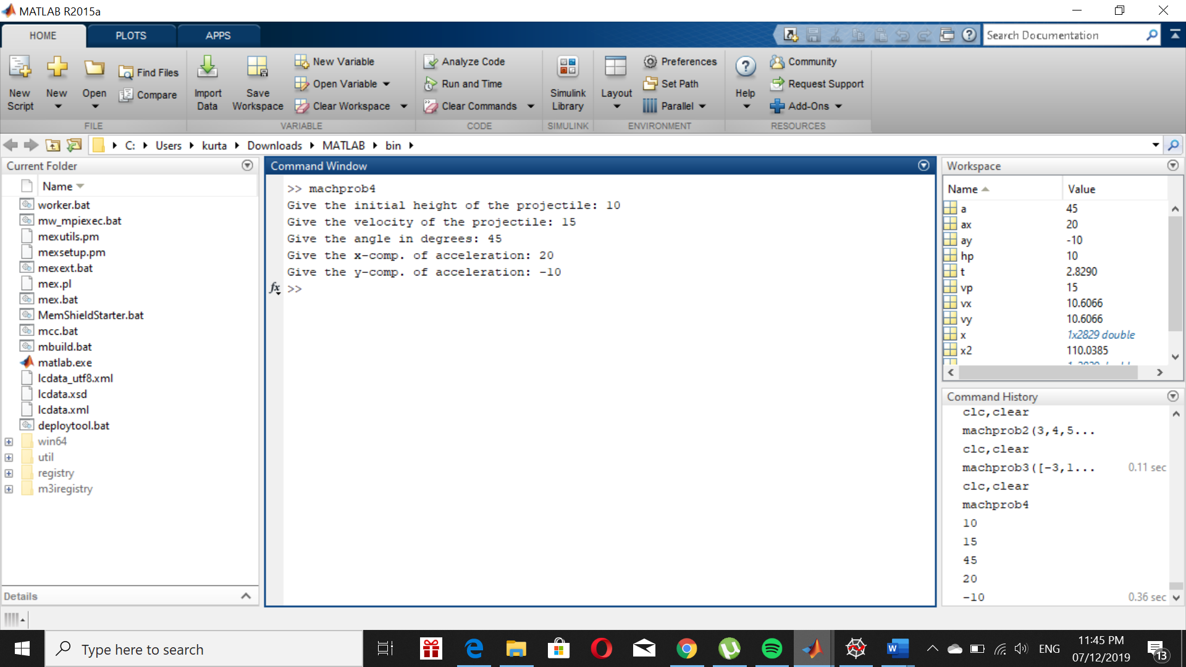**OUTPUT:**

