MACHINE PROBLEM

MATLAB SOLUTION PROBLEM # 5

Aguinaldo, Kurt 2ECE – A

Sales, Ace Lawrence

**SCRIPT FILE:**

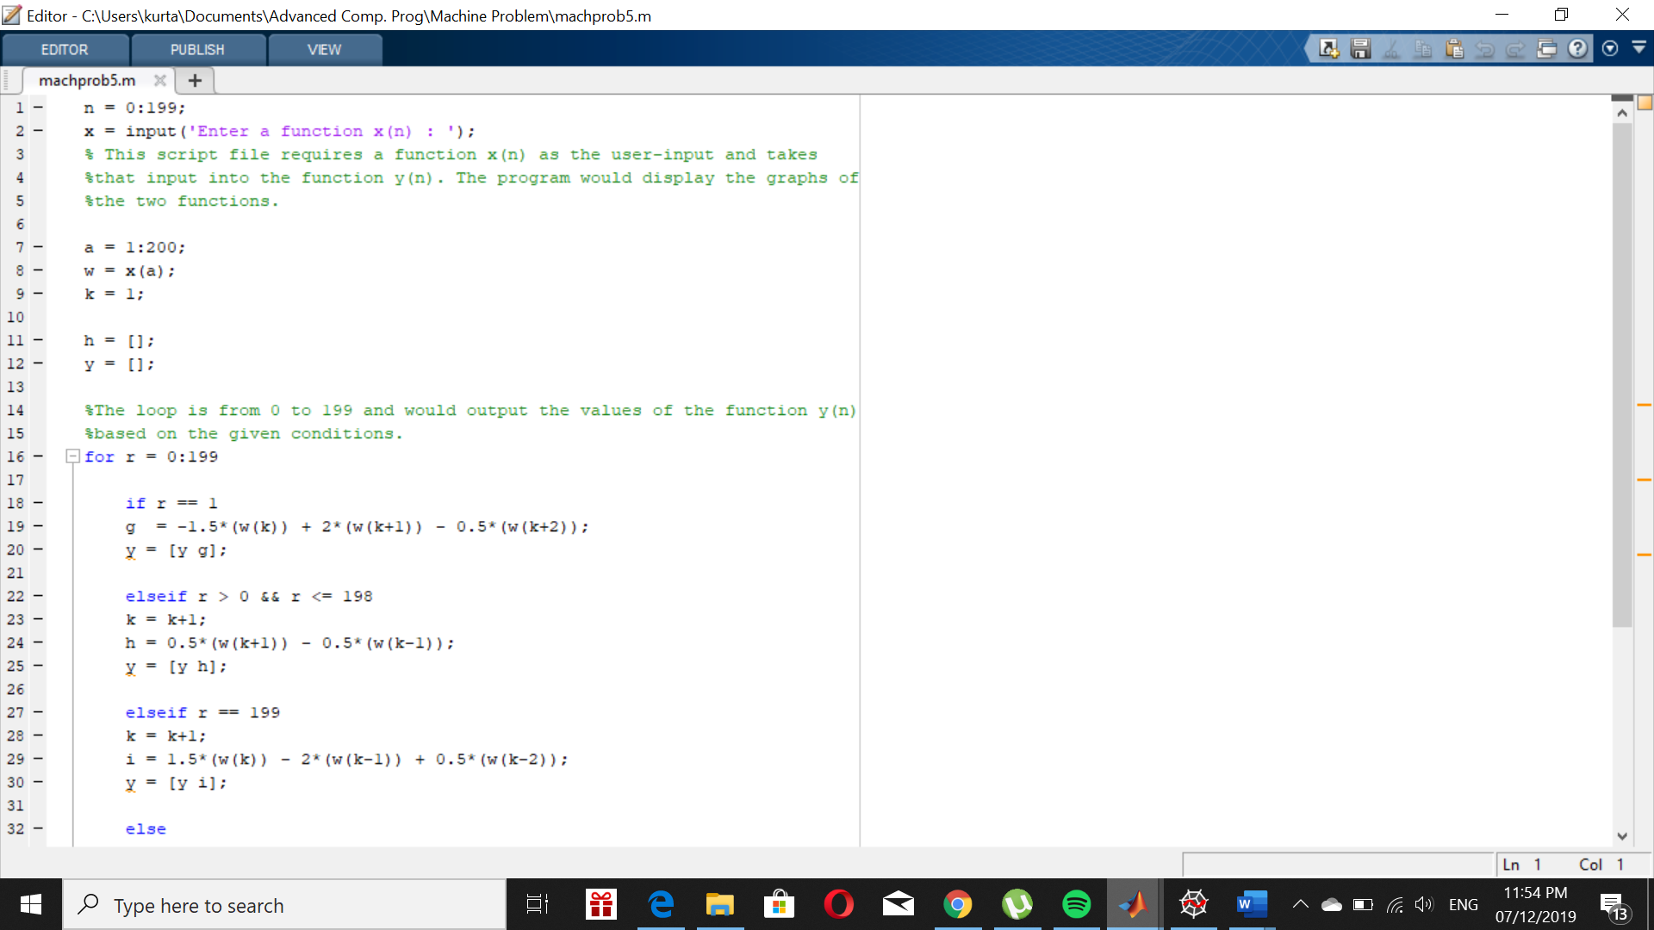

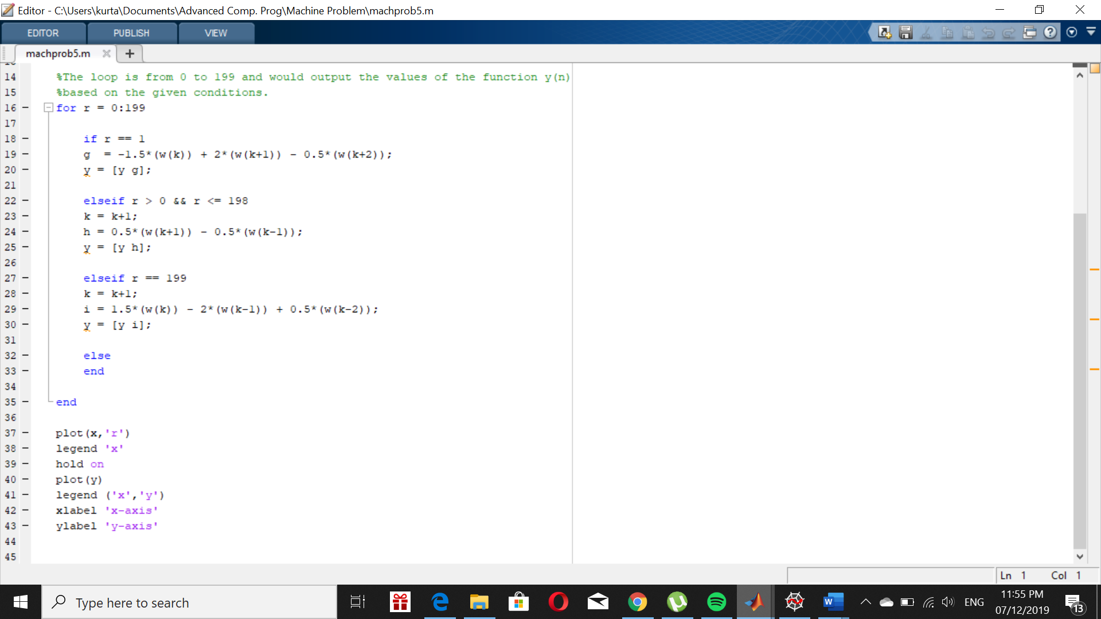

Using input problem5(sin(3*pi*n/100)

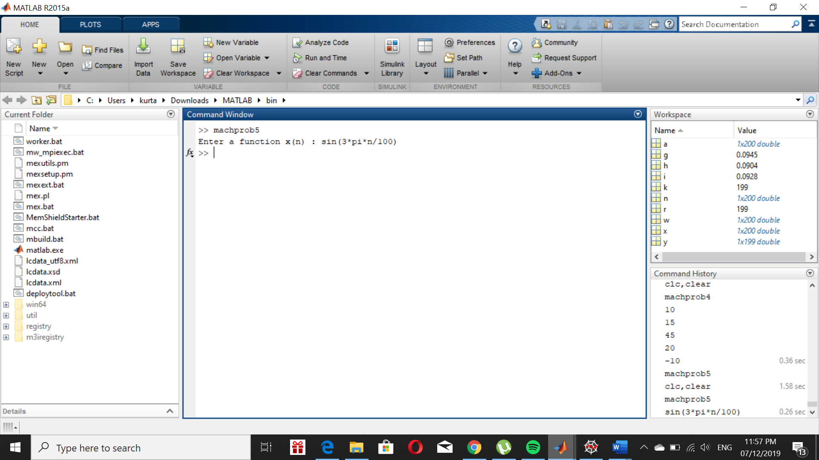**OUTPUT:**

