**Question 1a**

2 game engines are unity and construct 2. Four advantages of Unity are:

* Unity primarily makes use of C# which is the programming language we have been learning in school so far. Construct 2 does not support C# but instead makes use of JavaScript.
* Unity targets a wider range of platforms than construct 2 including PlayStation, Xbox and Nintendo. Unity even supports a variety of smart TVs.
* Unity can be used for free unless it is used to make a profit of more than $100k. Unlike unity, you have to pay to have access to certain features in construct 2.
* Unity consists of a great GUI which allows the creator of the game to manipulate scenes at any time. This includes pausing and processing the game frame by frame.

(slant, 2017)

**Question 1b**

2 programming languages used in game development are C# and C++. In this case, C# is used to support Unity. Four features of C# are:

* Simple.
* Modern Programming Language.
* Object Oriented.
* Rich Library.

(javatpoint, 2017)

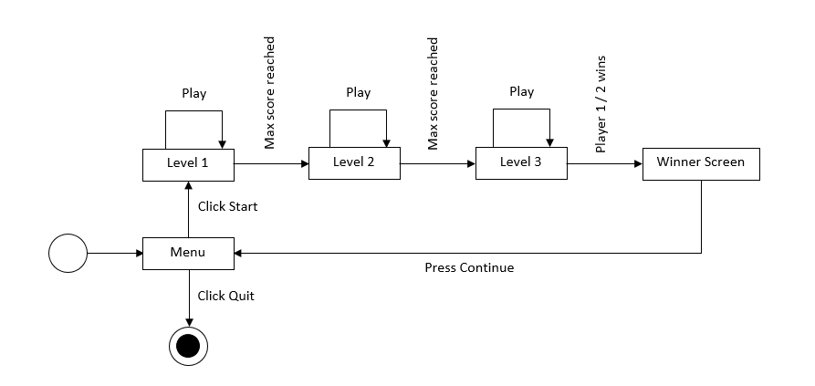

**Question 2a**

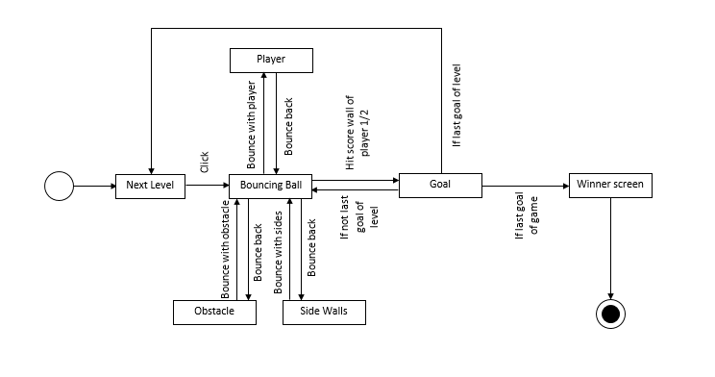**Question 2b**

**Question 3**

When using media assets, such as images, videos and audio, compression is needed due to the fact that they take up most of the space in the overall built app while scripts have the smallest impact on storage. This is done by removing redundant data when compressing the files and then restoring them back once they are uncompressed (Pot, 2012). This is important especially for mobile devices since certain app stores may force a certain size limit (Unity, 2017).

Furthermore, compressed apps will be easier to move around from place to place. For example; distribution of a game on an app store. It will take less time for the game to download and even update (Corporation, 2017).

Below is an example of a normal folder`s size vs a compressed folder`s size.

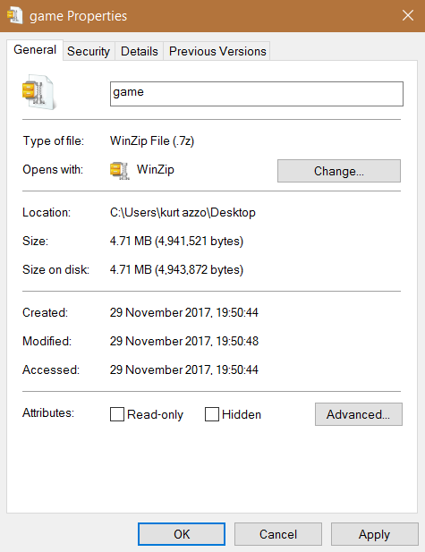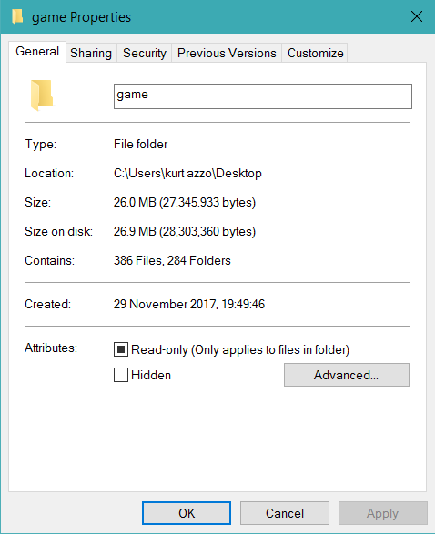

# Bibliography

Corporation, C., 2017. *Curriculum Corporation.* [Online]   
Available at: http://www1.curriculum.edu.au/videoresearch/compression.htm  
[Accessed 28 November 2017].

javatpoint, 2017. *C# Features.* [Online]   
Available at: https://www.javatpoint.com/csharp-features  
[Accessed 28 November 2017].

Pot, J., 2012. *makeuseof.* [Online]   
Available at: http://www.makeuseof.com/tag/how-does-file-compression-work/  
[Accessed 28 November 2017].

slant, 2017. *slant: unity vs construct 2.* [Online]   
Available at: https://www.slant.co/versus/1047/1058/~unity_vs_construct-2  
[Accessed 28 November 2017].

Unity, 2017. *Unity.* [Online]   
Available at: https://docs.unity3d.com/Manual/ReducingFilesize.html  
[Accessed 28 November 2017].