legend:

[m - minor]
[n - necessary]
[M - major]
[C - for consideration]

TOURIST SIDE

1.Home:

m - if booking already confirmed once, add locking mechanism/ change button to "Already added to My Bookings"

Wi-Fi Availability Information
- Display available public Wi-Fi locations.
- Can be shown:
  - On the Home page, or
  - Through a dedicated Free Wi-Fi tab.

2. Stay:

C – current set up shows all the homestays in Catarman; instead of showing the modal (for the adjustments) after clicking book now, make a separate dedicated page for the business showing all their room options,… in all the room options, the booking options from the current modal will be incorporated for easy booking.
Sample from agoda:

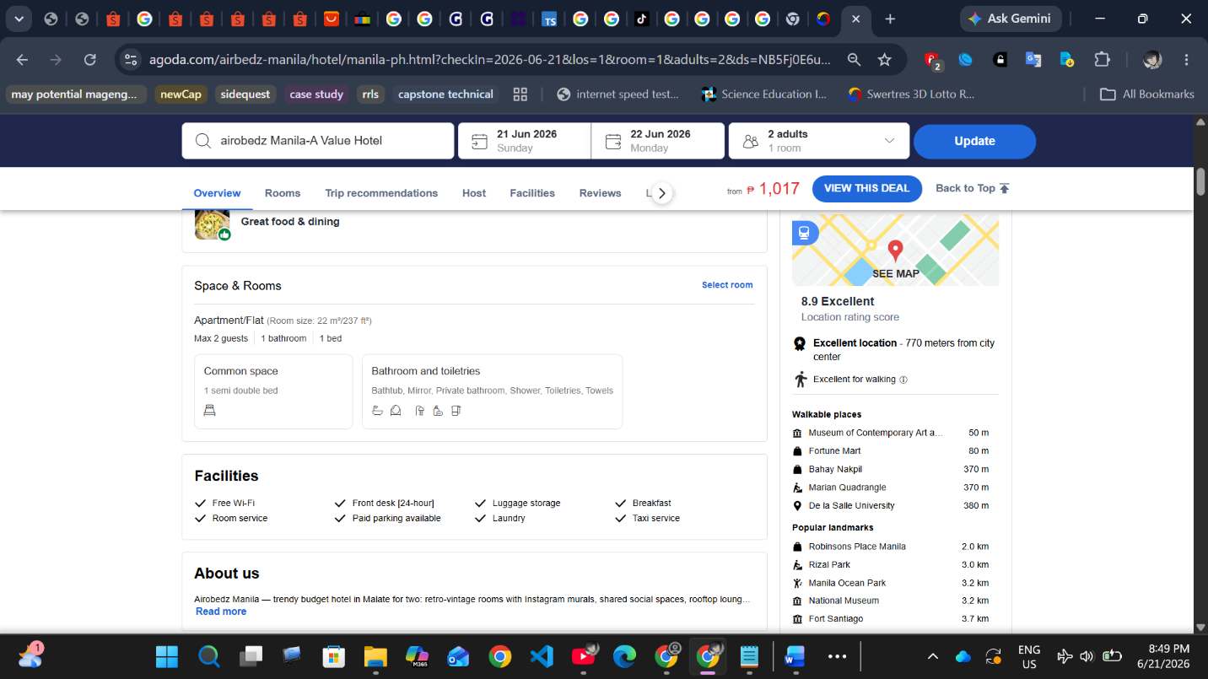

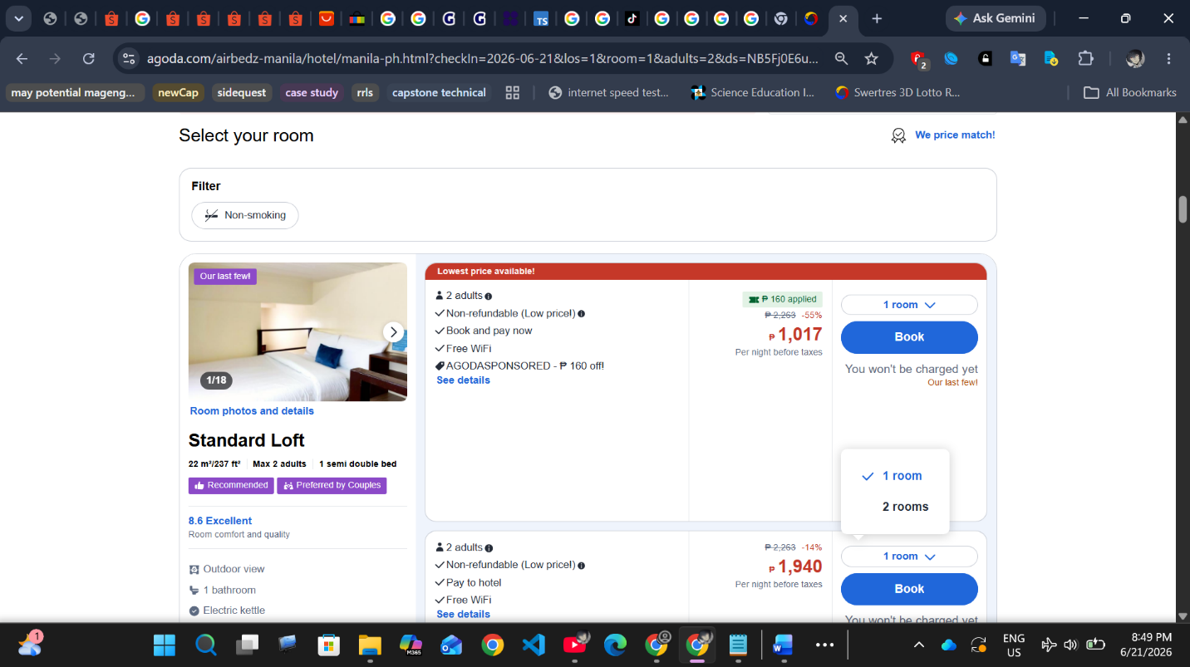

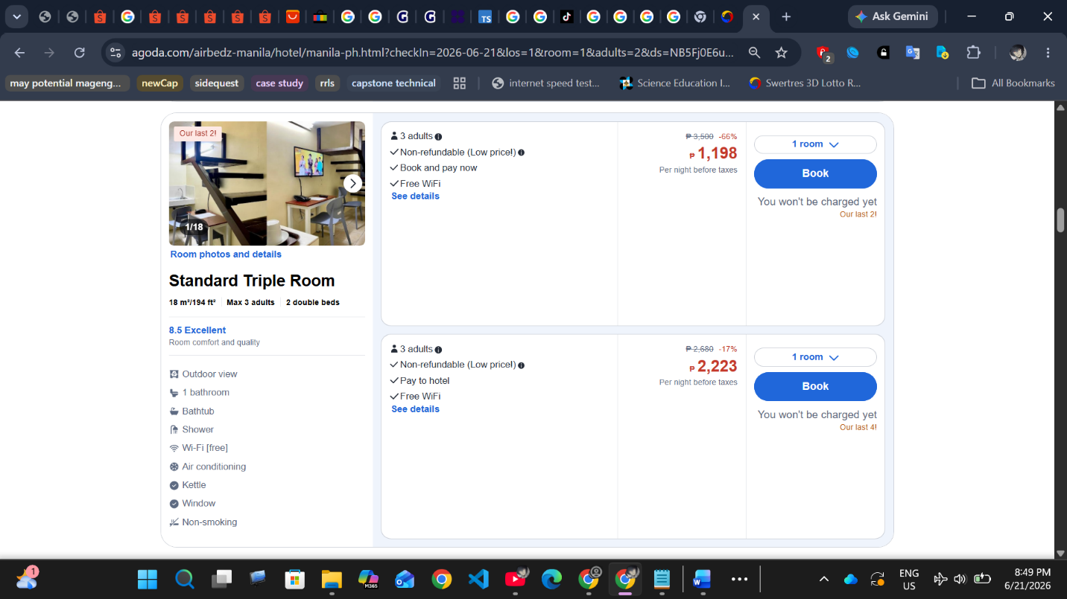

n - include all the "package stay promos if available" --- package stay promos should include description about how many persons the room can cater, days and nights duration of the promo, inclusions: breakfast, tour of the resort, etc,...
the promo package grid should be shown before the availability grid.

Sample:

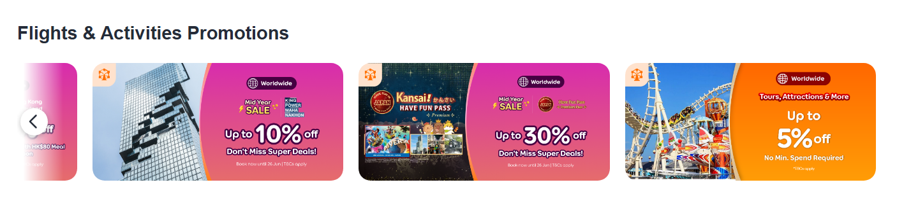

n - "child/tween" option for guests if the resort has separate pricing for kids/tweens,

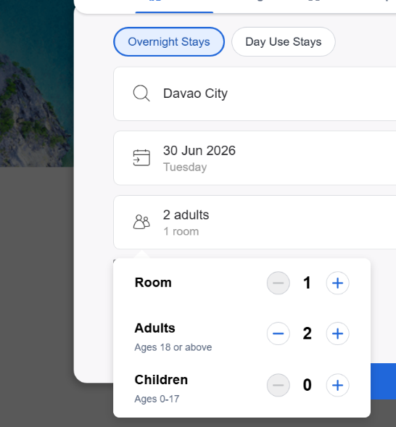

n – for breakfast bundle: for how many people option
n - the number of adults should have a limit for how many persons can a room cater.

3. Transport
n – include travel date, adult, children, bring vehicle? If avail: Roundtrip option?
n – if domestic tourist has vehicle, adjust AI planner.
n/C/M - include to, from, within Camiguin tabs. To and from: ship, flights; within Rental options.
C/M – after filling the travel date, vehicle, etc details above; shipping companies that cater to the tourists filled up preference should be shown below, for the tourist to compare prices. Since there is no port for catarman,.. benoni, guinsiliban, balbagon options should be available.
C/M – for consideration, include flight option. Maryusep,
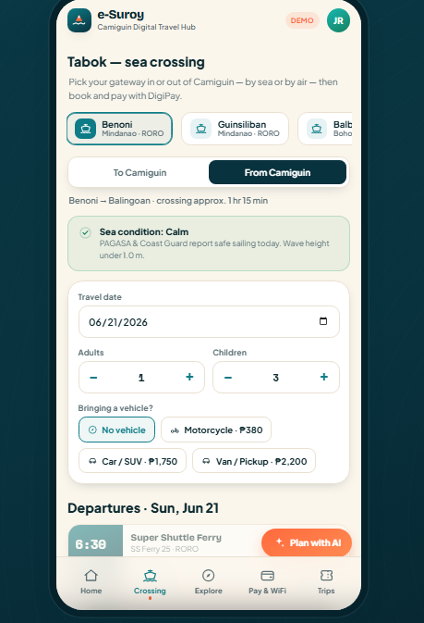
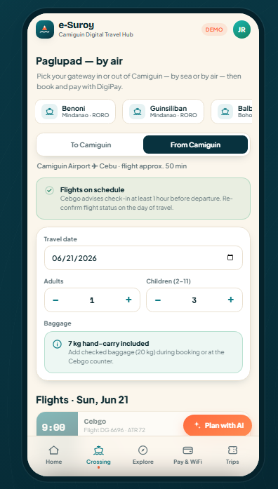
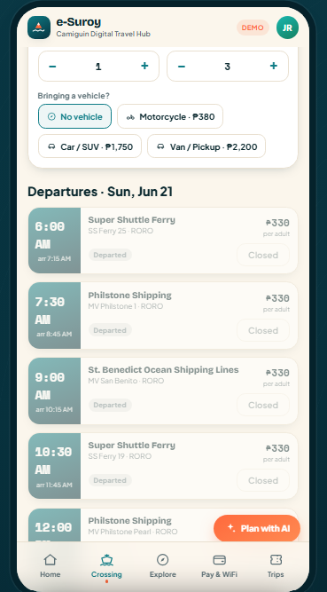

3. Shop

C/M – to include msmes shops. Each shop should have their separate page, mini shop mart something for reservation only. Where tourists can order/reserve foods, souvenirs, pay for it; there should be an option if the Tourist will walk-in/dine-in, or is the reservation for delivery. the business owners are responsible for deliveries.
Can also collaborate with IsleCart to include delivery.
Or the shop tab is IsleCart Tab (Integrate)

C- based on their reservations:
Show shops near you:

4. Location Tab

n – include the open schedule of the spot,
C – the name can be change to Tourist Spots
C – include more pictures, and reviews tab for tourists to read. Only those tourists who have complete the tour can post a review, they can also include pictures. similar to shoppee review.

5. My bookings:

n - Filter for pending/confirmed.
n – search/ filter to review experience/stay..
n – add button to re-book, re-stay, re-experience something.

BUSINESS SIDE

C – there should be an option for what type of business: Stay, Transport Ship, Transport Rental, for MSMEs shop, for Tourist Spot.

1. Stay

n – in adding new item in inventory, include checklists,.. the business owner can add many guests, inclusions, description, as many as he/she wants:
⏒ guests to cater: name: adult, price: _____
⏒ inclusions: name: breakfast, price: _____, for how many people: _____
⏒ checklist for description.. () wifi, Refrigerator, Shower, 1 bathroom, Air conditioning, etc.
or add description: name: _____;
⏒ also include textbox for sentence descriptions :

m - it should be stated in the description and shown in the Stay tab, the number of people the room can cater.

2. Transport side

M – if to include different shipping companies, shuttle/st.benedict, they should register as business,.
M - for flight,.. through api/ direct to official CebGo site and pay there.

3. Shop Business Option/Module

M - The shop includes: Name, Photo of Shop, description, Avail Time, contact information
Product Categories: _______, Product Name: ____,
Status: Avail/Out of Stock, Picture of Product:____
Number of Available products: _____,
Options: checklist if it’s for Walk-in/dine-in/ avail for delivery
Product Price: ,
Has create Promo option: then have checklist for all the products in the shop to include in the promo, discounts included, voucher etc.
n – prompt owner to update the availability of the product every three days… the product may be out of stock due to walk-in purchases that were not recorded in the system.

n – the tourist side should have an equivalent overall view of the shop..

n – the shop owner can also add earnings/product sold manually, have an option called manual updates” something. So that they can still view their total revenue, accounting not just the sold online but also offline.

4. Tourist Spot Management Module:

C- Spot name:______, how many people it can handle/ quota: _________,
Pictures:, Description checklist:, description narrative:.

Notify owner every three days: After spot has been added by the business owner, the owner is obliged to update the availability of the Spot every three days. For instance, the spot is close because of Holiday, other reasons.

C – add option for business owners to cancel an experience/stay/reservation. Since payment is automatic, and if the business owner forgot to update, they can give 100 percent refund.
C – have notification tab for the business owners to receive updates from LGU. Sample, LGU wants to conduct a safety inspection on a tourist spot, the tourist spot handlers/managers of the business can receive the notification directly.

LGU side

C – can add wifi spots on the map tab.

