A Statistical Analysis of Material vs. Mobility in Expert-Level Chess

Kurt S. Godden, Ph.D.

Simi Valley, CA

Abstract

Using random samples from a database of 1,696,727 expert level chess games (ELO ≥ 2000), we performed several statistical analyses regarding material and mobility in the population as well as samples taken from games won by either side. Linear regression models illustrate the relationship between material and mobility. Five thousand randomly selected games provided baseline point estimates of material and mobility in the population, regardless of outcome. Then, two separate random samples of one thousand games each for wins by black and wins by white provided additional data for hypothesis tests of significance against this baseline. We also calculated and compared the relative significance of material vs. mobility between the two players for wins by black and separately for wins by white. Perhaps not surprisingly, the winning side tends to have higher mean mobility compared to the baseline; however, this is not the case with material. There is no statistical change in white’s material over the baseline, while black’s material actually declines from the baseline even as black wins. Finally, when comparing winners vs. losers, the winning side has a statistical advantage in both material and mobility. However, the significance of these advantages differs substantially when considering black wins vs. white wins, with black’s advantages being more significant than white’s. We speculate that this more significant advantage is necessary to overcome white’s first move advantage.

*Keywords:* chess, material, mobility, statistics

Author Note

Please direct correspondence regarding this research to the author at kurtgodden@gmail.com.

A Statistical Analysis of Material vs. Mobility in Expert-Level Chess

The analysis presented here is an initial investigation into the statistical properties regarding both material and mobility in expert level chess games. We take the common definition of mobility as the number of moves of either player in a position, and material as the point value of the pieces on the board excepting the king, whose majesty exceeds finite value.

These analyses are motivated by the following questions. What is the relationship between material and mobility? What are the game means of both material and mobility in the population of expert-level games regardless of outcome? Do these population means differ from the means obtained from games won by either side? If so, how much do they differ and how significant are those differences? Do we obtain similar results when comparing games won by white to games won by black? When comparing the winning side to the losing side, do we obtain similar results regardless of which side triumphs?

This paper provides statistically based answers to each of these questions for expert-level players (ELO ≥ 2000) using game data available on the web (KingBase, http://www.kingbase-chess.net). 1,696,727 games were downloaded from that site on November 16, 2015 and preprocessed using J. Kunst’s *01_pgn_parser.R* code (https://github.com/jbkunst/chess-db). The following analyses use only the portable game notation (PGN) and result data from these games.

# Earlier Statistical Research

Most research on material and mobility has taken place in the context of chess playing computers. Both material and mobility are discussed in a famous paper by Claude Shannon (Shannon, 1950), wherein he proposes a basic evaluation function, *f(P)*, that computes a value for a given board position. Positive values of this function indicate an advantage for white while negative values are to black’s advantage. Shannon used material values for the pieces that are still generally taught to beginners, i.e. pawns are worth one point, bishops and knights are worth three, rooks five, and queens nine.

Shannon’s evaluation function summed three factors: the difference of the material values, subtracting black material from white, a factor that related to pawn structure, and a third factor for the difference between white and black mobility. The most interesting part of Shannon’s function is in the fact that his equation values a mobility advantage of 10 moves as equivalent to a material advantage of one pawn by virtue of the weighting coefficient ‘1’ for the difference between white and black pawns, and a coefficient of 0.1 for the difference in mobility. However, Shannon does qualify these coefficient choices by saying they are “merely the writer’s rough estimate”.

The first statistical investigation of mobility was by Eliot Slater (Slater, 1950). Slater supplied two data tables, shown here as Tables 1 and 2.

|  |  |  |
| --- | --- | --- |
| **After move** | **Winners** | **Losers** |
| 0 | 20.0 | 20.0 |
| 5 | 34.2 | 33.9 |
| 10 | 37.5 | 36.0 |
| 15 | 39.7 | 35.2 |
| 20 | 38.9 | 36.4 |
| 25 | 39.6 | 31.9 |
| 30 | 35.6 | 27.7 |
| 35 | 31.7 | 23.2 |

*Table 1: Slater’s Data on Mobility*

Table 1 describes “Means taken from 78 arbitrarily selected games which ended with a decision on or before the 40th move,” and Slater goes on to say how the data indicate that mobility for both players rises as pieces are developed, falls with piece exchanges, and reveal an increasing advantage to the winner. Figure 1 displays Slater’s data graphically.

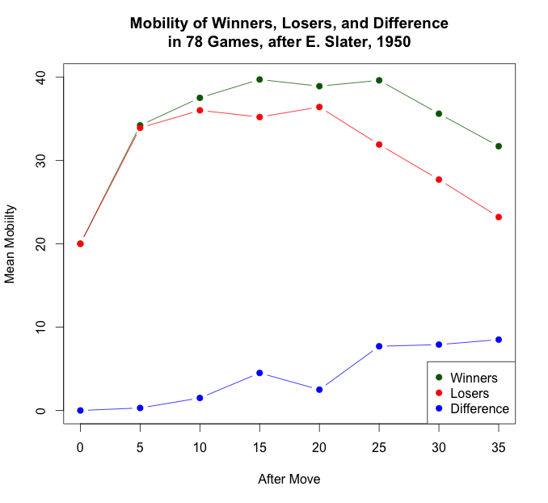

*Figure 1: Plot of Slater’s Mobility Data from Table 1*

The second dataset from Slater is used to predict the values of Shannon’s evaluation function from a player’s advantage in mobility, using mean values computed from 380 games.

|  |  |
| --- | --- |
| **Mobility Advantage** | **Value of Shannon’s Function** |
| + 0.26 | + 0.46 |
| + 0.19 | + 0.35 |
| + 0.14 | + 0.27 |
| + 0.09 | + 0.17 |
| + 0.04 | + 0.09 |
| - 0.01 | - 0.05 |
| - 0.07 | - 0.06 |
| - 0.13 | - 0.03 |
| - 0.24 | - 0.43 |

*Table 2: Slater’s Data for Regression Analysis*

Slater wrote that “If graphed these points approximate to a straight line, and to the equation f(P) = +.086 + 1.658M”, where ‘M’ represents the statistic of mobility advantage. Figure 2 provides this graph, along with the regression line from Slater’s equation and the least squares regression line computed in R from his data.

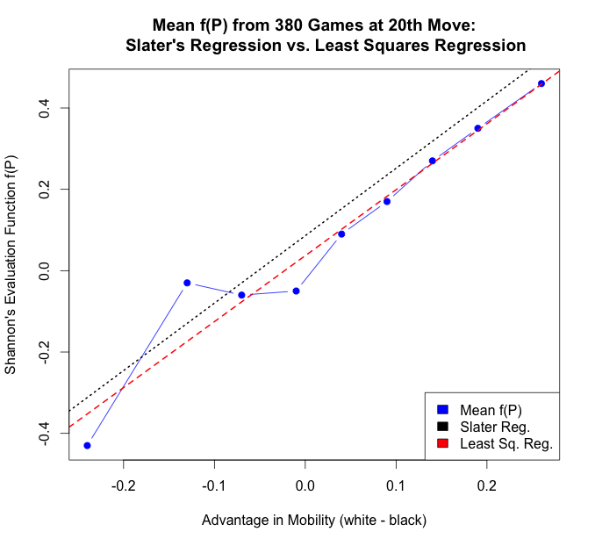

*Figure 2: Plot of Slater’s Regression Data*

Slater did not describe how he calculated his linear equation coefficients, but the equation computed by the ‘lm()’ function in R differs from his, and is: f(P) = 0.0369 + 1.62182M. The reader will note that the least squares equation has slightly smaller coefficients for both the intercept and the slope.

Levy and Newborn summarize both Shannon and Slater, as well as other research regarding material and mobility (Levy and Newborn, 1982). They refer to Hamish (no reference supplied) who computed weighting coefficients for material and mobility as 1/30 and 1/60, respectively, but no details are shared regarding the computation.

Some mobility research involves alternative notions of what mobility means. For example, Levinson and Snyder introduced *distance* as a generalization of mobility, taking a graph-theoretic view (Levinson and Snyder, 1993). Moves are ranked ‘good’ if they improve that side’s mobility graph or degrade that of the opponent’s. Levene and Fenner investigated the concept of *domination* as an alternative interpretation of mobility (Levene and Fenner, 2001). By domination they refer to moves that restrict the opponent’s choices of response, while maximizing their own. This concept is used to help guide minimax game tree searches.

# Statistical Analysis of Material and Mobility

## Analysis of the Population

Our first step was to establish baseline statistics and regression models for material and mobility from a random sample of expert-level games in the entire population consisting of games won by white, games won by black, and draws. We follow this in later sections by further analysis to determine the significance, if any, of departures from those baselines in samples taken from games ending in a win by white or a win by black.

For the game data, all players had ELO ratings of at least 2000, considered expert level by the United States Chess Federation. Computer memory limitations prevented computing the true population means for material and mobility, so we selected a random sample of 5,000 games from the dataset to compute point estimates of the population statistics. All code was written in the R statistical programming language, augmented with the *rchess* package written by Joshua Kunst, which provides R tools to load and process PGN chess data. This package is available at *The Comprehensive R Network* (https://cran.r-project.org). Adding to this rchess base, custom R code was developed (https://github.com/kurtgodden/chess) to analyze both material and mobility from random samples selected from the preprocessed data. The point estimates thus computed appear in Table 3.

To compute material we used the ‘standard’ values of pieces (1, 3, 3, 5, 9) as cited above for Shannon’s early research. Because at many moves the material for either side can change via promotions and captures, we computed the total material for both white and black at every board position in a game. After the final position, we divided each of these totals by the number of board positions to arrive at a *game mean material* for each player. Then each of those 5000 game means for each player were used to arrive at the population mean and standard deviation values shown here. A similar computation was done for mobility, except at each board position only the legal moves for the side to move were counted so that the *game mean mobility* for each side was the average number of legal moves for that player in the game.

|  |  |  |  |  |
| --- | --- | --- | --- | --- |
| **Statistic** | **White Material** | **Black Material** | **White Mobility** | **Black Mobility** |
| **Mean** | 29.574640 | 29.553987 | 33.13604 | 30.839317 |
| **St. Dev.** | 5.650526 | 5.680532 | 4.86725 | 4.354868 |

*Table 3: Population Statistics from Point Estimates of 5000 Games*

In these population estimates we see that white enjoys only a tiny advantage over black in material, but an advantage in mean mobility of almost 2.3 moves, although the standard deviations are larger than these advantages. In the random sample there were 1821 white wins, 1388 black wins, 1790 draws and one game in the sample of 5000 had a result of ‘*’, indicating an indeterminate outcome at the time the game data was collected.

The histograms in Figure 3 graphically illustrate the distribution of material and mobility using all 406,028 half-moves played in the 5000 games. Notice that the shapes of the histograms between black and white are not substantially different for either statistic.

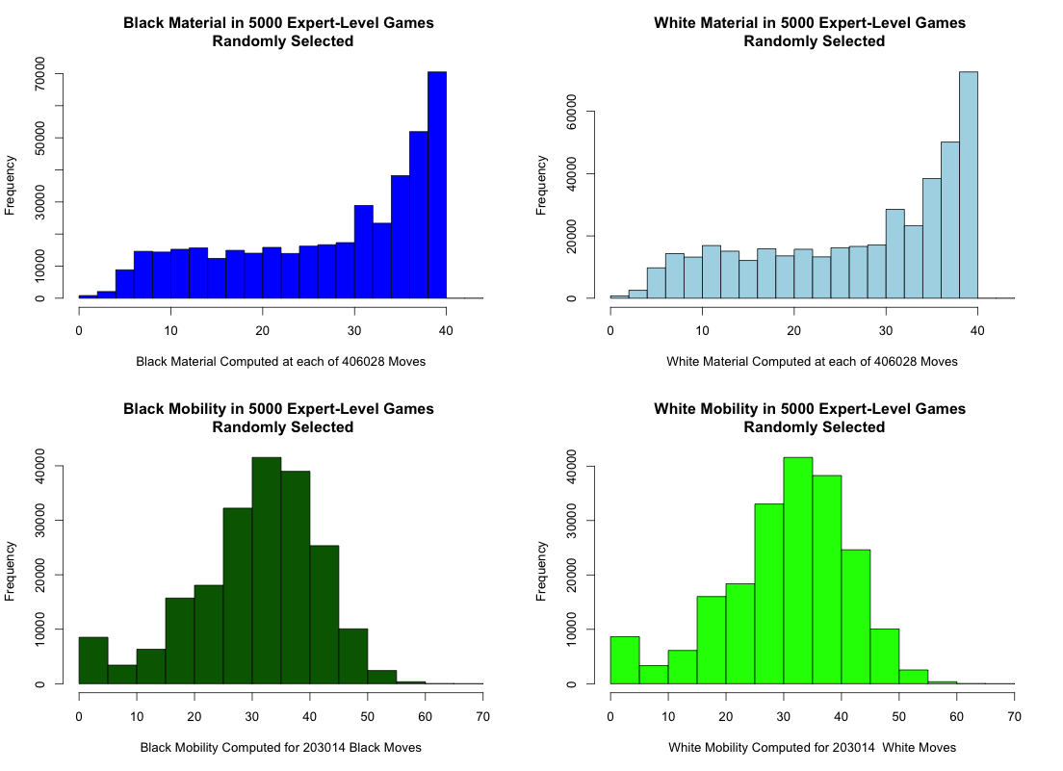

*Figure 3: Distributions of Material and Mobility in Population*

It is also instructive to consider the direct relationship between material and mobility for a given player. Given that both material and mobility have large values after pieces are developed in the opening and both are smaller in the end game, it is reasonable to expect a predictable relationship. Put simply, when a player has more material, then that player would be expected to have more possible moves, and fewer possible moves are expected with little material on the board. Consider the plots of Figure 4, which fit the following linear equation (1) to the data using the least squares method to estimate the coefficients β0 and β1:

mobility = β0 + (β1 * material) (1)

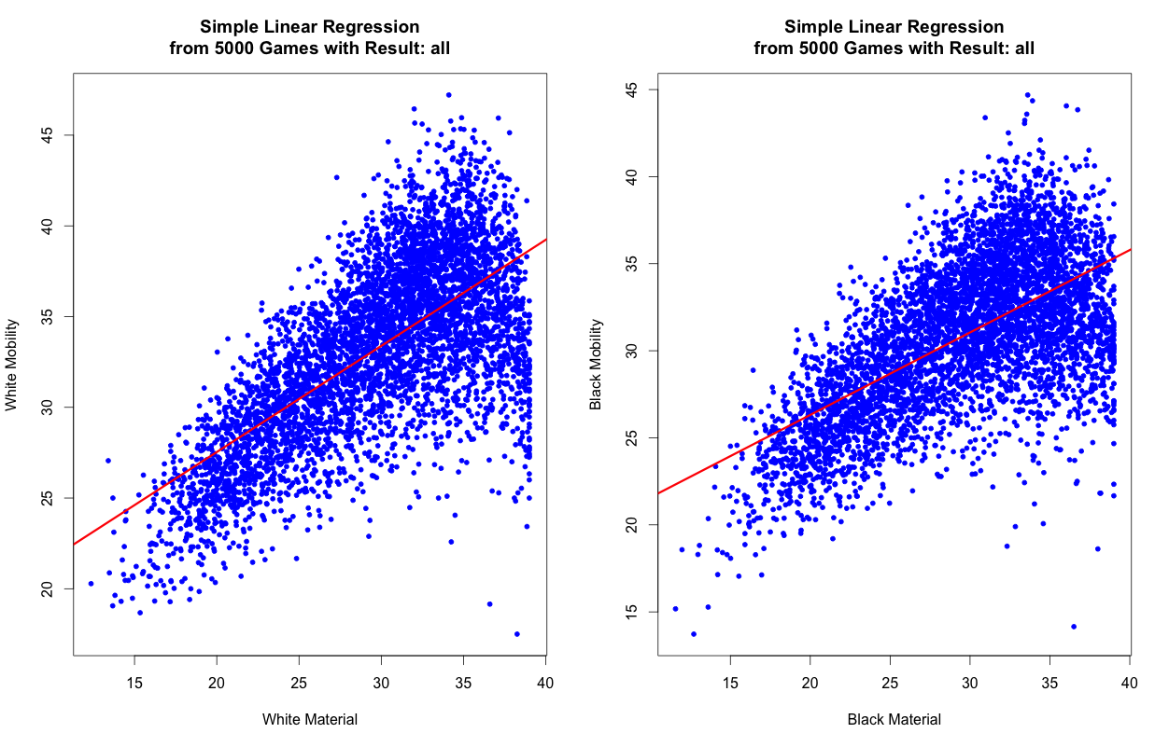

*Figure 4: Mobility vs. Material with Simple Linear Models, Equations (2) and (3)*

The blue points are the sample data, plotted for each of 5000 randomly selected games. The red lines show the regression fits of a simple linear model to the data. For the white model on the left side of Figure 4, the linear fit of equation (1) produces equation (2) while the black model on the right is equation (3).

white mobility = 15.835046 + (0.584994 * white material) (2)

black mobility = 16.846405 + (0.473470* black material) (3)

A brief examination of these models reveals two shortcomings. First, the lower left portions of the linear fits clearly overestimate the mobility values. Second, one can see that there is more variance among the plotted points on the right side of each plot, whereas a linear regression assumes that variance is constant.

To address the first issue, we add a quadratic term, the square of material, into the equations to introduce a slight curvature to better approximate the data. We address the increasing variance, called heteroscedasticity, by taking the log of the dependent variable, which reduces the larger residuals more than the smaller ones. Our new regression equation becomes:

log(mobility) = β0 + (β1 * material) + (β2 * material2) (4)

This quadratic equation can still be used by software to compute *linear* regressions because it is linear in the β-coefficients, and the least squares estimation of those parameters is still appropriate. Substituting the estimated coefficients for the two models into (4) we obtain equations (5) and (6) for the white and black models, respectively, and plot them in Figure 5.

log(white mobility) = 1.936 + (0.09225* white material) - (0.001296* white material2) (5)

log(black mobility) = 1.947 + (0.08914* black material) - (0.001285* black material2) (6)

*Figure 5: Regression Models for Population, Equations (5) and (6)*

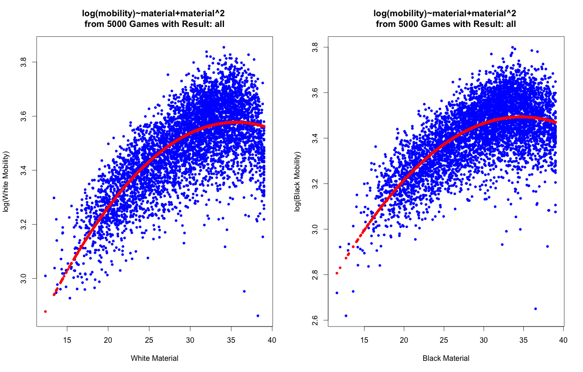

The quadratic term clearly improves the fit of the regression models, while the heteroscedasticity has improved slightly by adding the log(mobility) term. We will revisit this in the next section where we characterize won games.

## Regression Models of Won Games

We now investigate regression models for games resulting in a win for one side or the other. For won games we take random samples of 1000 games each and create regression models based on equation (4), resulting in the fitted equations in (7) and (8) for the sample of white wins, and equations (9) and (10) for the sample from black wins, Figures 6 and 7.

log(white mobility) = 2.077 + (0.08157* white material) - (0.001064* white material2) (7)

log(black mobility) = 2.086512 + (0.075543* black material) - (0.001029* black material2) (8)

log(white mobility) = 2.069006 + (0.079021* white material) - (0.001046* white material2) (9)

log(black mobility) = 1.964237 + (0.086987* black material) - (0.001178* black material2) (10)

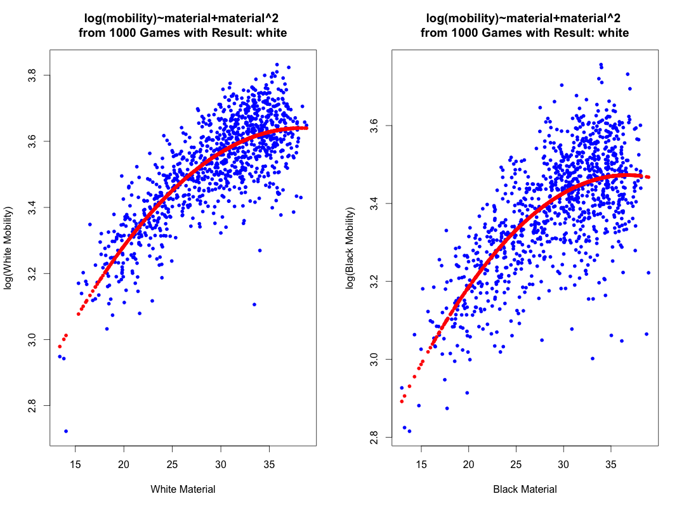

*Figure 6: Models for White Wins, Equations (7) and (8)*

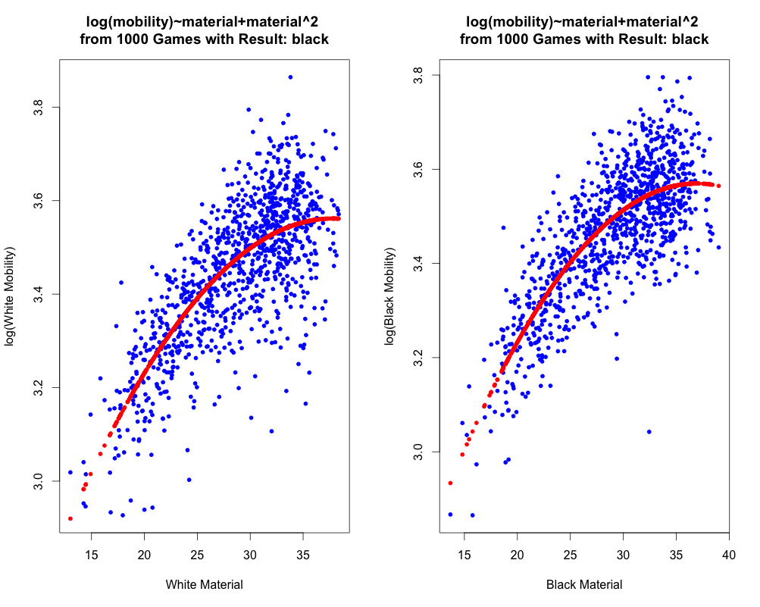

*Figure 7: Models for Black Wins, Equations (9) and (10)*

Regardless of which side wins, visually at least, the fitted models based on equation (4) appear to fit the data well. When we look at the residual plots, Figures 8 and 9 below, we notice an interesting effect. The log of the response variable has improved the heteroscedasticity for the winning side’s model, but much less so for the losing side, as can be seen in the more noticeable funnel shape in the losing side’s residual plot.

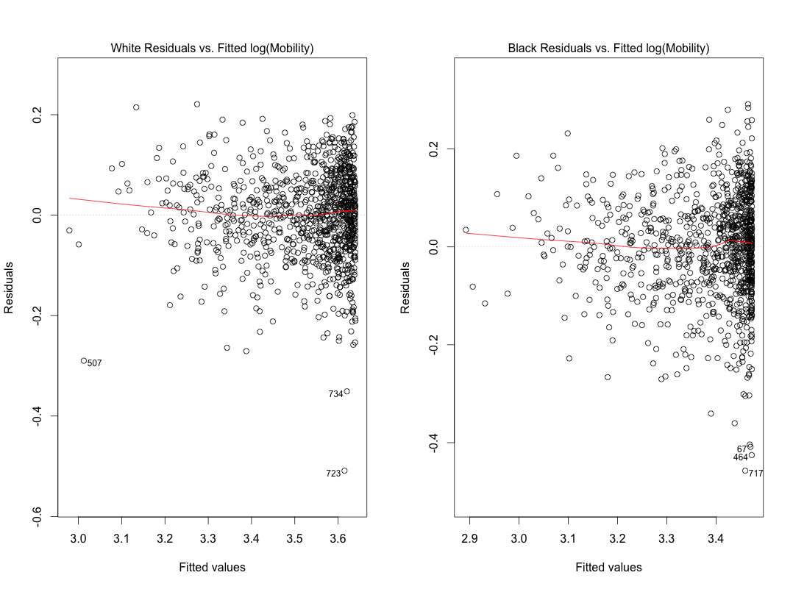

*Figure 8: Residual Plots for White Wins*

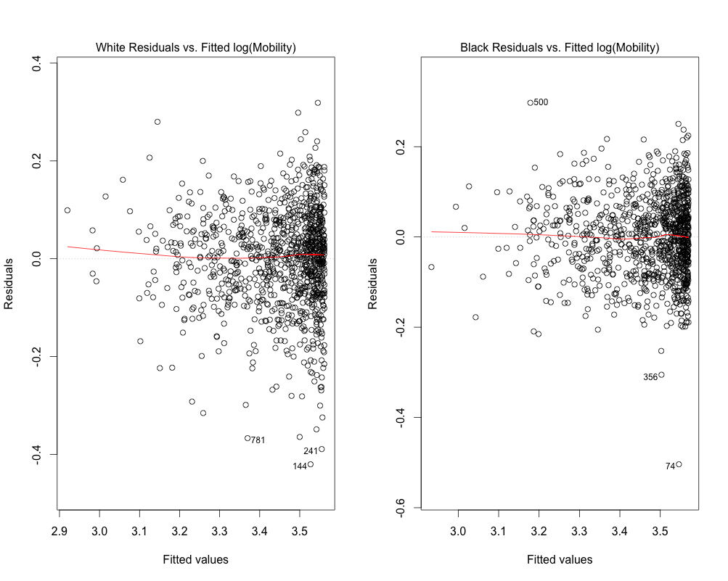

*Figure 9: Residual Plots for Black Wins*

Table 4 shows how all of the above models compare in goodness-of-fit statistics. In all eight models, the p-values for every β-coefficient are less than 2.2e-16, hence the extremely low F-statistic values.

|  |  |  |  |  |  |  |
| --- | --- | --- | --- | --- | --- | --- |
|  | **White R2** | **Black R2** | **White**  **RSE** | **Black**  **RSE** | **White F-stat**  **p-value** | **Black F-stat**  **p-value** |
| **Population,**  **Eqs. (2) & (3)** | 0.4612 | 0.3814 | 3.573  4998 d.f. | 3.425  4998 d.f. | < 2.2e-16 | < 2.2e-16 |
| **Population,**  **Eqs. (5) & (6)** | 0.5628 | 0.4894 | 0.101  4997 d.f. | 0.1048  4997 d.f. | < 2.2e-16 | < 2.2e-16 |
| **White Wins,**  **Eqs. (7) & (8)** | 0.6593 | 0.5106 | 0.088  997 d.f. | 0.1055  997 d.f. | < 2.2e-16 | < 2.2e-16 |
| **Black Wins,**  **Eqs. (9) & (10)** | 0.573 | 0.6283 | 0.1004  997 d.f. | 0.08703  997 d.f. | < 2.2e-16 | < 2.2e-16 |

*Table 4: Quality of Regressions in Figures 4 – 7*

Comparing the R2 values, the amount of variance explained, the models with the quadratic and log terms in equations (5) – (10) account for more of the variance than the simple linear fits of equations (2) and (3). Again, (2) and (3) are based on the simple linear model of (1), while the better performing models in (5) – (10) are based on the revised model of (4). But the more dramatic improvement between these two groups shows up in the residual standard errors (RSE), which improve as much as two orders of magnitude when moving from equation (1) models to equation (4) models. These improvements are due to the quadratic and log terms that were added in equation (4). Together, these goodness-of-fit statistics, R2 and RSE, clearly demonstrate that the models based on equation (4) are superior to those based on (1).

Table 4 also shows that for the models in won games, the regression fits are better for the winning side than the losing side. Finally, we also point out that the models fit white better than black. Notice that in the model for games won by black, the R2 for white, the losing side, is higher than it is for black, the losing side, when white wins, 0.573 vs. 0.5106, respectively. The RSE values are also better for white than black when comparing winning to losing sides.

Let us now turn to consider whether the mean material and mobility statistics in won games differ significantly from the population.

## Hypothesis Tests: Departure from Population Mean when Game is Won

One may reasonably conjecture that players who win would have more mobility than they have in the population, which also includes losses and draws. Would we also expect winners to have more material compared to the population? Tables 5 and 6 contain point estimates from random samples of won games with sample sizes of 1,000.

|  |  |  |  |  |
| --- | --- | --- | --- | --- |
| **Statistic** | **White Material** | **Black Material** | **White Mobility** | **Black Mobility** |
| **Mean** | 29.45825 | 29.142364 | 34.362652 | 29.786741 |
| **St. Dev.** | 5.34346 | 5.487446 | 4.900061 | 4.323617 |

*Table 5: Mean Material and Mobility in 1000 White Wins*

|  |  |  |  |  |
| --- | --- | --- | --- | --- |
| **Statistic** | **White Material** | **Black Material** | **White Mobility** | **Black Mobility** |
| **Mean** | 28.663276 | 29.038162 | 31.747328 | 32.336095 |
| **St. Dev.** | 5.214587 | 5.073105 | 4.688989 | 4.410876 |

*Table 6: Mean Material and Mobility in 1000 Black Wins*

Comparing these estimates with the population estimates in Table 3 we see that while our conjecture may be true for mobility, the material mean estimates for both winning sides are actually *less than* the population estimates. To validate this finding we need to see if those material differences are statistically significant or not, which we can do with hypothesis tests.

Let us use the notation *W.matw*to refer to white’s mean material in games won by white and *W.matp* to represent white’s mean material in the population regardless of the outcome. Similarly, *W.mobw* and *W.mobp* refer to white mean mobility in games won by white and in the population, respectively. Thus, for our first test the null hypothesis, H0, which is assumed true unless proven false beyond a reasonable doubt, is that white’s mean material in games won by white is the same as white’s mean material in the population. The alternative hypothesis, Ha, represents what is suggested by the data in Table 5, viz. that white’s mean material is smaller in games won by white than in the population as a whole. However, we cannot accept Ha unless there is overwhelming evidence of its truth. Expressing these concepts formally gives us:

|  |
| --- |
| H0: W.matw = W.matp |
| Ha: W.matw < W.matp |

*Hypothesis Test 1:*

*White Material in White Wins vs. the Population*

Hypothesis Test 2 is analogous to Test 1except the sample is now from black wins:

|  |
| --- |
| H0: B.matb = B.matp |
| Ha: B.matb < B.matp |

*Hypothesis Test 2:*

*Black Material in Black Wins vs. the Population*

**Discussion of Tests 1 and 2:** The standard test for two samples with different sample sizes (1,000 in won games vs. 5,000 in the population sample) and different variances (from Tables 3, 5 and 6) is Welch’s t-test. The first step in performing such a test is to obtain the t-statistic, which, for Hypothesis Test 1, is the distance in standard errors from W.matw to W.matp. If this distance is great enough, then we may regard it as strong evidence that there is, indeed, a true difference between W.matw and W.matp that is not due to chance. For Test 1 using the data from Tables 3 and 5, the t-statistic works out to be -0.622675. This value must be compared against the t-quantile, a value that controls the Type 1 error, the probability of incorrectly rejecting H0 when it is actually true, and an error I am loathe to make.

The default level of significance in statistical tests is to control the probability of a Type 1 error to be less than 0.05. For our data, this means that we must compare the t-statistic value to the t-quantile value of -1.645883. If the t-statistic is less than or equal to this t-quantile, then the probability of a Type 1 error is less than 0.05 if H0 is true, which is taken as strong evidence that H0 is therefore false and Ha is true.

Since -0.622675 is not less than -1.645883, we do not have sufficient evidence to reject the claim of H0 that the mean material of white in white wins is the same as that in the overall population. Put another way, the mean material of white in white wins is not statistically different than white’s mean material in the overall population, and the smaller value in Table 5 is within normal variation of the value in Table 3.

For Hypothesis test 2, the t-statistic is -2.875026 and the cutoff to limit the probability of incorrectly rejecting the null hypothesis is -1.645841. But this time we see that the t-statistic is much smaller than the cutoff, so there is very strong evidence to reject H0 in favor of Ha. When black wins there is a statistically significant reduction in black’s material compared to black’s material in the population.

This is quite interesting because it means that, on average, black wins in spite of having less material than when black does not win! Could these wins be due to a black advantage in mobility? That is a difficult question to answer, but we can certainly answer the simpler question of determining if either winning side has more mobility than it has in the population.

The third and fourth hypothesis tests are similar to the previous two, except that (a) they are stated for mobility; and (b) the direction of the inequality in Ha is reversed since Tables 5 and 6 suggest that mobility does increase over the population mobility for the winning side, as we originally conjectured.

|  |
| --- |
| H0: W.mobw = W.mobp |
| Ha: W.mobw > W.mobp |

*Hypothesis Test 3:*

*White Mobility in White Wins vs. the Population*

|  |
| --- |
| H0: B.mobb = B.mobp |
| Ha: B.mobb > B.mobp |

*Hypothesis Test 4:*

*Black Mobility in Black Wins vs. the Population*

**Discussion of Tests 3 and 4:** To determine the results of Tests 3 and 4, we compare the t-statistic for mobility against the appropriate t-quantiles. In the case of Test 3, the t-statistic is 7.234336 while the t-quantile cutoff is 1.645927. And since the direction of the inequality in Ha is reversed, we want to see if the t-statistic is larger than the t-quantile, which it most certainly is. In fact, it is nearly 4.4 times larger. Hence, we may safely conclude that white has significantly greater mobility when white wins than in the population. How does black compare?

The t-statistic for black mobility is 9.81651, so when winning, black’s mobility jumps nearly ten standard errors compared to the population. Since the t-quantile for black is only 1.645931, once again we see when winning, black’s mobility increase is quite significant. For black, the t-statistic is nearly 6 times larger than the cutoff. Thus, unlike the results with material, when considering mobility we conclude that both sides’ mobility increases significantly when they win, and for black the increase is more significant than it is for white. We cannot claim that this more significant result for black is the reason black wins in spite of having less material than in the population, but it is at least consistent with this view. Let us now consider how black and white compare directly against one another.

## Hypothesis Tests: Black vs. White Advantages

In Tables 5 and 6, the winning side’s mean material and mobility are both greater than the losing side’s. But again we need to perform hypothesis tests to see if these differences are statistically significant. This time we need to compare these differences against the differences in the population. From Table 3 we see that the difference between white and black material is 0.020653, white having the small fractional advantage. In Table 5 white’s advantage when winning jumps to 0.315886. To determine if that increase is significant or not we perform a paired t-test, again using the R programming language. The hypothesis test for material advantage is stated formally in Hypothesis Test 5 and the corresponding test for mobility is Hypothesis Test 6:

|  |
| --- |
| H0: W.matw – B.matw = W.matp – B.matp |
| Ha: W.matw – B.matw > W.matp – B.matp |

*Hypothesis Test 5:*

*White Material Advantage in White Wins vs. the Population*

|  |
| --- |
| H0: W.mobw – B.mobw = W.mobp – B.mobp |
| Ha: W.mobw – B.mobw > W.mobp – B.mobp |

*Hypothesis Test 6:*

*White Mobility Advantage in White Wins vs. the Population*

Table 6 tells us that when black wins, black also has a material advantage as well as a mobility advantage over white. Hypothesis Tests 7 and 8 are used to determine if those advantages are significant:

|  |
| --- |
| H0: B.matb – W.matb = B.matp – W.matp |
| Ha: B.matb – W.matb > B.matp – W.matp |

*Hypothesis Test 7:*

*Black Material Advantage in Black Wins vs. the Population*

|  |
| --- |
| H0: B.mobb – W.mobb = B.mobp – W.mobp |
| Ha: B.mobb – W.mobb > B.mobp – W.mobp |

*Hypothesis Test 8:*

*Black Mobility Advantage in Black Wins vs. the Population*

When performing these paired t-tests for mean differences in material and mobility for samples of 1000 games each in white wins and black wins, we obtain the results in Table 7.

|  |  |  |  |  |  |
| --- | --- | --- | --- | --- | --- |
|  | **t-stat** | **Deg.Freedom** | **p-value** | **Mean Difference** | **0.95 Confidence Interval** |
| **Test 5** | 15.566 | 999 | <2.2e-16 | 0.3158866 | [0.2846601, ∞] |
| **Test 6** | 15.739 | 999 | <2.2e-16 | 4.5759100 | [4.3374910, ∞] |
| **Test 7** | 21.124 | 999 | <2.2e-16 | 0.3748851 | [0.3440579, ∞] |
| **Test 8** | 20.818 | 999 | <2.2e-16 | 0.5887671 | [0.3605680, ∞] |

*Table 7: Paired t-test Results of Material and Mobility Advantage in Wins vs. Population*

First, the column *Mean Difference* shows the average value of the difference in mean material or mean mobility subtracting the loser from the winner. For example, in Test 5 for wins by white, we see that the mean difference of white minus black material is 0.3158866, confirming our manual computation above. This mean difference is an estimate of the true difference, which is unknown, but with 95% confidence the true mean difference lies within the interval [0.2846601, ∞].

The column t-stat shows the computed t-statistic, where larger values indicate differences that are more statistically significant, but all of these t-statistics are quite large. The statistics of most importance are the p-values, all of which are not only less than the cutoff of 0.05 for statistical significance at the 95% level, but exceed even the 99% level of significance by a wide margin. While the p-values are the most important, the most interesting are the t-statistics when we consider them in tandem with the values of the mean differences.

For example, the mean material advantage that black has in black wins is 0. 3748851. This seems only marginally larger than white’s material advantage in white wins, which is 0.3158866. However, recall that black suffers a deficit in material in the population, making black’s advantage in Test 7 more significant than it may appear, and this is reflected by the t-statistic for Test 7, which is much larger than white’s t-statistic in Test 5.

Even more interesting than that are the mean differences computed for mobility advantage in Tests 6 and 8. Test 6 for white wins tells us that when winning, white has a mobility advantage of more than 4.5 moves per game, whereas when black wins, black’s mobility advantage in Test 8 is not even 0.6 moves per game, and yet black’s t-statistic is 20.818 to white’s 15.739. Black’s ‘small’ mobility advantage is much more significant than white’s ‘large’ one.

# Summary

The preceding analyses have revealed some interesting and even surprising findings. First, we have found that the general equation in (4) provides a fairly good model of the relationship between material and mobility both for the population of expert level play and for the subset of games where one side wins, although the regression models fit white somewhat better than they do black.

Our hypothesis tests have shown that when white wins, there is no significant difference in white’s material vis-à-vis in the population as a whole, while black’s material actually degrades significantly from the population! Our mobility tests showed that both sides can expect significantly greater mobility over the population when they win, though the significance for black is much larger than it is for white.

Finally, when comparing white against black, each winning side has an advantage over the loser in both material and mobility. However, black’s advantage in both material and mobility when winning is much more significant than white’s advantage when winning. In the case of mobility, black’s advantage of about 0.6 moves is much more significant than white’s advantage of about 4.6 moves. In light of these direct comparison results and the well-known observation that white wins more often than black, it would appear that the advantage of having the first move is a rather remarkable advantage. It is quite possibly necessary for black to have more significant advantages in material and mobility than white in order to overcome white’s advantage of the first move.

# Future Research

For the immediate future, we will continue to investigate models of material and mobility to see if we can improve upon equation (4). As a regression model, we can use (4) or its refinement to predict mean mobility in games where we are given only the mean material values for both sides. In addition, we will investigate various classification models using both material and mobility to determine if a game’s outcome can be predicted from these statistics. We will also try to extend such predictive models to apply not only to game means, but positional means. That is, given a board position, how well, if at all, can we predict the game’s eventual outcome using only material and mobility at that position?

Some other interesting questions to address might be whether an individual player can gain insight into his or her relative strengths and weaknesses using these types of analyses on their own games vis-à-vis their opponents. Can these insights be converted into strategies of play? The data may well be able to provide us with answers to these questions.

**References**

Levene, M. and T. Fenner. (2001) The effect of mobility on minimaxing of game trees with random leaf values. *Artificial Interlligence.* Vol. 130 (1).

Levinson, R. and R. Snyder. (1993) Distance: Toward the unification of chess knowledge. *ICCA Journal*, Vol. 16 (3).

Levy, D. and M. Newborn. (1982). All about chess and computers: Chess and computers and more chess and computers. Second Edition, pp.31ff. Rockville, MD: Computer Science Press.

Shannon, C. E. (1950). Programming a computer for playing chess. *Philosophical Magazine.* Ser. 7, Vol. 41 (314). Retrieved from http://vision.unipv.it/IA1/ProgrammingaComputerforPlayingChess.pdf

Slater, E. (1950). Statistics for the chess computer and the factor of mobility. *Proceedings of the Symposium on Information Theory.* London. Published in 1953 under the same title in *Transactions of the Institute of Radio Engineers Professional Group on Information Theory,* 150-152, 198-200. London: Ministry of Supply. Retrieved from http://eliotslater.org/index.php/chess/147-statistics-for-the-chess-computer-and-the-factor-of-mobility