Game Launcher

Information
This program is a game launcher where you can add games and set its style.
The program was written in C# 2008 Express edition with .Net Framework 2.0 target platform.
Made by: Kurtis

System requirements
At least .Net Framework 2.0 is required to run this program.
The system requirement mostly depends on the style settings.

Minimal requirements
10-20 MB free memory
1.0 GHz processor

Install
Extract the game_launcher.exe file into a folder where you will be running it.

Uninstall
Delete the game_launcher.exe and the game_launcher.ini file.

Usage

Main window
After pressing the right mouse button 3 menu will appear:
- Edit games – Game list editing
- Edit style – Style editing
- Exit – Exit the program
After running the program a blank window like this will appear:
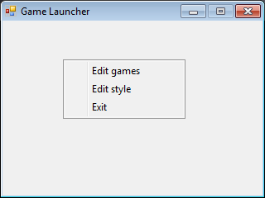

Edit games window
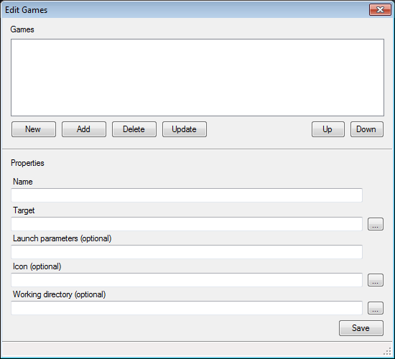
In this window you can add games to the list.

Games
New | Empty the text fields
Add | Add the filled data to the list
Delete | Delete the selected game from the list
Update | Overwrite the selected game from the list
Up/Down | Move the game up and down in the list
Double click on the selected game | Load the selected game’s data

Properties
Name | Display name
Target | Target path to the program
Launch parameters (optional) | Launch parameters
Icon (optional) | Icon
Working directory (optional) | Start in directory
Save or CTRL+S | Save data
You can browse with the buttons next to the text fields.
The program will warn you if any data isn’t saved. Also it will display in the lower area: Game not saved if the game is not added, Data not saved if any changes are not saved.

Edit style window
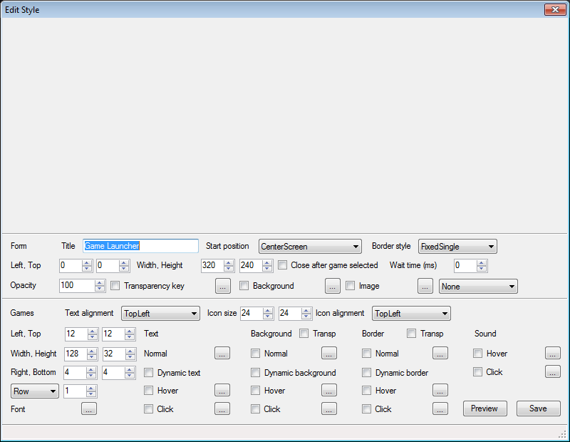
In this window you can set the window and the games display style. The upper empty area is for displaying the preview, it only shows maximum 4 clickable games. Some texts have a checkbox that turns on/off the appropriate property. (for ex.: If the checkbox next to Border > Normal is not checked then the element won’t have a border).

Form
Title | Window text
Start position | Window start position
Border style | Border style
Left, Top | X, Y coordinates, only works if the Border style is Manual
Width, Height | Width, height
Close after game selected | Closes the program after the game started
Wait time (ms) | Wait time after the game started in milliseconds
Opacity | Transparency
Transparency key | Transparency color
Background | Background color
Image | Background image, the drop down changes the fill mode

Games
Text alignment | Text alignment
Icon size | Icon size
Icon alignment | Icon alignment
Left, Top | X, Y start coordinate for generation
Width, Height | Width, height
Right, Bottom | Right and bottom margin per element
Row/Column | Generation by row or column, how many elements will be in a row/column
Font | Font

Text
Normal | Text color
Dynamic text | Enable text interactivity by mouse
Hover | Hover color
Click | Click color

Background
Transp | Transparent background color (for Normal)
Normal | Background color
Dynamic background | Enable background interactivity by mouse
Hover | Hover color
Click | Click color

Border
Transp | Transparent border color (for Normal)
Normal | Border color
Dynamic background | Enable border interactivity by mouse
Hover | Hover color
Click | Click color

Sound
Hover | Hover sound
Click | Click sound

Buttons
Preview | Preview settings
Save or CTRL+S | Save settings
The buttons next to the texts are to browse for color, font and file to the appropriate setting.
The program will warn you if any data isn’t saved. If any data is modified, then Data not saved text will appear in the lower area.

Example settings
