Simple Dock

Information
This is a simple, easy to style Dock, that requires very little system resources.
The Dock won’t store running programs. It supports drag and drop.
The program isn’t foolproof so unintended behavior can be expected.
The program was written in C# 2019 Community edition with .Net Framework 4.5 target platform.
Made by: Kurtis

System requirements
At least .Net Framework 4.5 is required to run this program.
The system requirement mostly depends on the style settings.

Minimal requirements
10-20 MB free memory
1.0 GHz processor

Install
Extract these files into a folder:
- sm_dock.exe
- sm_dock_cfg.exe

Uninstall
Delete these files or the folder where you extracted them:
- icons.img
- sm_dock.exe
- sm_dock_cfg.exe
- sm_dock.ini

Usage
Before anything you must configure the Dock with the sm_dock_cfg.exe file, because the required files are missing:
- icons.img
- sm_dock.ini

Simple Dock configuration – sm_dock_cfg.exe
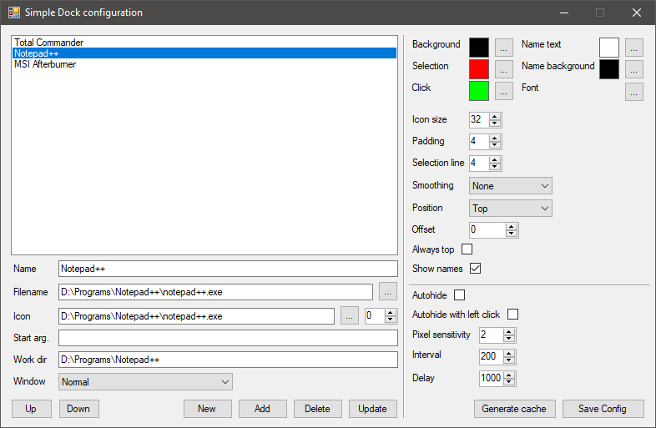
New | Empty the text fields
Add | Add the filled data to the list
Delete | Delete the selected item from the list
Update | Overwrite the selected item from the list
Up/Down | Move the item up and down in the list
Click on the selected item | Load the selected item’s data

Name | Name under the icon
Filename | Program that will run
Icon | Program’s icon
Start arg. | Start arguments
Work dir | Work directory
Window | Start with normal, maximized, minimized window
Background | Dock background color
Selection | Icon selection color
Click | Icon click color
Name text | Text color of the name under the icon
Name background | Text background color
Font | Text font
Icon size | Icon size
Padding | Padding between icons
Selection line | Line thickness under the icon
Smoothing | Icon smoothing quality
Position | Dock position
Offset | Position offset
Always top | Always on top
Show names | Show names under the icons
Autohide | Hide automatically
Autohide with left click | Hide automatically with mouse click
Pixel sensitivity | Sensitivity in pixels
Interval | Mouse checking interval
Delay | Display delay

After you have finished with the settings press the Save Config button, if there are no errors then press the Generate cache button – the next time you will need to use this button when you add or update the list. After that if everything completed without errors you can start the sm_dock.exe file.

Simple dock – sm_dock.exe
If you don’t like what you have set, close it with ALT+F4, then with the configurator fine-tune your settings until you are satisfied.
Some screenshots of the program:


