Simple Launcher

Information
This is a simple, easy to style Launcher, that requires very little system resources.
It supports drag and drop.
The program isn’t foolproof so unintended behavior can be expected.
The program was written in C# 2019 Community edition with .Net Framework 4.5 target platform.
Made by: Kurtis

System requirements
At least .Net Framework 4.5 is required to run this program.
The system requirement mostly depends on the style settings.

Minimal requirements
10-20 MB free memory
1.0 GHz processor

Install
Extract these files into a folder:
- sm_launcher.exe
- sm_launcher_cfg.exe

Uninstall
Delete these files or the folder where you extracted them:
- icons.img
- sm_launcher.exe
- sm_launcher_cfg.exe
- sm_launcher.ini

Usage
Before anything you must configure the Launcher with the sm_launcher_cfg.exe file, because the required files are missing:
- icons.img
- sm_launcher.ini

Simple Launcher configuration – sm_launcher_cfg.exe
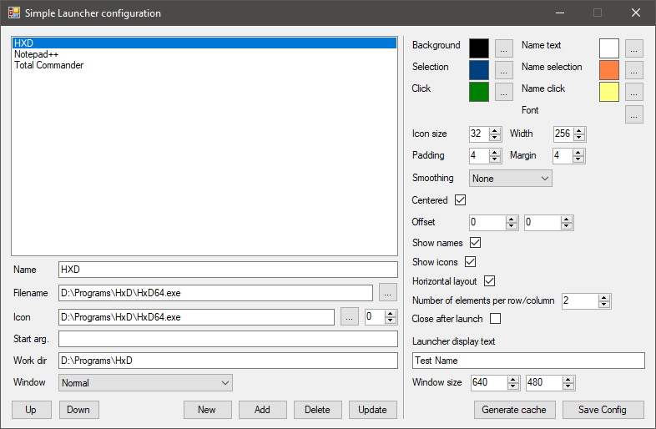
New | Empty the text fields
Add | Add the filled data to the list
Delete | Delete the selected item from the list
Update | Overwrite the selected item from the list
Up/Down | Move the item up and down in the list
Click on the selected item | Load the selected item’s data

Name | Name under the icon
Filename | Program that will run
Icon | Program’s icon
Start arg. | Start arguments
Work dir | Work directory
Window | Start with normal, maximized, minimized window
Background | Launcher background color
Selection | Icon selection color
Click | Icon click color
Name text | Text color of the name under the icon
Name selection | Text selection color
Name click | Text click color
Font | Text font
Icon size | Icon size
Padding | Padding inside icon
Margin | Margin between icons
Width | Icon width
Smoothing | Icon smoothing quality
Centered | Centered or manual positioning
Offset | Position offset
Show names | Show names in the icons
Show icons | Show icon images in the icons
Horizontal layout | Generate icons horizontally/vertically
Number of elements per row/column | Start a new row/column after number of elements under 2 it defaults to 10000
Close after launch | Close after successfully launched the selected program
Launcher display text | Text that will be displayed in the Launcher title
Window size | Window size, if elements overflow, then scrolls will appear

After you have finished with the settings press the Save Config button, if there are no errors then press the Generate cache button – the next time you will need to use this button when you add or update the list. After that if everything completed without errors you can start the sm_launcher.exe file.

Simple launcher – sm_launcher.exe
If you don’t like what you have set, close it, then with the configurator fine-tune your settings until you are satisfied.
Some screenshots of the program:
