December 05, 2021
Notice for Viva Voce Examination of BBA 46th Intake
The 4th & Final Viva Voce Examination of the students of BBA 46th Intake (both the sections) will be held in Room No. 805 of the University Campus (Building 04) according to the following time schedule:

Date | Time | ID
08/12/2021  Wednesday | 09.00 A.M. – 1.00 P.M. | 17183101001- 17183101061
08/12/2021  Wednesday | 02.00 P.M. – 4.00 P.M. | Retake Students

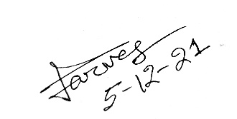
Md. Parvez Uddin
Assistant Professor and Chairman (Acting)
Department of Finance

