April 05, 2022
Notice for Viva Voce Examination of BBA 47th Intake
The 4th & Final Viva Voce Examination of the students of BBA 47th Intake will be held in Room No. 805 of the University Campus (Building 04) according to the following time schedule:

Date | Time | ID
10-04-22 | 10AM -1:00PM | 18191101001-18191101070
10-04-22 | 1:30PM-2:30PM | 18191101071-18191101110
11-04-22 | 10AM -12:30PM | 18191101111-18191101166
11-04-22 | 1:00PM-2:30PM | Students of other Intakes

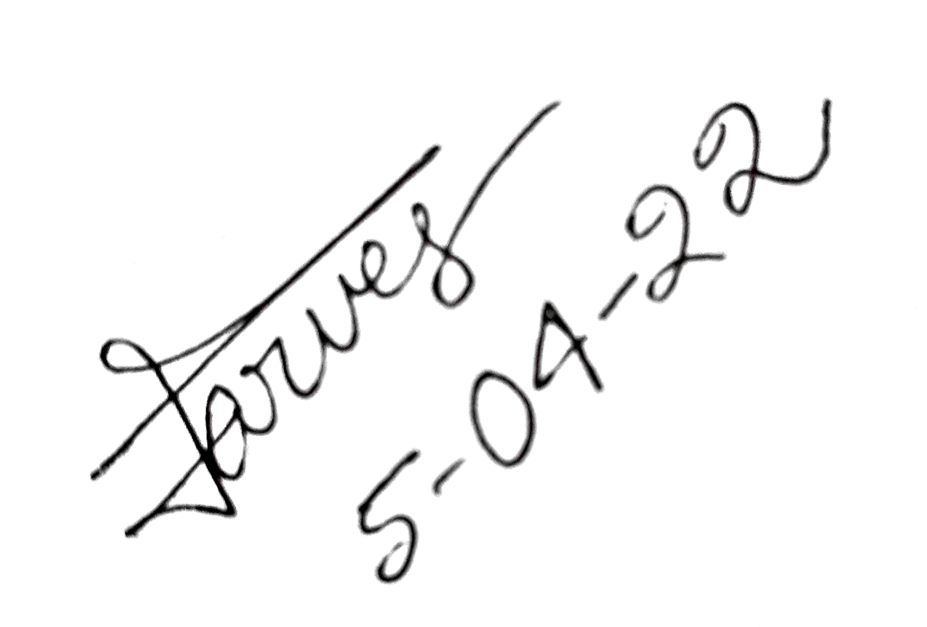

Md. Parvez Uddin
Assistant Professor
Department of Finance

