News from the Department of Economics for newsletter:

1. The Department of Economics, BUBT has arranged a Workshop on ‘Post EPR-Draft Improvement Plan’  
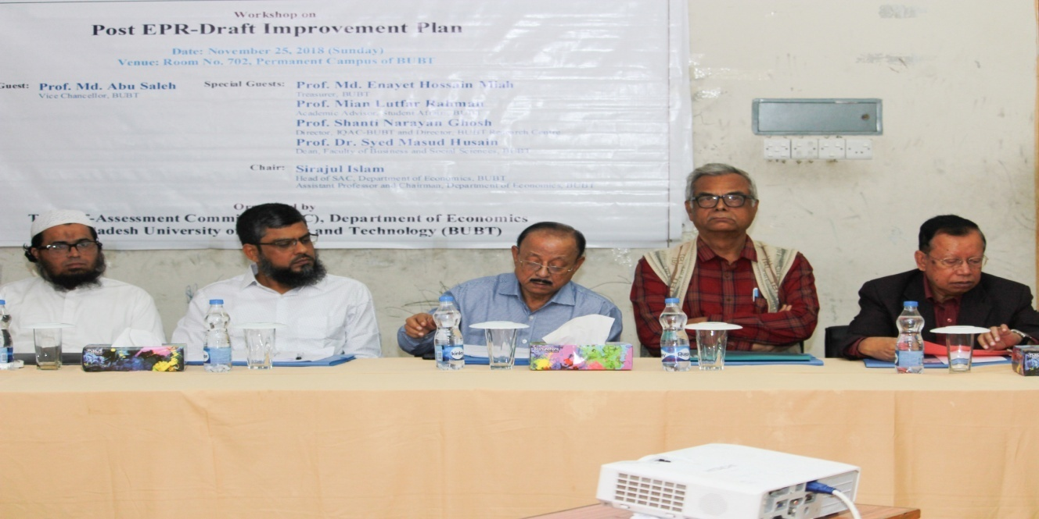

The SA-Committee of Economics Department of BUBT had organized its sixth workshop on Post EPR-Draft Improvement Plan at 25th November, 2018 in the permanent campus of BUBT. At this workshop the Chief Guest was Prof. Md. Abu Saleh, Vice Chancellor, BUBT. The special guests were Prof. Md. Enayet Hossain Miah, Treasurer, BUBT, Prof. Mian Lutfar Rahman, Academic Advisor, Student Affairs, BUBT, Prof. Shanti Narayan Ghosh, Director, IQAC-BUBT and Director, BUBT Research Centre and Prof. Dr. Syed Masud Husain, Dean, Faculty of Business and Social Sciences, BUBT. Dr. Mohammed Ziaul Haider,Professor, Department of Economics, Khulna University was the key discussant of the workshop. All the guests expressed their views on the Draft Improvement Plan of SAC-Economics, BUBT.

The keynote was jointly presented by the members of SAC-Economics, BUBT in three consecutive technical sessions. The second member of SAC-Economics Mr. Tareq Imam Zahid, lecturer in Economics had presented the main targets and possible interventions of nine quality assessment areas in technical session one. The first member of SAC-Economics Mahmuda Jahan Papia, Assistant Professor of Economics had presented the possible financial requirements and performance indicators about the future improvement of the department. In technical session three the Mr. Sirajul Islam, Head of the SAC-Economics had presented the possible roadblocks and how to overcome such roadblocks in nine QA areas. The discussant provided necessary suggestions and recommendations for further improvement. The workshop was presided over by Sirajul Islam, Chairman of Economics, BUBT.