Economics Department of BUBT holds seminar on budget 2019-20

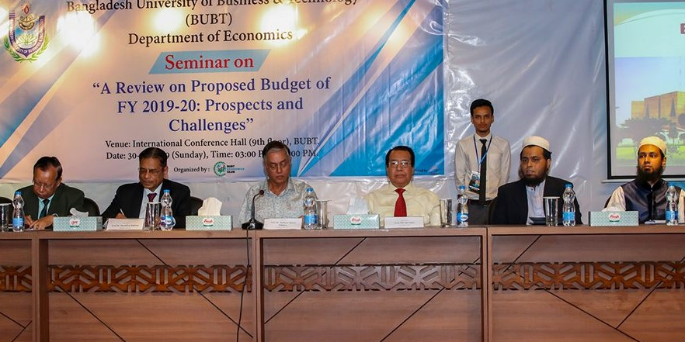

0n 30th June, 2019, the Economics Department of BUBT arranged a seminar titled 'A Review on Proposed Budget of FY 2019-20: Prospects and Challenges". Prof Dr Mustafizur Rahman, Distinguished Fellow, Center for Policy Dialogue (CPD), made a review on budget as chief guest. He said that budget allocation in education, health and agriculture sectors is not sufficient and it should be more logical and need based. Though it is a deficit budget it would be implementable if the government ensures transparency, accountability and reduce the cost of nonperforming loans and reduces indirect taxes. The prominent economist also said that the government must remove the obstacles of distributing funds among young entrepreneurs and should show zero tolerance on bank defaulters. Budget alone cannot address these issues we need others policies as well. The government should see that Bangladesh is developing but other countries are developing fast. Prof Dr Shafique Ahmed Siddique, Chairman of BUBT Trust, also spoke as special guest. He said that we should avoid the tendency of tax evasion. It will hamper our economic growth. Prof Md Abu Saleh, Vice-Chancellor of BUBT presided over the session. He said that we should not except that the budget will be 100 percent accurate. Assistant Prof Dr Md Mahmudul Hassan presented a paper at the seminar. Dr Syed Masud Husain, Dean. Faculty of Business and of Social Sciences delivered the welcome speech and Sirajul Islam, Chairman, Department of Economics gave a vote of thanks. The seminar was organized by the cooperation of BUBT Economics Club.