BUBT Economics Club has formed

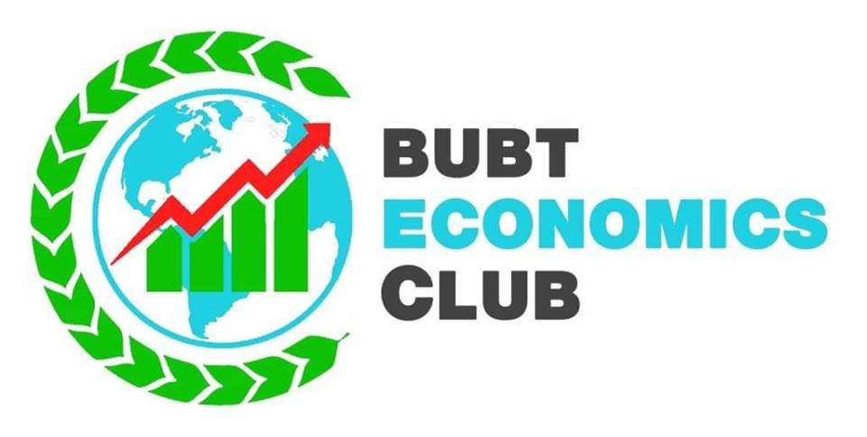

The Economics Department of BUBT has formed a club named BUBT Economics Club on 16th April, 2019. The club has got official approval by the authority of BUBT on 15th April, 2019. The formation of club was among the targets set by the Self-Assessment Committee of Economics Department. The main objective of the club is to create potential opportunities related to career for the students of BUBT specially for the students of Economics. Promoting the image of BUBT is another prime objective of the club. The club will organize several seminars, workshops and other activities on contemporary issues of Economics. It will also serve the social interest as well. Dr. Mahmudul Hassan, Assistant Professor of Economics has been appointed as the moderator of the club.