Assessment of the 4th & Final Viva Voce of the students of BBA Program of 45th Intake (section 1-3) will be held through Google Meet. All students are instructed to join as per their scheduled joining time as shown in the following table.

|  |  |  |
| --- | --- | --- |
| Date (Day) | Time to Join | ID |
| August 16, 2021  (Monday) | **10:00 AM** | **17182101001 - 17182101015** |
| **10:30 AM** | **17182101016 - 17182101030** |
| **11: 00 AM** | **17182101031 - 17182101040** |
| **11:30 AM** | **17182101041 - 17182101060** |
| **03:00PM** | **17182101061-17182101075** |
| **03:30PM** | **17182101076 -17182101090** |
| **04:00PM** | **17182101091- 17182101105** |
| August 17, 2021  (Tuesday) | **10:00 AM** | **17182101106- 17182101120** |
| **10:30 AM** | **17181101121-17181101135** |
| **11:30 AM** | **Students of other intakes** |

**You can use the following link or code to join Google Meet.**

**Google Meet Link:** <https://meet.google.com/rbg-mjcr-qjh>

**Google Meet Code:** rbg-mjcr-qjh

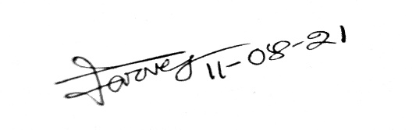

Md. Parvez Uddin

Assistant Professor and Chairman (Acting)

Department of Finance