NEW BRUNSWICK GOVERNMENT PERFORMANCE + ELECTORAL RISK
Susan Holt’s mandate
at day 674
Delivery, legitimacy, administrative health and the path to the next election

CURRENT L–PC MARGIN | CURRENT NOWCAST | 2028 PROBABILITY
+10.2 points | 30 L | 17 PC | 2 G | Not estimable
Current judgement: a real but soft electoral advantage. Implementation is substantial; conversion into outcomes, lived improvement and trust is inconsistent. Broad civil-service unhappiness is not established.
Evidence cutoff: 26 August 2026
Comparison clock: 674 days after the 21 October 2024 election
Ordinary election date: 16 October 2028, subject to earlier dissolution
Research rule: Facts, calculations, inferences and non-findings kept separate
Deep Research audit | Nonpartisan | Reproducible

1. Bottom line
At mandate day 674, Susan Holt is not presently behind in current election evidence. A transparent 90-day recency-weighted benchmark of the three qualifying polls is Liberal 43.2%, PC 33.0% and Green 13.4%. Its deterministic riding conversion is 30 Liberal, 17 PC and two Green seats; all three poll-specific conversions yield Liberal majorities ranging from 26 to 32 seats. The inputs themselves range from a four-point to a fourteen-point Liberal lead. This is a current benchmark, not a latent-support estimate, election probability or 2028 forecast. [S01, S06–S08, S42]
The advantage is soft rather than durable. In August 2026 Abacus found only 32% approving of the government’s overall handling, 34% saying the province was moving in the right direction, and weak issue-handling ratings on cost of living, health care and housing. Compared with its October 2025 wave, overall handling fell ten points, trust six, perceived positive change six, and Holt’s net favourability eighteen; the consulting/communicating measure fell only four. The directional comparison is useful but not a pristine trend because panel supplier and weighting details changed. [S06, S36]
The government’s implementation record is materially stronger than those perceptions imply: rent-cap authority, electricity relief, school breakfast, collaborative-care infrastructure and housing starts are real. But the chain weakens after output. Primary-care attachment fell in the latest independent survey; affordability gains are partly offset by other costs; housing starts are not completions; school-lunch reach and outcome data were not yet available; and the explicit promise to balance every mandate-year budget is off trajectory. [S10, S13, S15–S21, S32–S35]
The majority is not as protected as a ten-point provincial lead suggests. Under the same deterministic model, six Liberal losses remove the majority after about 8.2 points of adverse Liberal–PC margin erosion, while a PC plurality arrives after about 11.4. In the lowest current poll-specific scenario, only another 2.9 points separates the Liberals from losing their majority. These are stress-test boundaries, not probabilities or predictions of individual voter movement. [S01, S42]
The responsible 2028 conclusion is therefore: Liberal retention is the most consistent current conditional path, but a one-term government remains a material and readily intelligible risk. No defensible numerical probability can be assigned.

Verdict matrix
Question | Finding | Evidence status
Is Holt popular? | Personally competitive and electorally ahead, but goodwill and performance ratings have eroded. | Established current description; trend caution
Is policy delivery effective? | Implementation is substantial; population-level effectiveness is mixed or premature. | High confidence on outputs; low-to-moderate on causality
Is the problem “communications”? | There is an observed implementation-to-public-evaluation gap. Credit conversion and weak mandate compression are leading hypotheses, but awareness, attribution, comprehension, adequacy and lived experience have not been measured together. | Medium inference
Are senior civil servants broadly unhappy? | Public evidence cannot establish this. Morale is unobserved. | High-confidence non-finding
Is the administration healthy? | Mixed/amber: continuity coexists with identifiable capacity and change-management risks. | Moderate inference
Would Holt win today? | All three current poll-specific deterministic benchmarks yield Liberal majorities; no election-day probability is assigned. | Moderate current evidence; model is deterministic and polling sparse
Will Holt win in 2028? | Not estimable as a calibrated probability. | High-confidence model stop rule

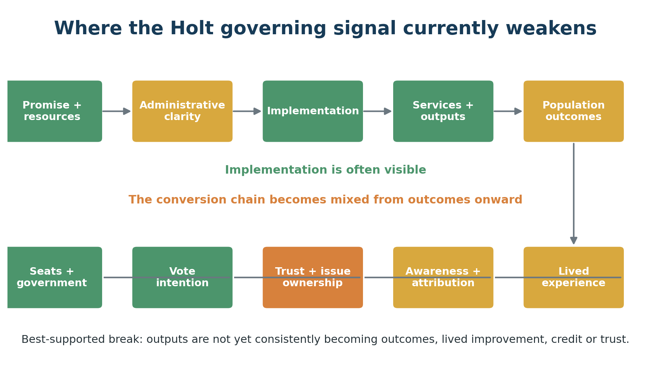
Figure 1. Governing signal chain and the best-supported current break. Green indicates stronger evidence; amber/orange indicates partial conversion or risk.

2. What was measured—and what was deliberately not claimed
The analysis uses a ten-stage governing signal chain:
1. promise and resources;
2. administrative authority and clarity;
3. implementation;
4. service availability and reach;
5. population outcomes;
6. lived experience;
7. awareness and attribution;
8. trust and issue ownership;
9. vote intention;
10. seats and government formation.
This matters because governments often publicize the earliest favourable stage and observers judge the final stage. A clinic announcement is not a staffed clinic; a staffed clinic is not a unique patient attachment; an attachment is not timely access; a housing start is not an occupied affordable home; a budget allocation is not expenditure or an outcome; and a provincial vote lead is not the same thing as forming government in 2028.
The report uses five claim types:
- Verified fact: directly supported by an original source or certified result.
- Calculation: reproducible transformation of disclosed inputs.
- Inference: the best explanation of multiple observations, with a rival explanation and a disconfirming test.
- Non-finding: a claim the available evidence cannot establish.
- Conditional path: a sequence that could lead to an electoral outcome; no probability is implied.

Evidence quality
The source hierarchy gives greatest weight to Elections New Brunswick, statutes, official administrative data, the Auditor General, the New Brunswick Health Council, original pollster releases and original fiscal documents. Contemporary secondary reporting is used only when it documents an event not preserved in a primary release. Government trackers are evidence of what government reports; they are not independent evaluations of government causality.
Three important discontinuities are preserved rather than smoothed away:
- Narrative Research’s June 2026 wave used an online panel, unlike its earlier telephone probability series. Its all-eligible party shares were normalized only for the current cross-poll comparison and are marked as derived from rounded values. [S08]
- Abacus’s October 2025 and August 2026 waves are directionally comparable, but the provider/weighting disclosure changed and the earlier fieldwork immediately followed a Throne Speech. [S06, S36]
- Historical polling around day 674 is too incomplete to support a validated 3-, 6-, 12-, 18- or 24-month trajectory cone. Endpoint movement is shown descriptively; no distribution is manufactured.

The model gate
A forecast model was permitted to produce a 2028 probability only if it could be hindcast without future information and improve on simple benchmarks with calibrated uncertainty. That threshold was not met. There are only three useful scheduled-term New Brunswick endpoint analogues in the central modern comparison, their mid-mandate poll records are not complete at model grade, and no preregistered cross-provincial training set was assembled for this report. The correct output is therefore NOT ESTIMABLE, not a percentage dressed up as precision.

3. Six-domain mandate dashboard
Domain | Current condition | Earliest weak link | Confidence
Political standing and legitimacy | Soft electoral advantage | Trust and performance evaluation | Moderate
Promise and implementation delivery | Substantial activity; selective proof | Operational scale and result verification | Moderate
Outcomes and fiscal stewardship | Mixed outcomes; fiscal promise off trajectory | Population outcomes and fiscal credibility | High description; low causality
Administrative health and confidence | Morale unobserved; bounded capacity strain | Role clarity, workload and service safeguards | Moderate strain; low morale inference
Communications and public credit | Implementation-to-public-evaluation gap; mechanism unmeasured | Felt experience, attribution and trust | Medium
Electoral coalition and formation | Broad lead with a shallow majority firewall | Saint John/Kennebecasis/Hampton and rural-Anglophone breadth | Moderate nowcast; low 2028

The dashboard is intentionally not collapsed into a weighted “mandate health score”. Such a score would disguise substantive disagreement among measures and require arbitrary weights. A government can be electorally ahead, administratively busy and still lose trust; it can improve a leading indicator while a population outcome lags; it can have a coherent policy but an inadequate benefit. The mixed profile is the finding.

A useful distinction: shelter versus strength
Holt currently benefits from both Liberal support and opposition shelter. In August 2026 only 17% approved of the PC opposition’s performance, about half could not rate either leadership contender, and 56% were unsure whom they preferred. That weakness reduces the immediate conversion of dissatisfaction into PC votes. It should not be mistaken for a permanent Liberal asset: leadership selection is an obvious discontinuity capable of changing recognition, issue ownership and regional consolidation. [S06]
Conversely, current Liberal support is not simply an illusion. Three separate poll inputs place the party first, the party remains strong in the North and among rural Francophone respondents in available regional breakouts, and every poll-specific riding benchmark returns at least 26 seats. The report therefore rejects both extremes: “Holt is cruising” and “Holt is already a one-term premier.”

4. Promise universe: what the government said it would do
The 2024 Liberal platform was extracted from its complete archived issue pages and atomized into discrete commitments. The ledger contains 108 textual rows. Four are explicit duplicates or cross-references, leaving 104 canonical promise units.
Government tracker labels were recorded exactly, but not treated as effectiveness scores. Among the 104 canonical units, the official public tracker classified 20 as complete, 48 as in progress, 35 with no public tracker status and one with no status. The analyst-coded public-evidence audit classified nine as fully operational at the promised scale, twelve with legislation or authority established, sixteen with operational implementation begun, eleven with funding appropriated, seven partially available, thirteen in design or consultation and thirty-six not publicly verifiable. Most stage evidence originates in government trackers and releases; the coding is analytical, not an independent performance evaluation.
These counts answer “what stage is publicly evidenced?”, not “how many promises have been kept?” The classifications differ because a government “complete” label can refer to a statute, programme launch or administrative milestone even when reach, timing, scale or outcomes remain unverified. The full promise text, duplicate handling, original status, analyst stage, evidence date, source and confidence are in the companion workbook.

What the counts reveal
First, the Holt government is not inert. A large share of the agenda has moved into authority, funding or operations. Second, public verification is selective: more than one-third of canonical units have no public tracker status and several “in progress” rows lack a result indicator. Third, the platform is broad enough that message compression is structurally difficult. Six government priorities cover much of the state, while the platform contains more than one hundred atomic commitments. A credible public narrative must therefore choose a governing thesis and a small number of proof points without pretending the rest does not exist.

A better promise-accountability standard
For every flagship commitment, the government should publish:
original promise → authority → appropriation → expenditure → operational capacity → unique people reached → service standard → population outcome → resident experience
Each stage should have a date, denominator, geographic coverage, revision history and explicit statement of what the metric does not prove. This would improve both administration and communication because it prevents policy stages from being collapsed into one another.

5. Five flagship signal-chain audits
The five flagships were selected before judging performance. Selection reflected platform prominence, recurring Throne Speech emphasis, fiscal scale, household salience and the expected time between action and observable result.
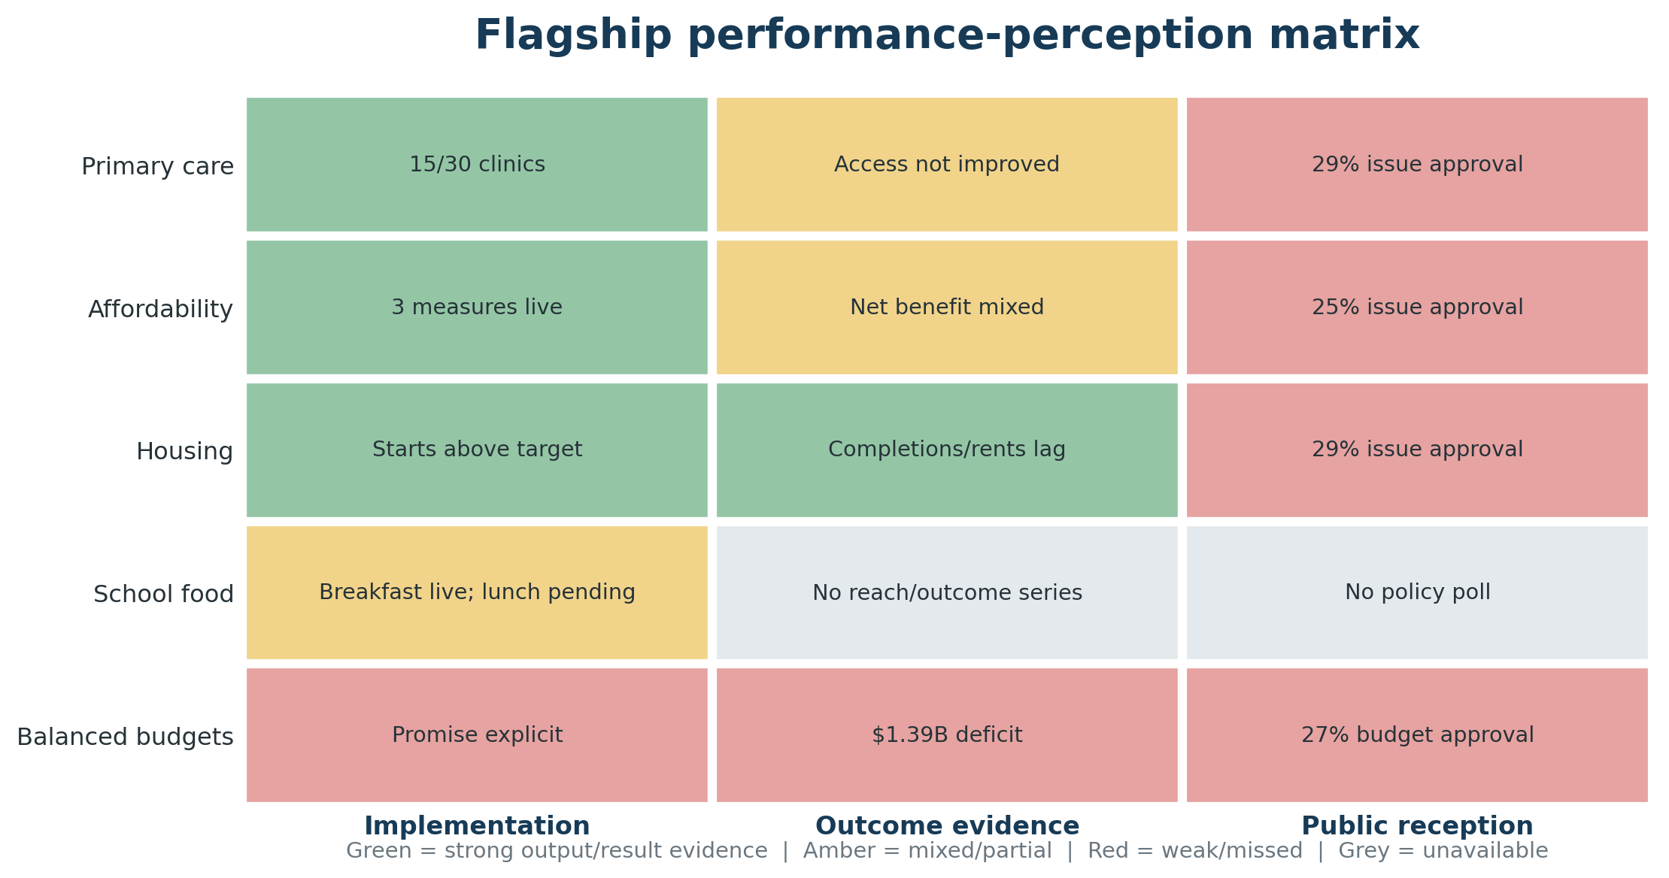
Figure 2. Flagship implementation, outcome evidence and public reception. Colours describe evidence strength, not causal scores.

5.1 Collaborative primary care
Promise and inputs. The government committed to 30 collaborative-care clinics by the end of 2028. It budgeted $30 million for clinics in each of 2025–26 and 2026–27, negotiated a $170.4-million physician agreement and budgeted $50 million for clinical-information modernization. [S15, S16, S21]
Verified outputs. By 4 May 2026, 15 clinics had been announced. The government reported that the first 14 had produced 6,853 additional attachments, with 22,204 expected, and that 67 net new physicians had been added in 2025–26, including 15 family physicians. These are meaningful administrative outputs, but “announced”, “created”, “supported” and “opened” are not consistently defined clinic by clinic. [S15, S16]
Population outcome. The New Brunswick Health Council’s 2025 survey found that the share reporting a permanent primary-care provider fell from 77% in 2024 to 73% in 2025. Only 34% of respondents with a provider obtained an appointment within five days, while approximately 52% of emergency visits remained non-urgent. Fieldwork ran from October 2025 through January 2026, too early to attribute the province-wide change to much of the clinic rollout. [S17, S18]
Public reception. Abacus found only 29% approving of the government’s handling of health care in August 2026. [S06]
Verdict. Implementation is advancing; system effectiveness is not yet established. The earliest weak link is the conversion from announced and funded capacity into unique permanent attachments and timely access. Communications cannot substitute for the missing outcome, but precise reporting can stop output claims from outrunning lived experience.

5.2 Household affordability
Promise and outputs. The government implemented a ten-per-cent rebate on eligible electricity consumption, removed the carbon adjuster and established a three-per-cent annual rent cap. [S10, S32]
Lived effect. The electricity rebate was estimated at about $216 annually for an average eligible account, but it applies to consumption rather than the total bill. Residential rates rose 9.7% in April 2025 and all-class rates rose 4.29% in April 2026; those changes materially offset the visible benefit, although the bases differ and cannot simply be subtracted. In 2025 provincial CPI rose 1.7%, but food rose 3.1% and shelter 2.9%. [S21, S32, S33]
Public reception. Only 25% approved of the government’s handling of cost of living in August 2026. [S06]
Verdict. The promised instruments are operational, but the net household effect and adequacy are mixed. The weak link is first the size of relief relative to total costs, then awareness and attribution. Calling the measure “ten per cent off power bills” would overstate what the policy legally does.

5.3 Housing supply and homelessness
Outputs. Total housing starts increased from 6,169 in 2024 to 7,587 in 2025, above the annual target and the highest comparable count since 1955. Affordable starts reached 343 in 2025 against a 2019–23 annual baseline of 59, with another 194 from January through March 2026. The official tracker reports tracked chronic homelessness falling from 1,050 in 2024 to 996 in December 2025 and 932 in May 2026. [S10, S21]
Limits. Starts are foundations begun, not completed or occupied homes. Affordability depends on tenure, rent, subsidy depth and household income. Housing supply is influenced by interest rates, population growth, municipal approvals and projects already in the pipeline. The homelessness series changes wording between the baseline and later observations and covers three urban centres, so denominator continuity must be verified.
Public reception. Housing handling approval was 29%. [S06]
Verdict. Housing provides the strongest favourable leading indicators and one of the clearest credit-conversion puzzles. Either residents do not know or attribute the gains, the outputs have not yet reached them, or they judge the scale inadequate. Existing polling cannot distinguish these mechanisms.

5.4 Universal school food
Outputs. Breakfast access expanded from 136 schools at the start of 2024–25 to all schools in September 2025, supported by $13 million in combined federal-provincial funding. The 2026–27 budget provided $26 million for pay-what-you-can lunch, scheduled to begin province-wide in September 2026. [S13, S34, S35]
Timing and outcomes. The election costing assumed a September 2025 programme start. At the evidence cutoff, universal lunch had not yet begun, making it roughly one year behind that assumption. No verified series reported meals served, unique participants, food-insecurity change, attendance effect or learning outcome attributable to the programme.
Verdict. Breakfast access is delivered; lunch was pending at cutoff; outcome evidence is absent. The next measurement must distinguish availability from take-up and benefit.

5.5 Balanced budgets and fiscal stewardship
Promise. The filed election disclosure said the Liberals would “balance the budget in each year of our mandate.” [S19]
Results and plans. Public Accounts recorded a $104.4-million deficit for 2024–25, a transition year partly predating the government. The 2025–26 third-quarter update projected a $1.328-billion deficit, and the 2026–27 budget planned a $1.394-billion deficit with year-end net debt projected at $15.902 billion. The later two figures are Holt-government plans, not inherited results. [S20–S22]
Public reception. Abacus found 27% approving of budget management and 23% approving of how taxpayer money was being spent. [S06]
Verdict. The annual balanced-budget commitment is a clear promise miss and is off trajectory. Legitimate explanations—health investments, trade uncertainty, wildfire pressures and population needs—may explain the choice, but they do not make the original promise fulfilled. Fiscal credibility now depends on explicitly acknowledging the change, defining a revised rule and showing the service and economic return from the borrowing.

6. Communications: naming the hypothesis precisely
The evidence does not justify the vague prescription “Holt needs to communicate more”, but it also does not identify a single communications cause. The government communicates frequently, publishes detailed targets and maintains bilingual formal channels. What is directly observed is an implementation-to-public-evaluation gap: programme outputs coexist with weak issue ratings, trust and perceived positive change. The leading mechanism to test is:
An output-to-outcome credit-conversion problem, possibly compounded by weak mandate compression.
This is a hypothesis, not a diagnosis proved by the current surveys. Awareness, correct attribution, comprehension, adequacy and lived experience were not measured in the same respondents. Weak mandate compression describes the public architecture—six coequal priorities beneath rotating umbrella phrases—but its effect on recall, trust or vote has not been measured.

6.1 The same-poll decomposition
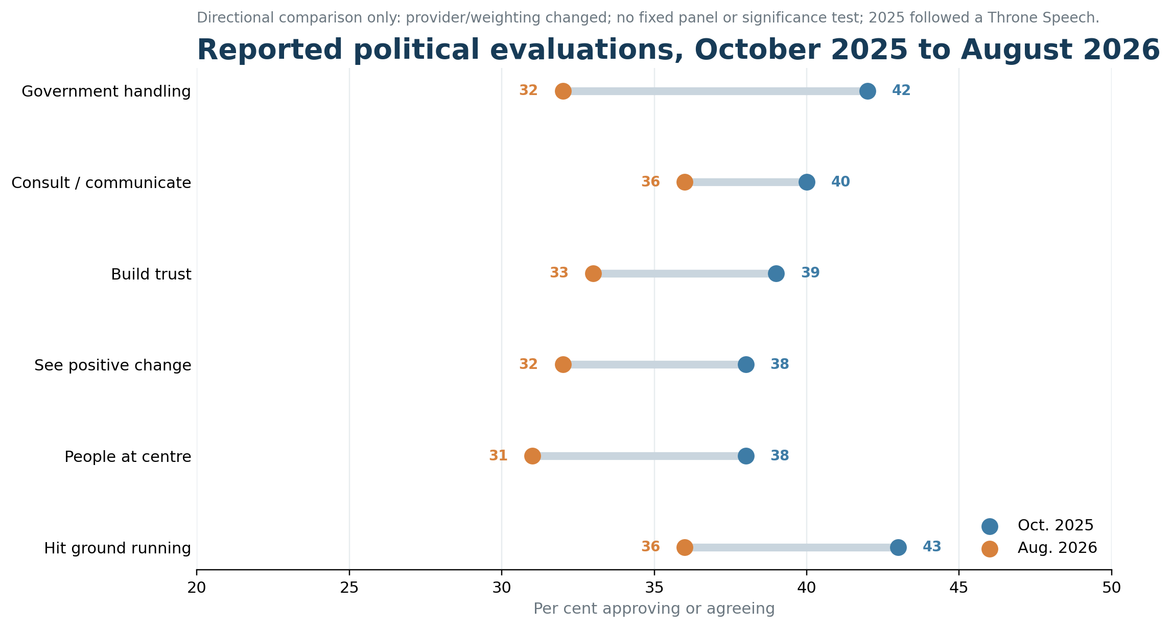
Figure 3. Directional comparison of two Abacus waves. Panel supplier/weighting changed and the 2025 wave followed a Throne Speech.
Between Abacus’s October 2025 and August 2026 waves, government handling declined from 42% to 32%; consulting/communicating from 40% to 36%; building trust from 39% to 33%; seeing positive change from 38% to 32%; putting people at the centre from 38% to 31%; and hitting the ground running from 43% to 36%. Holt’s net favourability fell from +21 to +3, while decided Liberal support fell from 53% to 45%. [S06, S36]
Overall handling and leader favourability fell more than the explicit communication measure, so a generic channel or visibility failure is not uniquely implicated. But the provider and weighting disclosures changed, no fixed panel was used, and no uncertainty test establishes that the four-point communication decline differs meaningfully from the other declines. Residents may be hearing the message and judging the result; they may also be missing, misattributing or discounting it. The next research wave must distinguish those mechanisms before a remedy is chosen.

6.2 Mandate compression
The formal agenda has remained stable—health, affordability and housing, education, economic development, environment and trusted leadership—but has sat beneath a succession of phrases: “fresh start”, “brighter future”, “change in motion”, “accelerating change”, “building the foundation” and “putting New Brunswickers first”. [S29, S30]
This is less compressed than Shawn Graham’s “self-sufficiency” or Brian Gallant’s “jobs first” frame, though not clearly more diffuse than the Alward or Higgs programmes. Formal simplicity is not a re-election strategy by itself: Graham and Gallant still lost government. Compression could give ministers, public servants, local MLAs, media and residents a common test for what matters and what should happen next, but whether New Brunswickers currently lack that shared understanding is unmeasured.
A plausible Holt formulation would need to pass three tests: it must describe the government’s actual resource choices; it must be capable of disconfirmation; and every flagship proof point must connect to it without rhetorical stretching. This report does not prescribe campaign language, but it identifies the measurement need: unaided recall of the government’s purpose and top priorities.

6.3 The post-secondary incident
A late-stage options paper asked universities to respond on a short timetable to scenarios including mergers, privatization, campus reductions and a grant cut. Public reporting treated the scenarios as government proposals before Holt rejected closures and privatization; the final budget effectively froze rather than cut operating grants. [S37, S38]
The defensible diagnosis is not that scenario analysis was illegitimate. It is a consultation-to-closure and internal-to-public translation failure. The sequence did not clearly distinguish exploratory analysis, stakeholder consultation, Cabinet direction and final decision. It is the strongest public example of a communication problem touching both administration and politics.

6.4 Negative controls
Two findings prevent overdiagnosis.
First, wildfire handling received the government’s highest issue rating. This is inconsistent with a simple claim that no government message or performance can receive public credit, although emergency response is unusually visible, concentrated and temporally clear. [S06, S39]
Second, a broad French-language transmission failure is not supported by the available broad indicators. Formal releases were supplied in both languages; available polls place Liberal support and government approval strongest in the North; and Porter O’Brien reported stronger Liberal support in its rural-Francophone than rural-Anglophone cell. None of this measures reception: North is not a language category, formal supply is not comprehension, and the rural-Francophone cell was only 97 respondents. A properly powered language-stratified awareness and trust study is still required. [S06, S07, S29]

6.5 The decision rule
The next research wave should distinguish four conditions:
Awareness | Attribution | Adequacy/experience | Diagnosis
Low | Low | Unknown | Transmission/attention problem
High | Low | Positive | Credit-attribution problem
High | High | Negative | Policy adequacy or delivery problem
High | High | Positive, trust still low | Broader credibility/identity problem

Without these linked measures, “communications” remains an umbrella word that can conceal the actual failure point.

7. Administrative health and the civil-service hypothesis
The report takes seriously the user’s reports of unhappiness among high-ranking civil servants. It does not convert those reports into a public fact. No representative senior-executive survey, voluntary-exit series, department-level turnover flow, vacancy rate, sick-leave series, acting-duration series or anonymized confidence measure was located. Senior civil-service morale is therefore coded UNOBSERVED. [S42]
That non-finding is not a clean bill of health. It means the question must be tested through observable mechanisms rather than inferred from anecdotes.

7.1 What the leadership record shows
The named senior-leadership changes through day 674 are predominantly internal promotions and transfers, acting assignments later regularized, and announced retirements. This is more consistent with managed transition and succession than with a demonstrated exodus. Absence from a later roster is not coded as a resignation, dismissal or expression of discontent unless a source establishes the disposition. [S23–S25]
Kelly Cain’s movement from the Premier’s political office to a deputy-minister role creates a legitimate political-administrative optics question. Her prior deputy-minister experience weakens any inference that she lacked administrative qualifications. No public evidence establishes loyalty tests, retaliation for unwelcome advice, suppression of professional analysis or a favouritism finding.

7.2 Objective strain mechanisms
Four signals justify an amber administrative-health rating:
1. Part I workforce reduction. The 2026–27 budget committed to reducing the Part I civil service by approximately 12% over three years, potentially saving $100 million. This is a credible source of uncertainty, workload pressure and vacancy suppression, but realized effects were largely unobservable only five months after announcement. [S22]
2. Dual-hatting and reform. The Finance deputy moved to a new reform and modernization portfolio, while the Human Resources deputy also became interim Finance deputy. This creates an objective continuity and workload risk, not proof of dysfunction. [S25]
3. RTIPPA capacity. Only 59.5% of 2024–25 requests met the 30-business-day period. Among surveyed RTIPPA professionals, 62% affirmed having necessary tools, resources and support; the review documented manual processes, uneven capacity and training gaps. This is strong function-specific evidence, but it cannot be generalized automatically to all departments. [S26]
4. Auditor General case. Tourism, Heritage and Culture said a 2025–26 performance report was unavailable because of staffing changes, alongside broader grant-control weaknesses. This is a concrete departmental execution risk, partly inherited, not a whole-of-government estimate. [S27]
Labour relations point in both directions. CUPE 1190 ratified a four-year agreement by 95%, and government reached a tentative master agreement with six New Brunswick Union groups. Labour organizations later warned that attrition could increase workload and service delay. Agreements show bargaining capacity; stakeholder warnings are not representative morale measures. [S40, S41]

7.3 The publicly unverified internal-translation risk
The defensible public-record label is an implementation-detail transparency gap, not a demonstrated internal strategic-translation failure:
The government has made the 12% workforce destination public, but the public record does not show a comparably complete department-by-department operating model.
Sequencing, vacancy rules, workload safeguards, service-level trade-offs, decision rights and workforce commitments are not comparably visible. Departments may possess internal instructions that are not public; their absence from public sources cannot be laundered into a finding that officials lack direction. The asymmetry identifies a risk to test through employee evidence and service data, not a conclusion about Holt’s personal relationship with officials.

7.4 What would prove or disprove the concern
A credible test requires:
- quarterly senior-executive appointment, transfer, secondment, retirement, dismissal and external-exit records;
- voluntary, involuntary and retirement separations by department and classification;
- vacancy, suppressed-vacancy, time-to-fill and long-acting data;
- sick leave, overtime, accumulated leave and stress/disability absence;
- service standards matched to staffing change;
- representative anonymous measures of priority clarity, decision rights, ability to provide frank advice, psychological safety, perceived political neutrality and intention to leave;
- a critical-incident interview protocol that separates direct observation, inference and hearsay.
Until then, “civil-service confidence” should not be coded high or low.

8. Historical comparison: what New Brunswick’s past actually says
At approximately mandate day 674, each named comparator government was ahead of its strongest opponent. Graham led by about 15 points, Alward by 12, Gallant by 22 and Higgs by 13; Holt’s current recency-weighted benchmark lead is 10.2. Yet Graham, Alward and Gallant did not remain in government at the next scheduled election. [S42]
Premier | Frozen polling input | Offset from target | Source grade and limitation
Shawn Graham | May 2008 quarterly value | Exact field dates not found | A− retrospective primary table; no exact midpoint, sample or mode
David Alward | 22 May 2012 midpoint | −71 days | B; original release identified but inaccessible
Brian Gallant | 12 July 2016 midpoint | −15 days | A− archived original
Blaine Higgs | 22 May 2020 midpoint | −68 days | A; closest pre-cutoff poll, New Brunswick decided n=199
Susan Holt | Three-poll recency benchmark; latest component midpoint 3 August 2026 | −24 days | A/A− primary releases; combined row is derived

These offsets matter. A ±30-day window does not preserve the full comparator set, and Graham’s exact distance cannot be computed. The comparison is therefore a coverage-limited historical case exercise, not a symmetric event-study window.
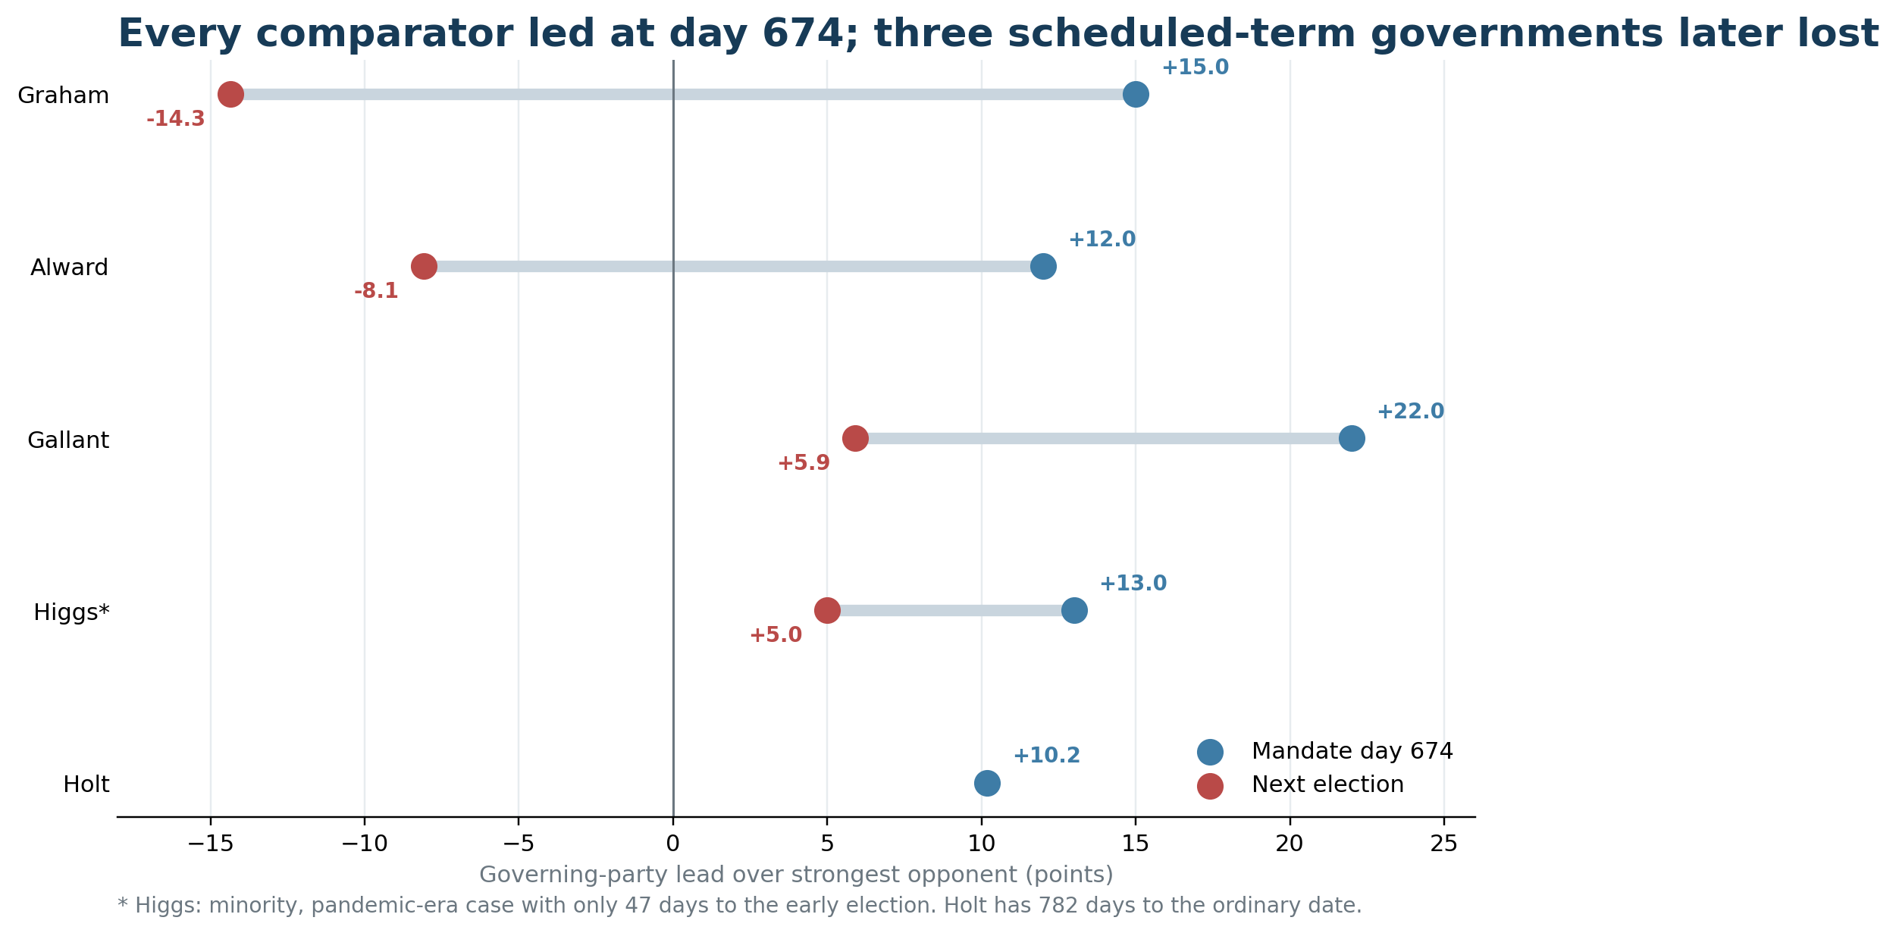
Figure 4. Frozen day-674 governing-party margins and next-election endpoints. Higgs is a minority, pandemic-era, short-horizon special case.

8.1 Comparator interpretation
- Shawn Graham: a majority government with a memorable “self-sufficiency” umbrella. Its day-674 lead eventually became a 14.3-point deficit, a 29.3-point margin decline. Message compression did not prevent defeat. [S28, S42]
- David Alward: a broad programme emphasizing culture, fiscal management, engagement and leadership. Its day-674 lead became an 8.1-point deficit, a 20.1-point decline. [S43, S42]
- Brian Gallant: a “jobs first” frame and a strong day-674 lead. The Liberals retained a popular-vote lead of 5.9 points but lost the seat plurality and ultimately government, demonstrating that vote, seats and government formation are different outcomes. [S44, S42]
- Blaine Higgs: a five-challenges/results frame, minority status and a pandemic-era comparison only 47 days before a snap election. The 8.0-point margin decline is a useful short-horizon case but not interchangeable with Holt, who is 782 days from the ordinary fixed date. [S45, S42]

8.2 Endpoint drift is not a forecast distribution
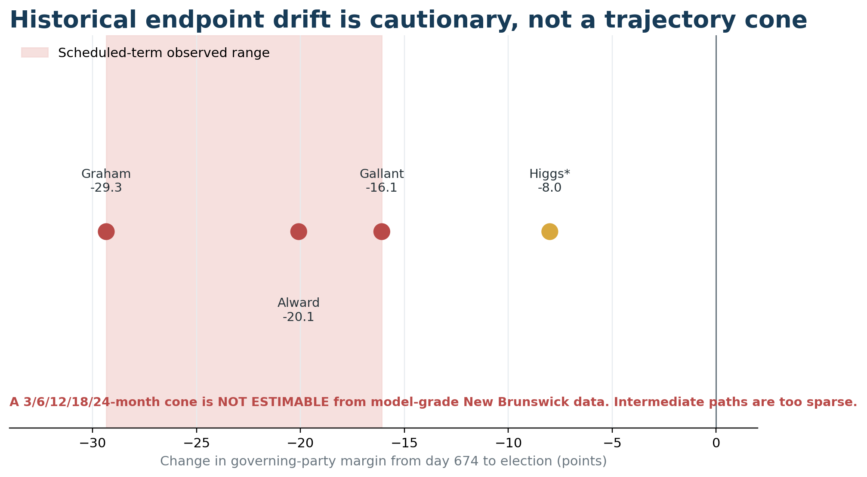
Figure 5. Observed endpoint movement is descriptive. Intermediate New Brunswick trajectory cones are not estimable from model-grade data.
The three scheduled-term cases experienced 16.1 to 29.3 points of adverse movement in governing-party margin between day 674 and election. This is a warning about impermanence, not an empirical probability interval. The sample is tiny; the political events differ; the historical polling ledger lacks complete, comparable intermediate observations; and selecting only these governments would overfit the very outcomes under discussion.
Accordingly:
- 3-month trajectory cone: NOT ESTIMABLE;
- 6-month trajectory cone: NOT ESTIMABLE;
- 12-month trajectory cone: NOT ESTIMABLE;
- 18-month trajectory cone: NOT ESTIMABLE;
- 24-month trajectory cone: NOT ESTIMABLE.
New Brunswick history supports one robust statement: a mid-mandate lead is weak long-horizon insurance. It does not support the claim that Holt is destined to repeat a predecessor’s loss.

8.3 Comparing policy effectiveness across governments
A credible cross-government outcome rank is not possible from the public record assembled here. Definitions, baselines, boundaries, fiscal conditions, administrative datasets and expected lags are not harmonized. The report therefore compares formal governing frames and polling endpoints, while keeping policy-effectiveness claims within the Holt mandate. A future comparative evaluation would need a preregistered common indicator set and information available at each historical cutoff, not revised data chosen after outcomes are known.

9. Electoral coalition and majority firewall
The 2024 Liberal coalition was geographically broad enough to win 31 of 49 seats with 48.3% of valid votes. The current recency benchmark implies an aggregate decline of 5.1 points. Aggregate data cannot reveal what share of individual 2024 Liberal voters were retained, switched, abstained or were replaced by new supporters. Any statement about voter flows is therefore ecological and bounded.

9.1 Current nowcast
Input | Liberal | PC | Green | Deterministic seats
Abacus, August 2026 | 45.0% | 31.0% | 14.0% | 32–15–2
Porter O’Brien, June 2026 | 43.0% | 39.0% | 13.0% | 26–21–2
Narrative, June 2026, derived decided basis | 40.6% | 30.4% | 13.0% | 30–17–2
Recency-weighted ensemble | 43.2% | 33.0% | 13.4% | 30–17–2

The ranges are more informative than the recency-weighted benchmark alone. Porter O’Brien’s narrower lead produces only 26 Liberal seats, one above majority. Narrative’s derived basis has an explicit rounding and mode warning; it is not quantitatively down-weighted for that limitation beyond its field-date weight. No interval is estimated. None of the polls is a classical census of likely voters, and the riding conversion uses a transparent proportional-swing benchmark rather than a fully calibrated regional model. [S06–S08, S42]

9.2 The firewall
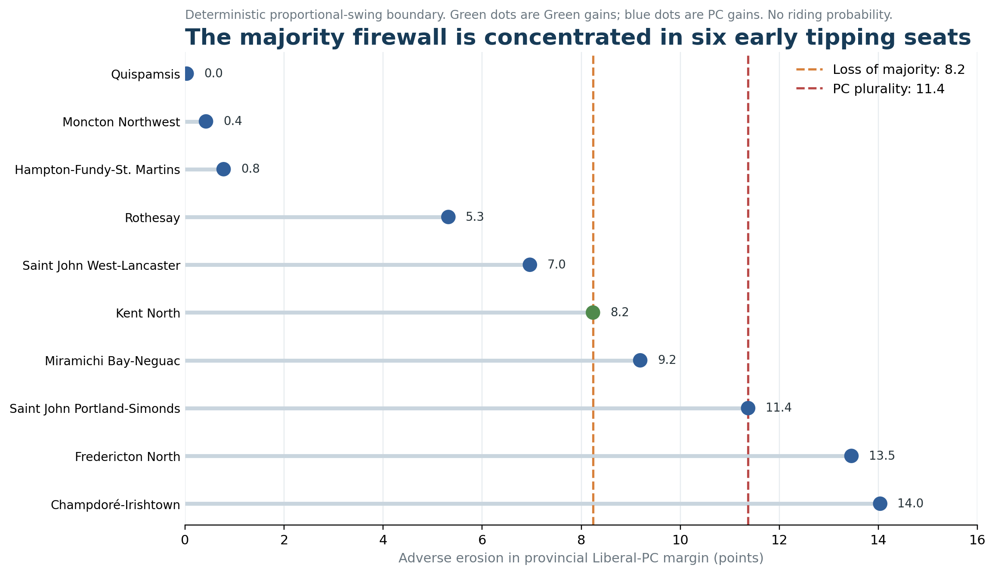
Figure 6. Deterministic proportional-swing tipping seats. The lines are seat boundaries, not probabilities or inferred voter flows.
Under the recency-benchmark swing, the first three Liberal seats—Quispamsis, Moncton Northwest and Hampton–Fundy–St. Martins—flip with less than one point of additional adverse provincial Liberal–PC margin erosion. Rothesay follows at 5.3, Saint John West–Lancaster at 7.0 and Kent North at 8.2, the sixth loss that removes the Liberal majority. Kent North flips to the Greens in the benchmark; the others flip to the PCs.
At the deterministic loss-of-majority boundary:
- adverse Liberal–PC margin erosion: 8.2 points;
- resulting province-wide margin: Liberals +2.0;
- party shares: L 39.0%, PC 37.1%, G 13.4%;
- seats: L 24, PC 22, G 3.
At the PC-plurality boundary:
- adverse margin erosion: 11.4 points;
- resulting margin: PCs +1.2;
- shares: L 37.5%, PC 38.7%, G 13.4%;
- seats: L 22, PC 24, G 3.
A seat plurality does not automatically determine government formation. Confidence, negotiation and the incumbent’s constitutional position matter in a hung legislature.

9.3 Four ecological stress routes
The workbook translates the same seat boundaries into four deliberately stylized aggregate mechanisms:
- direct Liberal-to-PC movement;
- Liberal turnout withdrawal;
- PC recruitment from prior non-voters;
- Liberal-to-Green movement.
For majority loss, the model requires respectively about 4.1 direct switchers per 100 baseline votes, 7.3 Liberal withdrawals, 9.1 PC recruits from non-voters, or 5.7 points of Liberal-to-Green movement. For a PC plurality, the corresponding magnitudes are 5.7, 9.3, 11.5 and 9.3. These scenarios do not estimate actual individual flows or their probability. They show that the same seat boundary can arise from politically different processes and therefore demands different evidence.

9.4 Lower-nowcast sensitivity
Beginning from Porter O’Brien’s 43–39–13 scenario and 26 Liberal seats, only a further 2.9 points of adverse Liberal–PC margin movement removes the majority, through additional losses in Miramichi Bay–Neguac and Saint John West–Lancaster. A further 5.3 points yields a PC plurality, adding Saint John Portland–Simonds. This is the most important sensitivity result: the firewall’s depth depends heavily on which current poll is closest to reality.

10. Conditional election paths
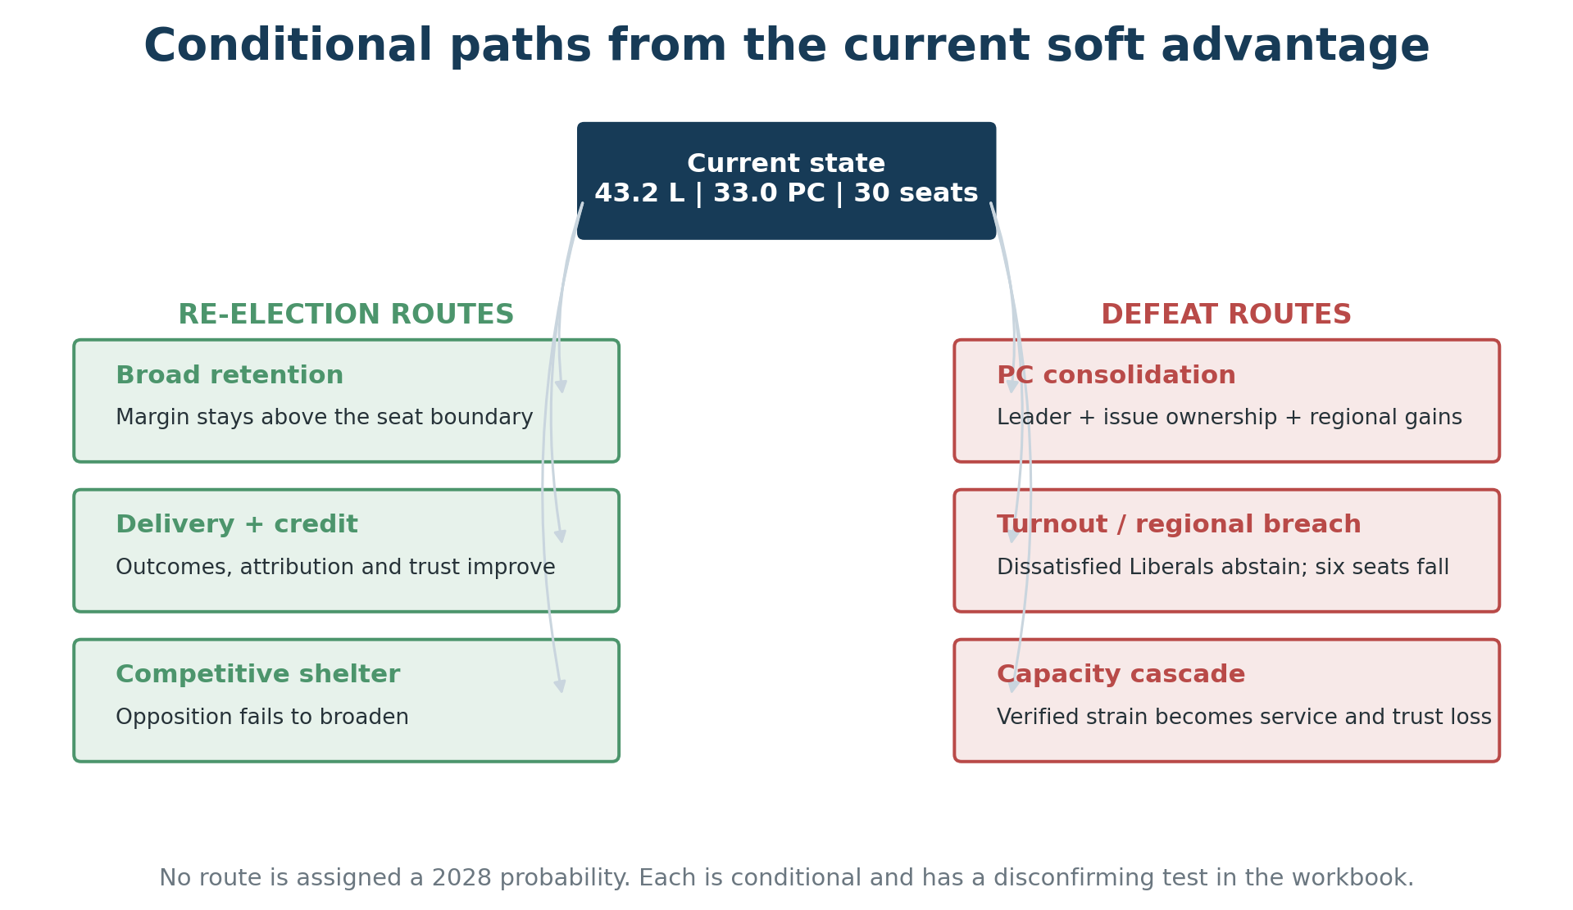
Figure 7. Conditional routes from the current state. No route is assigned a 2028 probability.
No route below is assigned a probability. Each states a required sequence and a disconfirming observation.

10.1 Re-election routes

Broad retention
The Liberals remain in the low-to-mid forties, preserve north/south breadth and avoid a correlated breach in Saint John, Kennebecasis, Hampton and rural-Anglophone seats. The minimum quantitative condition in the current deterministic model is to stay above the roughly +2-point Liberal–PC majority boundary.
Evidence for: all three current polls lead; ensemble produces 30 seats. Evidence against: approval and trust erosion; three ultra-marginal firewall seats. Disconfirmation: consecutive comparable nowcasts at 24 or fewer Liberal seats.

Delivery and credit conversion
Clinic access, housing completions and school-food reach become visible; awareness and correct attribution improve; issue ratings and trust recover.
Evidence for: real programme outputs and unusually explicit public metrics. Evidence against: weak current issue ratings and perceived positive change. Disconfirmation: high awareness and attribution paired with continued negative adequacy ratings, which would shift the diagnosis from communication to policy substance.

Competitive shelter
The PC leadership transition fails to broaden the party; Green support remains geographically concentrated; dissatisfaction does not consolidate.
Evidence for: opposition approval of 17%, low candidate recognition and 56% uncertainty. Evidence against: leadership selection provides a clear reset point. Disconfirmation: two comparable post-leadership waves showing PC favourability and issue ownership broadening.

10.2 Defeat routes

PC consolidation
A new leader becomes credible, owns affordability or fiscal management, and converts Central/rural-Anglophone dissatisfaction into regional gains.
Early indicators: PC favourability, preferred premier, cost-of-living ownership and the two-poll margin. Disconfirmation: no movement after two comparable post-leadership polls.

Turnout or regional breach
Dissatisfied 2024 Liberal voters abstain or shift, with six seats falling before the province-wide Liberal vote necessarily falls behind.
Early indicators: recalled 2024 vote crossed with certainty to vote, Saint John/Kennebecasis oversamples and repeated 24-seat boundaries. Disconfirmation: competitive-seat cells remain stable while province-wide volatility occurs elsewhere.

Administrative-capacity cascade
Workforce reduction and unclear operating rules produce verified service deterioration; those failures become salient, attributable and trust-eroding.
Early indicators: vacancies, overtime, sick leave, backlogs, service-standard misses and employee role clarity. Disconfirmation: stable service standards, engagement and workload through the reduction.

10.3 Current path judgment
The most consistent current path is Liberal retention through coalition breadth and opposition shelter, conditional on avoiding further trust and regional erosion. This is not an assertion that the path will persist. The next opposition leader, the next two method-comparable polls, the first independently comparable primary-care outcome release, the 2025–26 Public Accounts and the execution of the workforce plan are all capable of changing it materially.

11. Quarterly early-warning system
The workbook contains twelve indicators with green, amber and red rules. The most consequential are summarized here.
Indicator | Green | Amber | Red | Current reading
Two-poll Liberal–PC margin | at least +10 | +5 to under +10 | under +5 in two independent polls | +10.2, green-edge
Election-held-today Liberal seats | at least 27 | 25–26 | 24 or fewer in consecutive updates | 30, green
Government handling | at least 40% and net positive | 30–39% or near even | under 30% and disapproval over 50% | 32/37, amber
“Seeing positive change” | at least 45% | 30–44% | under 30% | 32%, amber
Health handling | at least 40% | 30–39% | under 30% | 29%, red-edge
Cost-of-living handling | at least 40% | 30–39% | under 30% | 25%, red
Primary-care attachment | improving toward target | flat | two comparable declines | 73%, red
Housing completion/affordability | completions and rent burden improve | starts only | starts fall and rent burden worsens | starts strong; final outcome unobserved
Fiscal trajectory | credible medium-term rule and improving balance | large but stabilized deficit | repeated deterioration without rule | $1.39b budget deficit, red
Administrative strain | stable service and employee indicators | isolated strain | correlated deterioration | unobserved/amber

Thresholds are operational warning rules, not statistical laws. A single poll should not change the regime classification. Political indicators should be replicated across independent, method-comparable waves; administrative and policy indicators should retain their own cadence and denominators.

Five observations that would reduce uncertainty most
1. Two method-comparable polls after the PC leader is selected.
2. A representative bilingual public survey linking policy awareness, attribution, lived experience, adequacy and vote.
3. Quarterly department-level workforce, vacancy, acting, absence, overtime and service-standard series.
4. Clinic-level operational, staffing, unique-attachment and wait-time data reconciled to the independent primary-care survey.
5. Housing completions, occupancy, rent burden and subsidy-depth data linked to the public starts series.

12. Phase-two measurement programme

12.1 Targeted information requests
The prepared request schedule prioritizes ten machine-readable datasets:
- collaborative-care clinic operational ledger;
- electricity-rebate distribution and net-bill effects;
- rent-cap administration and enforcement;
- housing starts-to-completions and affordability outcomes;
- school-food reach, cost and participation;
- Part I headcount, vacancies and suppressed positions;
- senior-executive transitions and long acting appointments;
- sick leave, overtime and service-standard performance;
- communications research, paid distribution and policy awareness;
- Cabinet-excluded process metadata for major consultation exercises.
Requests explicitly exclude personal identifiers, Cabinet confidences, legal advice and small cells that could identify individuals. The purpose is to measure system performance, not to expose individual officials.

12.2 Public survey
The proposed bilingual survey begins with unaided purpose and priority recall before naming any policy. Respondents are then randomly assigned policy modules measuring prior awareness, correct attribution, personal experience or local availability, adequacy, issue ownership, trust and vote certainty. Oversamples should permit English/French and urban/rural inference; weights and design effects must be published. A fixed-panel component would distinguish true opinion change from sample composition.

12.3 Employee survey
The confidential employee instrument measures:
- priority and role clarity;
- decision rights and rework;
- workload and capacity;
- psychological safety and ability to provide frank advice;
- perceived political neutrality;
- confidence in change management;
- intention to stay or leave;
- service consequences of staffing change.
Results should be reported by broad department/function and level only when privacy thresholds are met. Senior-executive sampling must be managed independently of the Premier’s Office and central agencies.

12.4 Critical-incident interviews
Interviews should ask for one specific decision or implementation incident, separate direct observation from hearsay, request the strongest contrary example, and record the decision point, consequence and alternative explanation. No names, Cabinet confidences, legal advice or unauthorized records should be solicited. This design converts elite anecdotes into auditable mechanism evidence without pretending they are representative.

13. Strongest evidence against this report’s diagnosis
A credible assessment must state what could make it wrong.
First, every qualifying current poll places the Liberals first, and every poll-specific seat benchmark returns a Liberal majority. The government may possess a genuinely broad coalition rather than merely opposition shelter.
Second, housing starts, clinic formation, school breakfast, rent-cap authority and electricity relief are real. Public evaluation may simply lag implementation; later outcomes could validate the present strategy without a major change in communications.
Third, the government’s public report-card infrastructure is unusually transparent. Weak awareness of it has not been measured. The problem may be policy adequacy rather than proof architecture.
Fourth, public pessimism is not unique to New Brunswick. Comparable Atlantic governments have also faced negative direction and performance assessments. Some decline may reflect normal midterm conditions, economic pressures and a fading post-election halo rather than a Holt-specific defect.
Fifth, the strongest evidence of administrative strain is bounded to functions or announced future reductions. The leadership record shows continuity, labour agreements show institutional capacity, and no representative morale evidence demonstrates broad internal disaffection.
These counterarguments do not reverse the report’s finding. They lower confidence from certainty to a testable medium or medium-high inference and define what the next evidence must adjudicate.

14. What would change the assessment in the next six months
The classification would move toward durable advantage if two comparable post-leadership polls kept the Liberal–PC margin near or above ten points, government handling and trust recovered, and leading policy outputs began to appear in independent outcome and experience measures.
It would remain a soft advantage if vote intention stayed favourable while government handling, issue ownership and lived outcomes remained weak.
It would move toward competitive/reset risk if the two-poll margin fell below five points, consecutive nowcasts reached 24 or fewer Liberal seats, or a new PC leader broadened recognition and issue ownership.
It would move toward administrative-capacity risk only if the workforce plan coincided with replicated vacancy, absence, backlog, service-standard and employee-confidence deterioration across multiple departments. Anonymous reports alone should trigger measurement, not a verdict.
It would move the communications diagnosis from credit conversion to policy inadequacy if a representative survey showed high awareness and correct attribution but negative personal experience and adequacy judgments.

15. Methods and limitations

Mandate clocks
The primary clock begins on election day, 21 October 2024, making 26 August 2026 mandate day 674. A swearing-in sensitivity begins on 2 November 2024, making the same cutoff day 662 in office. No claim is made that ±30-, ±60- and ±90-day windows preserve the same historical cases: Alward and Higgs fall outside ±30 days, Alward falls outside ±60, and Graham’s exact field dates are not found. The historical result is therefore reported with explicit offsets and coverage limits rather than as window-robust model output.

Poll synthesis
Current vote inputs retain each pollster’s actual field dates and respondent basis. The displayed benchmark is weighted only by 90-day recency: Porter O’Brien 0.267, Narrative 0.297 and Abacus 0.436. Narrative’s all-eligible results are converted to an approximate decided basis using the published rounded party denominator, but the weighting formula does not separately penalize that approximation. No uncertainty interval is produced. The 43.2/33.0/13.4 result is therefore a recency-weighted benchmark, not a latent-support estimate. Overlapping releases are not treated as independent. Classical margins of error are not assigned to opt-in panels.

Seat benchmark
The nowcast applies party-specific proportional swing to certified 2024 riding results and preserves Green geographic concentration better than a simple uniform additive swing. It is nevertheless deterministic. It does not model candidates, incumbency, turnout correlation, regional shocks, riding-level polling error or government-formation bargaining. Seat counts are therefore scenario outputs, not posterior probabilities.

Promise audit
Platform pages were archived, bullet points extracted and compound commitments split only where clauses created separately verifiable obligations. Explicit duplicates and cross-references retain their raw rows but share a canonical identifier. Official tracker status is preserved separately from analyst stage. No missing status is inferred.

Policy effectiveness
The report avoids causal attribution unless a credible counterfactual exists. Province-wide economic and social outcomes have many federal, municipal, market, demographic and inherited-policy drivers. Leading outputs are described as outputs; lagged outcomes are not back-assigned to a government merely because they move in the desired direction.

Administrative health
Public senior-leadership releases do not form a complete personnel-flow dataset. Workforce stocks do not reveal voluntary turnover. Bargaining outcomes do not measure executive confidence. RTIPPA and Auditor General findings are function-specific. The resulting “amber” assessment concerns observed risk mechanisms, not a claim of generalized morale failure.

Historical comparison
The four named premiers are cases, not a training sample. Higgs is a special minority/pandemic/snap-election analogue. Government-formation outcomes are kept distinct from popular vote and seat plurality. No historical trajectory is interpolated across missing observations.

Reproducibility
The companion workbook contains the 104-unit canonical promise ledger, source grades, claim ledger, policy and outcome dashboards, polling inputs, historical endpoints, riding calculations, firewall thresholds, stress tests, conditional paths, watchlist and phase-two instruments. The reproducibility package contains the source CSVs, transformation scripts, formulas, random seed where relevant and an audit manifest.

16. Final assessment
Holt’s government is faring better electorally than its public-performance numbers suggest and better administratively than an “all talk, no delivery” critique would imply. It is also less secure than the topline lead suggests.
The record through day 674 shows a government that can authorize, fund and launch. Its central political test is now conversion: can those outputs become independently verified outcomes; can residents feel and correctly attribute the improvement; can the government acknowledge misses without losing credibility; and can the public service execute the next phase without capacity deterioration?
The communications issue is therefore not well named as insufficient exposure or an unsuitable messenger. The observed fact is an implementation-to-public-evaluation gap. An output-to-outcome credit-conversion problem and weak mandate compression are leading hypotheses that require linked awareness, attribution, experience and recall evidence. Inside government, the public record shows an implementation-detail transparency gap; it does not establish that departments lack internal operating rules.
The civil-service concern deserves serious measurement. It does not yet deserve to be stated as established fact.
The election path is equally conditional. If the Liberals preserve their geographic breadth, turn delivery into credit and continue to benefit from weak opposition consolidation, they retain the clearest current route to government. If a new PC leader converts dissatisfaction, six early tipping seats can erase the majority before the province-wide Liberal lead fully disappears. New Brunswick history shows that two years is ample time for either path.
Research verdict: Every current poll-specific deterministic benchmark yields a Liberal majority, while no election-day probability is assigned. Holt’s mandate is active but not yet converting reliably into outcomes and trust. A one-term government is a material risk, not the most defensible interpretation of current evidence. The available evidence does not support a numerical 2028 probability.

Appendix A — Major claim ledger
Each conclusion states its type, confidence, strongest rival explanation and a prospective disconfirming observation.
C01 — All current poll-specific deterministic benchmarks yield Liberal majorities, but this is not an election probability or 2028 forecast.
Type: Current benchmark
Confidence: Moderate
Strongest rival: Sparse non-probability polling and proportional swing understate local/regional error.
Disconfirming evidence: Two independent polls tied/negative and consecutive benchmarks at 24 or fewer seats.
Sources: S06;S07;S08;S01
C02 — The current condition is a soft advantage, not a durable advantage.
Type: Inference
Confidence: Medium-high
Strongest rival: Opposition weakness may be only one component of a genuinely broad Liberal coalition.
Disconfirming evidence: Sustained approval, trust and issue ownership gains after a settled opposition leadership.
Sources: S06;S07;S08;S09
C03 — An implementation-to-public-evaluation gap is observed; credit conversion and weak mandate compression are leading hypotheses, not identified causes.
Type: Inference
Confidence: Medium
Strongest rival: Residents may understand and credit the agenda but judge delivery inadequate or too recent.
Disconfirming evidence: Linked awareness, attribution, recall and experience data identifying a different failure point.
Sources: S06;S10;S15;S16;S28;S29;S30
C04 — Holt does not have a demonstrated generic public-communication failure.
Type: Inference
Confidence: Medium
Strongest rival: Available communication questions are broad and may miss channel or message failures.
Disconfirming evidence: Experimental exposure/comprehension evidence showing a broad transmission failure.
Sources: S06;S39
C05 — Policy implementation is substantial, but population outcomes are mixed and causal effectiveness is mostly premature.
Type: Descriptive assessment
Confidence: High on implementation; low on causality
Strongest rival: Some programs may already have local effects not visible in province-wide indicators.
Disconfirming evidence: Credible counterfactual evaluations showing broad outcome gains.
Sources: S10;S13;S15;S16;S17
C06 — The annual balanced-budget promise is missed and off trajectory.
Type: Verified outcome
Confidence: High
Strongest rival: 2024-25 was partly inherited and exceptional pressures affected later years.
Disconfirming evidence: None for already completed 2024-25; a credible balance path could change forward assessment only.
Sources: S19;S20;S21
C07 — Broad senior civil-service unhappiness is not established by public evidence.
Type: Non-finding
Confidence: High
Strongest rival: Private reports may be early signals not yet observable in lagging public records.
Disconfirming evidence: Representative survey plus independent multi-department capacity deterioration.
Sources: S23;S24;S25;S42
C08 — Administrative health is mixed/amber because objective strain mechanisms exist.
Type: Inference
Confidence: Moderate
Strongest rival: Attrition and modernization may reduce staffing without service harm.
Disconfirming evidence: Stable service standards, workloads, vacancies and employee engagement through implementation.
Sources: S22;S25;S26;S27
C09 — A broad French-language communication failure is not supported by available broad indicators, but language reception is unmeasured.
Type: Descriptive non-finding
Confidence: Low-medium
Strongest rival: Region is not language, supply is not reception and the relevant subsample is small.
Disconfirming evidence: Large language-stratified awareness/trust study showing a French gap.
Sources: S06;S07
C10 — The majority firewall is shallower than the 10.2-point province-wide lead suggests.
Type: Deterministic stress test
Confidence: Moderate for model mechanics
Strongest rival: Regional and local effects could move different seats and Green concentration is simplified.
Disconfirming evidence: Regional polls and local results showing these seats are materially safer.
Sources: S01;S42
C11 — New Brunswick history does not support a calibrated 2028 re-election probability.
Type: Model stop rule
Confidence: High
Strongest rival: A broader Canadian dataset could eventually support partial pooling.
Disconfirming evidence: A preregistered model that beats simple benchmarks in leave-one-government/province-out hindcasts.
Sources: S42
C12 — The most consistent current path is Liberal retention through coalition breadth and opposition shelter, conditional on avoiding further trust and regional erosion.
Type: Conditional path, not probability
Confidence: Moderate
Strongest rival: Leadership consolidation plus modest Saint John/Central movement can remove the majority.
Disconfirming evidence: Post-leadership PC gains, issue-ownership shift and replicated firewall erosion.
Sources: S06;S07;S08

Appendix B — Promise-ledger summaries
The canonical promise universe contains 104 units. Four additional raw rows are retained as duplicates or cross-references in the workbook.

By official public tracker status
Official status | Canonical units
COMPLETE | 20
IN PROGRESS | 48
NO PUBLIC TRACKER STATUS | 35
NO STATUS | 1

By analyst-coded public-evidence stage
Verified stage | Canonical units
Design or consultation | 13
Fully operational at the promised scale | 9
Funding appropriated | 11
Legislation or authority established | 12
Not verifiable | 36
Operational implementation begun | 16
Partially available to intended residents | 7

By platform domain
Domain | Canonical units
Affordability and housing | 14
Economic development | 15
Education | 16
Environment | 11
Health care | 35
Trusted leadership | 13

These counts are descriptive. They are not a weighted completion score, a causal effectiveness score or a cross-government rank.

Appendix C — Full quarterly watchlist
W01 — Two-poll Liberal-PC margin
Type: Lagging political
Cadence: After each poll / quarterly
Green: >=10 points
Amber: 5 to <10
Red: <5 in two independent polls within 90 days
Current: 10.189
Status: GREEN-EDGE
W02 — Election-held-today Liberal seats
Type: Lagging electoral
Cadence: After each poll
Green: >=27
Amber: 25-26
Red: <=24 in consecutive updates
Current: 30
Status: GREEN
W03 — Government handling approval / disapproval
Type: Coincident legitimacy
Cadence: Quarterly, same wording/mode
Green: >=40 approval and net positive
Amber: 30-39 or near even
Red: <30 approval and >50 disapproval in comparable waves
Current: 32 / 37
Status: AMBER
W04 — Holt approval or favourability
Type: Coincident leader
Cadence: Quarterly by same series
Green: Net positive and stable
Amber: Near even
Red: Approval <45 and net negative in two comparable waves
Current: Abacus favourability 35/32; Angus approval 41/49
Status: AMBER-RED
W05 — Positive change / trust / issue handling
Type: Coincident conversion
Cadence: Quarterly
Green: Sustained +5 point improvement
Amber: Flat
Red: Further decline across two waves
Current: Positive change 32; trust 33; priority handling 25-29
Status: AMBER
W06 — Permanent primary-care provider
Type: Lagging outcome
Cadence: Annual plus administrative attachment
Green: Persistent improvement toward 81
Amber: Flat
Red: Further decline
Current: 73
Status: RED
W07 — Housing completions, affordable completions and rents
Type: Coincident/lagging outcome
Cadence: Quarterly
Green: Completions rise and rent pressure eases
Amber: Starts only
Red: Starts/completions weaken and rents accelerate
Current: Starts strong; completions/rent effect not audited
Status: AMBER
W08 — School food reach and repeat use
Type: Coincident reach
Cadence: Monthly/term
Green: >=70% school participation with stable uptake
Amber: Launch without denominator
Red: Material access or supplier failure
Current: Breakfast universal; lunch pre-launch
Status: AMBER
W09 — Fiscal forecast error and balance path
Type: Leading credibility
Cadence: Quarterly
Green: Deficit narrows with credible service safeguards
Amber: Near plan
Red: Further material deterioration or unexplained supplementary spending
Current: $1.33b projected 2025-26; $1.39b budgeted 2026-27
Status: RED
W10 — Part I workforce and service-capacity pulse
Type: Leading administrative
Cadence: Quarterly
Green: Planned attrition with stable workloads/services
Amber: Vacancies/acting roles rise
Red: Cross-department service deterioration plus poor engagement
Current: No public series
Status: GREY
W11 — PC leader recognition, favourability and issue ownership
Type: Leading opposition
Cadence: Quarterly after leadership
Green: Low recognition/no broadening
Amber: Recognition rises
Red: Positive net plus issue gains and regional broadening
Current: About half cannot rate candidates
Status: GREEN FOR LIBERALS / UNSTABLE
W12 — Regional firewall replication
Type: Leading electoral
Cadence: Every pooled 2-3 polls / by-election
Green: No replicated erosion
Amber: One weak cell
Red: Replicated Saint John/Central/rural-Anglophone erosion
Current: Central/rural-Anglophone weak
Status: AMBER

Appendix D — Corrections and audit trail
2024 riding table valid-vote reconciliation — Riding-table total included 162 votes for a withdrawn NDP candidate
Corrected value: Official valid total 374,661; 162 withdrawn-candidate votes excluded
Reason: Elections NB treats those votes outside official party/valid totals
Effect: No effect on three-party seat model
Status: Carried forward from prior QA
Narrative June 2026 vote basis — Headline all-eligible values
Corrected value: Derived decided normalization L 40.58, PC 30.43, G 13.04 from rounded party denominator 69
Reason: Make basis comparable while flagging approximation
Effect: Included only with derived-base warning
Status: Carried forward
Narrative satisfaction series — Could appear continuous
Corrected value: 2026 online-panel wave separated from earlier telephone probability waves
Reason: Mode break
Effect: No causal trend claim
Status: Carried forward
2028 re-election probability — No estimate
Corrected value: No estimate
Reason: No validated broader model and historical endpoint sample remains too small
Effect: Conditional paths and boundaries only
Status: Confirmed
Civil-service unhappiness — Private reports only
Corrected value: Morale coded UNOBSERVED; administrative health MIXED/AMBER
Reason: No representative direct measure; bounded strain mechanisms found
Effect: Excluded from election model
Status: New audit finding
Abacus August 2026 Green value in report — 13.0%
Corrected value: 14.0%
Reason: Original release and model inputs report 14%; 13% was a transcription error
Effect: No seat or benchmark change; seat row already used 14%
Status: Corrected in final QA
Historical window sensitivity — Conclusion described as unchanged under plus/minus 30, 60 and 90 days
Corrected value: Offsets and source grades disclosed; no symmetric-window robustness claim
Reason: Alward and Higgs fall outside plus/minus 30 days and Graham exact field dates are not found
Effect: Historical cases remain descriptive with stronger coverage caveat
Status: Corrected in final QA
Communications mechanism — Credit-conversion diagnosis stated as best-supported
Corrected value: Implementation-to-public-evaluation gap observed; credit conversion and mandate compression are leading hypotheses
Reason: Awareness, attribution, comprehension, adequacy and lived experience were not jointly measured; no significance test
Effect: Confidence reduced to medium; direct measurement gate added
Status: Corrected in final QA
Promise-stage audit label — Independent stage audit
Corrected value: Analyst-coded public-evidence audit
Reason: Most stage inputs originate in government trackers and releases
Effect: Clarifies that coding is not an independent effectiveness evaluation
Status: Corrected in final QA

Appendix E — Source ledger
Grades: A original official or methodological source; A− original pollster release with a material comparability limitation; B reliable contemporaneous secondary source; Reproducible derived calculation from disclosed local inputs.

S01 — Forty-First Provincial General Election report
Publisher/date: Elections New Brunswick, 2025-06-02 Grade: A Use: Certified 2024 votes, seats and riding results URL: Open source

S06 — Holt Liberals maintain strong lead as PCs search for new leader
Publisher/date: Abacus Data, 2026-08-14 Grade: A- Use: Vote, approval, favourability, trust, issues and regions URL: Open source

S07 — First public semi-annual New Brunswick poll
Publisher/date: Porter O'Brien, 2026-06-23 Grade: A Use: Vote and regional comparison URL: Open source

S08 — Low provincial government satisfaction levels reflected in voter intentions
Publisher/date: Narrative Research, 2026-07-02 Grade: A Use: All-eligible vote and satisfaction URL: Open source

S09 — Premiers' performance June 2026
Publisher/date: Angus Reid Institute, 2026-06-13 Grade: A Use: Holt approval; small NB subsample URL: Open source

S10 — Affordability and housing priority tracker
Publisher/date: Government of New Brunswick, 2026-06-12 Grade: A Use: Commitment status and housing indicators URL: Open source

S11 — 2025 progress report card
Publisher/date: Government of New Brunswick, 2026 Grade: A Use: Official targets, hits and misses URL: Open source

S12 — Economic development priority tracker
Publisher/date: Government of New Brunswick, 2026-06-12 Grade: A Use: Economic commitments and indicators URL: Open source

S13 — Education priority tracker
Publisher/date: Government of New Brunswick, 2026-06-12 Grade: A Use: Education commitments and results URL: Open source

S14 — Environment priority tracker
Publisher/date: Government of New Brunswick, 2026-06-12 Grade: A Use: Environmental commitments and results URL: Open source

S15 — Province reaches midway point of collaborative-care clinic commitment
Publisher/date: Government of New Brunswick, 2026-05-04 Grade: A Use: Clinic count and local reach URL: Open source

S16 — Government provides update on health-care system
Publisher/date: Government of New Brunswick, 2026-04-29 Grade: A Use: Attachments, workforce and program outputs URL: Open source

S17 — New Brunswick Primary Care in 2025: Access, Experience and Equity
Publisher/date: New Brunswick Health Council, 2026-06-23 Grade: A Use: Independent primary-care outcomes URL: Open source

S18 — 2025 Primary Care Survey
Publisher/date: New Brunswick Health Council, 2026-06-23 Grade: A Use: Survey timing and sample URL: Open source

S19 — Disclosure L-003: Balanced budgets
Publisher/date: New Brunswick Liberal Association, 2024-09-19 Grade: A Use: Exact election promise URL: Open source

S20 — Public accounts for 2024-25
Publisher/date: Government of New Brunswick, 2025-09-29 Grade: A Use: Actual deficit and net debt URL: Open source

S21 — Budget 2026-27 and Main Estimates
Publisher/date: Government of New Brunswick, 2026-03-17 Grade: A Use: Budget, deficit and departmental estimates URL: Open source

S22 — Budget 2026-27: Putting New Brunswickers first
Publisher/date: Government of New Brunswick, 2026-03-17 Grade: A Use: 12% Part I plan and major investments URL: Open source

S23 — Premier announces senior leadership changes and retirements
Publisher/date: Government of New Brunswick, 2025-03-31 Grade: A Use: Leadership roster and movements URL: Open source

S24 — Senior government leadership changes
Publisher/date: Government of New Brunswick, 2025-08-29 Grade: A Use: Clerk and acting appointments URL: Open source

S25 — Senior government leadership changes
Publisher/date: Government of New Brunswick, 2026-04-27 Grade: A Use: Reform portfolio, dual-hatting and retirements URL: Open source

S26 — Right to Information and Protection of Privacy Act Review Report
Publisher/date: Finance and Treasury Board, 2026-06-18 Grade: A Use: RTIPPA timeliness, resourcing and culture URL: Open source

S27 — Grant Processes and Outcomes: Tourism, Heritage and Culture
Publisher/date: Auditor General of New Brunswick, 2026-06-02 Grade: A Use: Controls and staffing-related reporting gap URL: Open source

S28 — Our Action Plan to be Self-Sufficient
Publisher/date: Government of New Brunswick, 2007-11-23 Grade: A Use: Graham formal governing frame URL: Open source

S29 — 2025 Throne Speech release
Publisher/date: Government of New Brunswick, 2025-10-21 Grade: A Use: Priority and slogan architecture URL: Open source

S30 — 2026 State of the Province address
Publisher/date: Government of New Brunswick, 2026-01-29 Grade: A Use: Mandate framing URL: Open source

S31 — Trusted leadership priority tracker
Publisher/date: Government of New Brunswick, 2026-06-12 Grade: A Use: Leadership commitments URL: Open source

S32 — Electricity rebate
Publisher/date: Government of New Brunswick, 2025 Grade: A Use: Eligibility and rebate mechanics URL: Open source

S33 — Rate decision
Publisher/date: NB Power, 2026 Grade: A Use: Electricity-rate context URL: Open source

S34 — Universal breakfast announcement
Publisher/date: Government of New Brunswick, 2025-09-03 Grade: A Use: Breakfast availability URL: Open source

S35 — Pay-what-you-can lunch launch
Publisher/date: Government of New Brunswick, 2026-06 Grade: A Use: Lunch timing and budget URL: Open source

S36 — One year in, Holt Liberals strengthen their lead
Publisher/date: Abacus Data, 2025-11-12 Grade: A- Use: Same-pollster directional comparison URL: Open source

S37 — Profs decry catastrophic cuts proposed by N.B. government
Publisher/date: University Affairs, 2026-03-03 Grade: B Use: Post-secondary option-paper event URL: Open source

S38 — New Brunswick effectively freezes post-secondary funding
Publisher/date: University Affairs, 2026-03-18 Grade: B Use: Final budget outcome after options controversy URL: Open source

S39 — High wildfire hazard leads to Crown land closures
Publisher/date: Government of New Brunswick, 2025-08-09 Grade: A Use: Negative control for messenger failure URL: Open source

S40 — New collective agreement signed with CUPE 1190
Publisher/date: Government of New Brunswick, 2025-03-05 Grade: A Use: Labour-relations counter-signal URL: Open source

S41 — New Brunswick Federation of Labour budget response
Publisher/date: New Brunswick Federation of Labour, 2026-03-19 Grade: B Use: Stakeholder concern about reductions URL: Open source

S42 — Prior mandate-day-674 data model
Publisher/date: OpenAI Deep Research working file, 2026-08-26 Grade: Reproducible derived Use: Ensemble, day-674 and seat calculations URL: Open source

S43 — Legislative report: first Alward Throne Speech
Publisher/date: Canadian Parliamentary Review, 2011 Grade: B Use: Alward formal governing frame URL: Open source

S44 — First Gallant Throne Speech
Publisher/date: Legislative Assembly of New Brunswick, 2014-12-03 Grade: A Use: Gallant jobs-first frame URL: Open source

S45 — First Higgs Throne Speech
Publisher/date: Legislative Assembly of New Brunswick, 2018-11-20 Grade: A Use: Higgs five-challenges/results frame URL: Open source

