NEW BRUNSWICK POLITICAL MANDATE ANALYSIS
Susan Holt at
mandate day 674
Historical comparison, election-held-today nowcast and 2028 model gate

LIBERAL-PC LEAD | LIBERAL SUPPORT | UNIFORM-SWING NOWCAST
+10.2 pts | 43.2% | 30 seats
Current judgement: Holt is favoured if New Brunswick voted now. On raw party-support, retention and change-from-election metrics, she is weaker than Graham and Gallant, weaker than the COVID-rally Higgs, and approximately level with Alward. A one-term government is a material risk, but calling it the 2028 forecast would overstate the evidence.
Evidence cutoff | August 26, 2026
Primary comparison clock | 674 elapsed days after election day
Ordinary election date | October 16, 2028, subject to dissolution
Forecast status | Current state estimated; 2028 probability not estimated
Independent research report | August 26, 2026

1. Bottom line
Susan Holt is ahead, but she is not unusually strong among the four named New Brunswick historical comparators at the same mandate age. The three independent 2026 polls produce a 90-day half-life ensemble of Liberal 43.2%, PC 33.0%, Green 13.4%, a Liberal lead of 10.2 points. A diagnostic reference interval that combines nominal sampling variance with the observed disagreement among pollsters is roughly 5.0 to 15.4 points at 90%, but it is not a classical confidence interval because all three surveys use non-probability or mixed panels and two variance inputs require approximations.
On the raw party-support, retention and change-from-election metrics, Holt is weaker than Graham and Gallant, weaker than the COVID-rally Higgs, and approximately level with Alward. Her Liberals retain about 89% of their election vote, the lowest observed ratio in this five-case comparison, and their lead has narrowed by about three points. These are descriptive comparisons, not posterior rankings.
If an election were held now, the Liberals would be favoured to remain government. The three poll-specific uniform-swing scenarios produce 26 to 32 Liberal seats, all at or above the 25-seat majority threshold. This is a deterministic stress test, not a probability forecast.
The evidence does not support a calibrated 2028 re-election probability. The historical record shows that large mid-mandate leads did not save Graham, Alward or Gallant, but the sample is too small and structurally inconsistent to declare a one-term government the most likely outcome. A one-term government is a material risk; calling it the forecast is premature.

2. Evidence snapshot
Item | Finding
Evidence cutoff | August 26, 2026
Latest poll field date | August 7, 2026, Abacus Data
Independent polls | 1 in past 30 days; 3 in past 90 days; 3 in past 180 days
Current vote estimate | Liberal 43.2, PC 33.0, Green 13.4, reported other-party aggregate 10.0; unallocated rounding residual 0.4
Liberal-PC margin | +10.2 points; approximate 90% reference interval +5.0 to +15.4
Government measure | Narrative satisfaction 35/37 in June; Abacus government-handling approval 32/37 in August
Leader measures | Angus Reid Holt approval 41/49 in June; Abacus Holt favourability 35/32 in August
Election-now benchmark | Liberal 26-32 seats across the three poll-specific uniform-swing scenarios
Ordinary election date | October 16, 2028, subject to dissolution and statutory exceptions
2028 forecast | No calibrated probability; model gate fails

Data quality is adequate for a cautious current-state estimate and a simple seat stress test. It is inadequate for a validated 782-day probability forecast. The principal weaknesses are sparse polling, differing denominators, non-probability samples, missing historical methodology, small regional subsamples and a major opposition-leadership breakpoint after the cutoff.

3. Definitions and clocks
The primary outcome is whether the Liberal Party remains the governing party after the next general election and initial confidence or government-formation process, conditional on Holt remaining leader and contesting it. This is not identical to winning the popular vote, winning the most seats, Holt remaining Premier or Holt retaining her seat.
Elections New Brunswick's official 2024 report records the October 21, 2024 election, 31 Liberal seats, 16 PC seats and two Green seats. The report's candidate totals are 180,806 Liberal votes, 131,332 PC votes and 51,558 Green votes out of 374,661 valid votes. That produces conventional valid-vote shares of 48.26%, 35.05% and 13.76%. The official popular-vote page instead divides by all ballots, including rejected ballots, and therefore prints slightly lower percentages. This report uses valid votes for cross-election comparability.
Holt became Premier on November 2, 2024, according to the Office of the Premier. August 26, 2026 is 674 elapsed days after election day and 662 after swearing-in. Under section 3 of the current consolidated Legislative Assembly Act, verified at the evidence cutoff, the ordinary date is the third Monday of October in the fourth calendar year after the previous ordinary election, or October 16, 2028. The Lieutenant-Governor's dissolution discretion remains intact. The ordinary date was 782 days after the evidence cutoff.
The historical forecast is frozen at each day-674 date. Polls whose fieldwork came later are not used as if they had been available. A nearby post-cutoff poll appears only as a sensitivity and is clearly labelled.

4. Holt's current standing

Vote intention
The current estimate uses the three independent polls whose fieldwork midpoints fell within approximately 90 days of August 26:
Poll | Fieldwork | Reported basis | Liberal | PC | Green | Liberal lead
Porter O'Brien | May 27-June 3; n=802, decided n=603 | Decided voters | 43.0 | 39.0 | 13.0 | 4.0
Narrative Research | June 10-17; n=495 | Derived normalization of rounded all-eligible values | 40.6 | 30.4 | 13.0 | 10.1
Abacus Data | July 29-August 7; n=601 | Decided voters | 45.0 | 31.0 | 14.0 | 14.0

Narrative reported an all-eligible distribution of Liberal 28, PC 21, Green 9, Libertarian 6, NDP 4, other 1, none 4 and undecided 27. The displayed decided values above divide each rounded party figure by the 69-point party denominator. They are approximate and are never represented as Narrative's own topline.
The base specification gives each poll an exponential recency weight with a 90-day half-life. Ages are computed from the exact midpoint of each pair of field dates, allowing half-days rather than inconsistently rounding calendar midpoints. The normalized weights are 26.7% Porter O'Brien, 29.7% Narrative and 43.6% Abacus. The current estimate is Liberal 43.15, PC 32.96 and Green 13.45. Changing the half-life produces Liberal leads of 11.8 points at 30 days, 10.6 at 60 days, 10.2 at 90 days and 10.0 at 120 days. The Liberal lead survives every tested decay assumption.
The observed poll spread matters more than a mechanical sample-size calculation. A random-effects diagnostic gives a between-poll variance of about 14.2 percentage-points squared, or τ≈3.8 points. Combining that with nominal multinomial variance yields an ensemble standard error of about 3.2 points and a 90% reference interval of +5.0 to +15.4. For Narrative, the effective n≈342 is derived as 69% of n=495 from rounded response shares; it is not pollster-reported. For Abacus, the calculation uses total n=601 because the decided base is undisclosed, an optimistic information assumption. Tau is itself unstable with only three polls. The interval is therefore a modelling diagnostic, not a classical confidence interval.
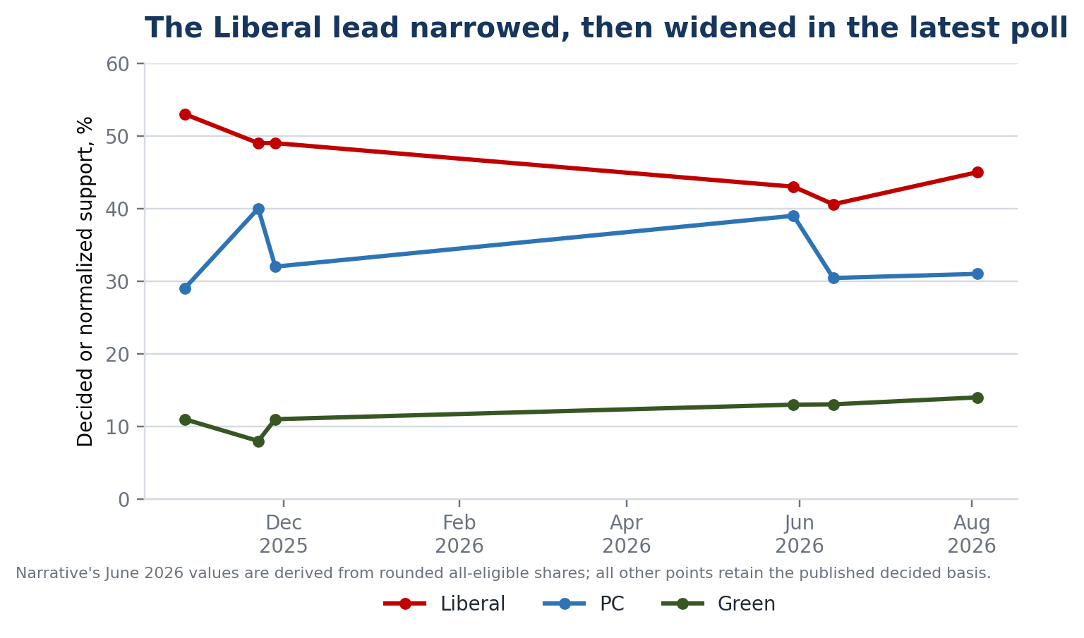
Figure 1. Published or explicitly derived province-wide vote intention. Source: pollster releases cited in the text and companion workbook.

The vote lead and the performance measures diverge
The Liberals' vote position remains strong, while government and leader ratings have weakened:
- Narrative government satisfaction was 59/29 in May 2025 and 63/30 in August 2025, then 35/37 in June 2026. The first two were telephone probability samples; the 2026 wave used an online panel. The magnitude of change therefore crosses a material mode break.
- Angus Reid's Holt approval was 53/28 in December 2024, peaked at 60/28 in March 2025, and fell to 41/49 in June 2026.
- Abacus in August 2026 measured government-handling approval at 32/37, Holt favourability at 35/32 and right direction at 34/45.
These are different questions and are not pooled. The consistent substantive signal is that the electorate remains willing to choose the Liberals over the PCs even while its assessment of government performance and Holt personally is considerably less favourable than in 2025.
Same-pollster changes reinforce the caution but do not justify linear extrapolation. Abacus's Liberal lead fell from 24 points in October 2025 to 14 in August 2026. Porter O'Brien's fell from nine points in November 2025 to four in June 2026. Method equivalence is not fully documented, especially for Porter O'Brien's prior wave, and two pairs are too little evidence for a trend model.
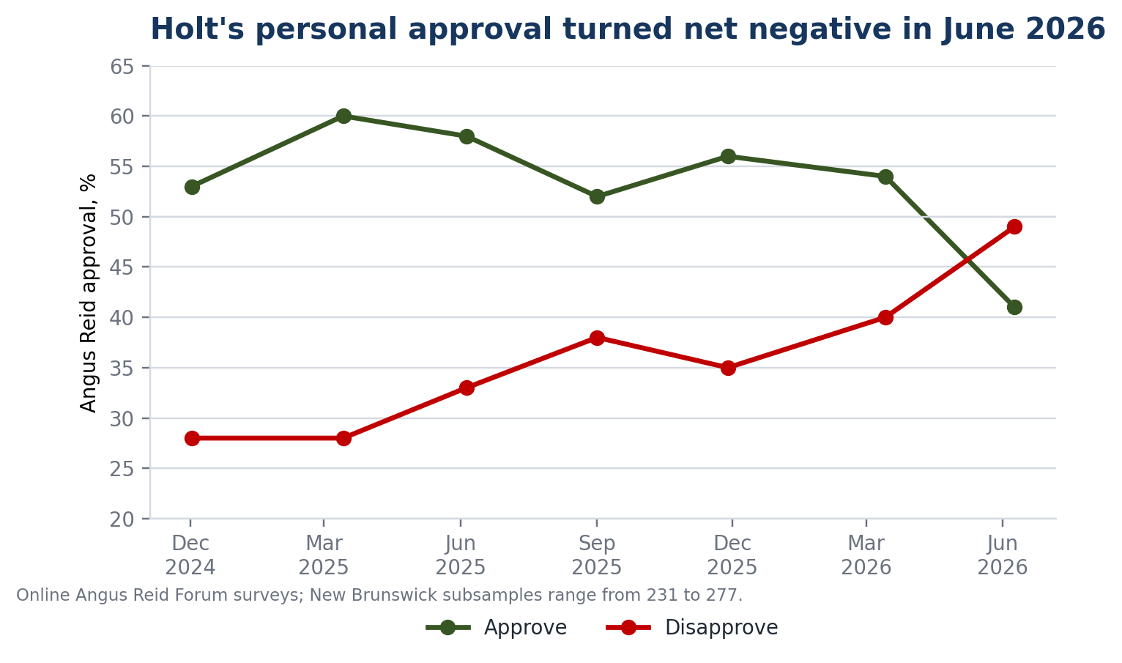
Figure 2. Susan Holt approval and disapproval. Source: Angus Reid Institute; New Brunswick subsamples are small.

Regional breadth
The regional evidence is descriptive. Abacus reported the Liberals at 65% in the North but only 27% in Central New Brunswick, where the PCs had 38% and the Greens 29%. Porter O'Brien reported a Liberal lead in Moncton and rural Francophone New Brunswick, but a large PC lead in rural Anglophone areas. Regional bases are small or undisclosed, so no regional effect is estimated.
The October 6, 2025 Miramichi West by-election is also local evidence. The Legislative Library result shows the PCs retained the seat with 57.40%, almost unchanged from 57.08% in 2024. The PC vote share was nearly unchanged in that riding. It is not a province-wide swing estimate.

5. Historical comparison at day 674

Comparison rule
The main row uses the latest qualifying poll value available by the historical cutoff. Where exact field dates are not recoverable, the gap is left as NOT FOUND. Government satisfaction and leader measures appear only with their question type; they are not treated as one scale.
Premier | Election share | Day-674 input | Retention | Government lead | Government / leader measures | Outcome
Shawn Graham | 47.16 | 51.0 | 108.1% | +15.0 | Satisfaction 59; preferred premier 38 | Lost government in 2010
David Alward | 48.80 | 44.0 | 90.2% | +12.0 | Satisfaction 45; preferred premier 37 | Lost government in 2014
Brian Gallant | 42.73 | 50.0 | 117.0% | +22.0 | Satisfaction 49 in separate CRA wave; MQO leadership 4.8/10 | Popular-vote plurality, fewer seats, lost government in 2018
Blaine Higgs | 31.89 | 39.0 | 122.3% | +13.0 | Narrative satisfaction 81 in a separate survey; Angus Reid approval 80 | Re-elected with a majority in 2020
Susan Holt | 48.26 | 43.16 | 89.4% | +10.20 | Narrative satisfaction 35; Angus Reid approval 41 | Unknown

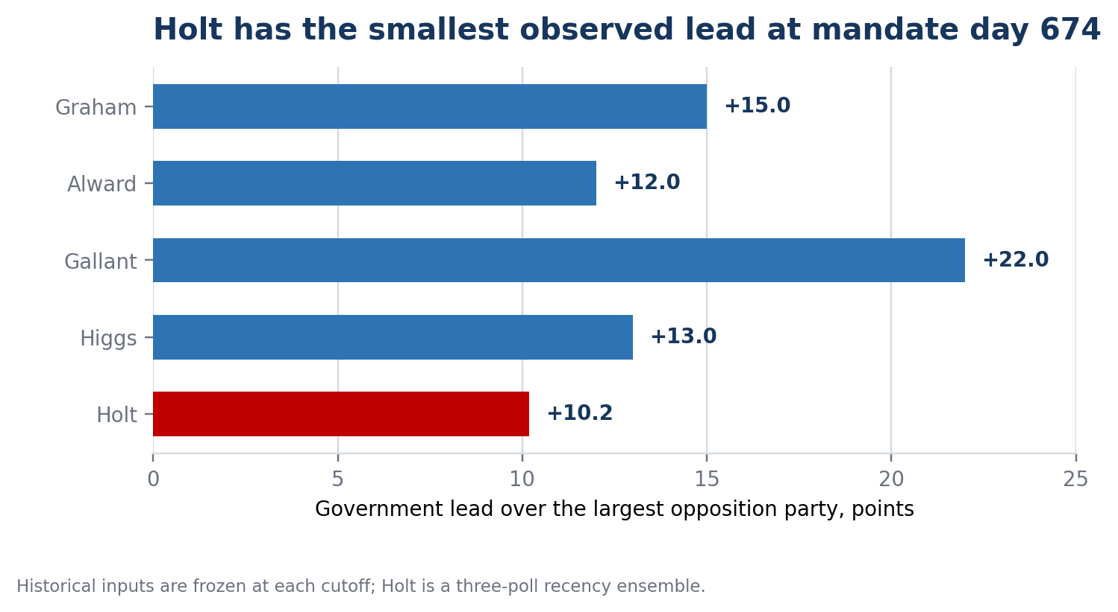
Figure 3. Government lead over the largest opposition party at the frozen day-674 comparison. Sources: Elections New Brunswick and the cited pollster releases; calculations in the companion workbook.
Sources: official election results from Elections New Brunswick; Graham values from the archived CRA Summer 2008 primary table; Alward from CRA's Spring 2012 release corroborated by Global News; Gallant vote intention and leadership from the archived MQO July 2016 report, with satisfaction 49 from a separate CRA May 10-June 1 wave; Higgs from Angus Reid with a Narrative telephone sensitivity.
The observed ranking is unflattering to Holt among these five cases: fifth on raw lead, fifth on support retention and fifth on change in government support since the election. That ordering is not a posterior probability ranking. Graham's May 2008 field dates and sample metadata are unavailable, the Alward input is 71 days old, the Higgs result varies nine points by pollster, and the underlying survey modes differ. On the raw retention and change-from-election metrics, Holt is weaker than Graham and Gallant, weaker than the COVID-rally Higgs, and approximately level with Alward. Higgs's 13-point poll lead overlaps Holt's diagnostic reference interval, so the difference in raw lead alone is not decisive.

Poll timing and the Higgs exception
Premier | Day-674 date | Model-input midpoint | Signed distance | Actual days to next election
Graham | July 23, 2008 | NOT FOUND for May wave | NOT FOUND | 796
Alward | August 1, 2012 | May 22, 2012 | -71 | 782
Gallant | July 27, 2016 | July 12, 2016 | -15 | 789
Higgs | July 29, 2020 | May 22, 2020 | -68 | 47
Holt | August 26, 2026 | August 3, 2026 rounded latest-component midpoint; three-poll ensemble | -23.5 from exact latest-component midpoint | 782 to ordinary date

The fully documented Graham Summer 2008 wave had an August 17 midpoint, 25 days after the cutoff. It is excluded from the historical forecast; it reported Liberal 49, PC 34, satisfaction 53 and Graham preferred 37. The closest Higgs poll had an August 14 midpoint, 16 days after the cutoff, and its fieldwork overlapped the August 17 election call. It is also excluded. The Narrative release reported PC 44 and Liberal 33 and separately identified the election-call break in government satisfaction.
Higgs is not exchangeable with the full-term analogues. He was leading during the first COVID rally, governed in minority and called an election that occurred only 47 days after day 674. Graham, Alward, Gallant and Holt were approximately 782 to 796 days from the next scheduled election at the same point.
The swearing-in clock shifts the comparison dates only three days for Graham, Alward and Gallant. For Higgs it moves the comparison to September 1, 2020, inside the campaign. It does not change the substantive conclusion; it demonstrates why the election clock is the cleaner primary definition.

6. Election-held-today nowcast
The benchmark begins with the 2024 riding-level Liberal, PC and Green votes. Each party's vote in every riding is multiplied by the ratio of its target three-party share to its 2024 three-party share. The highest projected index wins. The extracted riding table also shows 162 votes for withdrawn NDP candidate Bobby Martin in Saint John Portland-Simonds. Elections New Brunswick excludes those votes from its official NDP and valid-vote totals; subtracting them reconciles the riding ledger from 374,823 to the official 374,661 valid votes. The three-party model is unaffected.
Input | Liberal | PC | Green | Liberal seats | PC seats | Green seats
Porter O'Brien | 43.0 | 39.0 | 13.0 | 26 | 21 | 2
Narrative, derived | 40.6 | 30.4 | 13.0 | 30 | 17 | 2
Abacus | 45.0 | 31.0 | 14.0 | 32 | 15 | 2
90-day ensemble | 43.2 | 33.0 | 13.4 | 30 | 17 | 2

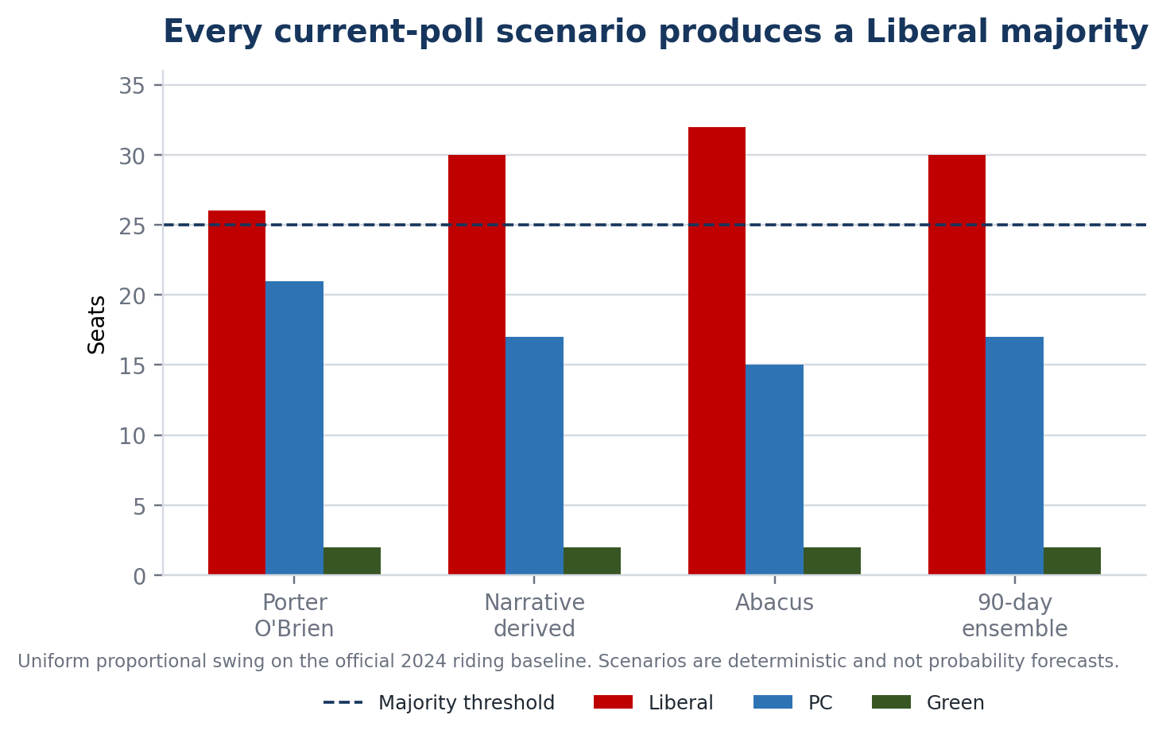
Figure 4. Deterministic uniform-swing seat scenarios on the official 2024 riding baseline. These are not probability forecasts.
All three poll-specific scenarios return a Liberal majority. The lowest result is 26 seats, one above the threshold. In an additional stored sensitivity that holds the Liberal-plus-PC and Green shares fixed, a two-point Liberal provincial lead produces 25 Liberal, 22 PC and two Green seats in the simple model, the approximate majority threshold. A provincial tie produces approximately 23 Liberal, 23 PC and three Green seats.
This is not a probabilistic seat forecast. It assumes uniform change, freezes the 2024 candidate geography, omits future candidate availability, cannot estimate correlated riding errors and does not reliably preserve Green concentration under large swings. The proper conclusion is a range of deterministic scenarios, not a majority probability.

7. What can be said about 2028

The model gate
The preferred state-space, Canadian hierarchical and Monte Carlo seat models are withdrawn from the headline result. The available evidence supports a historical comparison and current nowcast but does not support a calibrated next-election probability.
The reasons are cumulative:
1. Only three independent polls fall within the current 90-day window, and all use non-probability or mixed panels.
2. The historical New Brunswick ledger contains material gaps in field dates, modes, denominators and samples, especially before 2014.
3. Only four named first-term cases are complete, of which Higgs has a fundamentally different 47-day forecast horizon.
4. A pre-specified Canadian training set of at least 30 completed mandates, with contemporaneous polling vintages and consistent government-formation outcomes, could not be verified to the required primary-source standard.
5. The regional evidence cannot calibrate party-specific regional swing, correlated riding errors or Green concentration.
6. A fixed opposition leader is not yet observable. The PC leadership election was scheduled for October 17, 2026, after the evidence cutoff.
It would be misleading to replace those missing ingredients with a precise percentage.

Historical drift scenarios
The full-term day-674 margins later moved as follows:
Government | Day-674 lead | Final election margin | Change
Graham | +15.0 | -14.3 | -29.3
Alward | +12.0 | -8.1 | -20.1
Gallant | +22.0 | +5.9 | -16.1

The range is -16.1 to -29.3 points, with a median of -20.1. Applying those movements mechanically to Holt's current +10.2 would yield a Liberal deficit of roughly six to 19 points. That is not a forecast; it is an illustration of how little protection a mid-mandate lead provided in the three full-term cases.
Higgs's margin moved by only -8.0 points from the closest pre-cutoff Angus Reid poll to the election, leaving the PCs ahead by five. Applying that movement to Holt would leave the Liberals ahead by about two. But Higgs was only 47 days from the vote and in a pandemic rally, so this is an early-election analogue, not a fixed-date one.
The workbook includes two transparent seat scenarios beyond the election-now inputs:
- A five-point erosion from the current margin gives approximately 27 Liberal, 20 PC and two Green seats.
- The full-term analogue median erosion gives approximately 16 Liberal, 29 PC and four Green seats.
The first is a mild illustrative stress; the second is a deliberately adverse historical replay. Neither has a probability attached.

Benchmark hindcasts
Four frozen-date cases are too few for validation, but the audit is still informative. Three simple vote-share benchmarks produce these mean absolute errors:
Benchmark | MAE, all four | MAE, excluding Higgs
Carry forward preceding election share | 9.8 | 10.6
Carry forward day-674 poll | 9.6 | 12.7
Leave-one-out mean poll-to-election drift | 6.6 | 4.4

The drift benchmark looks better in-sample, but each leave-one-out estimate is trained on only two or three cases. It cannot support reliable interval coverage, calibration, Brier scores or log scores. A model that cannot be validated on an adequate sample is not promoted merely because its four-case MAE is lower.

8. Interpretation
Holt most resembles Alward on electoral retention: both were near 90% of their winning vote at day 674 and still led the opposition. Holt's current lead is a little smaller, and her performance measures are lower than Alward's last fully documented pre-cutoff wave. Those measures are not cleanly comparable because timing, mode and question context differ.
She least resembles Higgs. His government was a minority, his support was elevated by the first COVID wave, his personal approval was about 80 and he was only weeks from an early election. His successful re-election does not establish that a ten-point lead 782 days out is durable.
Graham and Gallant are the most important warnings. Both had substantially larger mid-mandate leads and better vote retention than Holt. Both ultimately lost government. Gallant also shows why popular-vote plurality, seat plurality and government formation must remain separate.
The vote and performance measures currently tell different stories. That is possible when the governing party benefits from a weak or unsettled opposition, regional polarization or reluctant strategic support. The current PC leadership contest increases that uncertainty. A new leader can consolidate or further fragment opposition support; the existing polls cannot determine which.

9. What would change the assessment
The following indicators are objective enough to update the judgement:
1. Post-leadership confirmation: At least two independent province-wide polls after October 17, 2026. The current estimate rests partly on an interim and unfamiliar opposition leadership environment.
2. Liberal-PC lead: Two consecutive independent polls below a five-point Liberal lead would fall at or below the rounded lower bound of the present 90% reference interval and approach the narrow-majority region of the uniform-swing benchmark.
3. Loss of lead: A tied or negative two-poll average would produce approximately a hung legislature or PC plurality in the simple seat model.
4. Government performance: Satisfaction or handling approval below 30%, paired with disapproval above 50% in comparable questions, would strengthen the evidence that the 2026 deterioration is not a wording artefact.
5. Leader measure: Holt approval remaining below 45% and net negative in two Angus Reid-style waves would make the June 2026 reversal look persistent.
6. Regional breadth: A replicated PC lead in Central New Brunswick and rural Anglophone areas, combined with Liberal erosion in Saint John or Fredericton, would weaken the uniform-swing majority conclusion.
7. Vote retention: A decided-voter Liberal estimate below about 43% would push retention below 89% of the 2024 result and below the observed five-case range near day 674.
8. Election timing: A credible early-election signal would shorten the horizon and make current polling more predictive; the ordinary 2028 horizon demands much wider uncertainty.
These are monitoring thresholds, not causal claims or guarantees.

10. Limitations and exclusions
- The historical poll inventory is useful for completeness but many older rows remain grade C until their original releases and methods are recovered. Only upgraded A/A-/B observations enter the comparison.
- Pollster-reported shares use different denominators. All-respondent, decided-voter and leaning-voter results are preserved separately.
- Classical margins of error are not assigned to opt-in online panels.
- The random-effects interval uses a derived Narrative effective base and Abacus total n where its decided base is undisclosed. Those nominal inputs are optimistic, and between-poll heterogeneity is unstable with three observations.
- Narrative's 2025 government-satisfaction waves were telephone probability samples, while its June 2026 wave was an online panel. The apparent decline crosses a mode break.
- Graham's May 2008 fieldwork dates, sample and mode are not found. The value is verified retrospectively in an original CRA table.
- Alward's closest post-cutoff poll has incomplete surviving metadata and is excluded.
- Higgs's May 2020 polls disagree materially, and the period was affected by a pandemic rally.
- New Brunswick electoral boundaries and assembly size changed between 2010 and 2014 and again before 2024. Raw historical seat counts are not used to calibrate the 2024 map.
- Regional subsamples are small or undisclosed. They are descriptive only.
- The 2025 by-election is one local contest and is not pooled with province-wide polling.
- Government satisfaction, premier approval, leader favourability and preferred premier are separate constructs.
- Economic and fiscal predictors are excluded from the forecast layer. Reconstructing comparable historical data vintages was not completed, and four New Brunswick outcomes cannot identify their independent predictive effect. A polling-only result is safer than introducing revised data or post-selected variables.
- A wider Canadian provincial training set was not built to the prompt's required primary-source and historical-vintage standard. Consequently, no hierarchical re-election probability, fan chart or Monte Carlo seat distribution is reported.
- Whether a party forms government after a hung legislature depends on confidence and political bargaining, not only seat count.

11. Reproducibility and audit trail
The companion workbook contains:
- the six current vote-intention observations and three core 2026 inputs;
- a separate current-indicator ledger;
- 114 historical poll-index observations, each labelled as a grade-C completeness inventory until upgraded;
- the five day-674 comparison rows and formulas for swing, retention and margin change;
- official election totals from 2006 through 2024;
- all 49 riding-level Liberal, PC and Green baselines, plus an explicit reconciliation of the 162 withdrawn-candidate votes to the official valid-vote total;
- scenario-specific riding calculations and seat counts;
- decay sensitivities, random-effects diagnostic values and hindcast errors;
- a claim-to-source ledger with URLs and source grades.
The executable analysis script uses Python, pandas, NumPy and lxml. The seat benchmark normalizes each scenario to the Liberal-PC-Green three-party total and applies province-wide proportional swing to each riding. The aggregate uses weight = 0.5^(age / half-life), normalized across the three core polls, with field ages computed from exact start/end-date midpoints. The Narrative decided values use party share / 69 * 100. The random-effects diagnostic is a DerSimonian-Laird calculation applied to Liberal-PC margins, with nominal multinomial variance as a reference and explicit variance-base provenance. Random seed 20260826 is reserved for any stochastic extension; the published analysis is deterministic.

Core source ledger
1. Elections New Brunswick, Forty-First Provincial General Election, June 2, 2025. https://www.electionsnb.ca/content/dam/enb/pdf/october-21-2024-forty-first-provincial-general-election.pdf
2. Elections New Brunswick, Thirty-Sixth Provincial General Election. https://www.electionsnb.ca/content/dam/enb/pdf/2006ProvRpt.pdf
3. New Brunswick Laws, Legislative Assembly Act, RSNB 2014, c 116, current consolidated text verified August 26, 2026. https://laws.gnb.ca/en/document/cs/2014%2C%20c.116
4. Abacus Data, Holt's Liberals maintain strong lead as PCs search for new leader, August 14, 2026. https://abacusdata.ca/holts-liberals-maintain-strong-lead-as-pcs-search-for-new-leader/
5. Porter O'Brien, First public semi-annual New Brunswick poll, release text dated June 23, 2026; CMS byline dated June 26. https://www.porterobrien.com/post/porter-o-brien-releases-first-public-semi-annual-new-brunswick-poll-liberals-narrowly-lead-pcs-amo
6. Narrative Research, Low provincial government satisfaction levels reflected in voter intentions, July 2, 2026. https://narrativeresearch.ca/low-provincial-government-satisfaction-levels-reflected-in-voter-intentions-across-atlantic-canada/
7. Angus Reid Institute, Premiers' performance, June 2026. https://angusreid.org/premiers-performance-june-2026/
8. MQO Research, New Brunswick July 2016 Report, archived original. https://web.archive.org/web/20170207112809/https://www.mqoresearch.com/am-nb-0716.pdf
9. Angus Reid Institute, COVID-19 creates comfort zone for incumbent governments, June 8, 2020. https://angusreid.org/provincial-outlook-june2020/
10. Narrative Research, Satisfaction reaches highest level recorded for the province, May 27, 2020. https://narrativeresearch.ca/satisfaction-with-the-performance-of-the-nb-government-reaches-highest-level-ever-recorded-for-the-province/
11. Global News / Corporate Research Associates, Tories drop in support but still ahead in New Brunswick, June 7, 2012. https://globalnews.ca/news/253743/tories-drop-in-support-but-still-ahead-in-n-l-n-b-cra-poll/
12. Legislative Library of New Brunswick, Miramichi West by-election results, October 6, 2025. https://www1.gnb.ca/leglibbib/en/Resources/NBElections.aspx/ElectionResults/10-6-2025
13. Corporate Research Associates, Support for the New Brunswick Liberal Party rebounds, June 9, 2016, archived original. https://web.archive.org/web/20170510125642/https://cra.ca/wp-content/uploads/2016/06/16-2-NB-Press-Release-29348243950262.pdf
14. Narrative Research, Satisfaction remains high despite trending down after the election call, August 27, 2020. https://narrativeresearch.ca/satisfaction-levels-with-the-nb-provincial-government-remain-high-despite-trending-down-after-the-election-call/

