**Simple Multiple Email Sender Java Application**

**Introduction**

The Simple Multiple Email Sender Java Application is designed to provide users with a straightforward way to send emails to multiple recipients and receive feedback on the status of their requests. This documentation outlines the features and usage of the application.

**Features**

1. **Email Sending**: Users can input email addresses to send emails to multiple recipients.
2. **Feedback Display**: Users can view feedback on the status of their email sending requests.

**Technologies Used**

* Java: Programming language used for backend logic.
* SMTP: Protocol used for sending emails.
* HTTP: Protocol used for communication between the application and any external services.
* Java Swing / JavaFX: Libraries used for building the graphical user interface.
* CSS: Styling language for customizing the appearance of the user interface.
* JavaScript: Scripting language for interactive features.
* HTML5: Markup language for structuring the user interface.

**Usage**

**1. Input Email Addresses**

Users can input the email addresses of the recipients to whom they want to send emails.

**2. Send Email**

After inputting the email addresses, users can initiate the email sending process.

**3. View Feedback**

Once the email sending process is complete, users can view the feedback on the status of their email sending requests, including whether the emails were sent successfully or if there were any errors.

**Implementation Details**

The application is implemented using the following steps:

1. **Backend Logic**: Implementing the email sending functionality using Java and SMTP.
2. **Graphical User Interface**: Creating the user interface using Java Swing or JavaFX for inputting email addresses and displaying feedback.
3. **Integration with SMTP Server**: Configuring the application to communicate with an SMTP server for sending emails.
4. **Error Handling**: Implementing error handling mechanisms to handle any issues that may arise during the email sending process.
5. **Testing**: Thoroughly testing the application to ensure its functionality and reliability.

**Conclusion**

The Simple Multiple Email Sender Java Application offers a convenient way for users to send emails to multiple recipients and receive feedback on the status of their requests. By following the guidelines provided in this documentation, users can effectively utilize the application for their email sending needs.

**Appendices**

1. Simple UI Design

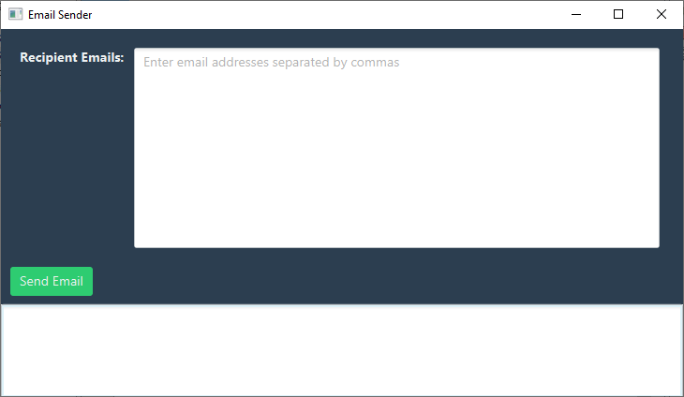

1. Email Validation

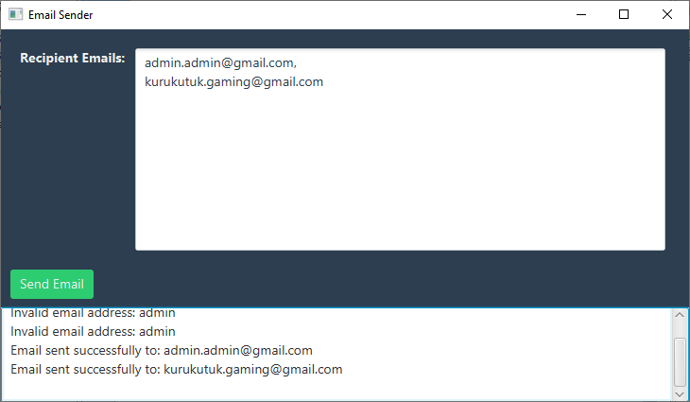

1. Sample Recipient Email

