This assignment is due on Monday, September 30, 2024, at 11:59 pm.

# Assignment 1-Part1

## Goals

In this assignment, you will practice traditional image processing based on the images in the "assignment1-part1" directory. The goals of this assignment are as follows:

* Become proficient in using the “**Colab platform**”.
* Develop proficiency in writing **image processing** code with Pillow and OpenCV.
* Implement and apply **Image Stitching and Cropping**.
* Implement and apply **Image Color Space Transformations**.
* Implement and apply **Image Histograms**.
* Implement and apply Image Filters (**Gaussian filters** and **Laplacian filters**).

Note: In subsequent requirements, "Write code" means implementing the functionality yourself rather than using existing functions.

## Q1：Basic Image Operations [10 points]

Create a new notebook named basic.ipynb in Colab to perform the following operations:

1. Stitch assignment1/image1.jpg (Image A) and assignment1/image2.jpg (Image B) together.
2. Crop Image A.

The specific requirements are as follow:

1. Image Stitching:

* Read the two images, A and B in basic.ipynb.
* Resize A and B to 256×256.
* Write code to **Horizontally Stitch** the resized images A and B into a new image C, where the left half of C is image A and the right half is image B.
* Save image C and display images A, B, and C in the notebook.

2. Image Cropping:

* Write code to crop image A. The starting position is (100, 50), and the cropping area is: width 200 pixels, height 150 pixels.
* Save the cropped image
* Display image A and the cropped image in the notebook.

## Q2：Color Spaces [10 points]

Create a new notebook named color_trans.ipynb in Colab to perform the following operations:

1. Convert assignment1/image1.jpg (Image A) to a grayscale image.
2. Convert the grayscale image to a binary image.
3. Convert Image A to the HSV (Hue-Saturation-Value) color space.

The specific requirements are as follows:

* Write code to convert image A to a grayscale image B (use the average weighting).
* Write code to convert image B to a binary image C (with a threshold of 127).
* Save images B and C, and display images A, B, and C in the notebook.
* Use the cv2.cvtColor() method in OpenCV to convert image A from RGB to HSV color space.
* Display image A and its conversion result in the notebook.

## Q3：Image Histogram [10 points]

Create a new notebook named histogram.ipynb in Colab to perform the following operations:

1. Write code to extract the histogram of assignment1/image1.jpg (Image A).

The specific requirements are as follows:

* Convert assignment1/image1.jpg (Image A) to a grayscale image B.
* Write code to extract the histogram of image B
* Use Pillow to plot this information as image C.
* Display image C in the notebook.

## Q4：Image Filtering [10 points]

Create a new notebook named filter.ipynb in Colab to perform the following operations:

1. Implement the Gaussian filter and apply it on assignment1/image1.jpg (Image A).
2. Implement the Laplacian filter and apply it on assignment1/image1.jpg (Image A).

The specific requirements are as follows:

* Write code to implement a 5×5 Gaussian filter (sigma=2).
* Perform Gaussian filtering on Image A, resulting in Image B.
* Display both Image A and Image B in the notebook.
* Write code to implement a Laplacian filter, Use the following Laplacian operator for the Laplacian filter:

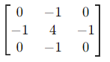

* Perform Laplacian filtering on Image A, resulting in Image C.
* Display both Image A and Image C in the notebook.

## Submitting your work

**Important.** Please make sure that the submitted notebooks have been run, the cell outputs are visible and the notebook names meet the requirements.

Once you have completed all notebooks and filled out the necessary code, you need to follow the below instructions to submit your work:

1. Open collect_submission.ipynb in Colab and execute the notebook cells.

This notebook/script will:

* Generate a zip file of your code (.py and .ipynb) named a1_code_submission.zip.
* Convert all notebooks into a single PDF file.

If your submission for this step was successful, you should see the following display message:

* ### Done! Please submit a1_code_submission.zip and a1_inline_submission.pdf to eLearning###

2. Submit the PDF and the zip file to eLearning.

Download a1_code_submission.zip and a1_inline_submission.pdf and rename them to student name+ID+part1.zip and student name+ID+part1.pdf before submitting to eLearning.

# Assignment 1-Part2

Student ID: Student Name:

## Problem 1 [30 points]

Design a three layer neural network whose decision boundary is as shown in Figure 1. The gray region belongs to class 1 and other region belongs to class 0. Show your network structure, weights and nonlinear activation function.

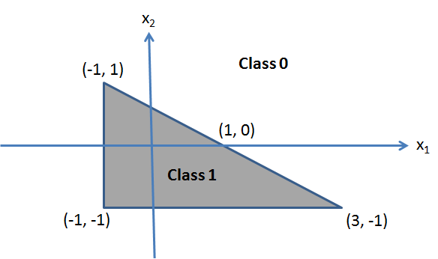

## Problem 2 [30 points]

Let x be an image and f(·) is a convolution operation. g(·) is spatial translation applied to an image. Prove that convolution has equivariance to translation, i.e. f(g(x)) = g(f(x)). Is convolution equivariant to downsampling? Explain why.

## Submitting your work

Submit the solution as a pdf file with the name: student name+ID+part2.pdf to eLearning.