**1 INTRODUCTION**

**1.1 Overview**

Responsible for concept, design and production of innovative high quality print and digital artwork, including logos advertisements,

Brochures and websites.

**1.2 purpose**

The template emphasizes your picture, job title, cv summary/objective, and contact information through the use of bold colours and straight lines.

**2 Problem Definition & Design Thinking**

**2.1 Empathy map**

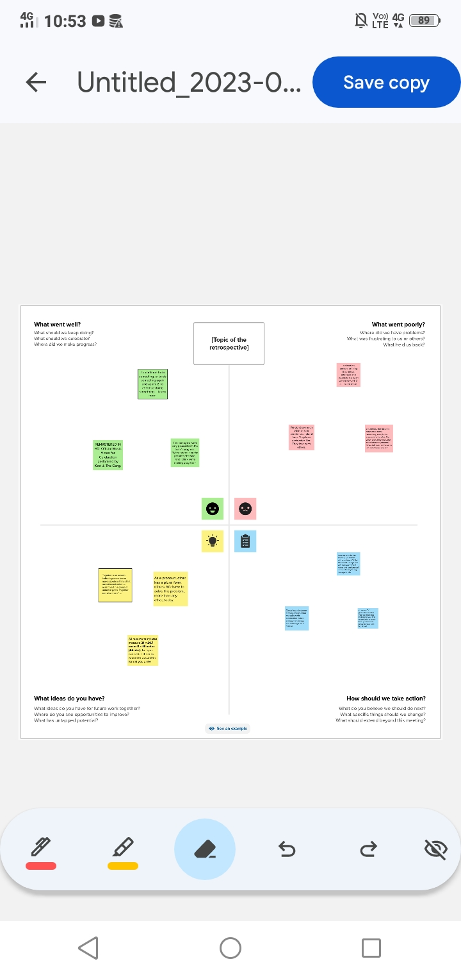

**2.2 Ideation & Brainstorming map**

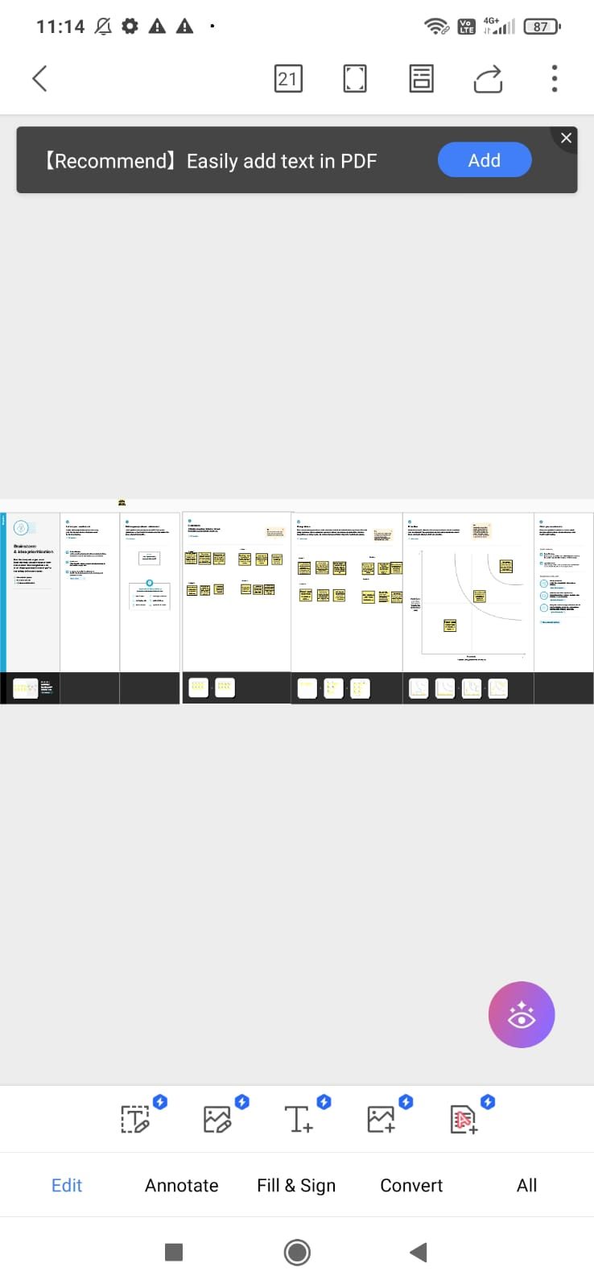

**3 RESULT**

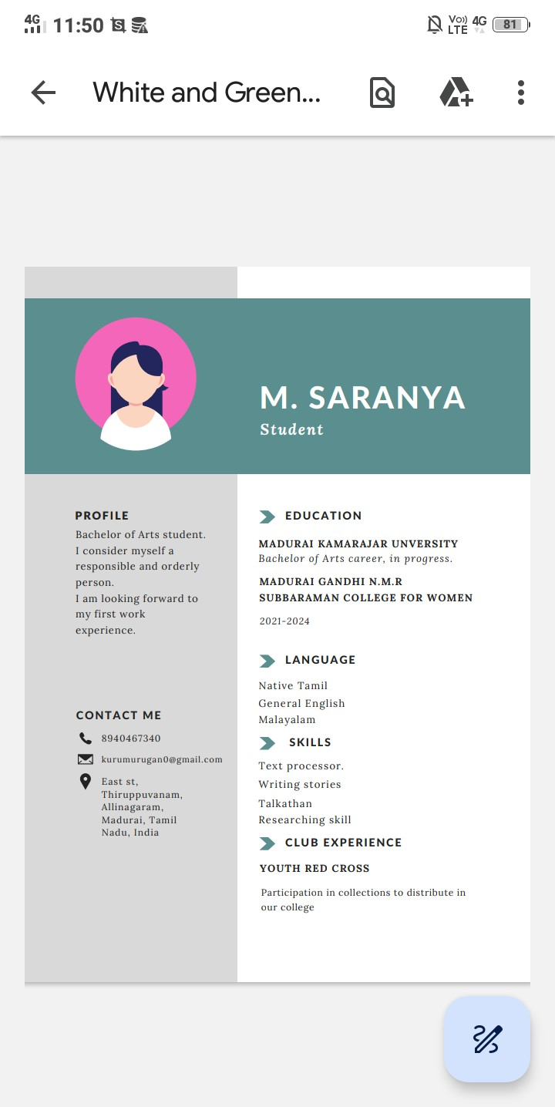

**4 ADVANDAGES & DISADVANDAGES**

**4.1 Advantages**

Boost your self-confidence.

Prove your knowledge.

Show teamwork skills.

Make your application stand out and leave a lasting impression.

.

**4.2 Disadvantages**

It is harder to compare the skills and experience of different candidates.You may not get a true sense of whether a candidate is suitable for the job and skills required to perform their role. Gaps in education or work can be hidden more easily by the job applicant.

**5 Applications**

I used to Mural Application and Canva Application

**6 CONCLUSION**

We have created design resume with the help of canva

**7 FUTURE SCOPE**

We were planningto join the Graphic Designing course