ECOMINSIGHT AI
AI-Powered E-Commerce Analytics Dashboard
Project Report
AICTE | IBM SkillsBuild Data Analytics with AI Internship 2026
Prepared by
Pranav Kurupath
Technology: Python • Streamlit • Pandas • Plotly • AI-assisted Analytics
Dataset: Madhav E-Commerce Sales Dataset (Kaggle)

1. Abstract
EcomInsight AI is an interactive e-commerce analytics platform designed to convert raw sales data into understandable business insights. The application combines data processing, KPI analysis, interactive visualizations, geographical and payment analysis, sales forecasting, and an AI Business Analyst interface in a single Streamlit dashboard.
The project uses the Madhav E-Commerce Sales Dataset, supplied through two related CSV files: Orders.csv and Details.csv. The files are joined using Order ID and analyzed using actual transaction records rather than fabricated data.

2. Problem Statement
E-commerce transaction data can contain useful information about sales, profit, customers, products, geography and payment behavior, but raw CSV files are difficult to interpret quickly. A business user needs a simple interface that presents important KPIs, trends, comparisons and actionable insights without requiring manual spreadsheet analysis.

3. Objectives
- Build an interactive dashboard for e-commerce sales and profit analysis.
- Calculate and present important business KPIs clearly.
- Analyze category, sub-category, customer, state/city and payment performance.
- Provide historical sales and profit trends using interactive charts.
- Generate a lightweight sales forecast from historical data and clearly label it as an estimate.
- Provide an AI Business Analyst interface for natural-language questions about the loaded data.
- Present business insights and recommendations based on calculated results.

4. Dataset Description
File | Main Fields | Purpose
Orders.csv | Order ID, Order Date, Customer Name, State, City | Order and customer/location information
Details.csv | Order ID, Amount, Profit, Quantity, Category, Sub-Category, PaymentMode | Transaction, product and payment information
Relationship: Orders.csv and Details.csv belong to the same dataset and are joined using Order ID.
Dataset reference: Madhav E-Commerce Sales Dataset — Kaggle: https://www.kaggle.com/datasets/amitkumar209/madhav-e-commerce-sales-dataset

5. Proposed Solution
EcomInsight AI provides a single dashboard where users can filter the dataset and move through specialized analytical sections. The application loads and cleans the CSV data, joins the two files, calculates KPIs, creates Plotly visualizations, performs lightweight forecasting and answers predefined/natural-language analytical questions using the loaded dataset.

6. System Architecture & Workflow
- CSV Data Sources → Orders.csv + Details.csv
- Data Processing → validation, cleaning, date conversion and Order ID join
- Analytics Layer → KPIs, trends, category, geography, customer and payment analysis
- Prediction Layer → historical monthly sales aggregation and lightweight forecast
- AI Analyst Layer → question selection/input and data-backed analytical response
- Presentation Layer → Streamlit dashboard with filters, charts, KPIs and recommendations

7. Technologies Used
Python, Streamlit, Pandas, NumPy, Plotly and Python-based data analysis libraries. IBM Bob was used as an AI-assisted development environment for project implementation.

8. Key Dashboard Features
Feature | Description
Executive KPIs | Total Sales, Total Profit, Profit Margin, Total Orders, Average Order Value and Units Sold.
Sales Analysis | Monthly sales/profit trends, quarterly sales and customer performance.
Category Analysis | Sales share, sales vs profit and category-level comparison.
Geographical Analysis | State-wise performance and regional sales/profit patterns.
Payment Analysis | Payment-mode share and sales/profit comparison across payment methods.
Forecasting | Historical sales trend with a lightweight future estimate.
AI Business Analyst | Interactive questions and data-backed responses based on the loaded dataset.
Insights & Recommendations | Business observations and practical recommendations derived from the analysis.

9. Dashboard Screenshots
The following screenshots demonstrate the major modules and capabilities of the working EcomInsight AI dashboard.
Screenshot 1 — Executive Dashboard / KPI Overview

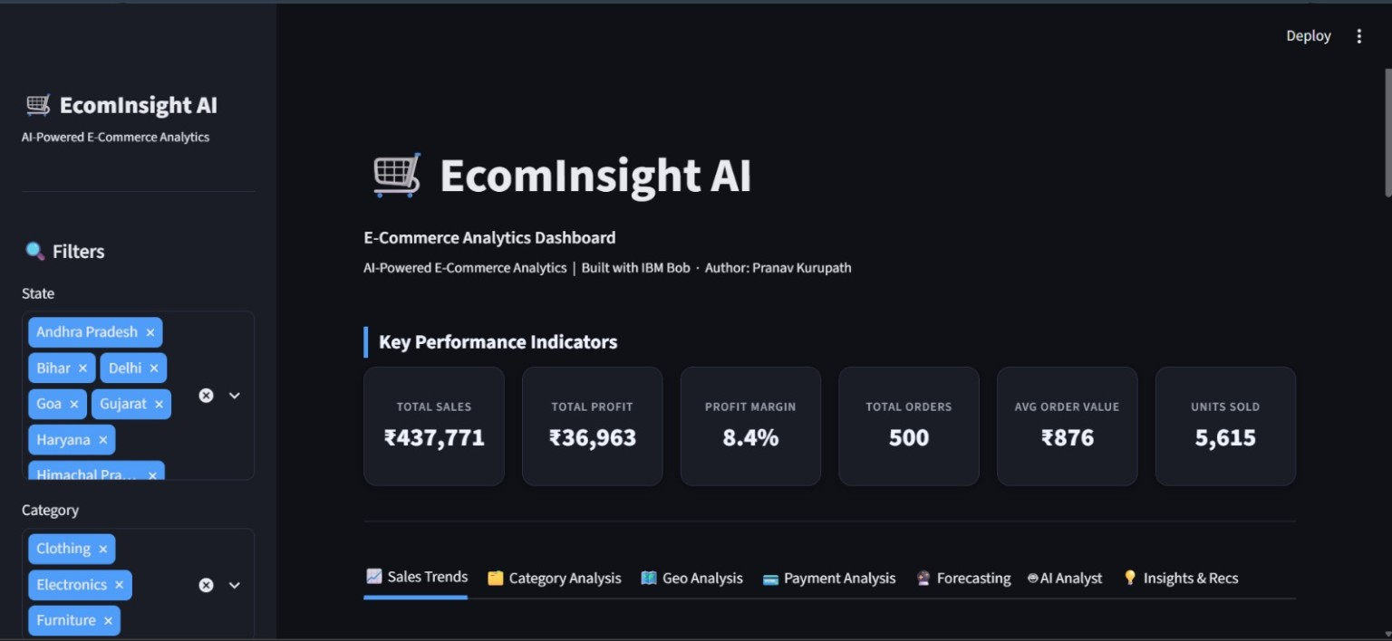

Screenshot 2 — Sales Trends

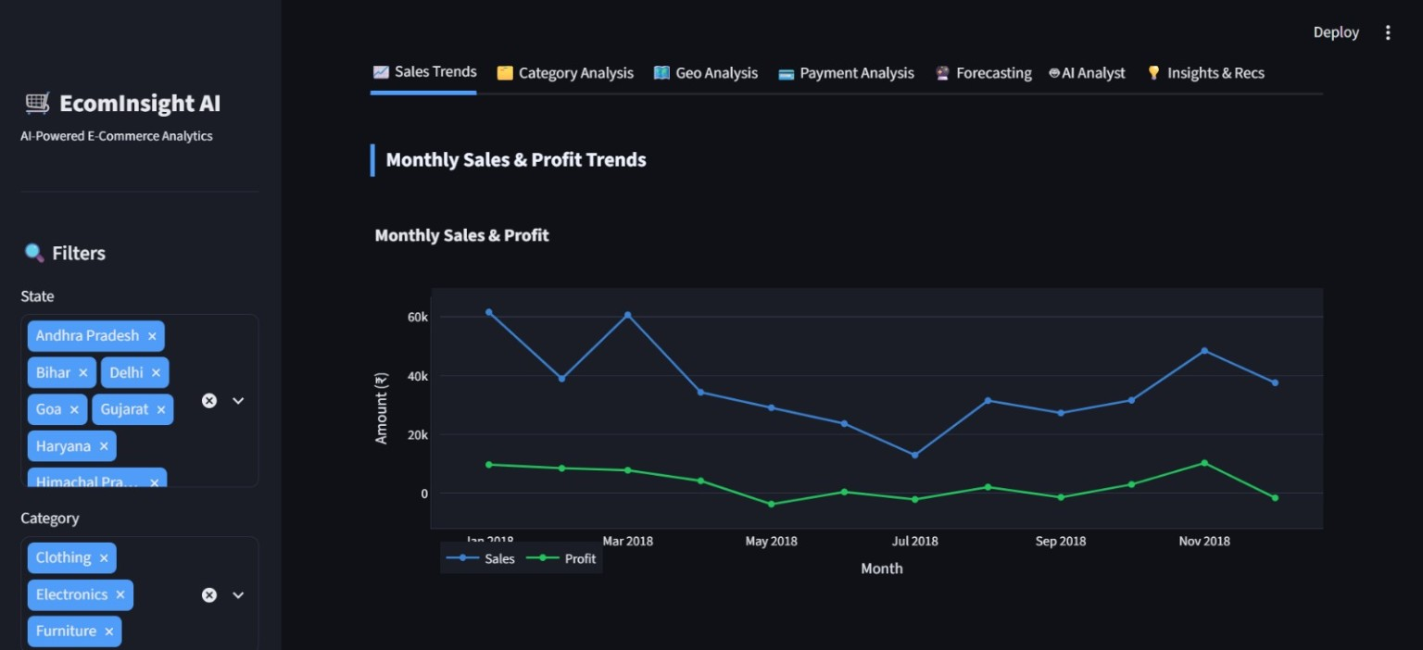

Screenshot 3 — Category Analysis

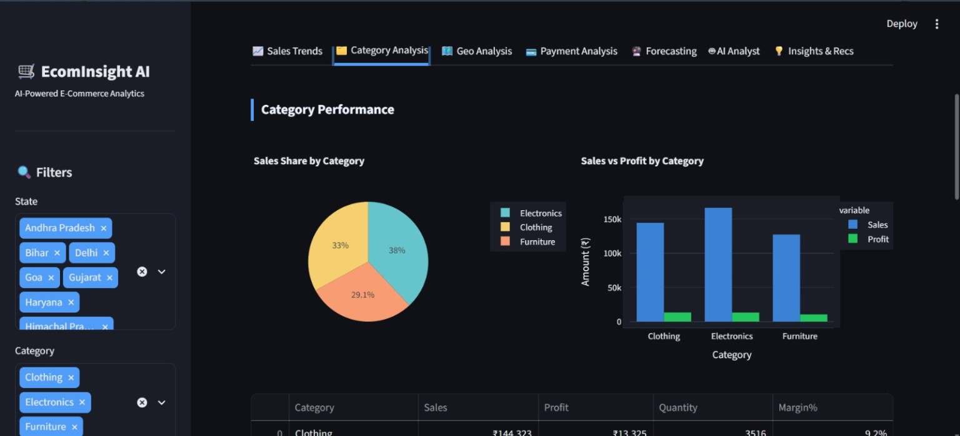

Screenshot 4 — Geographical Analysis

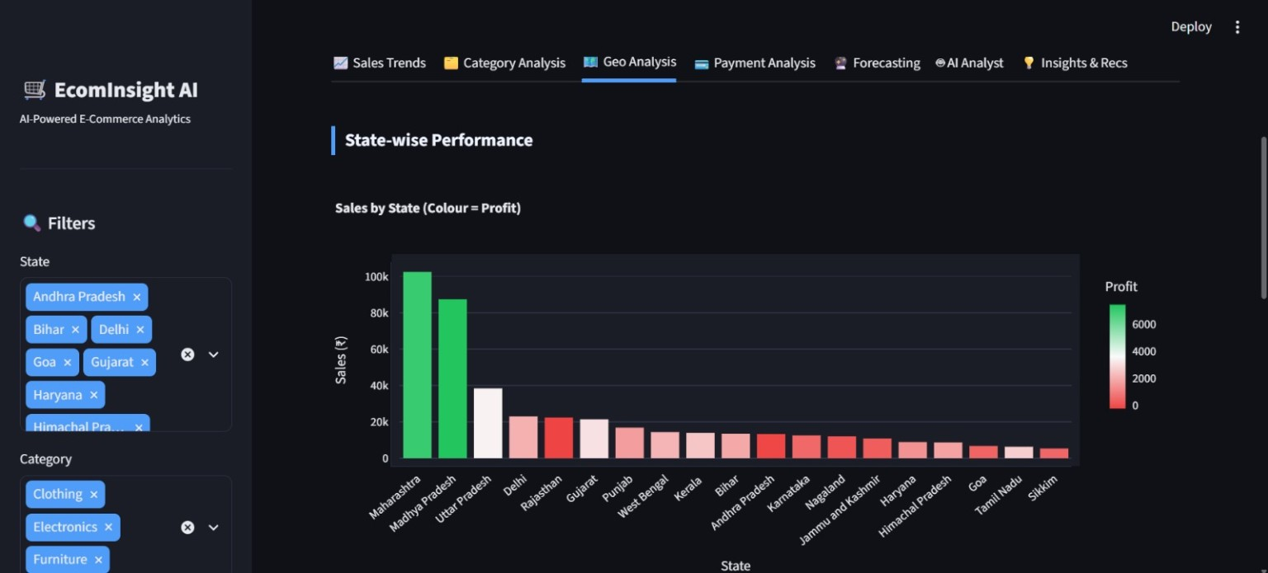

Screenshot 5 — Payment Analysis

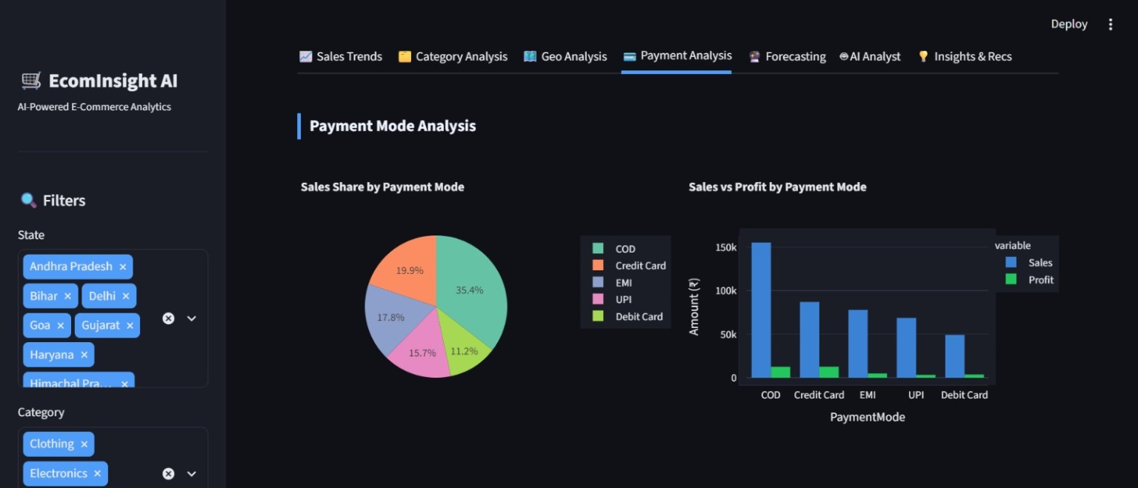

Screenshot 6 — Forecasting

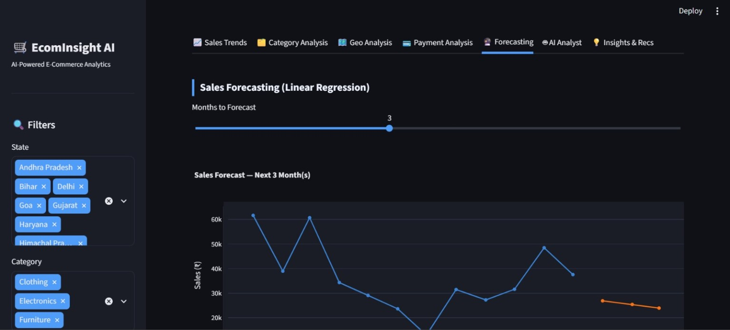

Screenshot 7 — AI Business Analyst

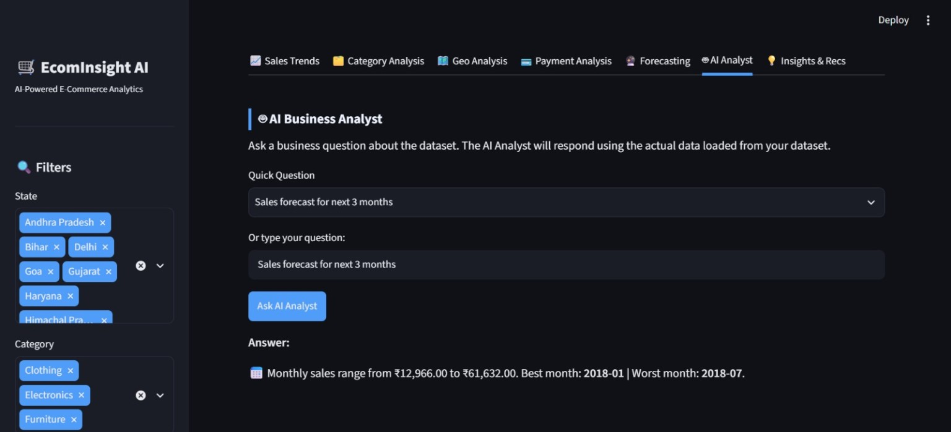

Screenshot 8 — Insights & Recommendations

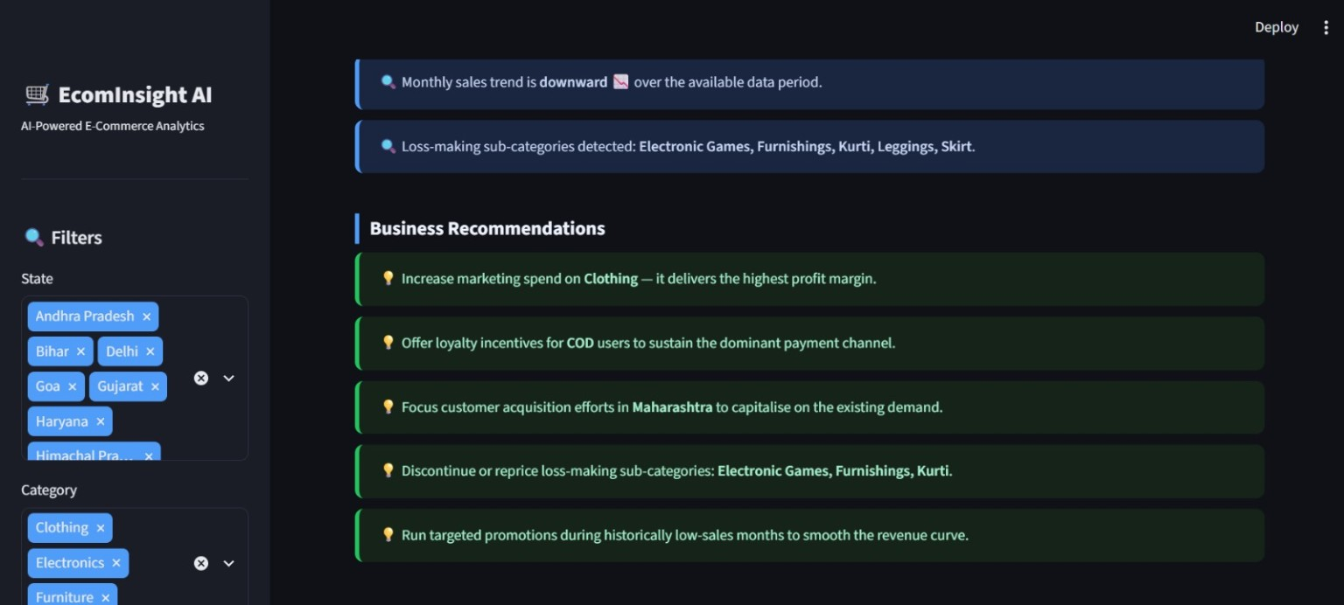

10. Data Processing Methodology
- Load Orders.csv and Details.csv using Pandas.
- Validate required columns and normalize date/numeric fields.
- Convert Order Date into a proper date format for time-based analysis.
- Join the two related files on Order ID.
- Apply dashboard filters for state and category.
- Aggregate sales, profit, quantity and orders for the required analytical dimensions.
- Use the filtered/processed data for charts, KPI calculations and AI Analyst responses.

11. KPI Definitions
- Total Sales: Sum of transaction Amount after the selected filters.
- Total Profit: Sum of Profit after the selected filters.
- Profit Margin: Total Profit divided by Total Sales, expressed as a percentage.
- Total Orders: Count of order records represented in the dashboard.
- Average Order Value: Total Sales divided by Total Orders.
- Units Sold: Sum of Quantity.

12. Forecasting Methodology
Historical transaction amounts are aggregated by month and used to identify the sales trend. A lightweight linear-regression approach is used to estimate future sales. Forecast values are presented as estimates and should not be interpreted as guaranteed business outcomes.

13. AI Business Analyst
The AI Business Analyst allows users to select or enter questions about the dataset. Responses are generated from the actual loaded and calculated data. Example questions include sales trends, best-performing categories, payment behavior and sales forecasts. The feature is designed to make analytics accessible to users who may not know SQL or Python.

14. Results & Business Insights
The dashboard provides a consolidated view of sales performance, profitability, category behavior, geographical distribution, customer contribution and payment methods. The final recommendations are generated from the observed analytical patterns and are intended to support business review and decision-making.

15. How to Run the Project
1. Install Python 3.x.
2. Place the project files and dataset CSV files in the required project structure.
3. Install dependencies:
pip install -r requirements.txt
4. Start the Streamlit application:
python -m streamlit run PranavKurupath_EcomInsightAI.py
5. Open the local Streamlit URL shown in the terminal/browser.

16. Project Structure
- PranavKurupath_EcomInsightAI.py — Main Streamlit application
- requirements.txt — Python dependencies
- README.md — Project documentation
- Orders.csv — Dataset order information
- Details.csv — Dataset transaction/product information
- PranavKurupath_EcomInsightAI_ProjectReport.docx — Project report

17. Future Enhancements
- Connect to live e-commerce databases or APIs.
- Add advanced time-series forecasting and confidence intervals.
- Add role-based dashboards for management, marketing and finance teams.
- Add automated report generation and scheduled insight delivery.
- Expand the AI Analyst with richer conversational context and additional analytical tools.

18. Conclusion
EcomInsight AI demonstrates how Python, interactive visualization and AI-assisted analytics can turn raw e-commerce transactions into a practical business intelligence application. The project combines KPI monitoring, trend analysis, category and geographical insights, payment analysis, forecasting and an AI Business Analyst into one accessible Streamlit dashboard.

19. Dataset Reference
Madhav E-Commerce Sales Dataset, Kaggle. The dataset is used for educational/project analysis and consists of the related Orders.csv and Details.csv files.
Kaggle URL:Dataset_link

