9. Perform Rotation of an image to clockwise and counter
clockwise direction.
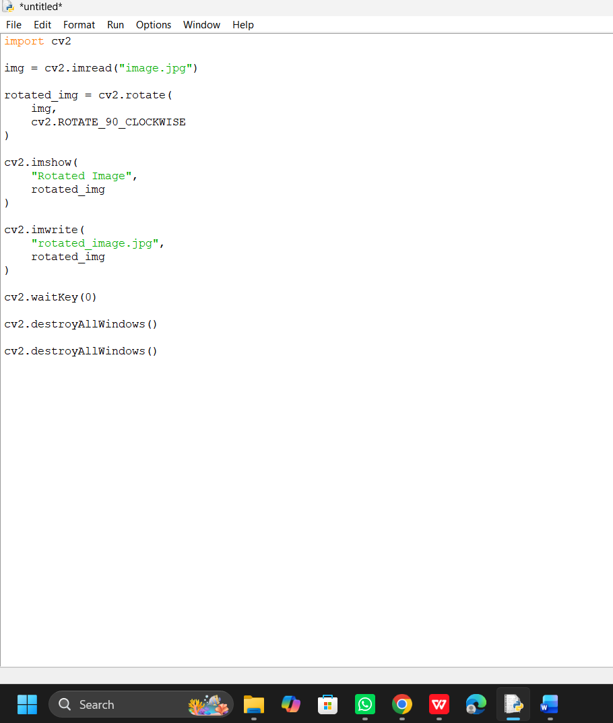
Output
