1)Perform basic Image Handling and processing operations on the image.
AIM:- Read an image in python and Convert an Image to Grayscale
PROGRAM

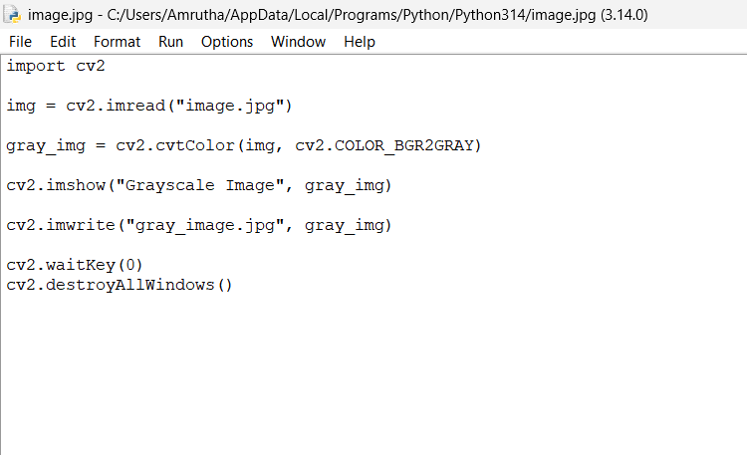
OUTPUT
