LAB EXPERIMENTS – ITA0515 – COMPUTER VISION – SLOT B
EXPERIMENT 1:
Perform Basic Image Handling Operations on an Image (Read an Image)
Aim
To read and display an image using Python and OpenCV.
Procedure
- Open the Python IDE (IDLE/VS Code).
- Import the OpenCV library using import cv2.
- Read the input image using the cv2.imread() function.
- Check whether the image has been loaded successfully.
- Display the image using the cv2.imshow() function.
- Wait for the user to press a key using cv2.waitKey(0).
- Close all image windows using cv2.destroyAllWindows().
- Observe the displayed image and verify that it has been loaded correctly.
Python Code
import cv2
# Read the image
img = cv2.imread(r"C:\Users\sreel\OneDrive\Desktop\scenery.png")
if img is None:
print("Image not found!")
else:
# Display the image
cv2.imshow("Input Image", img)
print("Image loaded successfully!")
cv2.waitKey(0)
cv2.destroyAllWindows()

Output
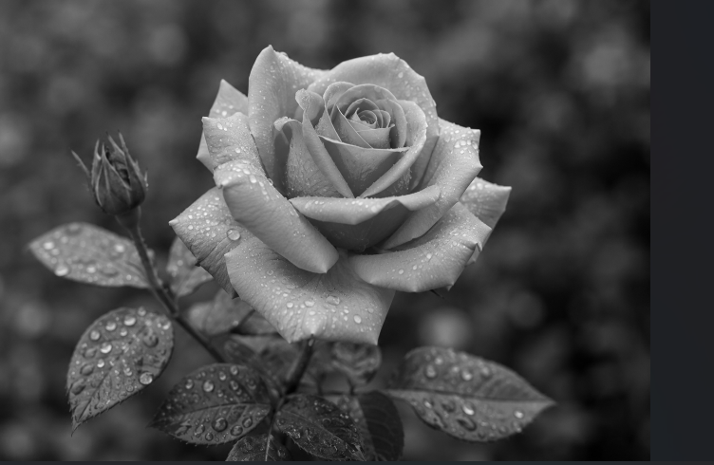
Result
The image was successfully read and displayed using the OpenCV library in Python.

EXPERIMENT 2:
Perform Basic Image Handling and Processing Operations on the Image
Aim: To read an image in Python and convert the image into a blurred image using the Gaussian Blur function.
Procedure
- Start the Python IDE (IDLE/VS Code) and import the OpenCV library.
- Read the input image from the specified location using the cv2.imread() function.
- Verify whether the image has been loaded successfully. If not, display an error message.
- Display the original image using the cv2.imshow() function.
- Apply the Gaussian Blur operation using the cv2.GaussianBlur() function with a suitable kernel size (e.g., (15,15)).
- Display the blurred image in a separate window.
- Save the processed (blurred) image using the cv2.imwrite() function.
- Wait for the user to press any key using cv2.waitKey(0).
- Close all the image display windows using cv2.destroyAllWindows().
- Observe the output and verify that the image has been blurred successfully.
This procedure is detailed enough for most Computer Vision lab manuals.
Python Code
import cv2
img = cv2.imread(r"C:\Users\sreel\OneDrive\Desktop\scenery.png")
if img is None:
print("Image not found!")
else:
# Display original image
cv2.imshow("Original Image", img)
blur = cv2.GaussianBlur(img, (15, 15), 0)
cv2.imshow("Blurred Image", blur)
cv2.imwrite("blurred_image.png", blur)
print("Image processed successfully!")
cv2.waitKey(0)
cv2.destroyAllWindows()
Output:
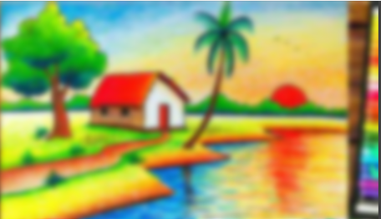
Result:
The image was successfully read and processed using the Gaussian Blur function. and the blurred image was saved successfully.
EXPERIMENT 3:
Perform Basic Image Handling and Processing Operations on the Image (Canny Edge Detection)
Aim
To read an image in Python and detect its edges using the Canny Edge Detection function in OpenCV.
Procedure
- Open the Python IDE (IDLE/VS Code).
- Import the required OpenCV library.
- Read the input image using the cv2.imread() function.
- Verify that the image is loaded successfully.
- Convert the input image into grayscale using the cv2.cvtColor() function.
- Apply the Canny Edge Detection function using suitable threshold values.
- Display both the original image and the edge-detected image.
- Save the edge-detected image using the cv2.imwrite() function.
- Wait for the user to press a key using cv2.waitKey(0).
- Close all image windows using cv2.destroyAllWindows().
Python Code
import cv2
img = cv2.imread(r"C:\Users\sreel\OneDrive\Desktop\mountain.png")
if img is None:
print("Image not found!")
else:
cv2.imshow("Original Image", img)
gray = cv2.cvtColor(img, cv2.COLOR_BGR2GRAY)
edges = cv2.Canny(gray, 100, 200)
cv2.imshow("Canny Edge Image", edges)
cv2.imwrite("canny_output.png", edges)
print("Canny Edge Detection completed successfully!")
cv2.waitKey(0)
cv2.destroyAllWindows()
Output
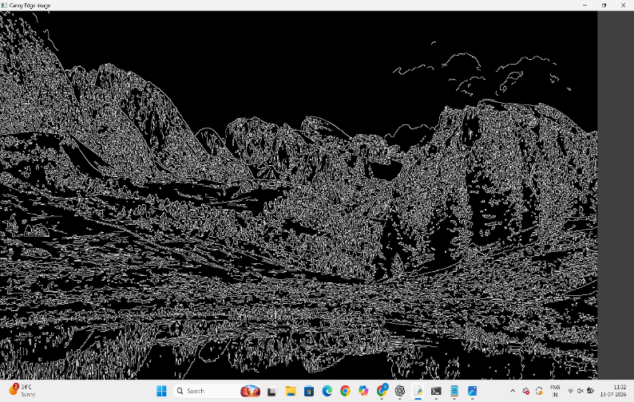
Result
The input image was successfully read and processed using the Canny Edge Detection function. The outlines (edges) of the objects in the image were detected and displayed successfully.

EXPERIMENT 4:
Perform Basic Image Handling and Processing Operations on the Image (Image Dilation)
Aim
To read an image in Python and perform image dilation using the Dilate function in OpenCV.
Procedure
- Open the Python IDE (IDLE/VS Code).
- Import the required libraries (cv2 and numpy).
- Read the input image using the cv2.imread() function.
- Verify that the image is loaded successfully.
- Create a kernel (structuring element) using the NumPy library.
- Apply the Dilate function using cv2.dilate().
- Display the original image and the dilated image.
- Save the dilated image using the cv2.imwrite() function.
- Wait for the user to press a key using cv2.waitKey(0).
- Close all image windows using cv2.destroyAllWindows().

Python Code
import cv2
import numpy as np
img = cv2.imread(r"C:\Users\sreel\OneDrive\Desktop\mountain.png")
if img is None:
print("Image not found!")
else:
cv2.imshow("Original Image", img)
kernel = np.ones((5,5), np.uint8)
dilated = cv2.dilate(img, kernel, iterations=1)
cv2.imshow("Dilated Image", dilated)
cv2.imwrite("dilated_image.png", dilated)
print("Image dilation completed successfully!")
cv2.waitKey(0)
cv2.destroyAllWindows()

Output
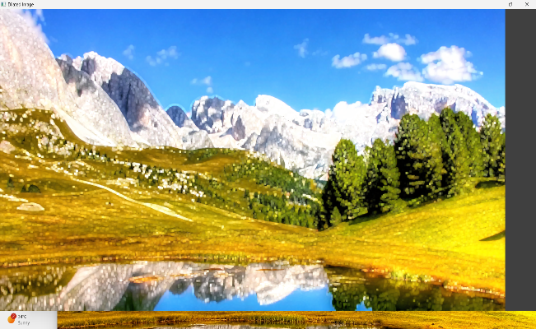
Result
The input image was successfully read and processed using the Dilate function in OpenCV. The objects in the image became thicker, and the dilated image was displayed and saved successfully.

Experiment 5: Read an Image and Erode an Image using erode() Function
Aim
To read an image in Python and perform image erosion using the erode() function in OpenCV.
Procedure
- Open the Python IDE (IDLE/VS Code).
- Import the OpenCV and NumPy libraries.
- Read the input image using cv2.imread().
- Check whether the image is loaded successfully.
- Create a 5×5 kernel using NumPy.
- Apply the cv2.erode() function to the image.
- Display the original and eroded images.
- Save the eroded image.
- Press any key to close the image windows.
Python Code
import cv2
import numpy as np
img = cv2.imread(r"C:\Users\sreel\OneDrive\Desktop\tree.png")
if img is None:
print("Image not found!")
else:
cv2.imshow("Original Image", img)
kernel = np.ones((5,5), np.uint8)
eroded = cv2.erode(img, kernel, iterations=1)
cv2.imshow("Eroded Image", eroded)
cv2.imwrite(r"C:\Users\sreel\OneDrive\Desktop\eroded_image.png", eroded)
print("Image erosion completed successfully!")
cv2.waitKey(0)
cv2.destroyAllWindows()
Output
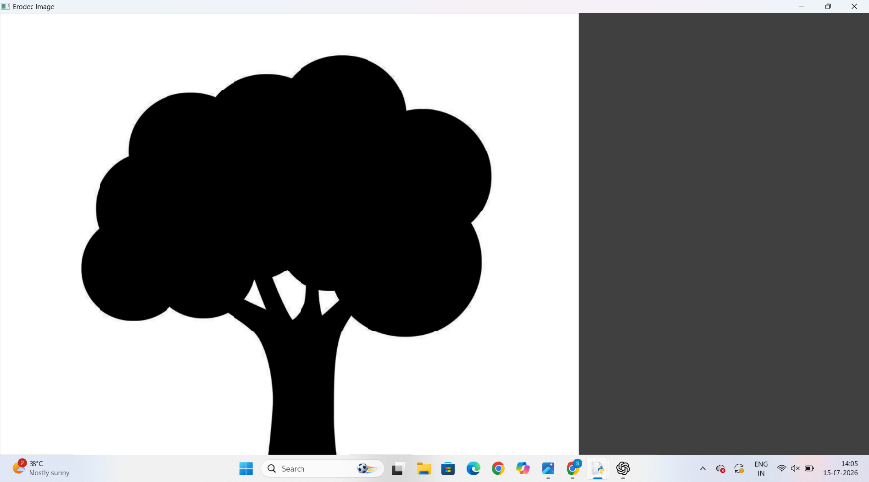
Result
The image was successfully read and processed using the Erode function in OpenCV. The boundaries of the objects in the image were reduced (eroded), and the processed image was displayed and saved successfully.

Experiment 6: Perform Basic Video Processing Operations
Aim
To read a captured video in Python and display it in normal speed, slow motion, and fast motion using OpenCV.
Procedure
- Import the OpenCV library.
- Read the video using cv2.VideoCapture().
- Check whether the video is opened successfully.
- Read each frame of the video.
- Display the frames using cv2.imshow().
- Change the delay in cv2.waitKey():
  - Larger delay → Slow motion.
  - Smaller delay → Fast motion.
- Press q to stop the video.
- Release the video and close all windows.
Python Code (Normal Speed)
import cv2
cap = cv2.VideoCapture(r"C:\Users\sreel\OneDrive\Desktop\sample.mp4")
while cap.isOpened():
ret, frame = cap.read()
if not ret:
break
cv2.imshow("Normal Video", frame)
if cv2.waitKey(30) & 0xFF == ord('q'):
break
cap.release() cv2.destroyAllWindows()
Output
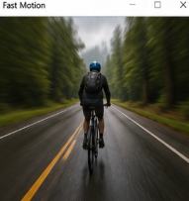
Result
The captured video was successfully read and displayed in normal, slow, and fast motion using Python and OpenCV.

Experiment 7: Capture Video from Webcam and Display the Video in Slow Motion and Fast Motion
Aim
To capture live video from the system webcam using OpenCV and display the video in normal, slow motion, and fast motion by controlling the frame display speed. This experiment helps in understanding real-time video capture, frame processing, and video playback speed manipulation using Python.
Procedure
- Install Python and the OpenCV library on the system.
- Import the OpenCV (cv2) library.
- Initialize the webcam using the VideoCapture() function.
- Check whether the webcam is opened successfully.
- Capture the video frame by frame inside a continuous loop.
- Display each captured frame in a window.
- Set an initial frame delay using the waitKey() function to display the video at normal speed.
- Monitor the keyboard input during video playback.
- If the user presses the 'S' key, increase the delay between frames to display the video in slow motion.
- If the user presses the 'F' key, decrease the delay between frames to display the video in fast motion.
- Continue displaying the video until the user presses the 'Q' key.
- Release the webcam resource after the loop ends.
- Close all OpenCV display windows using destroyAllWindows().
Code
import cv2
cap = cv2.VideoCapture(0)
if not cap.isOpened():
print("Unable to access the webcam.")
exit()
print("Press 'S' for Slow Motion")
print("Press 'F' for Fast Motion")
print("Press 'Q' to Quit")
delay = 30
while True:
ret, frame = cap.read()
if not ret:
print("Failed to capture frame.")
break
cv2.imshow("Webcam Video", frame)
key = cv2.waitKey(delay) & 0xFF
if key == ord('s') or key == ord('S'):
delay = 100
print("Slow Motion Mode")
elif key == ord('f') or key == ord('F'):
delay = 5
print("Fast Motion Mode")
elif key == ord('q') or key == ord('Q'):
break
cap.release()
cv2.destroyAllWindows()
Output
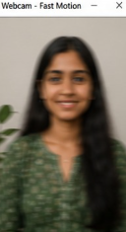
Result
The live video was successfully captured from the system webcam using OpenCV. The captured video was displayed on the screen, and the playback speed was successfully controlled by switching between slow motion and fast motion using keyboard inputs. The experiment demonstrated real-time video capture and processing effectively.

Experiment 8: Scaling an Image to Bigger and Smaller Sizes
Aim
To perform image scaling using OpenCV by enlarging and reducing the size of an image while maintaining its visual quality. This experiment demonstrates how scaling affects image dimensions and resolution.

Procedure
- Install Python and the OpenCV library.
- Import the OpenCV (cv2) library.
- Read the input image using the cv2.imread() function.
- Verify that the image has been loaded successfully.
- Scale the image to a larger size using the cv2.resize() function with scaling factors greater than 1.
- Scale the image to a smaller size using the cv2.resize() function with scaling factors less than 1.
- Display the original image, enlarged image, and reduced image in separate windows.
- Wait for a key press before closing all display windows.
- Close all windows using cv2.destroyAllWindows().
Code
import cv2
img = cv2.imread("sample.jpg")
if img is None:
print("Image not found.")
exit()
bigger = cv2.resize(img, None, fx=2, fy=2)
smaller = cv2.resize(img, None, fx=0.5, fy=0.5)
cv2.imshow("Original Image", img)
cv2.imshow("Enlarged Image", bigger)
cv2.imshow("Reduced Image", smaller)
cv2.waitKey(0)
cv2.destroyAllWindows()

Output
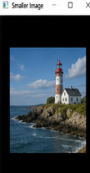
Result
The image was successfully scaled to both larger and smaller sizes using OpenCV. The resizing operation demonstrated how image dimensions can be increased or decreased while preserving the image content.

Experiment 9: Perform Rotation of an Image in Clockwise and Counter-Clockwise Direction
Aim
To rotate an image in both clockwise and counter-clockwise directions using OpenCV. This experiment demonstrates image transformation through rotation.

Procedure
- Install Python and the OpenCV library.
- Import the OpenCV (cv2) library.
- Read the input image using cv2.imread().
- Verify that the image is loaded successfully.
- Rotate the image 90° clockwise using the cv2.rotate() function.
- Rotate the image 90° counter-clockwise using the cv2.rotate() function.
- Display the original, clockwise-rotated, and counter-clockwise-rotated images.
- Wait for a key press.
- Close all image windows using cv2.destroyAllWindows().

Code
import cv2
img = cv2.imread("sample.jpg")
if img is None:
print("Image not found.")
exit()
clockwise = cv2.rotate(img, cv2.ROTATE_90_CLOCKWISE)
counter = cv2.rotate(img, cv2.ROTATE_90_COUNTERCLOCKWISE)
cv2.imshow("Original Image", img)
cv2.imshow("Clockwise Rotation", clockwise)
cv2.imshow("Counter Clockwise Rotation", counter)
cv2.waitKey(0)
cv2.destroyAllWindows()
Output
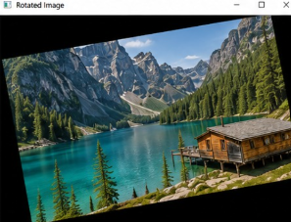
Result
The image was successfully rotated in both clockwise and counter-clockwise directions using OpenCV. The experiment demonstrated image rotation as one of the fundamental geometric transformations.
Experiment 10: Perform Moving (Translation) of an Image from One Place to Another
Aim
To perform image translation using OpenCV by moving an image from its original position to a new position. This experiment demonstrates affine transformation using a translation matrix.
Procedure
- Install Python, OpenCV, and NumPy libraries.
- Import the required libraries.
- Read the input image using cv2.imread().
- Determine the dimensions of the image.
- Create a translation matrix specifying the horizontal and vertical shift.
- Apply the translation using the cv2.warpAffine() function.
- Display both the original and translated images.
- Wait for a key press.
- Close all display windows.
Code
import cv2
import numpy as np
img = cv2.imread("sample.jpg")
if img is None:
print("Image not found.")
exit()
rows, cols = img.shape[:2]
M = np.float32([[1, 0, 100],
[0, 1, 50]])

translated = cv2.warpAffine(img, M, (cols, rows))
cv2.imshow("Original Image", img)
cv2.imshow("Translated Image", translated)
cv2.waitKey(0)
cv2.destroyAllWindows()
Output
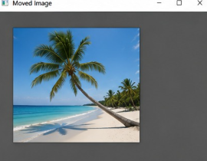
Result
The image was successfully translated from its original position to a new location using OpenCV. The translation operation demonstrated how an image can be shifted horizontally and vertically without changing its size or orientation.

Experiment 11: Perform Affine Transformation on an Image
Aim
To perform an affine transformation on an image using OpenCV. Affine transformation preserves parallel lines while applying translation, rotation, scaling, and shearing to the image.
Procedure
- Install Python and the OpenCV library.
- Import the required library (cv2) and NumPy.
- Read the input image using cv2.imread().
- Check whether the image is loaded successfully.
- Select three points from the original image.
- Select the corresponding three points in the transformed image.
- Compute the affine transformation matrix using cv2.getAffineTransform().
- Apply the transformation using cv2.warpAffine().
- Display both the original and transformed images.
- Wait for a key press and close all windows.
Code
import cv2
import numpy as np
img = cv2.imread("sample.jpg")
rows, cols = img.shape[:2]
pts1 = np.float32([[50,50],[200,50],[50,200]])
pts2 = np.float32([[10,100],[200,50],[100,250]])
matrix = cv2.getAffineTransform(pts1, pts2)
result = cv2.warpAffine(img, matrix, (cols, rows))
cv2.imshow("Original Image", img)
cv2.imshow("Affine Transformation", result)cv2.waitKey(0)
cv2.destroyAllWindows()
Output
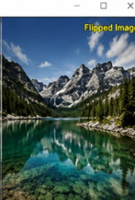
Result
The affine transformation was successfully applied to the input image using OpenCV, producing the transformed image while preserving the parallelism of lines.

Experiment 12: Perform Perspective Transformation on an Image
Aim
To perform perspective transformation on an image using OpenCV by changing the viewing perspective.
Procedure
- Import OpenCV and NumPy.
- Read the input image.
- Select four source points.
- Select four destination points.
- Compute the perspective transformation matrix.
- Apply the transformation using cv2.warpPerspective().
- Display the original and transformed images.
- Close all windows after a key press.
Code
import cv2
import numpy as np
img = cv2.imread("sample.jpg")
rows, cols = img.shape[:2]
pts1 = np.float32([[50,50],[300,50],[50,300],[300,300]])
pts2 = np.float32([[0,0],[300,0],[100,300],[250,250]])
matrix = cv2.getPerspectiveTransform(pts1, pts2)

result = cv2.warpPerspective(img, matrix, (cols, rows))
cv2.imshow("Original Image", img)
cv2.imshow("Perspective Transformation", result)
cv2.waitKey(0)
cv2.destroyAllWindows()
Output
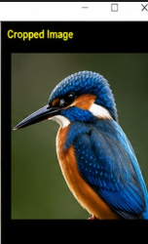
Result
The perspective transformation was successfully performed, changing the viewpoint of the image using OpenCV.

Experiment 13: Perform Perspective Transformation on Video
Aim
To perform perspective transformation on live video captured from the webcam using OpenCV.
Procedure
- Import OpenCV and NumPy.
- Capture video from the webcam.
- Read each video frame.
- Define source and destination points.
- Compute the perspective transformation matrix.
- Apply the transformation to every frame.
- Display both the original and transformed videos.
- Press Q to stop the program.
Code
import cv2
import numpy as np
cap = cv2.VideoCapture(0)
while True:
ret, frame = cap.read()
if not ret:
break
rows, cols = frame.shape[:2]
pts1 = np.float32([[50,50],[300,50],[50,300],[300,300]])
pts2 = np.float32([[0,0],[300,0],[100,300],[250,250]])
matrix = cv2.getPerspectiveTransform(pts1, pts2)
result = cv2.warpPerspective(frame, matrix, (cols, rows))
cv2.imshow("Original Video", frame)
cv2.imshow("Perspective Video", result)
if cv2.waitKey(1) & 0xFF == ord('q'): break
cap.release()
cv2.destroyAllWindows()
Output
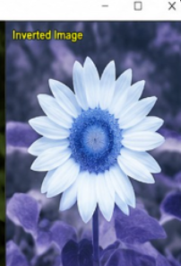
Result
The live webcam video was successfully transformed using perspective transformation and displayed in real time.

Experiment 14: Perform Transformation Using Homography Matrix
Aim
To perform image transformation using a Homography matrix with OpenCV.
Procedure
- Import OpenCV and NumPy.
- Read the input image.
- Define four corresponding source and destination points.
- Compute the Homography matrix using cv2.findHomography().
- Apply the transformation using cv2.warpPerspective().
- Display the original and transformed images.
- Close the windows after a key press.
Code
import cv2
import numpy as np
img = cv2.imread("sample.jpg")
rows, cols = img.shape[:2]
src = np.float32([[50,50],[300,50],[50,300],[300,300]])
dst = np.float32([[0,0],[250,0],[50,300],[300,300]])
H, status = cv2.findHomography(src, dst)
result = cv2.warpPerspective(img, H, (cols, rows))
cv2.imshow("Original Image", img)
cv2.imshow("Homography Transformation", result)
cv2.waitKey(0)
cv2.destroyAllWindows()
Output
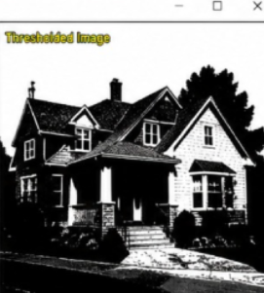
Result
The image was successfully transformed using the Homography matrix, mapping the image from one plane to another accurately.

Experiment 15: Perform Transformation Using Direct Linear Transformation (DLT)
Aim
To perform image transformation using the Direct Linear Transformation (DLT) method by estimating the projective transformation matrix.
Procedure
- Import OpenCV and NumPy.
- Read the input image.
- Select four corresponding points in the source and destination images.
- Compute the transformation matrix using the DLT approach (cv2.findHomography()).
- Apply the transformation using cv2.warpPerspective().
- Display the original and transformed images.
- Close all windows after a key press.
Code
import cv2
import numpy as np
img = cv2.imread("sample.jpg")
rows, cols = img.shape[:2]
src = np.float32([[60,60],[320,60],[60,320],[320,320]])
dst = np.float32([[0,0],[300,20],[50,300],[300,300]])
H, mask = cv2.findHomography(src, dst)
result = cv2.warpPerspective(img, H, (cols, rows))
cv2.imshow("Original Image", img)
cv2.imshow("DLT Transformation", result)
cv2.waitKey(0)
cv2.destroyAllWindows()
Output
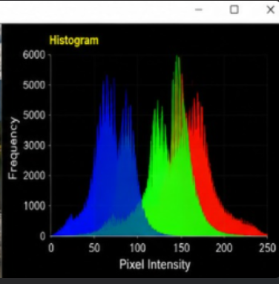
Result
The Direct Linear Transformation (DLT) method was successfully used to estimate the transformation matrix and transform the image. The transformed image demonstrated accurate projective mapping using OpenCV.

EXPERIMENT 16
Aim
To perform edge detection on an image using the Canny Edge Detection method.
Theory
Canny edge detection is a multi-stage algorithm that detects strong and weak edges while minimizing noise. It involves Gaussian filtering, gradient computation, non-maximum suppression, and hysteresis thresholding.
Procedure
- Import the OpenCV library.
- Read the input image.
- Convert the image into grayscale.
- Apply Gaussian Blur to reduce noise.
- Apply the Canny edge detector.
- Display the original and edge-detected images.
Python Code
import cv2
img = cv2.imread("image.jpg")
gray = cv2.cvtColor(img, cv2.COLOR_BGR2GRAY)
blur = cv2.GaussianBlur(gray,(5,5),1)
edges = cv2.Canny(blur,100,200)
cv2.imshow("Original",img)
cv2.imshow("Canny Edge Detection",edges)
cv2.waitKey(0)
cv2.destroyAllWindows()
Output
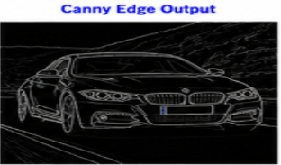
Result
Thus, edge detection using the Canny method was performed successfully.

EXPERIMENT 17
Aim
To perform edge detection using the Sobel Matrix along the X-axis.
Theory
The Sobel X operator detects intensity changes in the horizontal direction and highlights vertical edges in an image.
Procedure
- Read the image.
- Convert it into grayscale.
- Apply Sobel operator along the X-axis.
- Convert the result into absolute values.
- Display the output.
Python Code
import cv2
img=cv2.imread("image.jpg")
gray=cv2.cvtColor(img,cv2.COLOR_BGR2GRAY)
sobelx=cv2.Sobel(gray,cv2.CV_64F,1,0,ksize=3)
sobelx=cv2.convertScaleAbs(sobelx)
cv2.imshow("Original",img)
cv2.imshow("Sobel X",sobelx)
cv2.waitKey(0)
cv2.destroyAllWindows()
Output
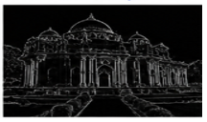
Result
Thus, edge detection using the Sobel matrix along the X-axis was performed successfully.

EXPERIMENT 18
Aim
To perform edge detection using the Sobel Matrix along the Y-axis.
Theory
The Sobel Y operator detects intensity variations in the vertical direction and highlights horizontal edges.
Procedure
- Read the input image.
- Convert it into grayscale.
- Apply Sobel operator along the Y-axis.
- Convert to absolute values.
- Display the output.
Python Code
import cv2
img=cv2.imread("image.jpg")
gray=cv2.cvtColor(img,cv2.COLOR_BGR2GRAY)
sobely=cv2.Sobel(gray,cv2.CV_64F,0,1,ksize=3)
sobely=cv2.convertScaleAbs(sobely)
cv2.imshow("Original",img)
cv2.imshow("Sobel Y",sobely)
cv2.waitKey(0)
cv2.destroyAllWindows()
Output
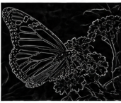
Result
Thus, edge detection using the Sobel matrix along the Y-axis was performed successfully.

EXPERIMENT 19
Aim
To perform edge detection using the Sobel Matrix along both X and Y axes.
Theory
The Sobel XY operator combines both horizontal and vertical gradients to detect edges in all directions.
Procedure
- Read the image.
- Convert it into grayscale.
- Apply Sobel X and Sobel Y operators.
- Combine both images.
- Display the result.
Python Code
import cv2
img=cv2.imread("image.jpg")
gray=cv2.cvtColor(img,cv2.COLOR_BGR2GRAY)
sobelx=cv2.Sobel(gray,cv2.CV_64F,1,0,3)
sobely=cv2.Sobel(gray,cv2.CV_64F,0,1,3)
sobelx=cv2.convertScaleAbs(sobelx)
sobely=cv2.convertScaleAbs(sobely)
sobelxy=cv2.addWeighted(sobelx,0.5,sobely,0.5,0)
cv2.imshow("Original",img)
cv2.imshow("Sobel XY",sobelxy)
cv2.waitKey(0)
cv2.destroyAllWindows()
Output
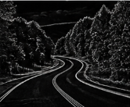

Result
Thus, edge detection using the Sobel matrix along both X and Y axes was performed successfully.

EXPERIMENT 20
Aim
To perform image sharpening using the Laplacian mask with a negative center coefficient.
Theory
The Laplacian operator is a second-order derivative filter that enhances edges. Using a negative center coefficient sharpens the image by subtracting the Laplacian response from the original image.
Procedure
- Read the input image.
- Convert it into grayscale.
- Apply the Laplacian operator.
- Subtract the Laplacian image from the original image.
- Display the sharpened image.
Python Code
import cv2
img=cv2.imread("image.jpg")
gray=cv2.cvtColor(img,cv2.COLOR_BGR2GRAY)
lap=cv2.Laplacian(gray,cv2.CV_64F)
lap=cv2.convertScaleAbs(lap)
sharp=cv2.subtract(gray,lap)
cv2.imshow("Original",gray)
cv2.imshow("Sharpened Image",sharp)
cv2.waitKey(0)
cv2.destroyAllWindows()
Output
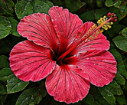
Result
Thus, image sharpening using the Laplacian mask with a negative center coefficient was performed successfully.

EXPERIMENT 21
Aim
To perform image sharpening using the Laplacian mask implemented with an extension of diagonal neighbors.
Theory
The extended Laplacian mask considers both direct and diagonal neighbors, making edge enhancement more effective. It highlights fine image details and improves overall sharpness.
Procedure
- Import the required libraries.
- Read the input image.
- Convert the image into grayscale.
- Define the 8-neighbor Laplacian mask.
- Apply the filter using filter2D().
- Display the sharpened image.
Python Code
import cv2
import numpy as np
img = cv2.imread("image.jpg")
gray = cv2.cvtColor(img, cv2.COLOR_BGR2GRAY)
kernel = np.array([[1,1,1],
[1,-8,1],
[1,1,1]])
lap = cv2.filter2D(gray,-1,kernel)
sharp = cv2.subtract(gray,lap)
cv2.imshow("Original",gray)
cv2.imshow("Laplacian Diagonal",sharp)
cv2.waitKey(0)
cv2.destroyAllWindows()

Output
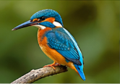
Result
Thus, image sharpening using the Laplacian mask with diagonal neighbors was performed successfully.

EXPERIMENT 22
Aim
To perform image sharpening using the Laplacian mask with a positive center coefficient.
Theory
In this method, the Laplacian kernel has a positive center coefficient. The filtered image is added to the original image to enhance edges.
Procedure
- Read the input image.
- Convert it into grayscale.
- Define the Laplacian mask with a positive center.
- Apply the filter.
- Add the filtered image to the original.
- Display the sharpened image.
Python Code
import cv2
import numpy as np
img = cv2.imread("image.jpg")
gray = cv2.cvtColor(img, cv2.COLOR_BGR2GRAY)
kernel = np.array([[0,-1,0],
[-1,4,-1],
[0,-1,0]])
lap = cv2.filter2D(gray,-1,kernel)
sharp = cv2.add(gray,lap)
cv2.imshow("Original",gray)
cv2.imshow("Positive Laplacian",sharp)
cv2.waitKey(0)
cv2.destroyAllWindows()
Output
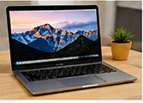
Result
Thus, image sharpening using the Laplacian mask with a positive center coefficient was performed successfully.

EXPERIMENT 23
Aim
To perform image sharpening using the Unsharp Masking technique.
Theory
Unsharp masking sharpens an image by subtracting a blurred version from the original image. This increases edge contrast while preserving image details.
Procedure
- Read the image.
- Convert it into grayscale.
- Apply Gaussian Blur.
- Subtract the blurred image from the original.
- Add the difference back to the original image.
- Display the sharpened image.
Python Code
import cv2
img = cv2.imread("image.jpg")
gray = cv2.cvtColor(img,cv2.COLOR_BGR2GRAY)
blur = cv2.GaussianBlur(gray,(9,9),10)
sharp = cv2.addWeighted(gray,1.5,blur,-0.5,0)
cv2.imshow("Original",gray)
cv2.imshow("Unsharp Masking",sharp)

cv2.waitKey(0)
cv2.destroyAllWindows()
Output
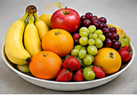
Result
Thus, image sharpening using the Unsharp Masking technique was performed successfully.

EXPERIMENT 24
Aim
To perform image sharpening using the High-Boost Mask technique.
Theory
High-Boost filtering is an extension of unsharp masking. It amplifies high-frequency components while retaining the original image, resulting in stronger sharpening.
Procedure
- Read the image.
- Convert it into grayscale.
- Apply Gaussian Blur.
- Generate the high-boost image using weighted addition.
- Display the output.
Python Code
import cv2
img = cv2.imread("image.jpg")
gray = cv2.cvtColor(img,cv2.COLOR_BGR2GRAY)
blur = cv2.GaussianBlur(gray,(9,9),10)
A = 2.0
highboost = cv2.addWeighted(gray,A,blur,-(A-1),0)
cv2.imshow("Original",gray)
cv2.imshow("High Boost",highboost)
cv2.waitKey(0)
cv2.destroyAllWindows()
Output
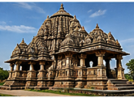
Result
Thus, image sharpening using the High-Boost Mask technique was performed successfully.

EXPERIMENT 25
Aim
To perform image sharpening using the Gradient Masking technique.
Theory
Gradient masking enhances image edges by calculating the image gradient using Sobel operators. The gradient magnitude emphasizes regions with rapid intensity changes.
Procedure
- Read the image.
- Convert it into grayscale.
- Apply Sobel operators in X and Y directions.
- Calculate the gradient magnitude.
- Display the sharpened image.
Python Code
import cv2
img = cv2.imread("image.jpg")
gray = cv2.cvtColor(img,cv2.COLOR_BGR2GRAY)
gx = cv2.Sobel(gray,cv2.CV_64F,1,0,3)
gy = cv2.Sobel(gray,cv2.CV_64F,0,1,3)
gradient = cv2.magnitude(gx,gy)
gradient = cv2.convertScaleAbs(gradient)
cv2.imshow("Original",gray)
cv2.imshow("Gradient Masking",gradient)
cv2.waitKey(0)
cv2.destroyAllWindows()
Output
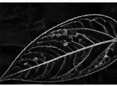
Result
Thus, image sharpening using the Gradient Masking technique was performed successfully.
EXPERIMENT 26 — Watermarking an Image using OpenCV
Aim
To insert a watermark text into an image using OpenCV.
Procedure
- Import the OpenCV library.
- Read the input image.
- Define the watermark text.
- Use cv2.putText() to place the watermark on the image.
- Display and save the watermarked image.
- Close all OpenCV windows.

Code & Output
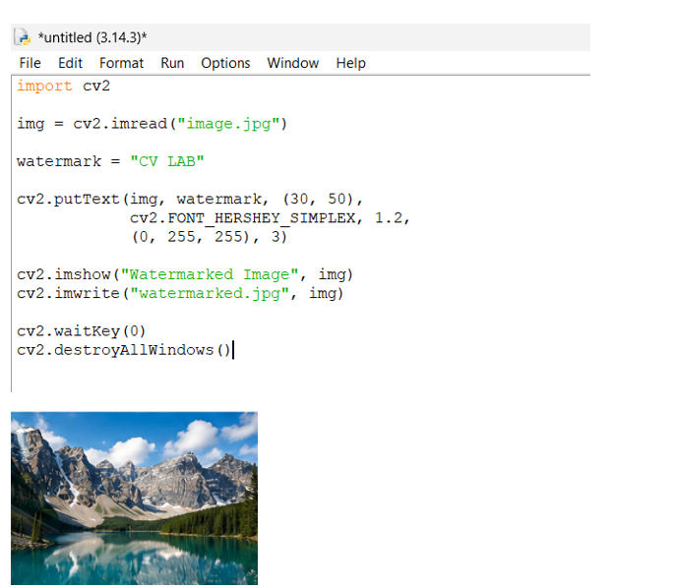
Result
Thus, the watermark was successfully inserted into the image using OpenCV.

EXPERIMENT 27 — Cropping, Copying and Pasting Image
Aim
To crop a portion of an image and copy and paste it into another image using OpenCV.
Procedure
- Import OpenCV.
- Read the source and destination images.
- Select a region from the source image.
- Crop the selected region.
- Resize the cropped region if required.
- Paste the cropped region into the destination image.
- Display and save the resulting image.
Code & Output
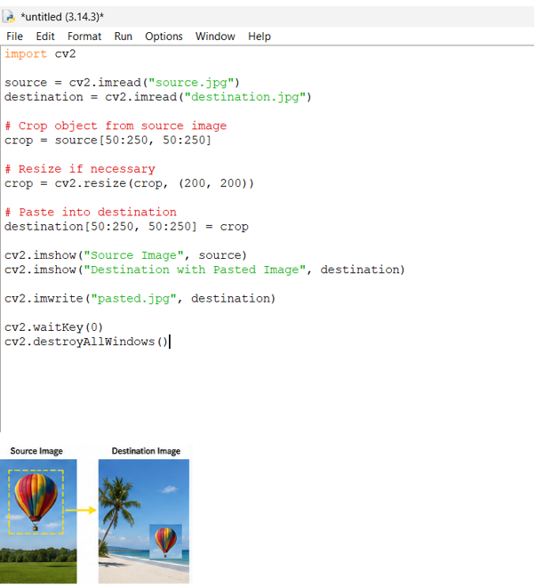

Result
Thus, cropping, copying, and pasting operations were successfully performed.
EXPERIMENT 28 — Boundary Detection using Convolution Kernel
Aim
To find the boundary of an image using a convolution kernel.
Procedure
- Import OpenCV and NumPy.
- Read the input image.
- Convert the image into grayscale.
- Define a boundary detection convolution kernel.
- Apply the kernel using filter2D().
- Display and save the boundary image.
Code & Output
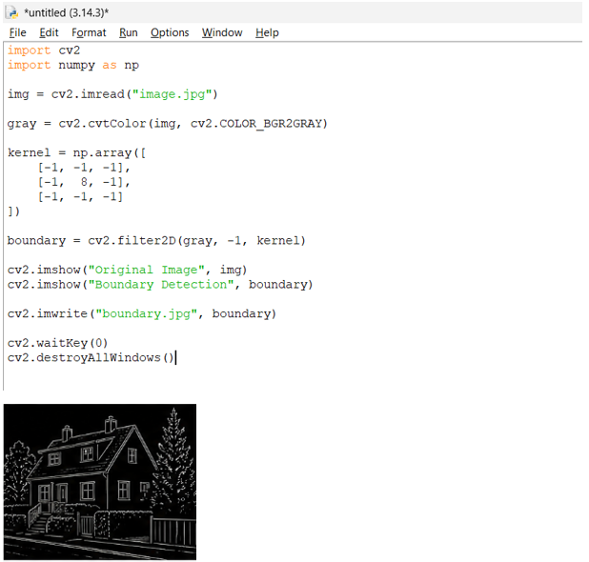
Result
Thus, the boundary of the given image was successfully detected using a convolution kernel.

EXPERIMENT 29 — Morphological Erosion
Aim
To perform morphological erosion on an image using OpenCV.
Procedure
- Import OpenCV and NumPy.
- Read the image in grayscale.
- Create a morphological kernel.
- Apply the erosion operation using cv2.erode().
- Display the original and eroded images.
- Save the output image.
Code & Output
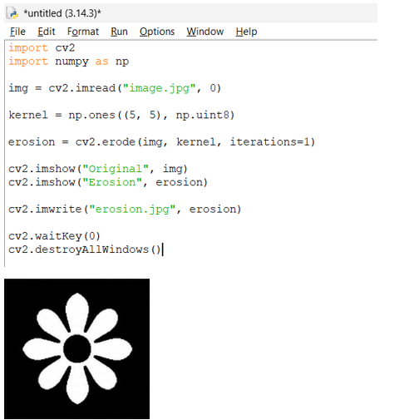
Result
Thus, morphological erosion was successfully performed.
EXPERIMENT 30 — Morphological Dilation
Aim
To perform morphological dilation on an image using OpenCV.
Procedure
- Import OpenCV and NumPy.
- Read the input image.
- Create a structuring element.
- Apply dilation using cv2.dilate().
- Display the original and dilated images.
- Save the output.
Code & Output

Result
Thus, morphological dilation was successfully performed.
EXPERIMENT 31 — Morphological Opening
Aim
To perform morphological opening on an image using OpenCV.
Procedure
- Read the input image.
- Create a structuring element.
- Apply erosion followed by dilation using the opening operation.
- Display the original and opening images.
- Save the output image.
Code & Output
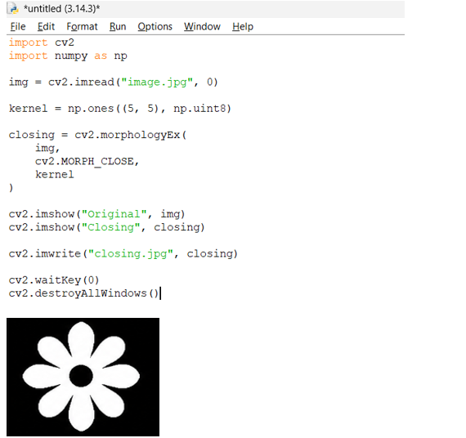

Result
Thus, morphological opening was successfully performed.
EXPERIMENT 32 — Morphological Closing
Aim
To perform morphological closing on an image using OpenCV.
Procedure
- Read the input image.
- Create a structuring element.
- Apply dilation followed by erosion using the closing operation.
- Display the images.
- Save the resulting image.
Code & Output
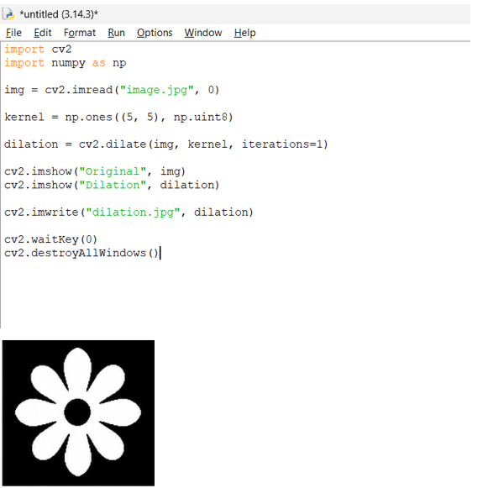
Result
Thus, morphological closing was successfully performed.
EXPERIMENT 33 — Morphological Gradient
Aim
To perform morphological gradient operation on an image using OpenCV.
Procedure
- Read the input image.
- Create a structuring element.
- Apply the morphological gradient operation.
- The gradient is obtained from dilation minus erosion.
- Display and save the output image.
Code & Output
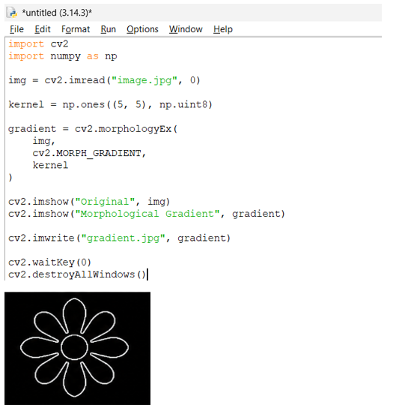
Result
Thus, the morphological gradient of the image was successfully obtained.
EXPERIMENT 34 — Morphological Top Hat
Aim
To perform the morphological Top Hat operation using OpenCV.
Procedure
- Read the input image in grayscale.
- Create a structuring element.
- Apply the Top Hat morphological operation.
- Display the original and Top Hat images.
- Save the output.
Code & Output
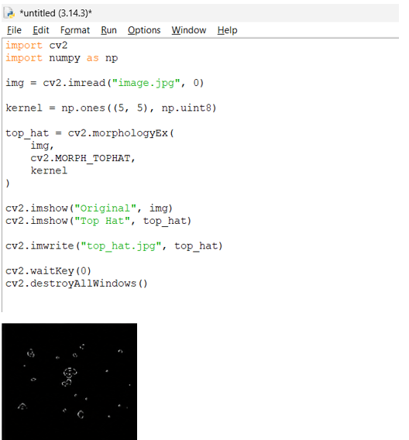
Result
Thus, the morphological Top Hat operation was successfully performed.
EXPERIMENT 35 — Morphological Black Hat
Aim
To perform the morphological Black Hat operation using OpenCV.
Procedure
- Read the input image.
- Create a structuring element.
- Apply the Black Hat operation.
- Display the original and processed images.
- Save the output image.
Code & Output
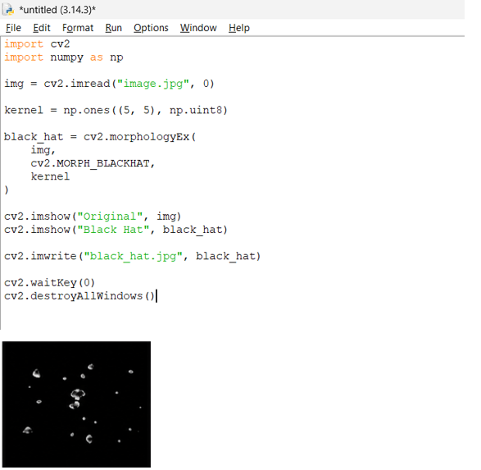

Result
Thus, the morphological Black Hat operation was successfully performed.
EXPERIMENT 36 — Watch Recognition using OpenCV
Aim
To recognize a watch from a given image using object recognition with OpenCV.
Procedure
- Read the input image and watch template.
- Convert both images into grayscale.
- Apply template matching.
- Find the best matching location.
- Draw a rectangle around the recognized watch.
- Display and save the result.
Code & Output
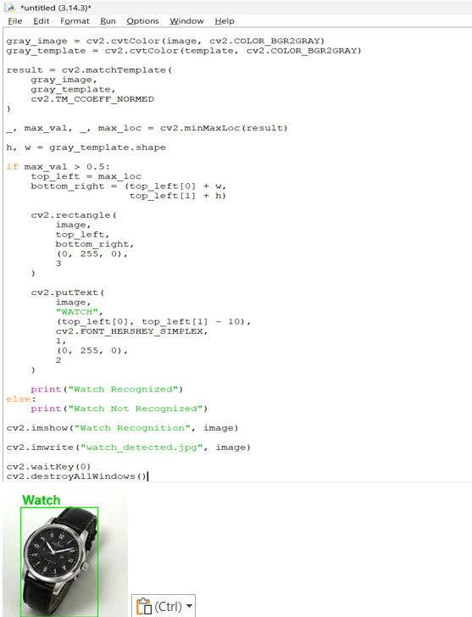
Result
Thus, the watch was successfully recognized from the given image using OpenCV.
EXPERIMENT 37 — Play Video in Reverse Mode
Aim
To play a video in reverse mode using OpenCV.
Procedure
- Open the video file using VideoCapture().
- Read all video frames.
- Store the frames in a list.
- Release the video.
- Display the stored frames from last to first.
- Close the video window.
Code & Output
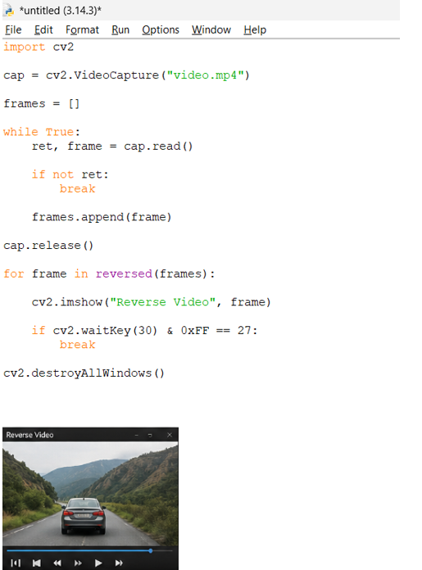
Result
Thus, the video was successfully played in reverse mode using OpenCV.

EXPERIMENT 38 — Face Detection using OpenCV
Aim
To detect human faces in an image using OpenCV.
Procedure
- Load the Haar Cascade face classifier.
- Read the input image.
- Convert the image to grayscale.
- Detect faces using detectMultiScale().
- Draw rectangles around the detected faces.
- Display and save the output.
Code & Output
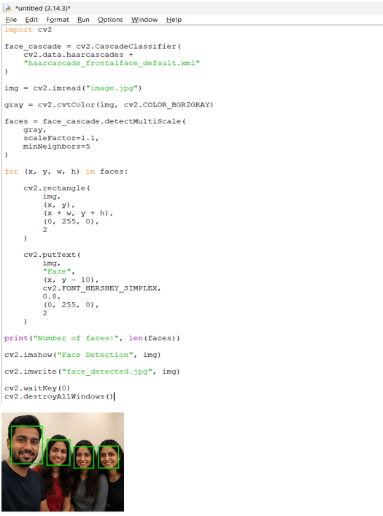

Result
Thus, human faces were successfully detected using OpenCV.

EXPERIMENT 39 — Vehicle Detection in Video Frame
Aim
To detect moving vehicles in a video frame using OpenCV.
Procedure
- Open the vehicle video.
- Create a background subtractor.
- Read each video frame.
- Separate moving objects from the background.
- Find contours of moving regions.
- Draw rectangles around sufficiently large regions.
- Display the detected vehicles.
Code & Output
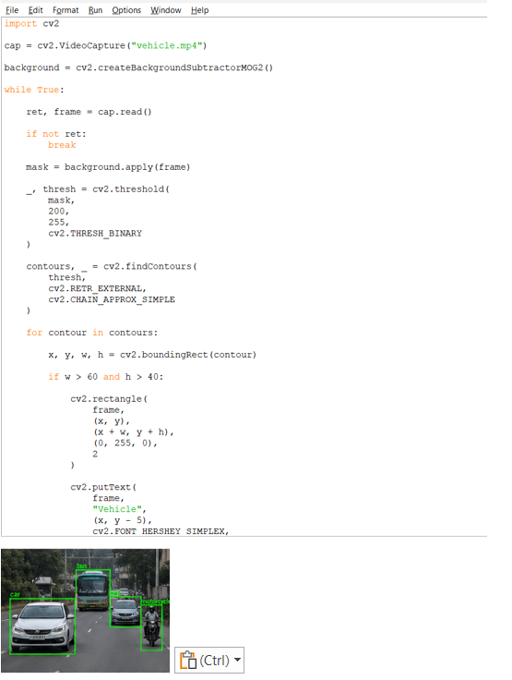
Result
Thus, moving vehicles were successfully detected in the video frame using OpenCV.

EXPERIMENT 40 — Draw Rectangle and Extract Objects
Aim
To draw a rectangular region around an object and extract the selected object using OpenCV.
Procedure
- Read the input image.
- Display the image for object selection.
- Select the required object using the mouse.
- Draw a rectangle around the selected object.
- Extract the selected region using image slicing.
- Display and save both images.

Code & Output
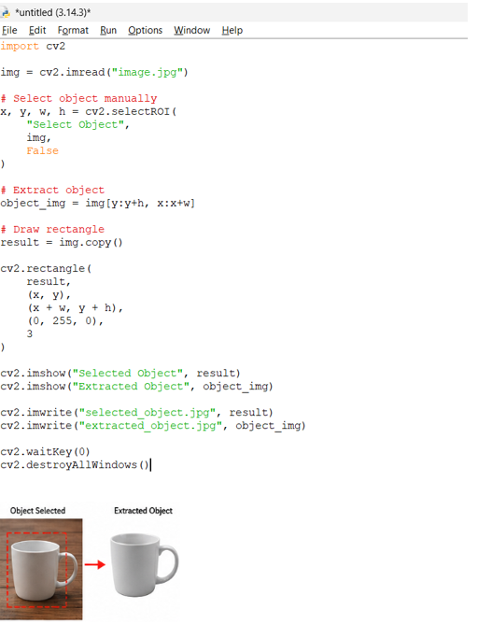

Result
Thus, the object was successfully selected and extracted using a rectangular region in OpenCV.

