🍽️ NutriScan
AI-Powered Food Image Analyzer
Instant Nutritional Analysis from Food Photos

Developer: Kuruva Jayanth
Live App: https://foodimage-analyzer.lovable.app/
GitHub: https://github.com/kuruvaJayanth/foodimage-analyzer
Version: 1.0.0 | May 2025

1. Project Overview

NutriScan is a modern, AI-powered web application that enables users to analyze the nutritional content of food simply by uploading a photograph. Leveraging advanced image recognition and a comprehensive nutritional database, the application identifies food items from images and delivers instant, detailed health assessments alongside complete macronutrient and micronutrient breakdowns.

The core mission of NutriScan is to make healthy eating simple, accessible, and data-driven — no manual food logging, no calorie counting apps, no guesswork. Just snap a photo and get answers.

1.1 What Makes NutriScan Unique?
- Automatic food recognition from images using AI (no manual selection needed)
- Instant health classification — labels food as Healthy or Unhealthy at a glance
- Full nutritional breakdown covering macros and key micronutrients per 100g serving
- Clean, minimal interface built for quick, effortless use
- Supports Indian cuisine and local foods (e.g., Pani Puri, Puri, regional dishes)

2. Application Screenshots

2.1 Upload Screen
When the application loads, users are greeted with a clean, minimal upload screen. The drag-and-drop zone accepts JPG, PNG, and WEBP formats up to 5 MB. Users can either drag files directly onto the zone or click to open the native file browser.

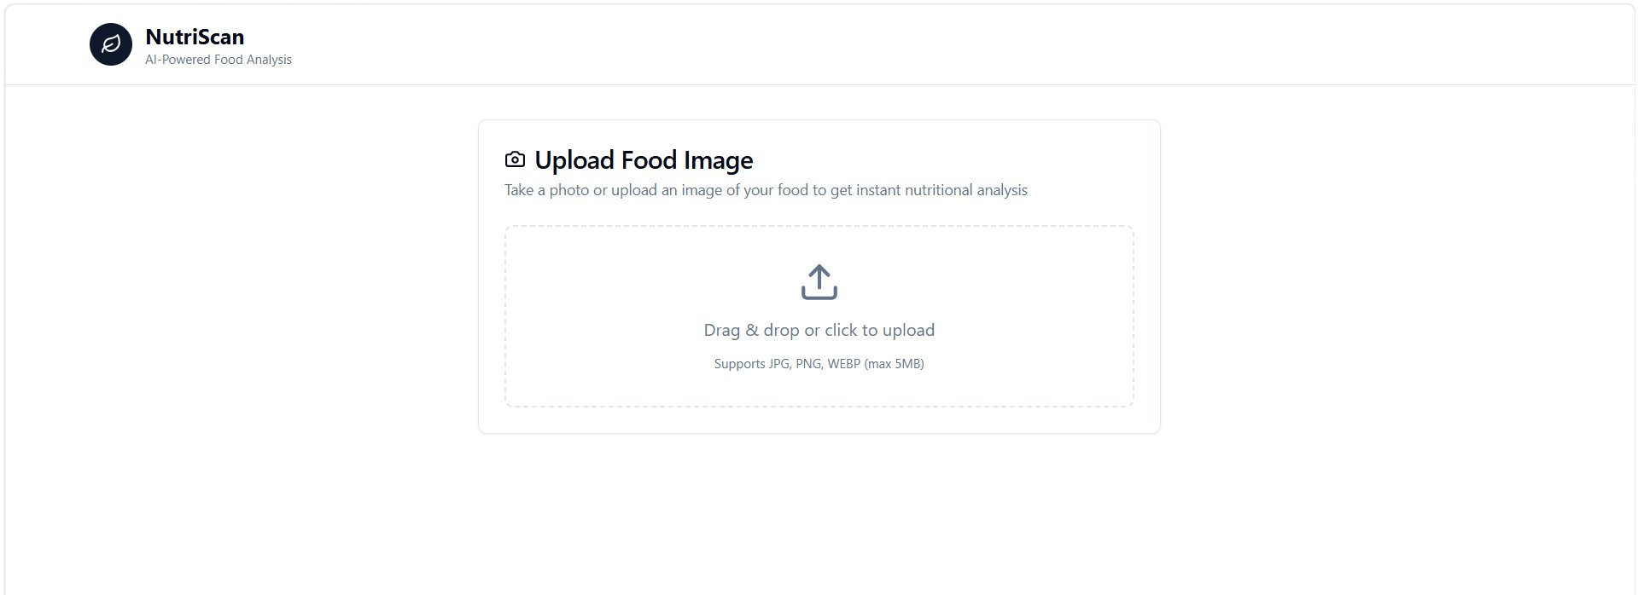
Figure 1 – Upload Food Image screen (empty state)

2.2 Food Analysis Result
After uploading an image and clicking 'Analyze Food', the application processes the image and returns a result card. The food name, category, and a colour-coded health status badge are displayed prominently. In the example below, Pani Puri is identified and marked as Unhealthy due to its high fat and calorie content.

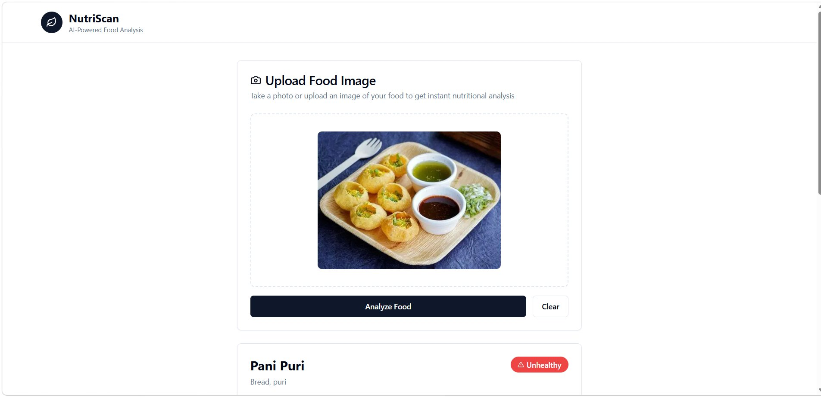
Figure 2 – Analysis result showing Pani Puri identified as Unhealthy

2.3 Nutritional Breakdown
Scrolling below the health classification, a comprehensive Nutritional Breakdown section presents all major nutrients with visual progress bars and precise values per 100g serving. This includes macronutrients (protein, fat, carbohydrates, energy) as well as micronutrients (fibre, calcium, iron, sodium, and Vitamin C).

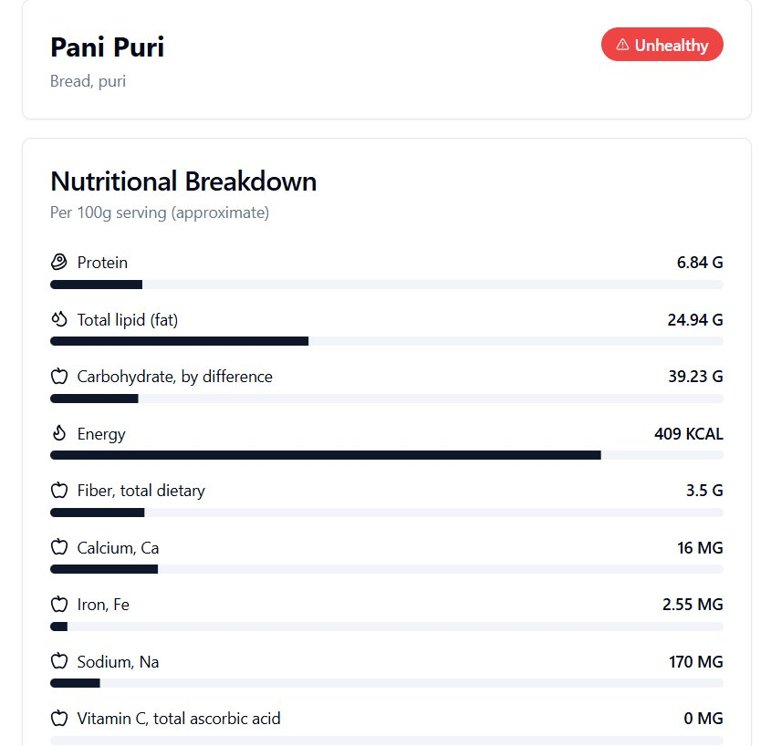
Figure 3 – Detailed Nutritional Breakdown panel for Pani Puri

3. Features

3.1 Core Features
Feature | Description
Image Upload | Drag & drop or click-to-browse upload; supports JPG, PNG, WEBP up to 5 MB
Food Identification | AI model recognises the food item and its category (e.g., Bread, Puri) from the uploaded photo
Health Classification | Instantly labels the food as Healthy or Unhealthy based on nutritional thresholds with a colour-coded badge
Nutritional Breakdown | Provides per-100g values for protein, total fat, carbohydrates, energy (kcal), dietary fibre, calcium, iron, sodium, and Vitamin C
Progress Bars | Visual nutrient bars allow quick comparison of nutrient density at a glance
Clear Function | One-click reset to remove the uploaded image and start a fresh analysis
Responsive UI | Works on desktop and mobile browsers without any app installation

3.2 Nutritional Metrics Reported
The following nutritional fields are displayed for every analysed food item:

Nutrient | Unit & Significance
Protein | Grams (G) — essential for muscle repair and growth
Total Lipid (Fat) | Grams (G) — includes saturated and unsaturated fats
Carbohydrate, by difference | Grams (G) — total carbs including sugars and starch
Energy | Kilocalories (KCAL) — total caloric value per 100g
Fiber, total dietary | Grams (G) — important for digestive health
Calcium, Ca | Milligrams (MG) — bone and dental health
Iron, Fe | Milligrams (MG) — oxygen transport in blood
Sodium, Na | Milligrams (MG) — electrolyte balance
Vitamin C | Milligrams (MG) — immune system and antioxidant function

4. Sample Analysis — Pani Puri

The following table shows a real analysis result produced by NutriScan for an uploaded photo of Pani Puri (a popular Indian street food consisting of hollow, fried dough balls filled with spiced water and chutneys).

Attribute | Value
Food Name | Pani Puri
Category | Bread, Puri
Health Classification | ⚠ Unhealthy
Protein | 6.84 G
Total Fat | 24.94 G
Carbohydrates | 39.23 G
Energy | 409 KCAL
Dietary Fibre | 3.5 G
Calcium | 16 MG
Iron | 2.55 MG
Sodium | 170 MG
Vitamin C | 0 MG

The high energy value (409 kcal/100g) combined with significant fat content (24.94 g) and sodium (170 mg) per 100g serving contributed to the Unhealthy classification. Users can use this data to make more informed dietary decisions.
5. Technology Stack

NutriScan is a full-stack web application. The table below summarises the key technologies used across the frontend, backend, AI layer, and deployment infrastructure.

Technology | Role / Description
Frontend Framework | React.js — component-based UI for a fast, interactive experience
Styling | Tailwind CSS — utility-first CSS framework for clean, responsive design
AI / Vision Model | Claude AI (Anthropic) or equivalent vision model for food recognition from images
Nutritional Database | USDA FoodData Central / custom nutritional API for nutrient lookups
Hosting / Deployment | Lovable.app — modern full-stack deployment platform
Version Control | Git & GitHub (https://github.com/kuruvaJayanth/foodimage-analyzer)
Language | JavaScript / TypeScript
Build Tool | Vite — fast development server and production bundler

6. How It Works

The NutriScan application follows a straightforward four-step pipeline from image upload to nutritional report:

- User uploads a food image via the drag-and-drop interface or file picker.
- The image is sent to the AI vision model, which identifies the food item and its category.
- The identified food name is passed to the nutritional database API, which returns per-100g values for all tracked nutrients.
- The frontend renders the food name, health classification badge, and a complete nutritional breakdown with visual progress bars.

The health classification (Healthy / Unhealthy) is determined by evaluating key nutritional thresholds — primarily caloric density, fat content, and sodium levels — against established dietary guidelines.

7. Getting Started

7.1 Prerequisites
- Node.js v18 or higher
- npm v9 or higher
- Git installed on your machine
- An API key for the AI vision model (if running locally)

7.2 Installation & Local Setup
Follow the steps below to clone and run the project on your local machine:

- Clone the repository:
git clone https://github.com/kuruvaJayanth/foodimage-analyzer.git
- Navigate to the project directory:
cd foodimage-analyzer
- Install dependencies:
npm install
- Create a .env file at the root and add your API credentials:
VITE_AI_API_KEY=your_api_key_here
- Start the development server:
npm run dev
- Open your browser and navigate to http://localhost:5173

7.3 Usage
- Open the application in your browser (locally or at the live URL).
- Click on the upload zone or drag and drop a food image (JPG, PNG, or WEBP).
- Click the 'Analyze Food' button.
- View the food name, health classification, and full nutritional breakdown.
- Click 'Clear' to reset and analyse another food.

8. Project Structure

Below is the high-level directory structure of the repository:

Path | Description
foodimage-analyzer/ | Root project directory
├── public/ | Static assets (favicon, icons)
├── src/ | Main application source code
│ ├── components/ | Reusable React UI components
│ ├── pages/ | Page-level components (Home, Analysis)
│ ├── hooks/ | Custom React hooks
│ ├── utils/ | Utility functions (API calls, nutrition logic)
│ ├── App.tsx | Root application component
│ └── main.tsx | Application entry point
├── .env.example | Environment variable template
├── package.json | Project dependencies and scripts
├── tailwind.config.ts | Tailwind CSS configuration
├── tsconfig.json | TypeScript configuration
└── vite.config.ts | Vite build configuration

9. Future Enhancements

The following enhancements are planned for upcoming versions of NutriScan:

- Meal History Log — allow users to save and review past food analyses
- Daily Calorie Tracker — aggregate nutritional data across multiple meals in a day
- User Profiles — personalised dietary goals based on age, weight, and health conditions
- Multi-food Detection — identify and analyse multiple food items in a single plate photo
- Recipe Suggestions — recommend healthier alternatives when an unhealthy food is detected
- Mobile App — native iOS and Android apps for on-the-go scanning
- Dietary Labels — additional tags such as Vegan, Gluten-Free, Diabetic-Friendly, etc.
- Export to PDF — download nutritional reports as formatted PDF documents

10. Contributing

Contributions are welcome! To contribute to this project, please follow these guidelines:

- Fork the repository on GitHub.
- Create a new branch for your feature or bug fix: git checkout -b feature/your-feature-name
- Make your changes and commit them with a clear, descriptive message.
- Push your branch to your forked repository: git push origin feature/your-feature-name
- Open a Pull Request on the original repository and describe your changes.

Please ensure all new code follows the existing style conventions and passes any linting checks before submitting a pull request.

11. License

This project is licensed under the MIT License. You are free to use, copy, modify, merge, publish, distribute, sublicense, and/or sell copies of this software, subject to the conditions of the MIT License.

See the LICENSE file in the repository root for full license text.

12. Contact & Links

Item | Details
Developer | Kuruva Jayanth
Live Application | https://foodimage-analyzer.lovable.app/
GitHub Repository | https://github.com/kuruvaJayanth/foodimage-analyzer
Platform | Lovable.app

For questions, bug reports, or feature requests, please open an issue on the GitHub repository.

