Lab 6

- Write the JavaFX code necessary to produce the following screen:

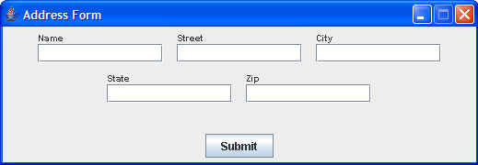

Add an appropriate EventHandler so that, when a user clicks the Submit button…
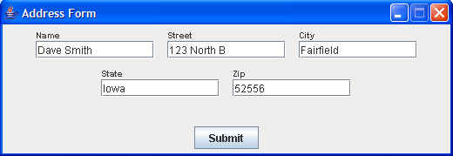

the data that has been entered into the GUI fields is output to the console in the following format:

Dave Smith
123 North B
Fairfield, Iowa 52556

2. Write the JavaFX code necessary to create the following screen:

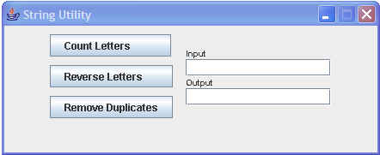

Create the necessary EventHandler so that, when Count Letters is clicked, the number of characters in the Input field is placed in the Output field,

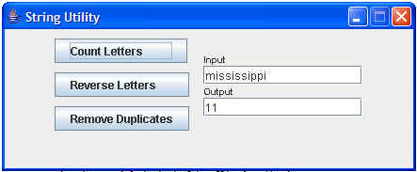

and, when Reverse Letters is clicked, the letters in the input area are reversed and placed in the output area,

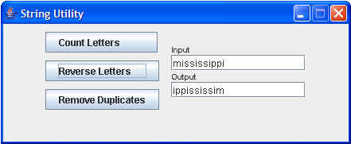

and, when the Remove Duplicates is clicked, the duplicate letters are removed and the result is placed in the output area.

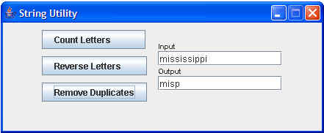
- DOM Parsing. In the package lesson6.labs.prob3, you have been given an XML file customer.xml together with the DOM processing code described in the lecture. You have also been given a Customer class having fields name, street, city, zip.
In this problem, extract from the XML file all customers whose city begins with the string “Ma”. Insert the data for each customer found into a new Customer object, and collect all these customers into a List.
The Main class in your package provides a skeleton of what needs to be done.

Hint: Create a modification of the method lookupEntry(String tagname, String value) in DomServiceClass so that the argument value is just the first part of the value you are looking for. Make a corresponding modification to the method lookupUsingNodeList(NodeList list, String value).
- Extra Credit – 5 Points. Rewrite the Login (with CSS) JavaFX application, demonstrated in class (lesson6.lecture.javafx.logincss) using FXML.

