**Usability Assessment of Deliveroo (**[**https://deliveroo.fr/en/**](https://deliveroo.fr/en/)**)**

I took the 10 usability heuristics from Chromes “UX Check” Add-on with some short explanation and added snapshots from Deliveroo pages and comments according to the heuristics.

**Visibility of system status**

The system should keep users informed through appropriate feedback within reasonable time

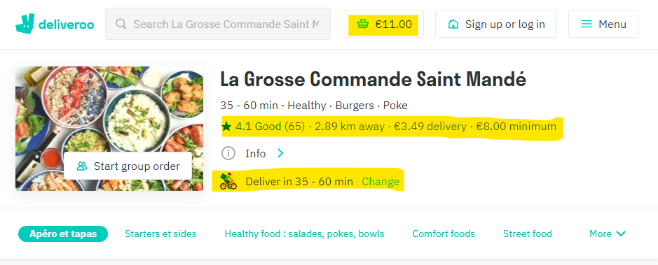

It is visible how much I ordered and how much is in the basket. There are additional information on quality and distance and costs for delivery. The delivery time is estimated before I finished my order. That is good.

**Match between system and the real world**

The system should speak the users' language rather than system-oriented terms. Follow real-world conventions

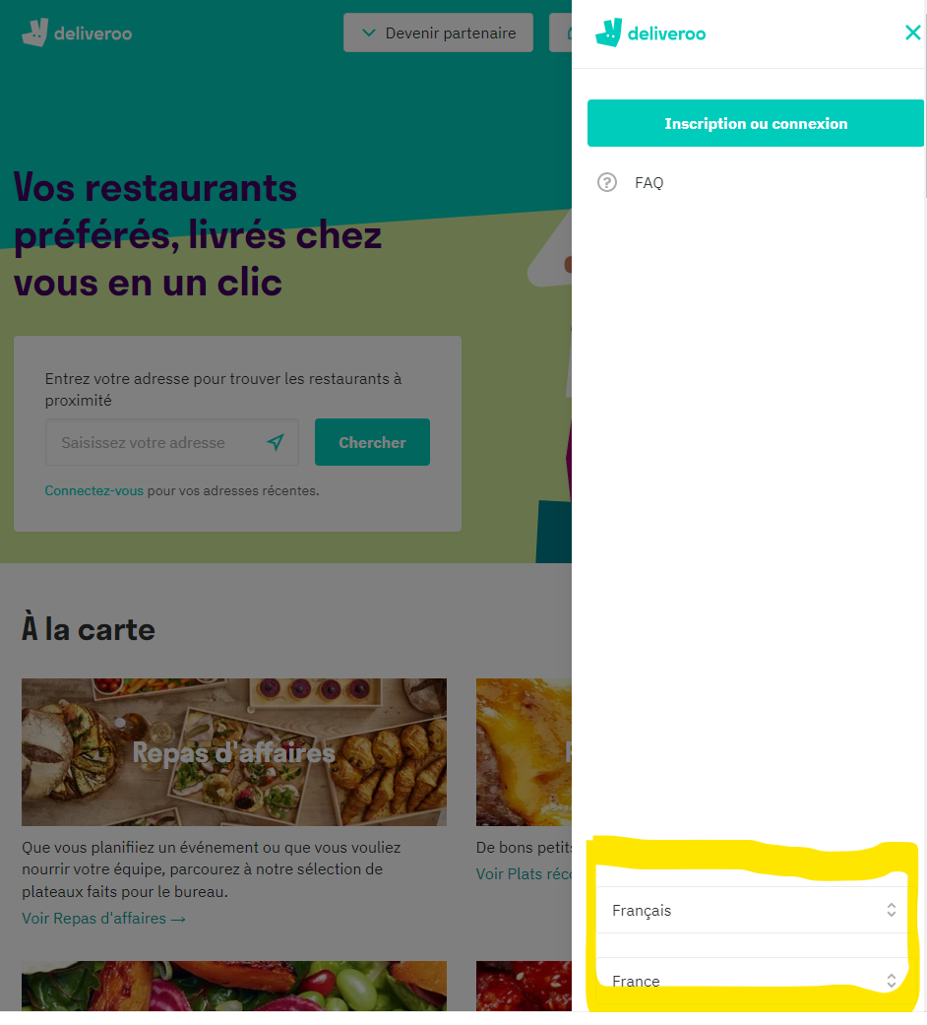

It is not easy to change the language for the pages. You have to go to “Menu” and at the bottom there you can change the language and the country.

Recommendation: Button on the head of the start page to change language easily.

**User control and freedom**

Users often make mistakes and need 'emergency exits' to leave the unwanted state. Support undo and redo

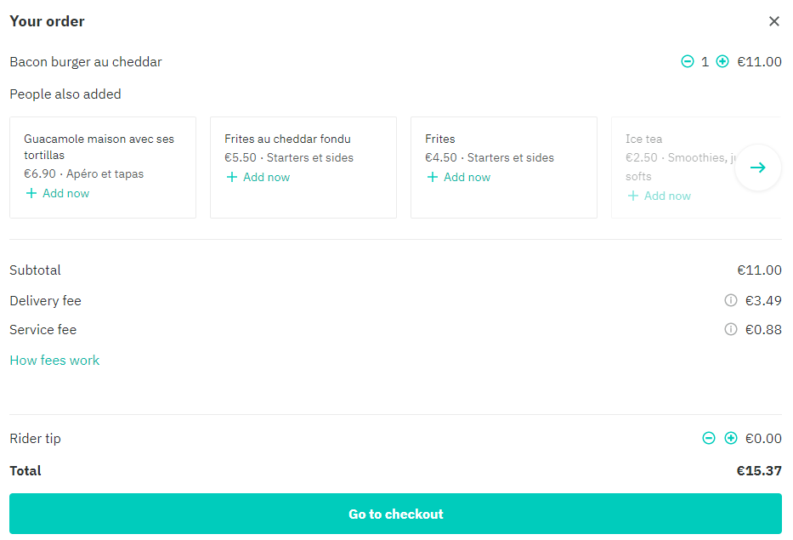

You can change the order and add or delete items. Or you can just close the browser and your order is forgotten. So, there is always this emergency exit.

**Consistency and standards**

Users shouldn't have to wonder whether different words, situations, or actions mean the same thing. Follow platform conventions

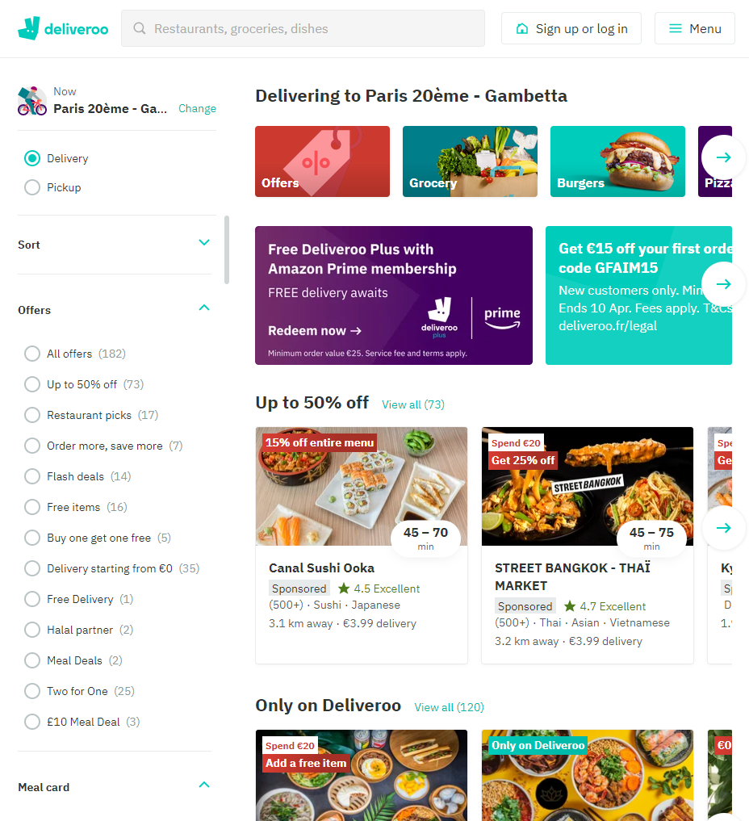

Fresh and modern layout as it is used by many websites today. Layout and content is consistent over all pages.

**Error prevention**

Prevent problems from occuring in the first place, or check for them and present users with a confirmation option before they commit to the action

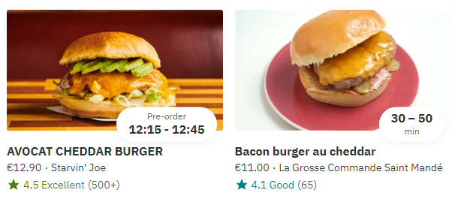

Good that expected delivery time is shown before I select a dish for order.

**Recognition rather than recall**

Minimize memory load by making objects, actions, and options visible. Instructions should be visible or easily retrievable

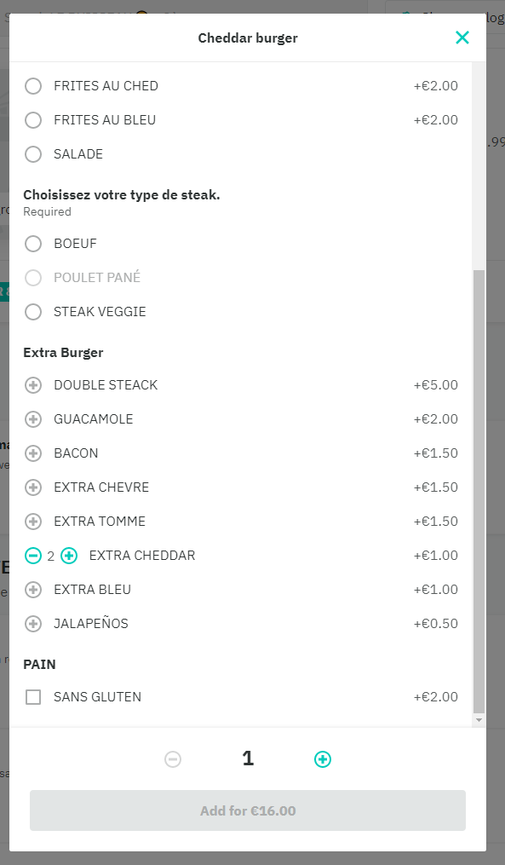

Clear overview of options for a dish. Price is transparent. Easy to select and order.

**Flexibility and efficiency of use**

Accelerators - unseen by the novice user - may often speed up the interaction for the expert user. Allow users to tailor frequent actions

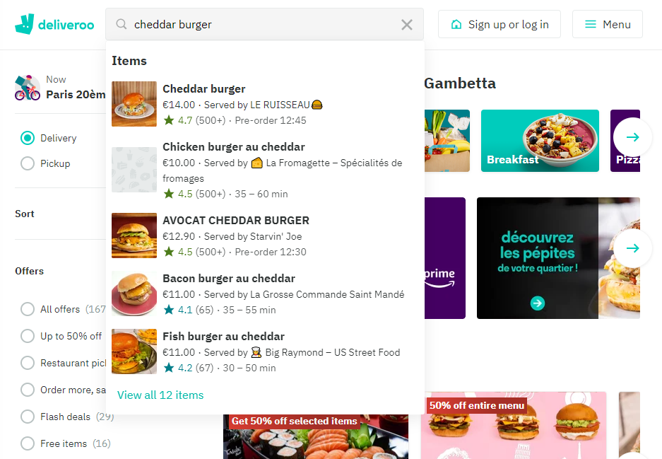

Good search function where you can search for restaurants, groceries and dishes. This is the most prominent function if you prepare a order.

Recommendation: Maybe the search should stay on top of the selection page, even if you scroll down in the list.

**Aesthetic and minimalist design**

Dialogues should not contain information which is irrelevant or rarely needed

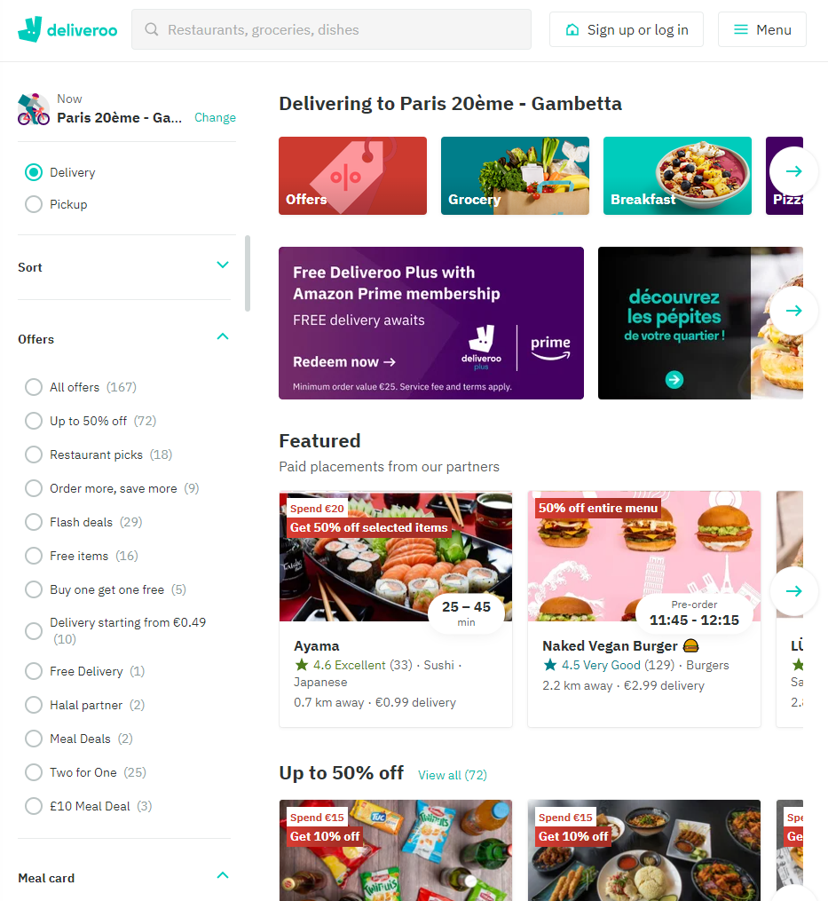

Selction page is well structured. Categories on the left and a list of offers on the right with some promotions on the top.

**Help recognize & recover from errors**

Error messages should be expressed in plain language, indicate the problem, and suggest a solution

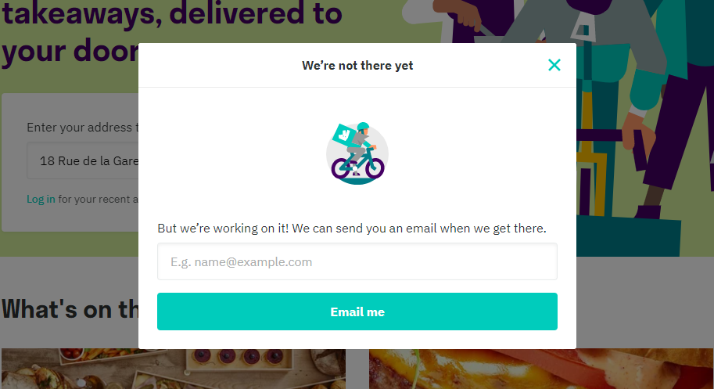

Good information on places where Deliveroo is not available. Even you can get an eMail if Deliveroo gets available.

**Help and documentation**

Any necessary help documentation should be easy to search, focused on the user's task, list concrete steps to be carried out, and not be too large

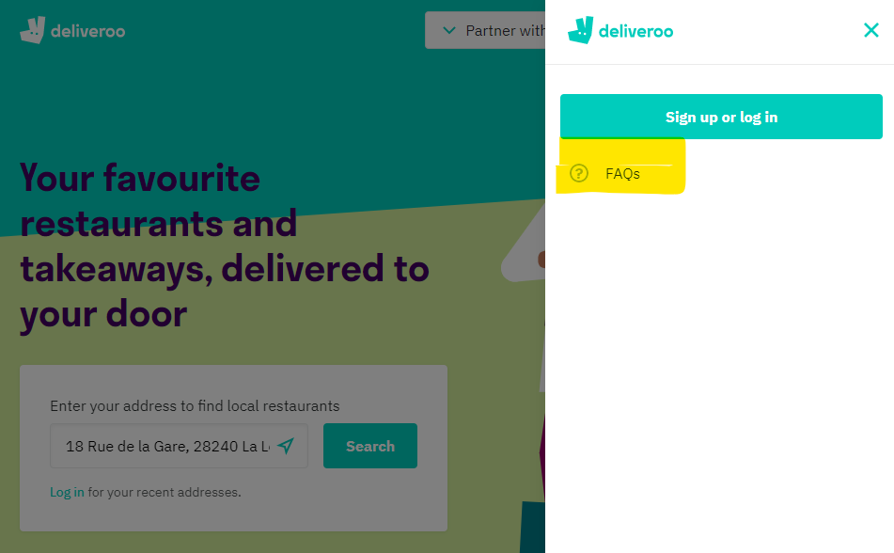

You have to open “Menu” before you get help information in form of FAQs.

Recommendation: Button on the head of the start page for FAQs.