

**Tribhuvan University Faculty of Humanities and Social Sciences**

**A Proposal**

**On**

**Project and Task Management System**

**Project I**

**Submitted to**

**Department of Computer Application**

**D.A.V College**

#### In partial fulfillment of the requirements for the Bachelors in Computer Application

Submitted by Amit Mahato

BCA 4th Semester



**Tribhuvan University**

**Faculty of Humanities and Social Sciences**

**D.A.V College**

**Supervisor’s Recommendation**

I hereby recommend that this project prepared under my supervision by SWECHCHHA CHHETRI entitled “**ONLINE BLOOD BANK SYSTEM”** in partial fulfillment of the requirements for the degree of Bachelor of Computer Application is recommended for the final evaluation.

**SIGNATURE**

Mr. Simanta Kasaju

**SUPERVISOR**

Lecturer

The Department of Bachelors in Computer Application Jawalakhel, Lalitpur



**Tribhuvan University**

**Faculty of Humanities and Social Sciences**

**D.A.V College**

**LETTER OF APPROVAL**

This is to certify that this project prepared by SWECHCHHA CHHETRI entitled “**ONLINE BLOOD BANK SYSTEM”** in partial fulfillment of the requirements for the degree of Bachelor in Computer Application has been evaluated. In our opinion it is satisfactory in the scope and quality as a project for the required degree.

|  |  |
| --- | --- |
| **SIGNATURE of Supervisor**  Mr. Simanta Kasaju, Lecturer  Department of Bachelors in Computer Application  Jawalakhel, Lalitpur | **SIGNATURE of HOD/ Coordinator**  Mr. Sudip Adhikari, H.O.D  Department of Bachelors in Computer Application  Jawalakhel, Lalitpur |
| **SIGNATURE of Internal Examiner**  **Internal Examiner** | **SIGNATURE of External Examiner**  **External Examiner** |

**ABSTRACT**

Online Blood Bank System is an online based system which facilitate the transaction of blood digitally. Information regarding blood, their donors and recipient are stored. Individuals can easily receive and donate the blood in one go, by the use of internet. Individuals can collect the fund for different events happening in different localities. This project is focused on making a system which can provide information about the blood banks, the type of blood that is available, and their quantities, which are maintained systematically. In the system, recipient and donors can simply put their information hence, allowing them to donate and receive the blood easily This project, at the core, depends on the back-end (the database). In order to make it work as desired, PHP was used. The technology used to make this project are HTML, CSS, JavaScript, PHP, MySQL, XAMPP, and visual studio. The progress of the work made is briefly explained later in this report.

**ACKNOWLEDGMENT**

The successful accomplishment of this project has been possible with the teachings and support of the respective teachers. I want to take this time to heartily thank all the people who have been concerned with this project.

I would like to extend sincere thanks to Tribhuvan University for giving this golden opportunity in enhancing hidden capabilities. I would like to thank DAV College where I have gained open help and an encouraging environment for learning along with proper infrastructures to make that possible. The list also includes the Head of Department Mr. Sudip Adhikari.

While I address several difficulties in coordinating the activities of the project, I am highly indebted to Mr. Simanta Kasaju for his guidance and constant supervision. He has been a big support in providing necessary information regarding the project and for his support in completing the project.

Last but not least I would like to thank my classmates who helped a lot during the making of this project.

**With Regards**

Swechchha Chhetri TU Registration No: 6-2-469-182-2020

**Contents**

List of Abbreviations vii

List of Figures viii

List of Tables ix

Chapter 1: INTRODUCTION 1

* 1. Introduction 1
  2. Problem Statement 2
  3. Objectives 3
  4. Scope and Limitations 4
  5. Development Methodology 4
  6. Report Organization 5

Chapter 2: BACKGROUND STUDY AND LITREATURE REVIEW 6

* 1. Background Study 6
  2. Literature Review 7

Chapter 3: SYSTEM ANALYSIS AND DESIGN 8

* 1. System Analysis 8
     1. Requirement Analysis 8
     2. Feasibility Analysis 9
     3. Data Modeling 10
     4. Process Modeling 11
  2. System Design 13
     1. Architectural Design 13

3.2.2. Database Schema Design 15

3.2.3 Interface Design 16

Chapter 4: Implementation and Testing 20

* 1. Implement 20
     1. Tools Used 20
     2. Implementation Details of Modules 23
  2. Testing 24
     1. Test Cases for Unit Testing 24
     2. Test Cases for System Testing 29

Chapter 5: Conclusion and Future Recommendation 31

* 1. Lesson Learnt/Outcome 31
  2. Conclusion 31
  3. Future Recommendation 31

REFERENCES 32

APPENDICES 33

# List of Abbreviations

CRUD- Create, Read, Update, Delete

Flow Diagram

ER- Entity Relationship Diagram HTML- Hypertext Markup Language JS- JavaScript

PHP- Hypertext Preprocessor

SDLC- Software Development Lifecycle SQL- Structured Query Language

VS- Visual Studio Code

|  |  |  |
| --- | --- | --- |
|  | **List of Figures** |  |
| Figure 1: Waterfall Model |  | 5 |
| Figure 2: ER Diagram |  | 10 |
| Figure 3: Gantt Chart |  | 10 |
| Figure 4: Context Diagram |  | 11 |
| Figure 5: Level 1 DFD |  | 12 |
| Figure 6: Architectural Design |  | 13 |
| Figure 7: Use Case Design |  | 14 |
| Figure 8: Schema Diagram |  | 15 |
| Figure 9: User Dashboard |  | 16 |
| Figure 10: Home Page |  | 17 |
| Figure 11: User Login Page |  | 18 |
| Figure 12: User Sign up page |  | 18 |
| Figure 13: Admin Login Page |  | 19 |
| Figure 14 : Admin Dashboard |  | 19 |

# List of Tables

* + 1. Admin Login Test
    2. User Registration Test
    3. User Login Test
    4. User/Admin Activity Test Case
    5. Test Case for System Testing
  1. **Introduction**

# Chapter 1: INTRODUCTION

Blood, which is one of the most essential fluids in the human body, helps the whole human system to function properly. In the case of heath emergencies such as heavy bleeding, the quantity of blood decreases from the human body. Blood donation is the practice of individuals giving their blood to save lives. It is an act of humanity. It involves giving blood to those in need. For that, blood banks are established in almost every community to contribute to needy peoples. Bloods are kept in blood banks for possible future use. Blood donation is a work of charity which brings up individuals from various castes, religions, and philosophies together.

A blood bank is a bank of blood, or a collection of bloods, gathered in one place, stored and preserved for future purpose. Before the establishment of digital blood banks, blood banks were manually managed for long period of time. All the information was handled by hand.

Today, blood banks are digital. It is an online based system which facilitate the transaction of blood digitally. Information regarding blood, their donors and recipient are stored. Individuals can easily receive and donate the blood in one go, by the use of internet.

This project is focused on making a system which can provide information about the blood banks, the type of blood that is available, and their quantities, which are maintained systematically.

**Keywords:**

*Blood, Human body, Blood donation, Blood banks, Heath emergencies, Humanity, Charity, Digital blood banks, Online system*

## Problem Statement

As the world is getting smaller day by day due to the immense invention and updates of technologies, the world is becoming more digital every day. Everyone’s information on health is increasingly accessible through smartwatches, smartphones, and e-health, however, our country Nepal still relies on blood bank that works in traditional manners/ manually.

Every day, hundreds of blood units are needed. With this manual method, it is almost impossible to manage the system accurately. These has cost errors, consuming more time and resources resulting in people having to wait for hours and hours for the availability of blood. The information regarding the donors and recipient are not managed systematically, especially with the limited availability of rare blood groups in the system. Also, what can be more depressing than witnessing individuals forced to show up in person at the blood bank even at the time of emergencies?

To oversee these, this system is designed. In the system, recipient and donors can simply put their information hence, allowing them to donate and receive the blood easily from anywhere around the Nepal, making it efficient, faster and reliable. The system will focus on accuracy level, and minimize the misuse of other resources that were not used in prior systems by making easy, simple and user-friendly User Interface.

## Objectives

* To insert the data regarding Donors, Receiver and Bloods.
* To manage the details of Blood, Blood Group, Stocks and Events.

## Scope and Limitations

This project focuses on studying the existing system of online blood bank to ease people donate, request the blood. This system will provide:

* + - Users of any or no experience can easily browse through website.
    - User- friendly environment.
    - Easier for people at the time of emergency as they don’t have to be physically present at the blood

The project has got some of the following limitations.

* + - It has no limit on how many users can be added to system, which can possibly lead to overcrowding.
    - Reliance on Internet Connectivity.
    - Privacy and Security Concerns.
    - Verification of Donor Eligibility.

## Development Methodology

This website is created using the waterfall methodology since it is simple and user-friendly. The Waterfall Model is the earliest System Development Life Cycle approach for software development. As this is an academic project as well as individual project, the time duration is minimum, waterfall model is best suited for it. The waterfall model is a sequential software development process model. This system progresses in a linear and sequential manner, flowing steadily downwards like a waterfall. The project is divided into distinct phases, and each phase must be completed before moving on to the next one. In this model, documentation is also highly prioritized. Different steps of the development of this project are based on waterfall model. First, requirements regarding blood banks were collected, system design was done, followed by implementation, testing, deployment and maintenance.

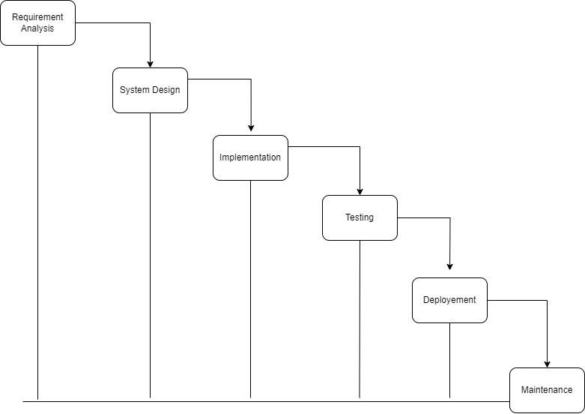

Figure 1– Waterfall Model

## Report Organization

The project has been organized into various chapters.

The first chapter discussed about the overall project introduction. This chapter includes the project introduction, problem objectives and scope and limitation has been included.

The second chapter of this project report has discussed about the background study and literature reviews.

The third chapter of this project report focuses in the statement of the problem where various aspect such as requirement analysis, feasibility study and system design are discussed.

The fourth chapter explains the implementation aspect of the project, and testing the system using different screen shots of various modules.

# Chapter 2: BACKGROUND STUDY AND LITREATURE REVIEW

## Background Study

The background study of an online blood bank system involves a thorough examination of the development, implementation, and utilization of such systems. It encompasses understanding the fundamental principles of blood banking and transfusion services, exploring existing offline and online blood bank systems, and identifying their functionalities and limitations. Additionally, the study involves delving into the system requirements and design, including technological aspects and infrastructure considerations. User experience and interface design, data management are also crucial areas of focus. Overall, the background study provides a comprehensive understanding of the online blood bank system's development, deployment, and usage. The project is being developed in order to bring a digital system to donate and request bloods. By using manual method, it is almost impossible to manage the system accurately. These has cost errors, consuming more time and resources resulting in people having to wait for hours and hours for the availability of blood. The information regarding the donors and recipient are not managed systematically, especially with the limited availability of rare blood groups in the system. Using online blood bank, individuals can easily receive and donate the blood in one go, by the use of internet. It is an online based system which facilitate the transaction of blood digitally. Information regarding blood, their donors and recipient are stored.

## Literature Review

**Hamro LifeBank- Digital Blood system**

The Hamro LifeBank-Digital Blood System is designed to manage their blood data as well as to find, attract, and keep donors as needed. People who need blood can access information on blood supply. To handle the present challenges with blood shortage and management, it relies heavily on technology.

The system includes functions including blood donation, blood donation requests, blood stories, donation events. It was founded on 2019. [1]

**e-Raktkosh:Centralized Blood Bank Management System**

On April 7, 2016, Hon. J. P. Nadda, Minister of Health and Family Welfare, officially launched eRaktKosh. In order to ensure correct collection and donation, efficient management, and close supervision of the quality and quantity of given blood, e-Rakt Kosh implements the Drug & Cosmetic Act and National Blood Policy standards and recommendations.

Features including blood grouping, TTI screening, antibody screening, component manufacturing, etc. are offered. It is a centralized system for managing blood inventories which is used by many different blood banks to maintain track of their blood supplies. [2]

**Nepal Blood Donor**

Nepali Blood Donor (NBD) is working to meet the regular needs for high-quality human blood all over Nepal. The intention of this application is developed is to make a mobile- based blood bank system after including all health services. Currently, available services of NBD are: Find Donors near to your location, Request Post and Share Blood Request, Find Ambulance near to your location, Event Management (Add and Share Events), News and Blogs, Profile and History Management, generating donor card and Registering you as member of NBD. It is also called a simple asking and accepting platform to provide immediate help for those who are in a medical emergency. [3]

# Chapter 3: SYSTEM ANALYSIS AND DESIGN

## System Analysis

### Requirement Analysis

* + - 1. **Functional Requirements**
         1. Login Modules

Users

Admin

* + - * 1. Donate blood Module

Users can fill the form to donate their blood.

* + - * 1. Request for blood Module

People of different blood groups can easily find their required blood

* + - * 1. Event Module.

User can choose the convenient event for the donation.

* + - * 1. Fund Raise Module

User raise fund for different events.

* + - * 1. View blood stocks (Report)

The system generates the report of system to admin.

* + - * 1. Add / remove / update stocks.

System should perform basic CRUD operations.

* + - * 1. Dashboard

A viewer is able to grasp the meaning of the data at a glance.

* + - 1. **Non-Functional Requirements**
         1. Security

Data protection, preservation, and high security are ensured by the system.

* + - * 1. Speed/performance

The overall performance of system is time- effective.

* + - * 1. Usability

The clear (UI) makes the system simple for people to use the system.

-

* + - * 1. Reliability

- On the given period of time, the system correctly completes the duties.

* + - * 1. Accessibility

Accessibility of the system from anywhere around the world with a good internet connection and a system.

### Feasibility Analysis

* + - 1. **Technical Feasibility**

Users don't require any additional hardware/software to operate this web application. It is easily accessible. It can run in web browser easily. Anyone can ask for blood, donate the blood, collect the funds. Moreover, the system doesn't require any technological assistance. A good internet connection is needed to use the system. For the development of this system, modern and easily understood programming languages are used, which makes the system less prone to errors. The system is technically feasible.

* + - 1. **Operational**

This system facilitates effective, easier and faster transactions of blood, digitally. It has an easy and simple User Interface (UI) which makes user to interact with it easily. Thus, the system is operationally feasible.

* + - 1. **Economic**

For the development of this system, capital is not required. A good internet connection and a working device is needed to work as the software used are freely available, which makes it very affordable. When compared to physical blood banks, it offers the convenience of online transactions, which saves customers time & money. The system is economically feasible.

### Data Modeling

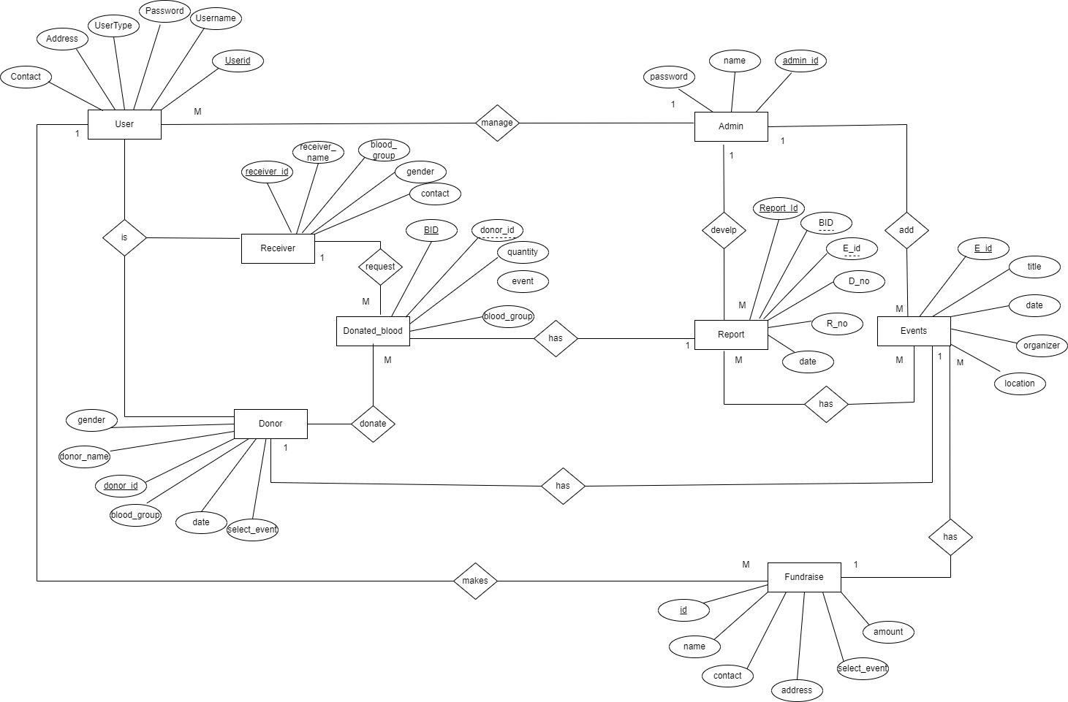

Figure 2- ER Diagram

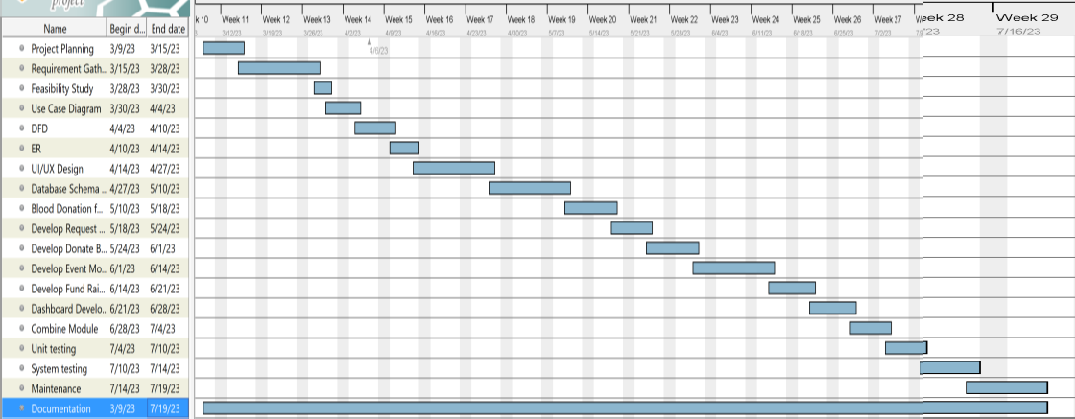

Figure 3- Gantt Chart

### Process Modeling

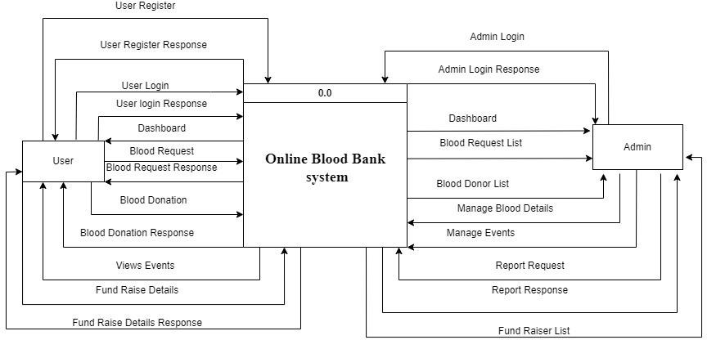

Figure 4 - Level 0 DFD

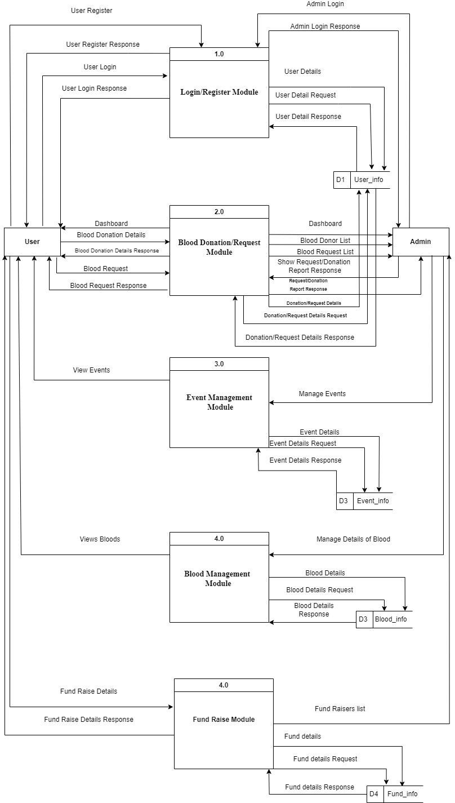

Figure 5 - Level 1 DFD

## System Design

### Architectural Design

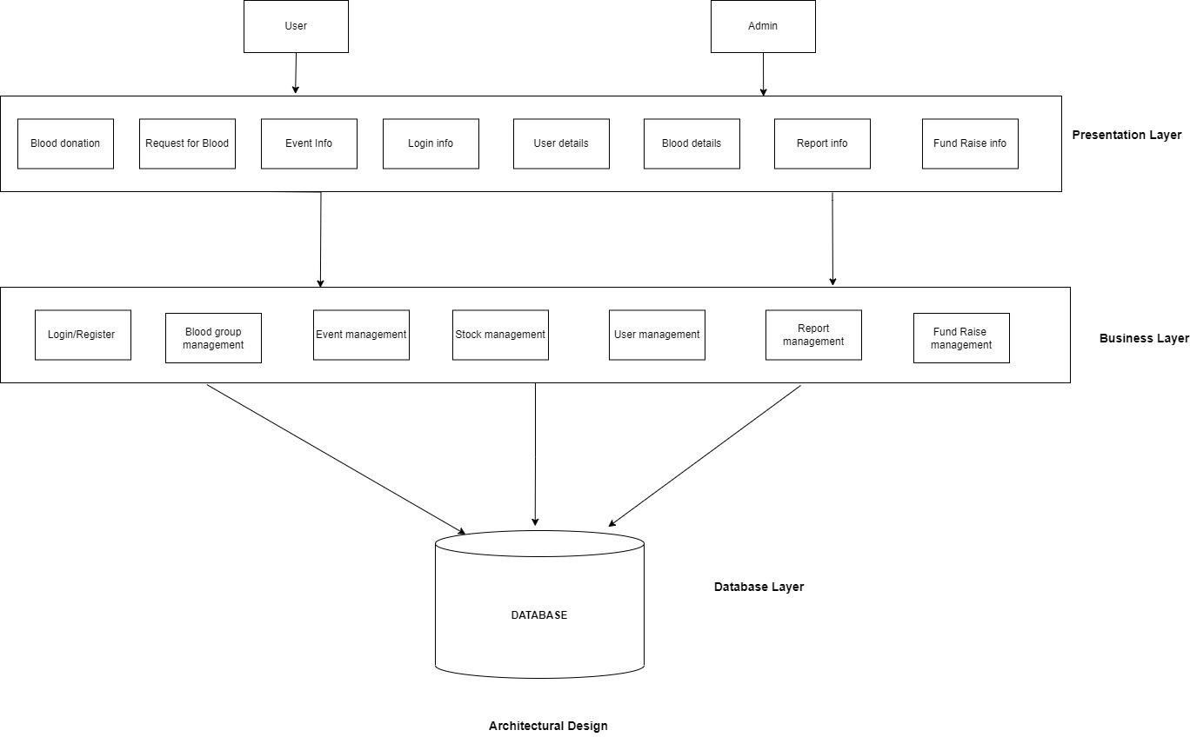

Figure 6 - Architectural Design

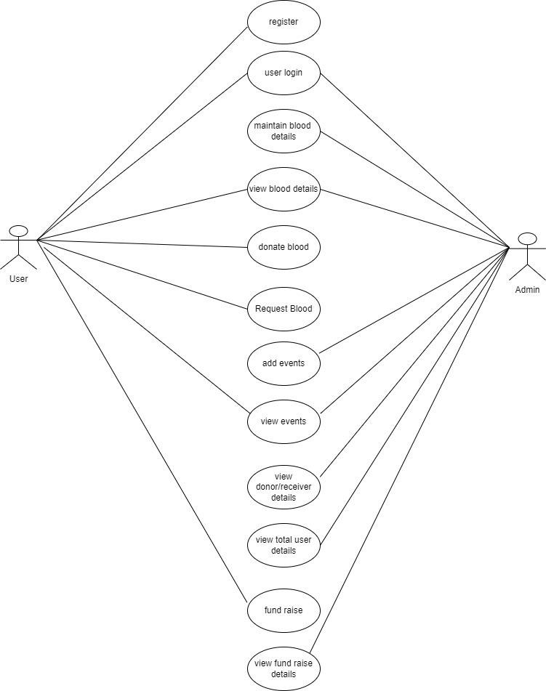

Figure 7 - Use Case Diagram

### 3.2.2. Database Schema Design

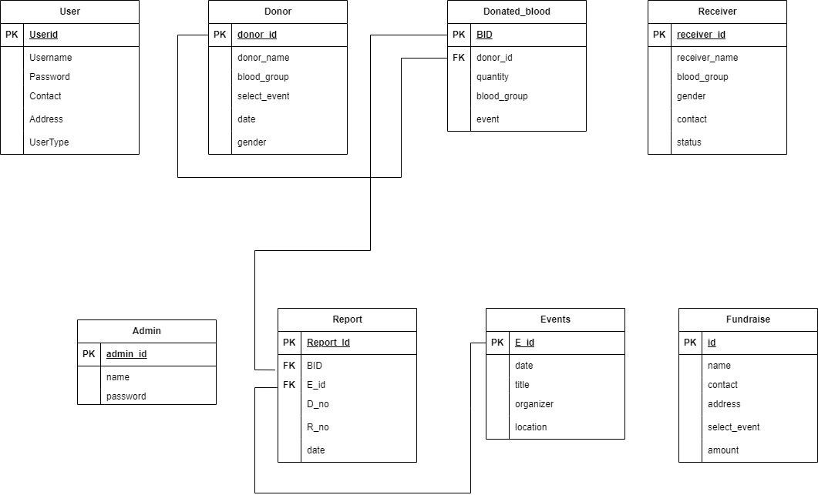

Figure 8 - Schema Diagram

### 3.2.3 Interface Design

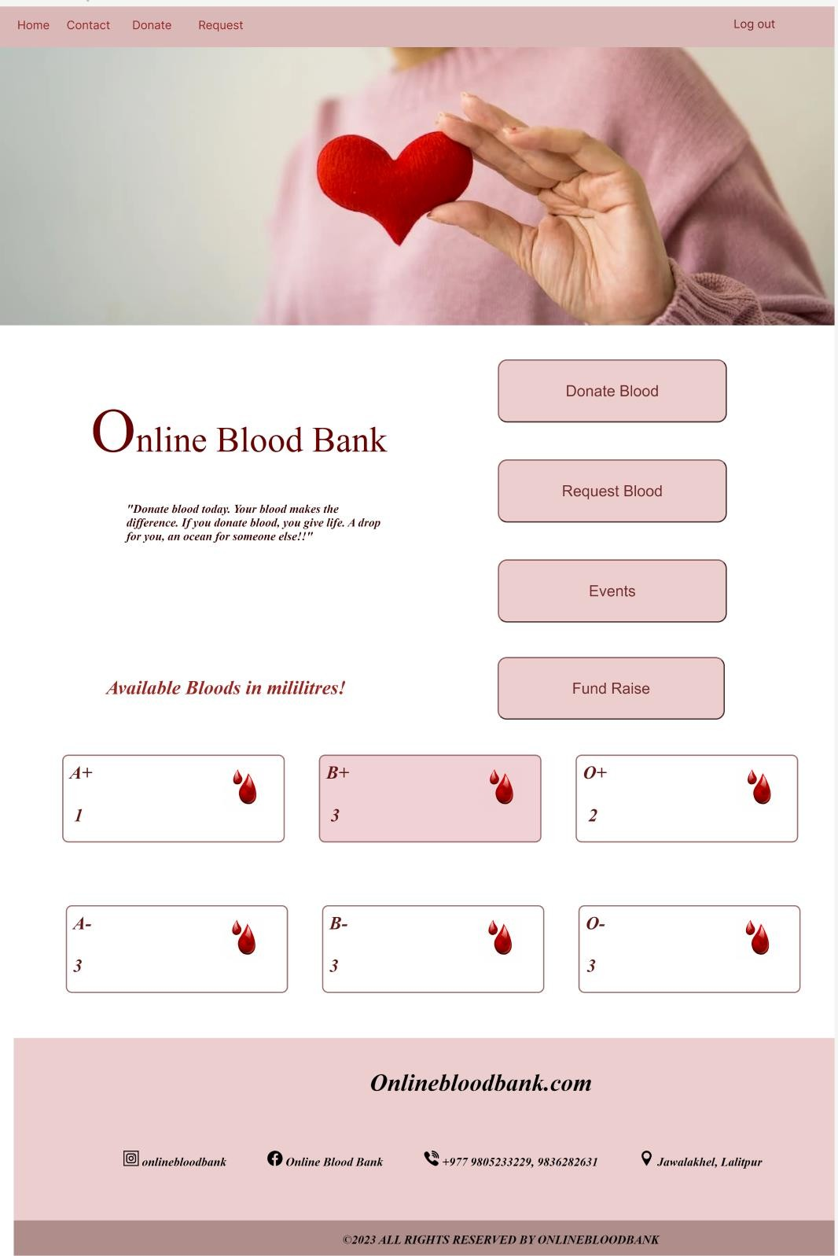

Figure 9 – User Dashboard

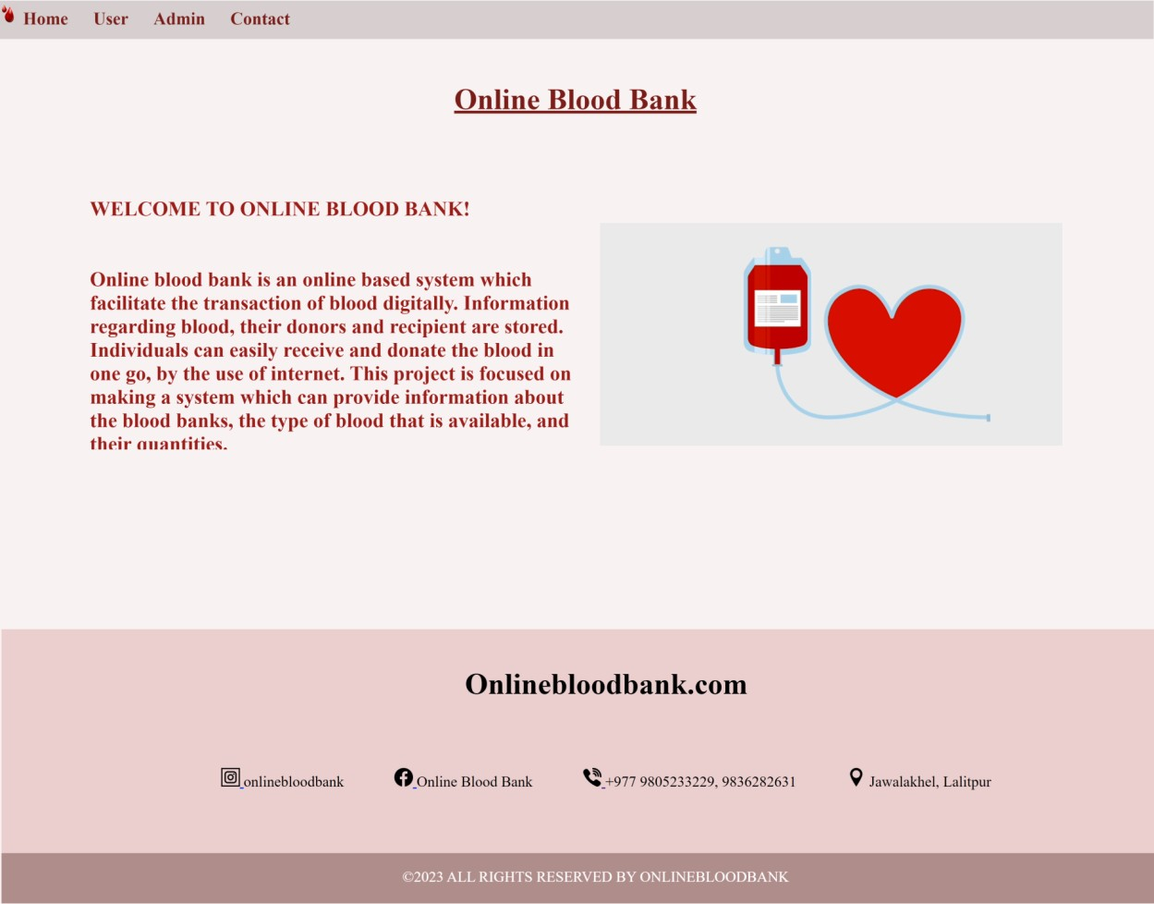

Figure 10- Home page

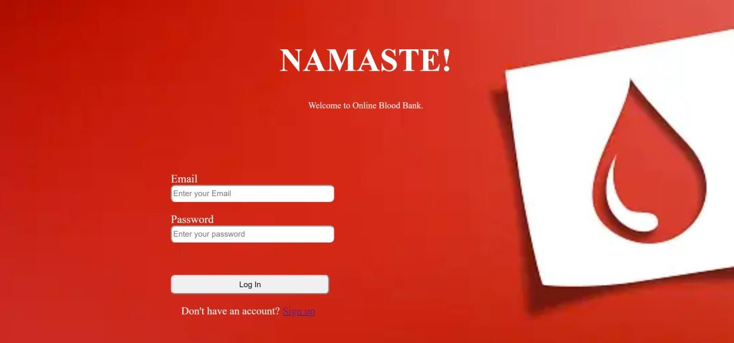

Figure 11-User Login Page

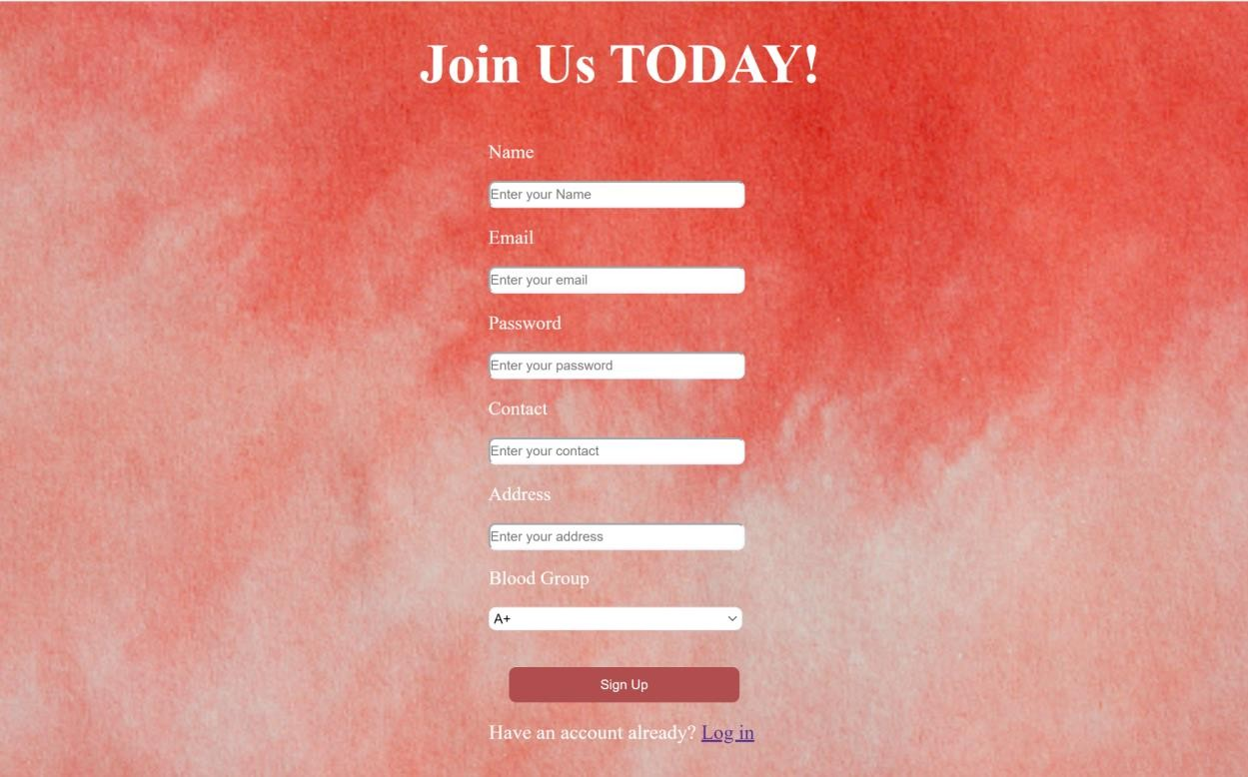

Figure 12- User Sign up page

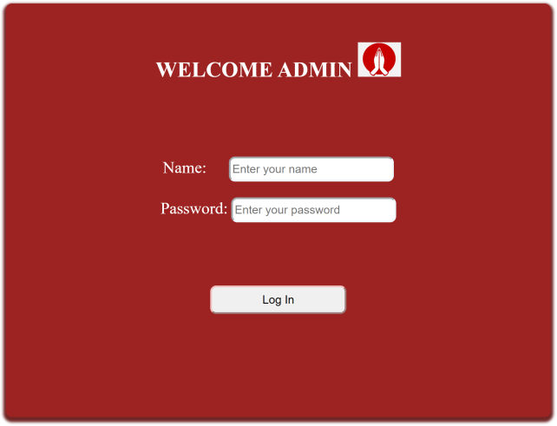

Figure 13- Admin Login Page

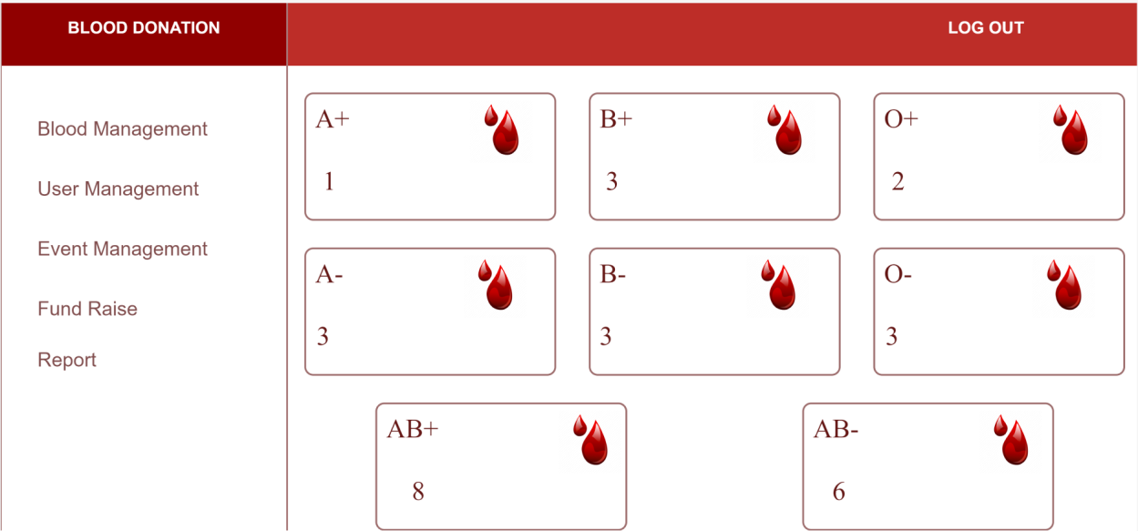

Figure 14- Admin Dashboard

# Chapter 4: Implementation and Testing

## Implement

### Tools Used

Different tools, application and technologies have been used in this project. And all of themare discussed below:

1. **Microsoft Visual Studio:**

Microsoft Visual Studio is an Integrated Development Environment (IDE) developed by Microsoft to develop GUI (Graphical user interface), console, web application. web apps, mobile apps, cloud, and web server, etc. With the help of this IDE can create manage a code as well as native code. It provides support for 36 different programming languages.

1. **XAMPP:**

XAMPP is one of the widely used cross-platform web servers, which helps developers to createand test their programs on a local webserver. It was developed by the Apache Friends, and itsnative source code can be revised or modified by the audiences. It consists of Apache HTTP Serves. Maria DB, and interpreter for the different programming languages like PHP and Perl.XAMPP is used to symbolize the classification of solution for different technologies. This collection of software contains a web server name Apache, a database management system named Maria DB and scripting/ programming languages such as PHP andPerl.

1. **Web Browser:**

A web browser, or simply "browser," is an application used to access and view websites. Common web browsers include Microsoft Internet Explorer. Google Chromes, Mozilla Firefox, and Apple Safari. The primary functional of a web browser is to render HTML, the code used to design or "mark-up" web pages. Each time a browser loads a web page, it processes that IITMI, which may include text, links, and references to images and other items,such as CSS (Cascading Style Sheets) and JavaScript.

1. **HTML:**

HTML stands for Hypertext Markup Language in which it is the set of markup symbols

or codes inserted into a file intended for displaying on the internet. The markup tells web browserhow to display a web page's word and images. Each individual piece’s markup code is referredto as an element, though many people also refer to it as a tag. Hypertext Markup Language (HTML) is the basic scripting language used by web browsers to render pages on the World Wide Web.

1. **CSS:**

CSS stands for a Cascading Style Sheet. Cascading style sheets are used to format the layout of Web Pages. They can be used to define text style, table sizes, and other aspects of web pagesthat previously could only be defined in a page's HTML. CSS helps Web developers create auniform look across several pages of a Web site. Instead of defining the style of each table andeach block of text within a page's HTML, commonly used style need to be defined only once in a CSS document. While CSS is great for creating text styles, it is helpful formatting other aspects of Web page layout as well.

1. **PHP:**

PHP stands for Hyper Pre-Processor (it is a recursive acronym, if you can understand what thatmeans) PHP is and HTML-embedded Web Scripting languages. This means PHP code can beinserted into the HTML of a Web pages. When a PHP page is accessed, the PHP code is read or "parsed" by the server the page resides on. The output forms the PHP functions on the pageresides on. The output forms the PHP functions 19 on the page are typically returned as HTMLcode, which can be read by the browser. Because the PHP code is transformed into HTML before the page is loaded, user cannot view the PHP code on a page. This makes PHP pages secure enough to access database and other secure information.

1. **MySQL:**

MySQL is a relational database management system based on SQL (Structured Query Language). This application is used for a wide range of purposed, including data warehousing,e-commerce, and logging applications. The most common used for mySQL however, is for thepurpose of a web database It can be used to store anything for a single record of information to an entire inventory of available product for an online store. MySQL provides an implementation of a SQL database very well. suited for a small to

medium web pages.

1. **JavaScript:**

JavaScript is a programming language commonly used in web development, it was originallydeveloped by NetScape as a means to add dynamic and interactive elements to websites. WhileJavaScript is influenced by java, the syntax is more similar to C and is based on ECMAScript,a scripting language developed by Sun Micro-systems JavaScript is a Client-Side Scripting language, which means the source code is processed by the client's web browser rather than onthe web server.

### Implementation Details of Modules

This project is focused on making a system which can provide information about the blood banks, the type of blood that is available, and their quantities. Modules of this project are listed below:

* + - * Login Form: Uses user’s credentials such as username and password to authenticate user to redirect to the dashboard.
      * Signup Form: Users registers into the system to access the facilities.
      * Donate blood module: User submits the form selecting blood group and their convenient events
      * Request blood module: User submits the form requesting specific blood group.
      * Fund raise module: User submits the form for raising fund for different events.
      * Event module: User views the table of events available, added by Admin.
      * Logout: On the profile card is a ‘Logout button’ when clicked destroys the session Id and redirects to the login page.

## Testing

### Test Cases for Unit Testing

For unit testing every functional module were tested separately and the result of those modules were analyzed. Each unit of application is tested to verify that the detailed designfor the unit has been correctly implemented. Unit testing can be done by following test cases:

For unit texting, we tested every functional module separately and the result of those modules were analyzed. The unit of the web application is tested to verify that the detaileddesign for unit testing has been correctly implemented.

Unit testing can be done by the following test cases:

|  |  |  |  |  |
| --- | --- | --- | --- | --- |
| S.N | Test Case | Test Data | Expected Result | Result |
| 1. | Admin enters valid username and password. | Username: swechchha password: 12345 | Redirects to Admin  Dashboard | Fail |
| 2 | Admin enters valid username and password. | Username: Swechchha  Password: 12345 | Redirects to Admin  Dashboard | Pass |
| 3. | Admin enters invalid username and password | Username: cswechchha  password: dav | Invalid email and password | Pass |

Table 1: Admin Login Test

|  |  |  |  |  |
| --- | --- | --- | --- | --- |
| S.N | Test Case | Test Data | Expected Result | Result |
| 1 | User registers to the system | Name: Swechchha Chhetri Email:  [cswechchha@gmail.com](mailto:cswechchha@gmail.com) Password:12345  Contact:9805280669 Address: bhairahawa Bloodgroup: A+ | Redirects to user login module | Pass |
| 2. | User registers to the system with same name, email, password, address, contact, bloodgroup | Name: Swechchha Chhetri  Email:  [cswechchha@gmail.com](mailto:cswechchha@gmail.com) Password:12345  Contact:9805280669 Address: Bhairahawa Bloodgroup: A+ | Account already exists. | Pass |

Table 2: User Registration Test

|  |  |  |  |  |
| --- | --- | --- | --- | --- |
| S.N | Test Case | Test Data | Expected Result | Result |
| 1. | User logs in with registered data. | Email:  [cswechchha@gmail.com](mailto:cswechchha@gmail.com) Password: 12345 | Redirects to user dashboard. | Pass |
| 2. | User logs in with invalid email and password | Email: [cswecha@gmail.com](mailto:cswecha@gmail.com) Password: dav | Invalid email or password | Fail |
| 3 | User logs in with  unregistered data | Email: [swechchha@gmail.com](mailto:swechchha@gmail.com)  Password: 2341 | Invalid email or password | Pass |

Table 3: User Login Test

|  |  |  |  |  |
| --- | --- | --- | --- | --- |
| S.N | Test Case | Test Data | Expected Result | Result |
| 1.  2.  3.  4  5. | Admin adds event  User donate blood through form with all field filled.  User request blood through form with all field filled.  User request blood with negative quantity  User request blood with negative quantity | Event date: 2080/04/05  Event title: Blood Campaign Event Organizer: Dav  Location: Dhobighat  Donor Name: Swechchha Blood group: A+  Select Event: Blood Campaign  Date:2080/04/05 Gender: Female  Recipient name: Swechchha Blood group: A+  Date: 2080/05/04 Gender: Female  Contact: 9805280669 Quantity in mililitres:2  Recipient name: Swechchha Blood group: A+  Date: 2080/05/04 Gender: Female  Contact: 9805280669 Quantity in mililitres: - 2 Recipient name: Swechchha Blood group: A+  Date: 2080/05/04 Gender: Female  Contact: 9805280669 Quantity in mililitres:-2 | New event is added to the list of events  Show form submitted successfully.  Show form submitted successfully and details sent to admin for approval.  Insertion must be failed.  Insertion must be failed | Pass  Pass  Pass  Fail  Pass |

|  |  |  |  |  |
| --- | --- | --- | --- | --- |
| 5. | User raise the fund through form with field filled. | Name: Swechchha Contact:9805280669 Address: bhairahawa  Select event: blood campaign Amount in rupees. | Show form submitted successfully and details sent to admin. | Pass |

Table 4: User/Admin activity test cas

|  |  |  |  |  |
| --- | --- | --- | --- | --- |
| S.N | Test Case | Test Data | Expected Result | Result |
| 1 | To destroy the user session id and log out the user out of the system. | When clicked logout the  user is redirected to the  login page. Session is  destroyed. | Destroys the session and logs the user out. | Pass |

Table 5: Logout Test

### Test Cases for System Testing

|  |  |  |  |  |
| --- | --- | --- | --- | --- |
| S.N | Test Case | Test Data | Expected Result | Result |
| 1.  2  3.  4 | User registers to the system  User logs in to the system  Admin insert new events  User donate blood | Name: Swechchha Chhetri  Email:  [cswechchha@gmail.com](mailto:cswechchha@gmail.com) Password:12345  Contact:9805280669 Address: Bhairahawa Bloodgroup: A+  Email:  [cswechchha@gmail.com](mailto:cswechchha@gmail.com) Password:12345  Event date: 2080/04/05  Event title: Blood Campaign  Event Organizer: Dav Location: Dhobighat Donor Name:  Swechchha  Blood group: A+  Select Event: Blood Campaign  Date:2080/04/05 Gender: Female | Redirects to login module  for login  procedure.  User dashboard is displayed.  New event is  added to the list of events  Show form submitted successfully. | Pass  Pass  Pass  Pass |

|  |  |  |  |  |
| --- | --- | --- | --- | --- |
| 5.  6.  7.  8. | User request blood  Admin approves request for blood  User raise the fund by filling the form.  Admin generates the report | Recipient name: Swechchha  Blood group: A+ Date: 2080/05/04 Gender: Female  Contact: 9805280669 Quantity in mililitres:2  Admin clicks approve button to approve the receiver  Name: Swechchha Contact:9805280669 Address: bhairahawa Select event: blood  campaign  Amount in rupees.  Event name: blood campaign | Show form submitted successfully and details sent to admin for approval.  Display  approved or pending.  Show form submitted successfully and details sent to admin  Display all records of respective donors and fund raisers. | Pass  Pass  Pass  Pass |

Table 6- Test Cases for System Testing

# Chapter 5: Conclusion and Future Recommendation

## Lesson Learnt/Outcome

While working with the system a great deal of knowledge was gained. All the learnings are listed below:

* Building a full-stack application.
* PHP and how it works with the database and as a programming language.
* Use of JavaScript, HTML, and CSS in building the front-end system.
* Relational database (MySQL) and its queries.
* Building a system in an organized and professional manner.

## Conclusion

Online Blood Bank System is an online based system which facilitate the transaction of blood. Information regarding blood, their donors and recipient are stored. Individuals can easily receive and donate the blood in one go, by the use of internet.Admin can add events and approve the receivers. Fund raisers from different localities can raise the fund for different events happening System stores details about the blood banks, the type of blood that is available, and their quantities, which are maintained systematically.

## Future Recommendation

Here, are some of the future works that can be implemented to improve the system:

* + - Built as a mobile app.
    - Availability of location-based blood bank details.
    - Accessing the online fund raise/payment meethod

# REFERENCES

* + - [1] LifeBank, H. (2023) *Newsletters - hamro lifebank*, *Newsletters - Hamro LifeBank*. Available at: https://hamrolifebank.com/newsletters (Accessed: April 13, 2023).
    - [2] *Eraktkosh Mobile Application* (2016) *e*. Available at: https:/[/www.eraktkosh.in/](http://www.eraktkosh.in/BLDAHIMS/bloodbank/transactions/bbpublicindex.htm)B[LDAHIMS/bloodbank/transactions/bbpublicindex.htm](http://www.eraktkosh.in/BLDAHIMS/bloodbank/transactions/bbpublicindex.htm) l (Accessed: April 13, 2023).
    - *[3] Welcome to NBD* (no date) *Nepali Blood Donors*. Available at: https:/[/www.nepaliblooddonors.com/](http://www.nepaliblooddonors.com/) (Accessed: 25 June 2023).

# APPENDICES

