**Question: 1 Write a query to find the average count of transactions per day on polygon.**

Data table: polygon.transactions

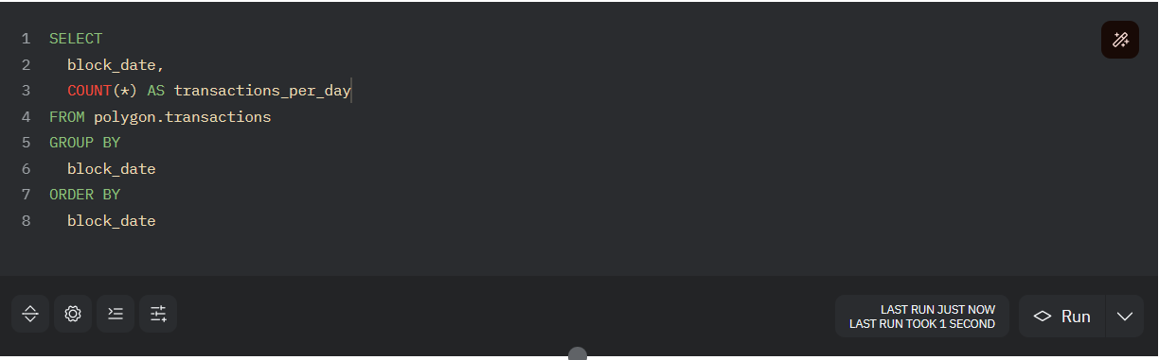

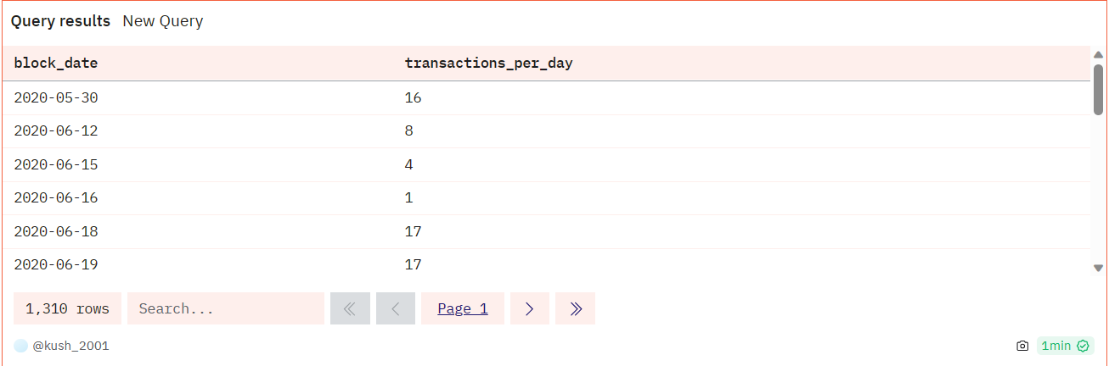

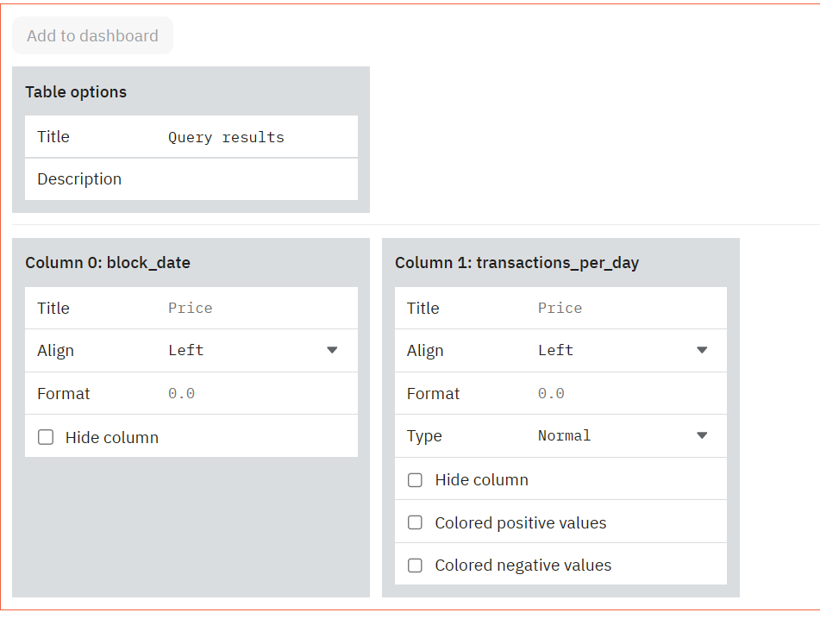

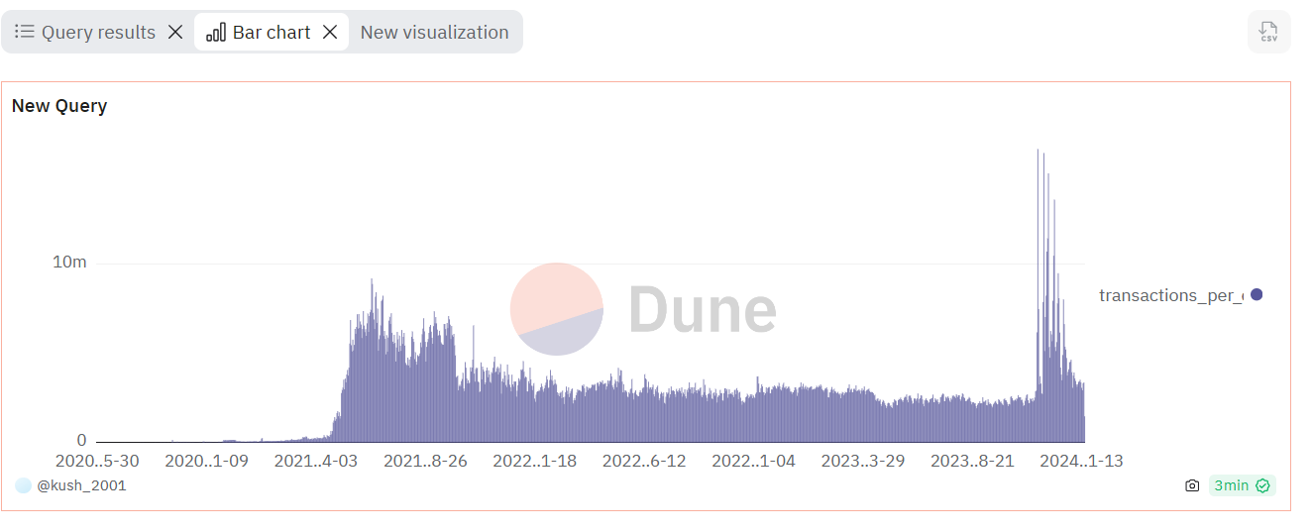

**Question: 2 Write a query to find the top 10 holders of OP tokens.**

Data table: op_token_distributions_optimism.transfer_mapping

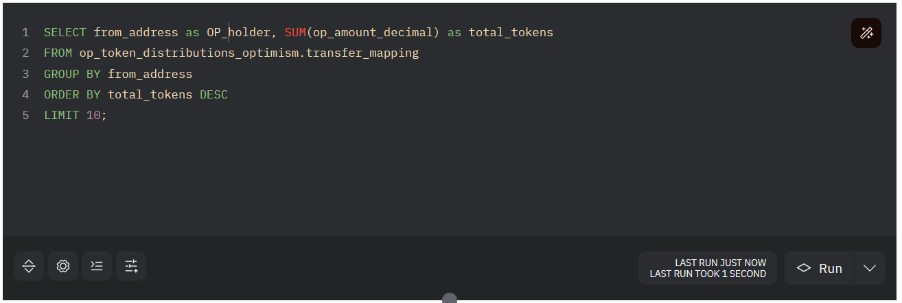

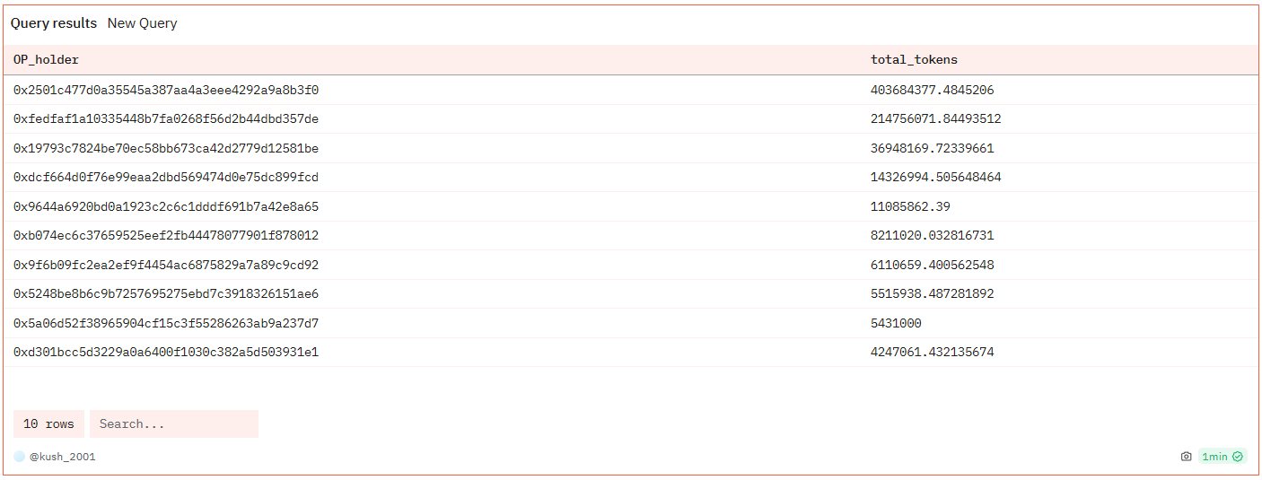

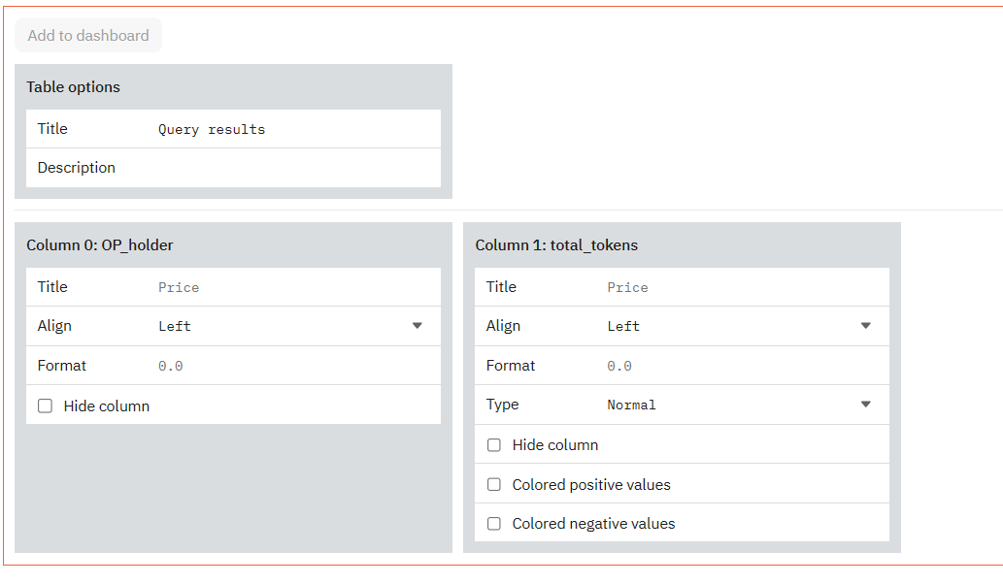

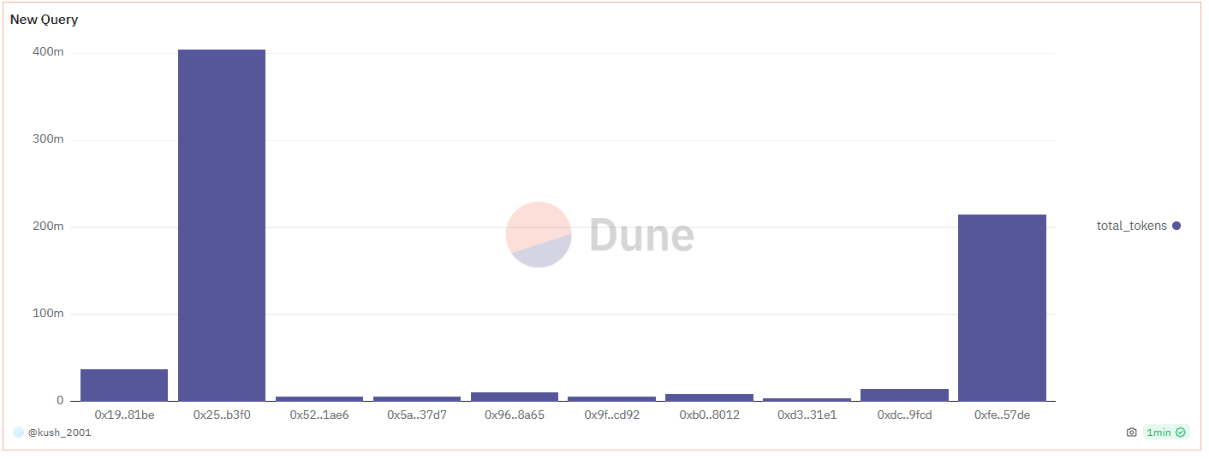

**DashBoard**:

