** **

**Product Dissection for Fiverr**

**Company Overview:**

Fiverr, founded in 2010 by Micha Kaufman and Shai Wininger. It is a global online marketplace for freelance services. It connects freelancers, known as "sellers" with clients seeking a variety of services across multiple categories such as graphic design, digital marketing, writing and programming. Known for its user-friendly platform and diverse service offerings, Fiverr has grown into a major player in the gig economy, providing a space where clients can find and hire freelancers for short-term projects and tasks.

**Product Dissection and Real-World Problems Solved by Fiverr:**

Fiverr has addressed several real-world challenges through its platform, providing solutions that benefit both freelancers and clients. By enabling freelancers to offer their services in a structured manner, Fiverr bridges the gap between skilled professionals and clients needing their expertise. The platform addresses the challenge of finding and hiring freelance talent efficiently, offering a solution for businesses and individuals to get specific tasks completed by professionals with the right skills.

Fiverr's diverse service offerings, including categories like graphic design, writing, programming and digital marketing, solving the problem of accessing specialised skills without the need for long-term commitments. The platform’s structure allows clients to quickly find and hire freelancers for specific projects, addressing the challenge of project-based work and ensuring that clients can easily access the expertise they need.

Additionally, Fiverr's rating and review system helps clients make informed decisions by providing feedback from previous users. This feature tackles the problem of trust and reliability in the freelance market, ensuring that clients can select freelancers based on their reputation and past performance.

**Case Study: Real-World Problems and Fiverr's Innovative Solutions**

Fiverr has transformed the freelance market by offering innovative solutions to common challenges faced by both freelancers and clients. Through its platform, Fiverr has addressed several key issues:

**Problem 1: Finding Reliable Freelancers**

**Challenge:** Businesses and individuals often struggle to find reliable freelancers with the right skills for specific projects. The lack of a centralised platform can make it difficult to assess the quality and reliability of potential candidates.

**Solution:** Fiverr provides a centralised marketplace where clients can browse through a vast array of freelance services across different categories. The platform's rating and review system, along with detailed freelancer profiles, help clients make informed decisions and find reliable professionals for their needs.

**Problem 2: Accessing Specialized Skills**

**Challenge:** Many projects require specialised skills that are not easily accessible through traditional hiring methods. Finding and hiring experts for short-term tasks can be challenging and time-consuming.

**Solution:** Fiverr allows freelancers to offer a wide range of specialised services, from graphic design and writing to programming and digital marketing. Clients can quickly find and hire freelancers with the specific skills needed for their projects, streamlining the process of accessing specialised expertise.

**Problem 3: Managing Project-Based Work**

**Challenge:** Managing project-based work often requires flexibility and short-term commitments, which traditional hiring methods may not always accommodate.

**Solution:** Fiverr’s platform is designed for project-based work, allowing clients to post specific tasks or projects and hire freelancers on a short-term basis. This model provides the flexibility needed for various projects without long-term commitments, making it easier to manage and complete tasks efficiently.

**Problem 4: Ensuring Trust and Reliability**

**Challenge:** Trust and reliability are crucial in freelance work, and clients often face challenges in ensuring that freelancers will deliver quality work.

**Solution:** Fiverr addresses this challenge through its rating and review system, where clients can rate freelancers and leave feedback based on their experiences. This system helps build trust and ensures that clients can choose freelancers with a proven track record of delivering quality work.

**Conclusion:**

Fiverr’s evolution from a startup to a leading freelance marketplace demonstrates its ability to address real-world problems effectively. By providing a platform that connects clients with freelancers, supports specialised skills, manages project-based work, and ensures trust and reliability, Fiverr has positioned itself as a key player in the gig economy. The platform’s innovative approach and user-centric features continue to shape the freelance market, offering practical solutions to the needs of its diverse user base.

**Top Features of Fiverr:**

1. **User Profiles:** Fiverr allows users to create detailed profiles showcasing their skills, experience, and service offerings. This includes profile pictures, descriptions, and ratings, providing a comprehensive view of each freelancer's capabilities.
2. **Gigs:** A core feature of Fiverr is the "gig" system, where freelancers list specific services they offer. Each gig includes a description, pricing options, and delivery times, allowing clients to select services that meet their needs.
3. **Ratings and Reviews:** Fiverr’s rating and review system enables clients to provide feedback on freelancers' work, helping future clients make informed decisions based on past performance.
4. **Search and Filters:** The platform offers advanced search and filtering options, allowing clients to find freelancers based on specific skills, categories, and other criteria.
5. **Communication Tools:** Fiverr provides built-in messaging and communication tools that facilitate interaction between clients and freelancers, ensuring clear and effective collaboration.

**Schema Description:**

The schema for Fiverr involves several entities representing different aspects of the platform. These entities include Users, Gigs, Orders, Reviews, and Categories. Each entity has specific attributes that describe its properties and relationships with other entities.

**User Entity**: The User entity represents individuals using the Fiverr platform:

* **UserID** (Primary Key): A unique identifier for each user.
* **Username**: The chosen username for the user's account.
* **Email**: The user's email address for account-related communication.
* **Full_Name**: The user's full name as displayed on their profile.
* **Bio**: A brief description that users can use to express themselves.
* **Registration_Date**: The date when the user joined Fiverr.

**Gig Entity**: The Gig entity represents the services offered by freelancers:

* **GigID** (Primary Key): A unique identifier for each gig.
* **UserID** (Foreign Key referencing User Entity): The freelancer offering the gig.
* **Title**: The title of the gig.
* **Description**: The description of the gig, detailing the service offered.
* **Price**: The cost of the gig.
* **Delivery_Time**: The time required to complete the gig.
* **CategoryID** (Foreign Key referencing Category Entity): The category of the gig.

**Order Entity**: Orders capture transactions between clients and freelancers:

* **OrderID** (Primary Key): A unique identifier for each order.
* **GigID** (Foreign Key referencing Gig Entity): The gig being purchased.
* **UserID** (Foreign Key referencing User Entity): The client who placed the order.
* **Order_Date**: The date when the order was placed.
* **Completion_Date**: The date when the gig was completed.

**Review Entity**: Reviews allow clients to provide feedback on gigs:

* **ReviewID** (Primary Key): A unique identifier for each review.
* **OrderID** (Foreign Key referencing Order Entity): The order associated with the review.
* **UserID** (Foreign Key referencing User Entity): The client who wrote the review.
* **Rating**: The rating given to the gig.
* **Text**: The text of the review.
* **Review_Date**: The date when the review was posted.

**Category Entity**: Categories organise gigs into various types:

* **CategoryID** (Primary Key): A unique identifier for each category.
* **Category_Name**: The name of the category.

**Milestone Entity**: Milestones track the progress of gig tasks:

* **MilestoneID** (Primary Key): A unique identifier for each milestone.
* **GigID** (Foreign Key referencing Gig Entity): The gig associated with the milestone.
* **Milestone_Number**: The number of the milestones in the sequence.
* **Description**: A description of the milestone.
* **Completion_Date**: The date when the milestone was completed.

**Payment Entity**: Payments represent the financial transactions for orders:

* **PaymentID** (Primary Key): A unique identifier for each payment.
* **OrderID** (Foreign Key referencing Order Entity): The order associated with the payment.
* **Amount**: The amount of the payment.
* **Payment_Date**: The date when the payment was made.
* **Payment_Status**: The status of the payment (e.g., completed, pending).

**Message Entity**: Messages facilitate communication between users:

* **MessageID** (Primary Key): A unique identifier for each message.
* **SenderID** (Foreign Key referencing User Entity): The user who sent the message.
* **RecipientID** (Foreign Key referencing User Entity): The user who received the msg.
* **Content**: The content of the message.
* **Sent_Date**: The date when the message was sent.

### **Relationships are:**

* Users can post multiple Gigs.
* Gigs can have multiple Milestones.
* Users can place multiple Orders.
* Orders are associated with a single Gig.
* Orders can have multiple Payments.
* Orders can have multiple Disputes.
* Users can send and receive multiple Messages.
* Users can write multiple Reviews.
* Reviews are associated with a single Order.
* Gigs belong to a single Category.
* Milestones track progress for Gigs.
* Payments are linked to Orders.
* Messages involve two Users.

**ER Diagram:**

An ER diagram for Fiverr will illustrate the relationships and attributes of these entities, providing a visual representation of how Fiverr manages its data model. This diagram helps in understanding the interactions and connections that define the platform’s functionality.

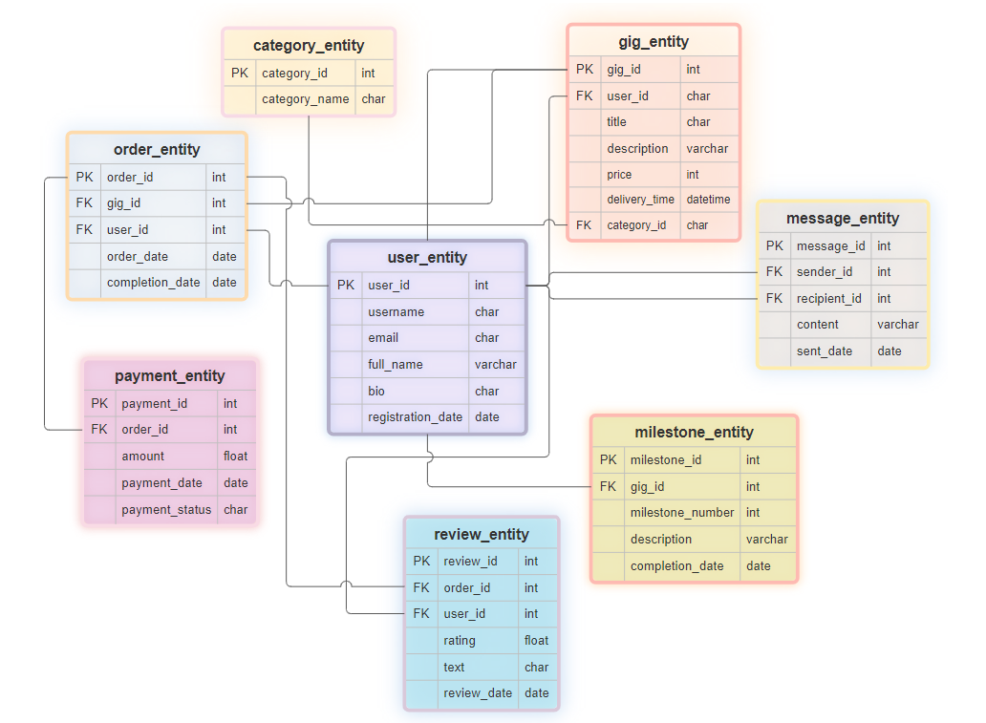

**Conclusion**

The case study on Fiverr’s schema and Entity-Relationship diagram highlights the platform's ability to connect clients with freelancers efficiently. By addressing key challenges such as finding reliable freelancers, accessing specialised skills, managing project-based work, and ensuring trust, Fiverr has established itself as a significant player in the freelance marketplace. The detailed data model, comprising entities like users, gigs, orders, reviews, and categories, supports Fiverr's operations and contributes to its success in the gig economy.