To Whom It May Concern,

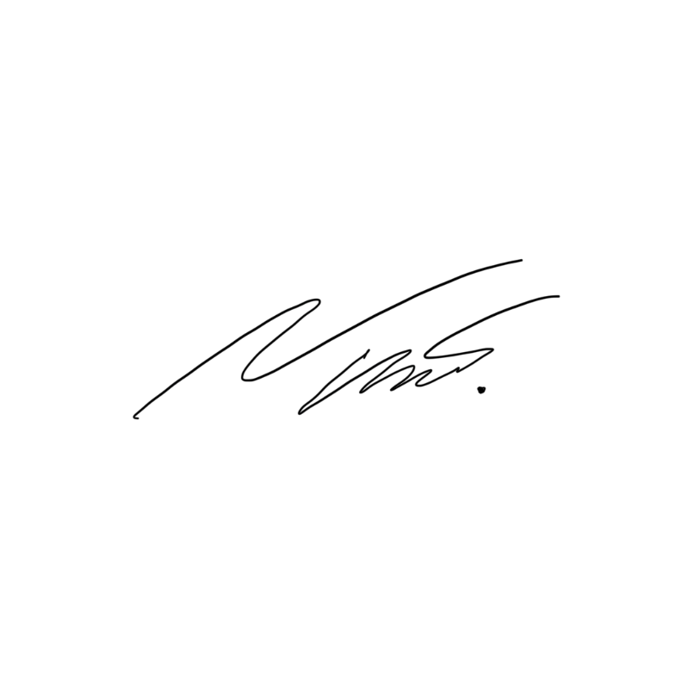
Yours faithfully,

Napa Arinaphat
Director
24 April 2025

