To Whom It May Concern,

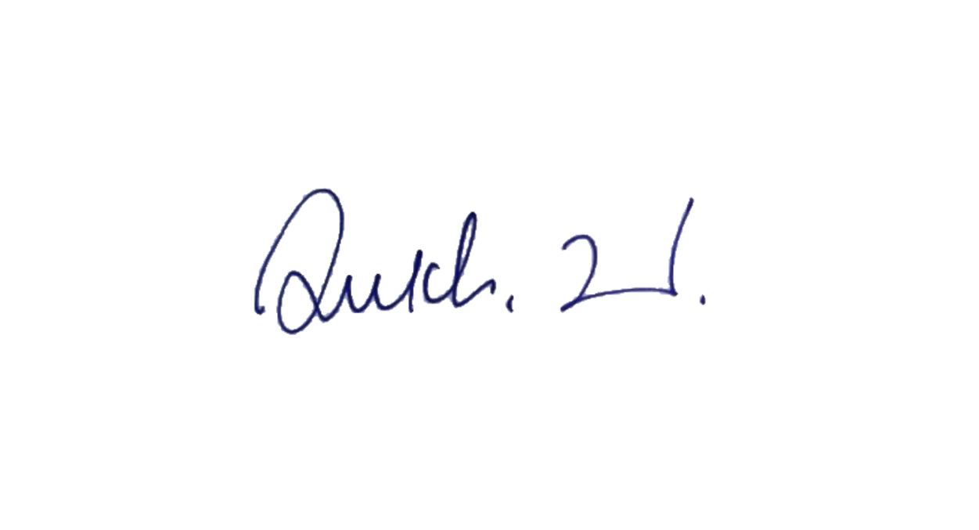

Yours faithfully,

Sukhwinder Singh
Director
24 April 2025

