**EXERCISE -> 3,4**

**NAME: KAUSHAL BAGHEL ROLL NO : 21MAI0003**

**EXERCISE-3**

**Operators and Functions**

**Aim: To understand different operators and types of function in SQL**

1. Find the employee names whose salary lies in the range between 30000 and 70000.

SELECT FIRST_NAME,MID_NAME,LAST_NAME FROM EMPLOYEE

WHERE SALARY BETWEEN 30000 AND 70000;

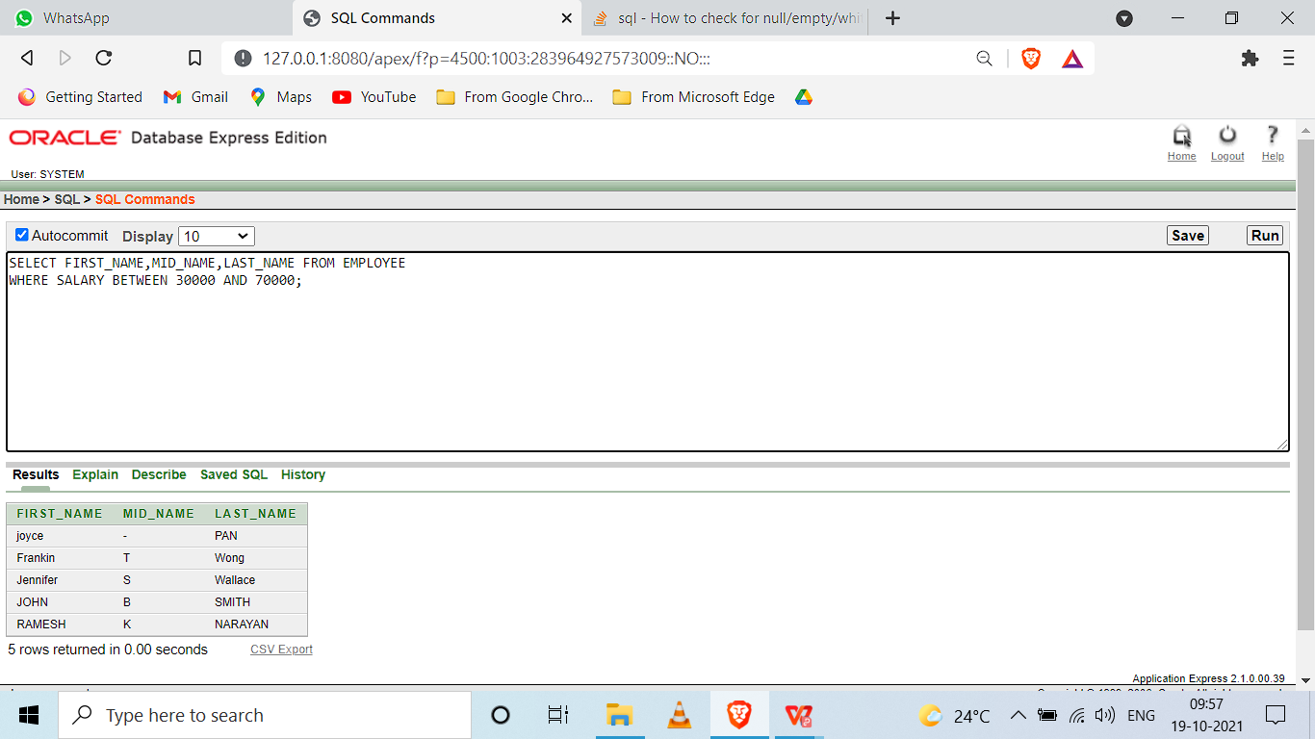

1. Find the employees who have no supervisor.

SELECT FIRST_NAME,MID_NAME,LAST_NAME FROM EMPLOYEE

WHERE SUPERVISOR_SSN IS NULL;

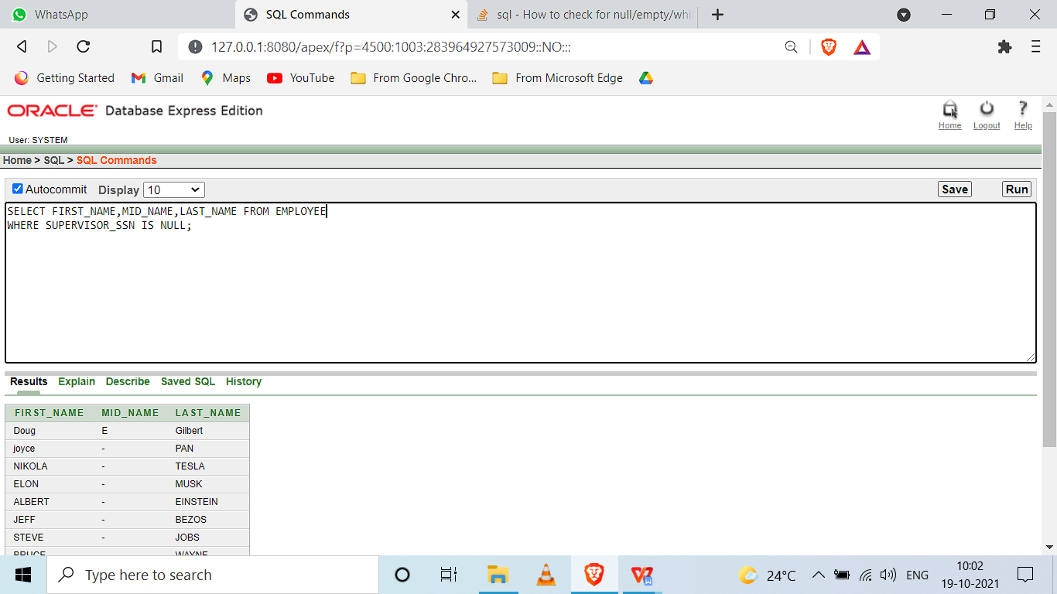

1. Display the bdate of all employees in the format ‘DDthMonthYYYY’.

select to_char (birthday, 'ddth "of" fmmonth yyyy') from employee;

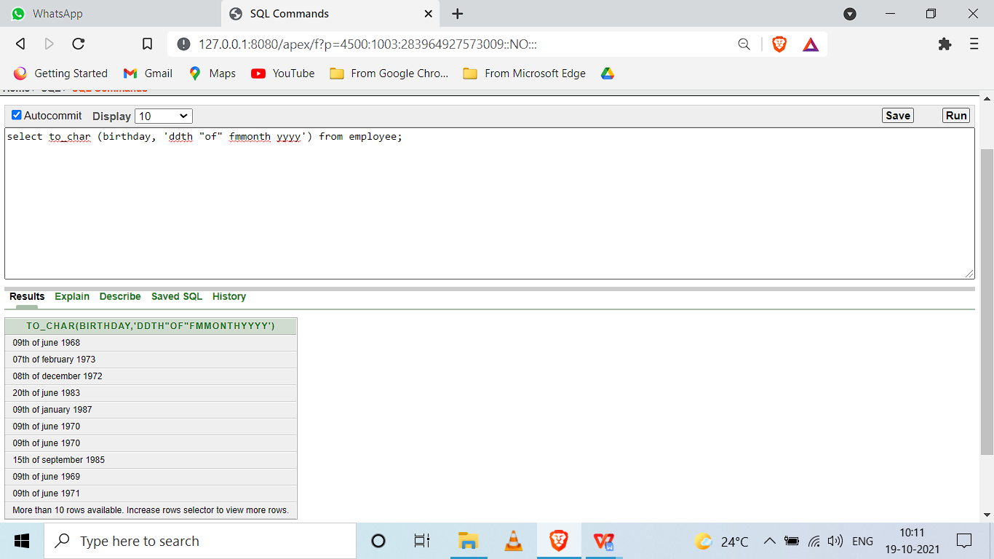

1. Display the employee names whose bdate is on or before 1978.

SELECT FIRST_NAME,LAST_NAME,BIRTHDAY

FROM EMPLOYEE

WHERE BIRTHDAY<('01-JAN-1978');

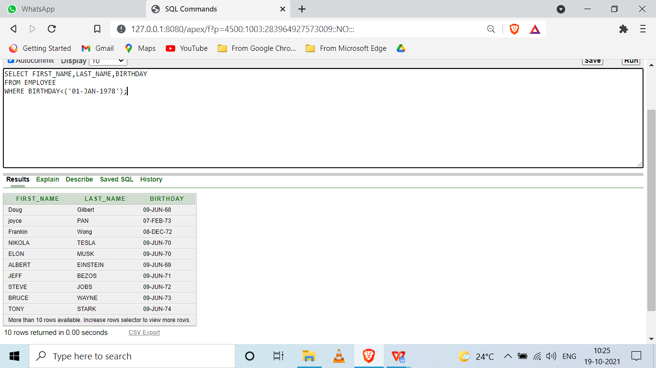

1. Display the department name that starts with ’M’.

select dept_name from dept where dept_name like 'M%';

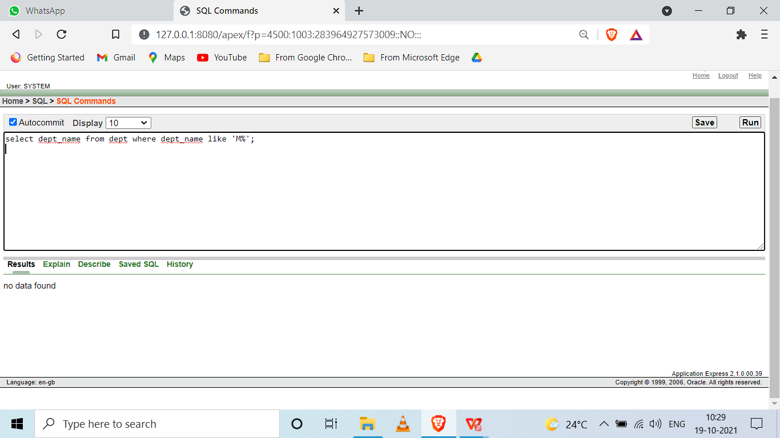

1. Display the department names’ that ends with ‘E’.

select dept_name from dept where dept_name like '%E';

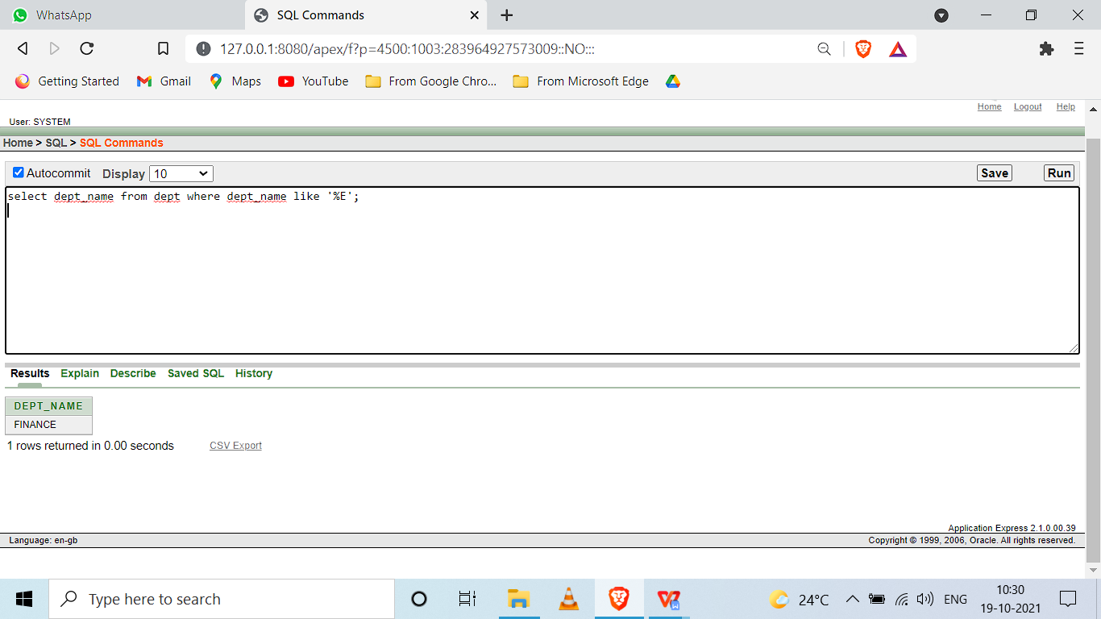

1. Display the names of all the employees having supervisor with any of the following SSN 123, 124

SELECT FIRST_NAME,MID_NAME,LAST_NAME FROM EMPLOYEE

WHERE SUPERVISOR_SSN IN ('123','124');

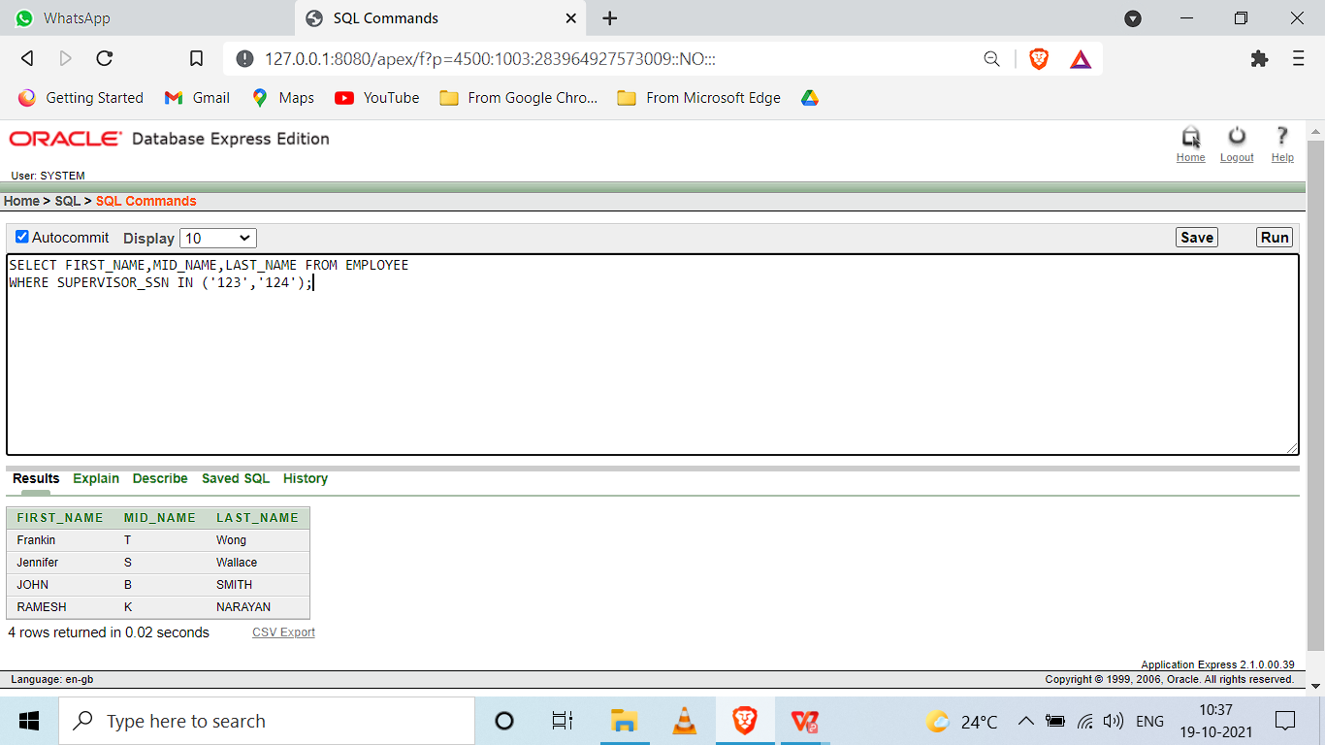

1. Display all the department names in upper case and lower case.

select lower(DEPT_NAME) from DEPT;

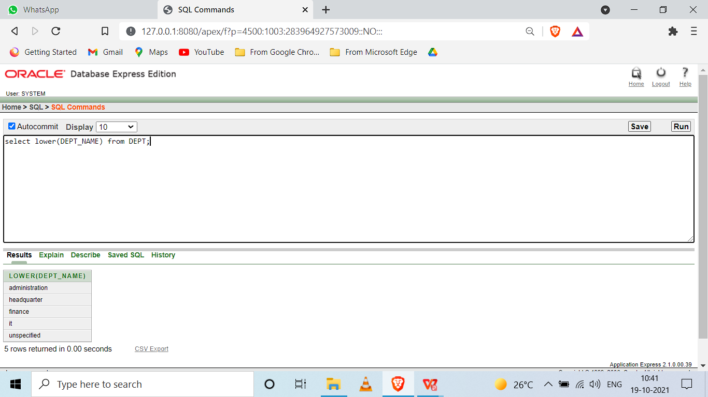

select UPPER(DEPT_NAME) from DEPT;

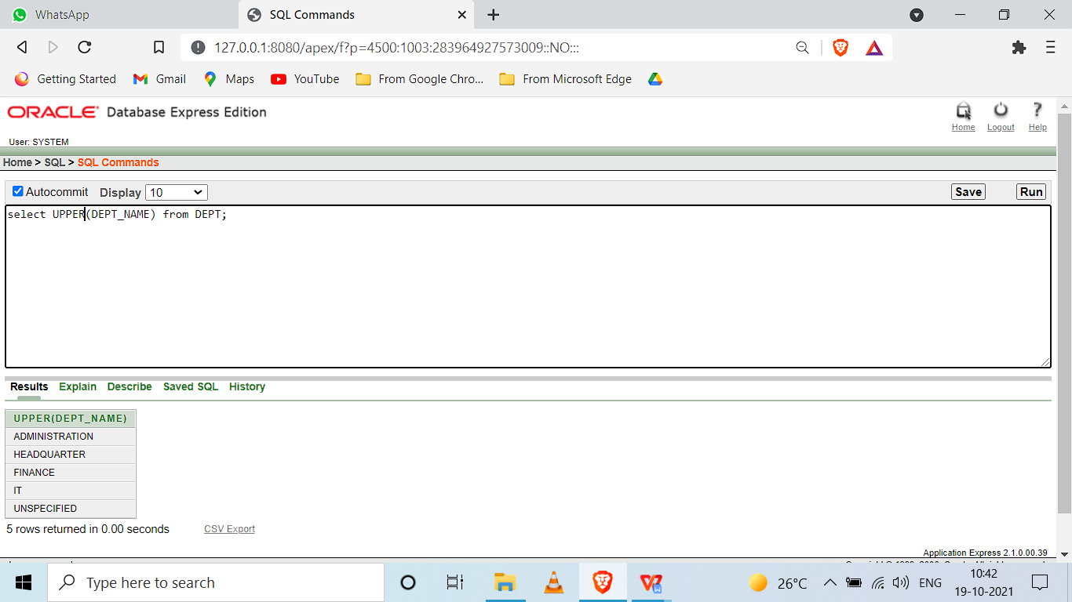

1. Display the first four characters and last four of the department names using substring function

select DEPT_NAME,SUBSTR(DEPT_NAME,4) from DEPT;

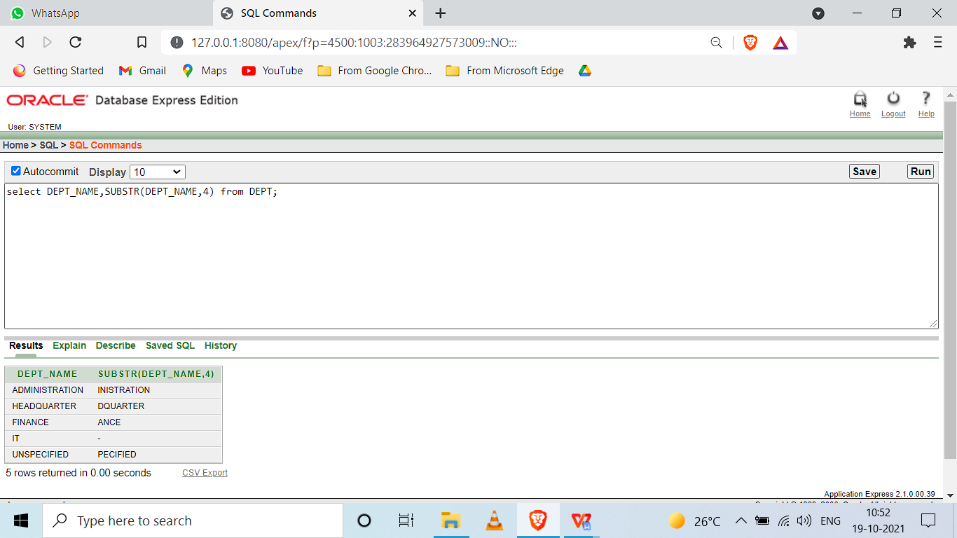

select DEPT_NAME,SUBSTR(DEPT_NAME,-4) from DEPT;

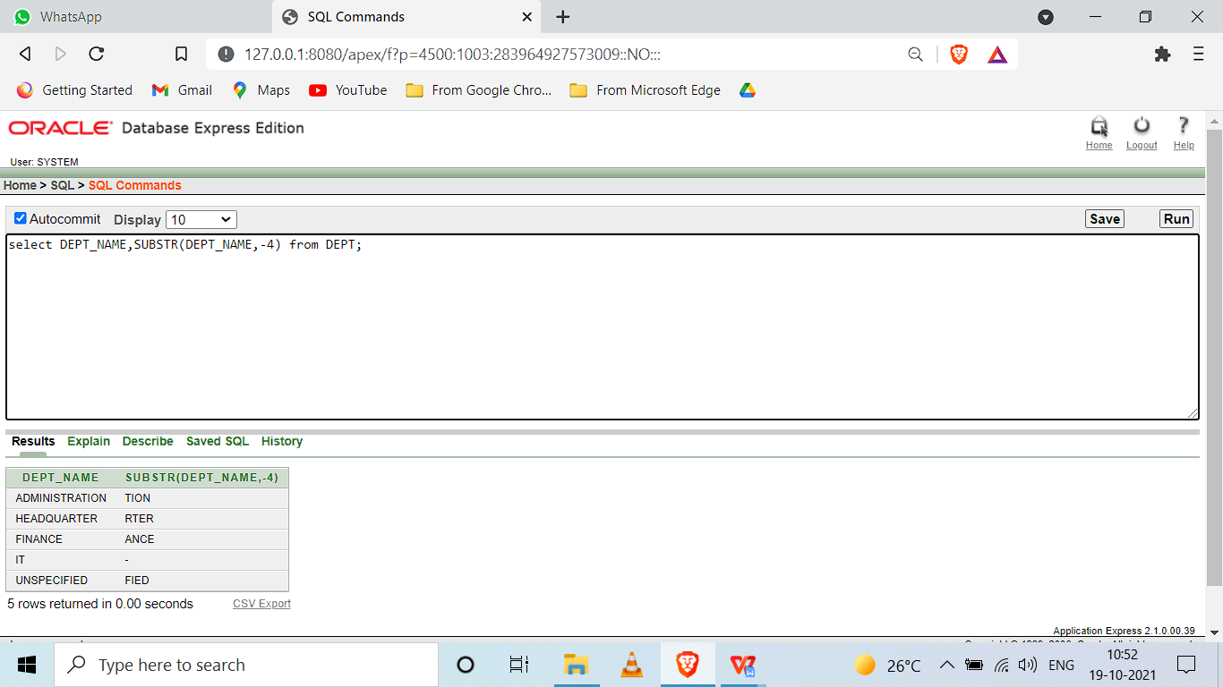

1. Display the substring of the Address (starting from 5th position to 11 th position) of all employees

select ADDRESS,SUBSTR(ADDRESS,5,11) from EMPLOYEE;

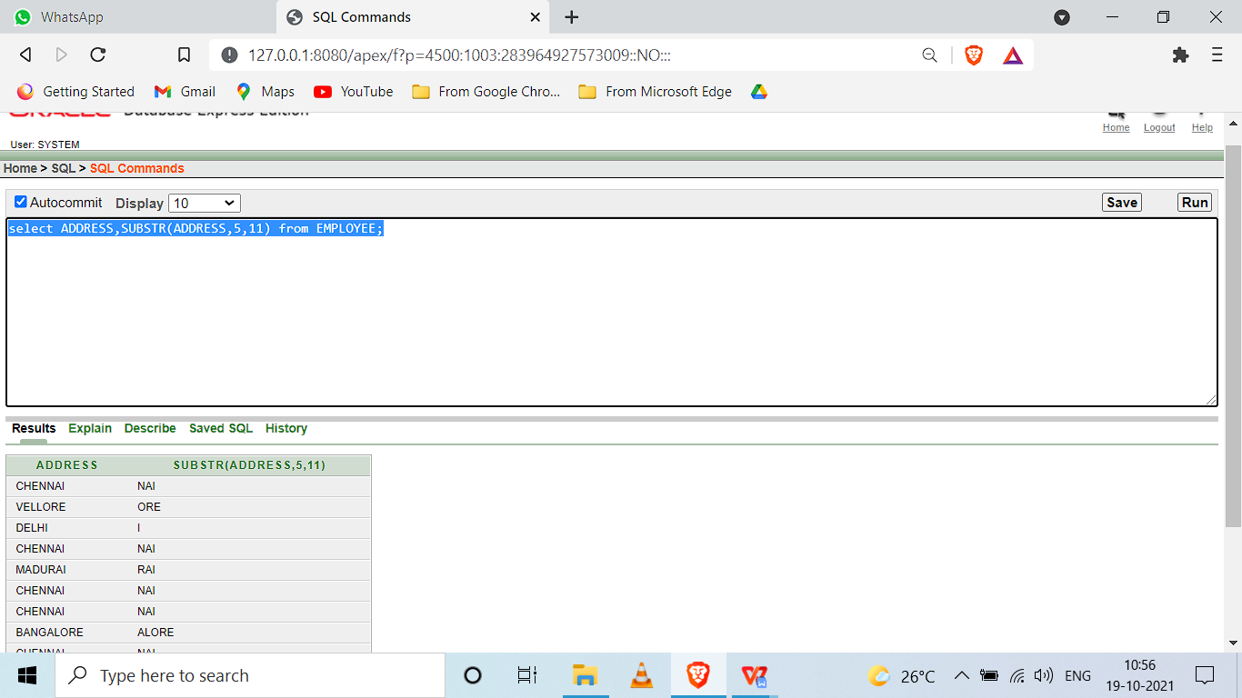

1. Display the Mgrstartdate on adding three months to it.

SELECT MANAGESTARTDATE,ADD_MONTHS(MANAGESTARTDATE,3) FROM DEPT;

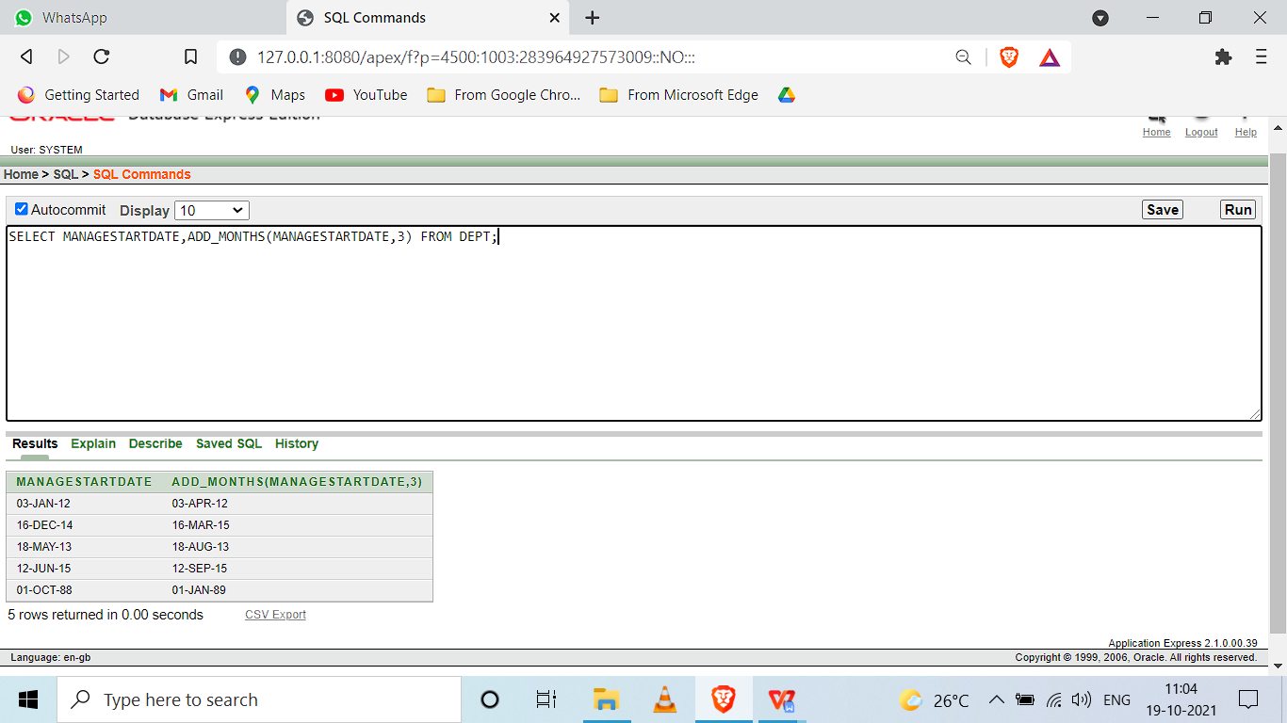

1. Display the age of all the employees rounded to two digits.

select FIRST_NAME,LAST_NAME,ROUND((months_between(sysdate,BIRTHDAY))/12) from employee;

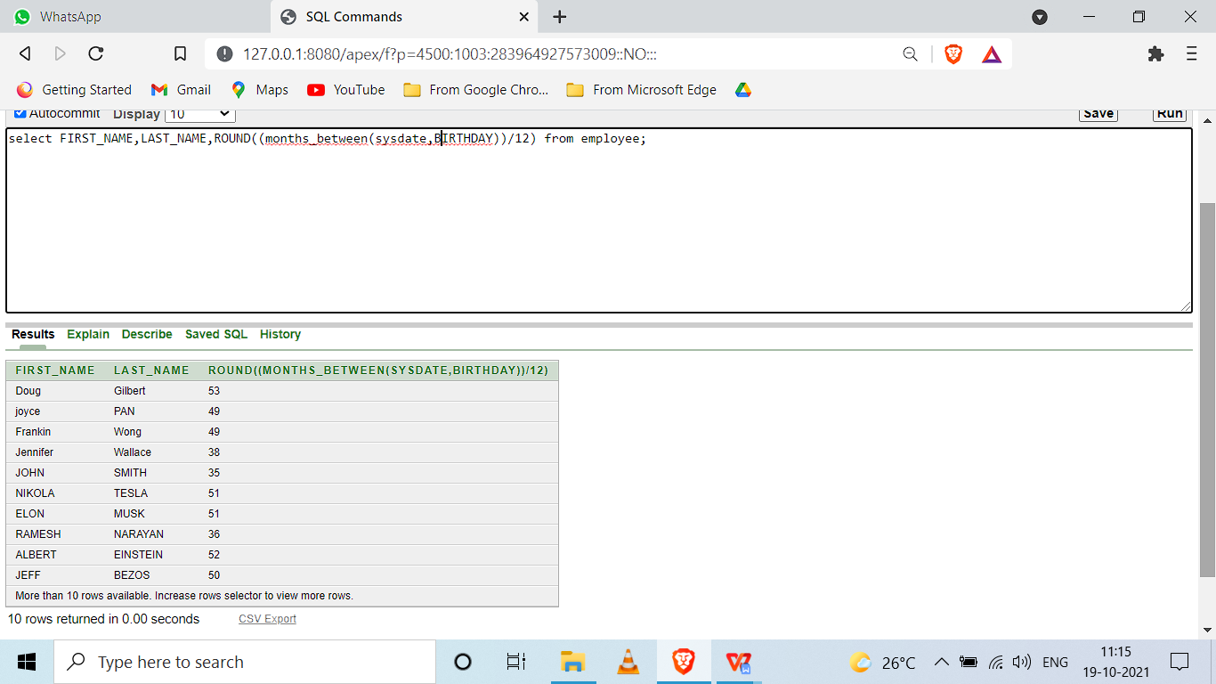

1. Find the last day and next day of the month in which each manager has joined.

select LAST_DAY(MANAGESTARTDATE) from DEPT;

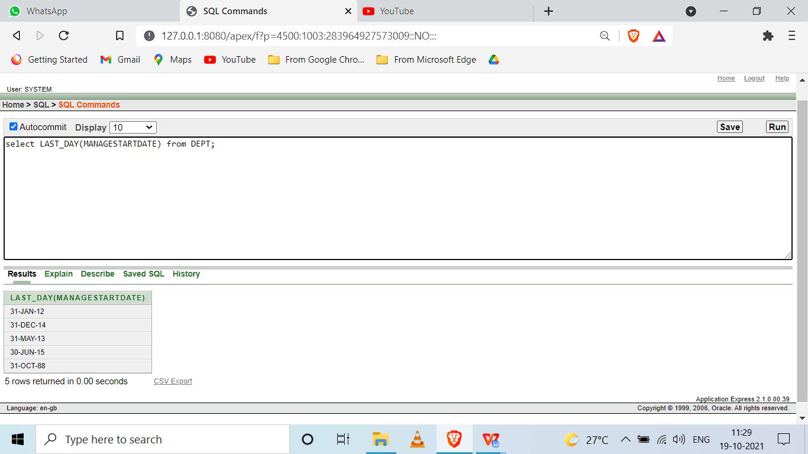

select NEXT_DAY(MANAGESTARTDATE,'SUNDAY') from DEPT;

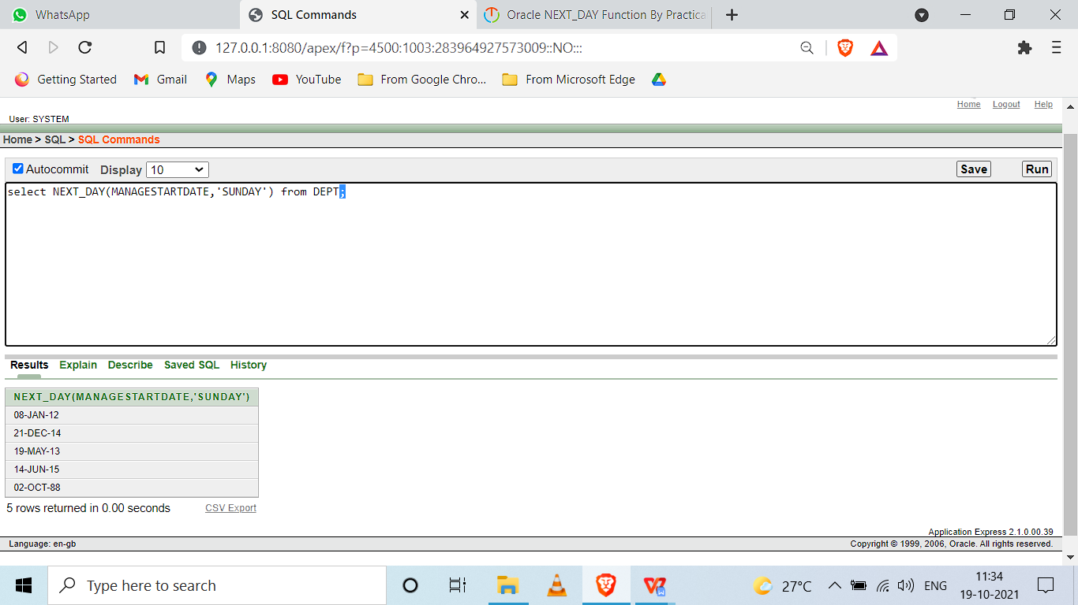

1. Print a substring from the string ‘Harini’.

SELECT SUBSTR('HARINI',3,4) "Substring"

FROM DUAL;

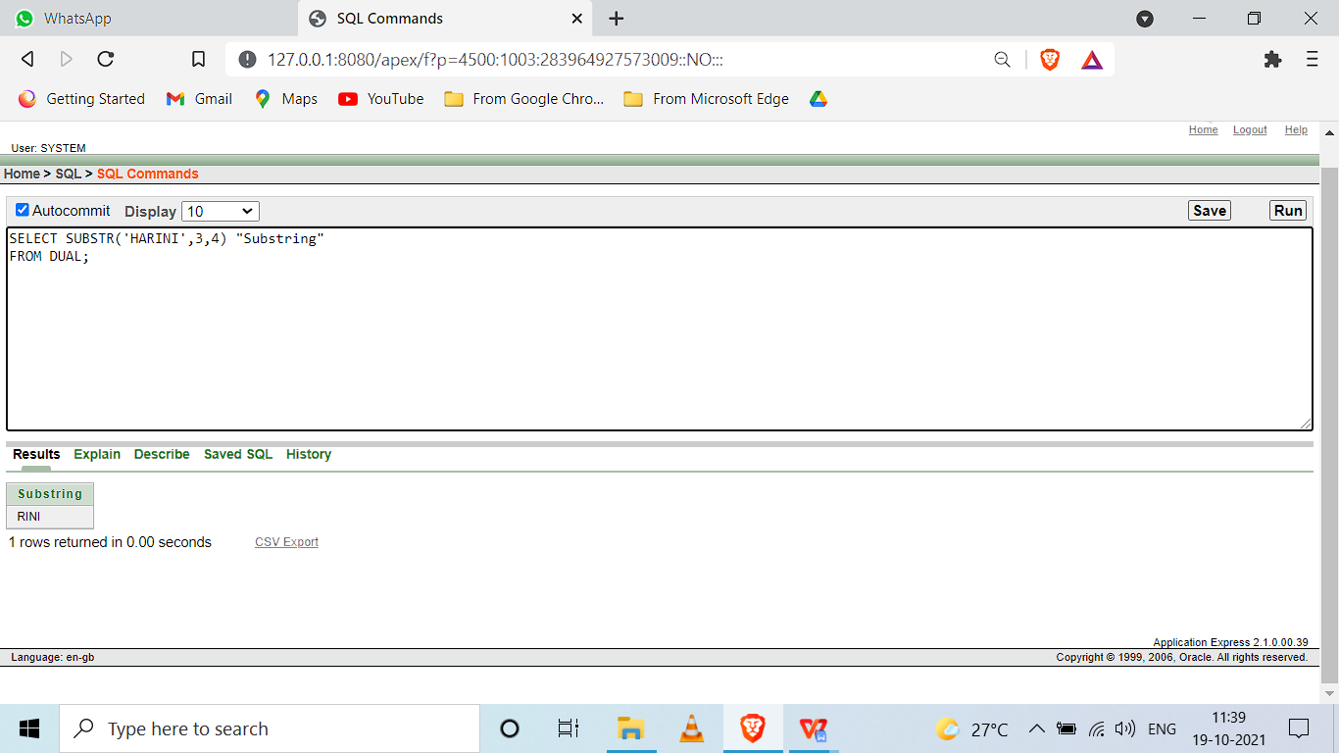

1. Replace the string ‘ni’ from ‘Harini’ by ‘sh’

SELECT REPLACE('HARINI','NI','SH') FROM DUAL;

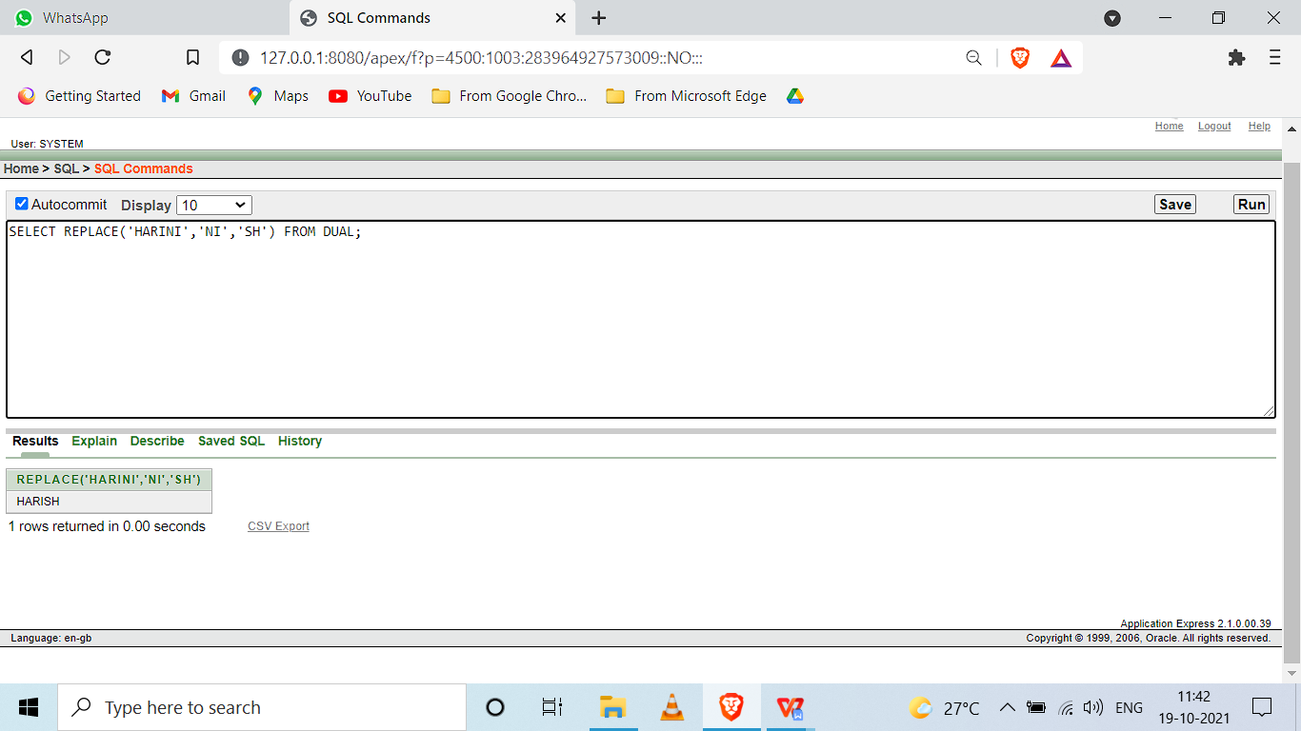

1. Print the length of all the department names.

SELECT DEPT_NAME,LENGTH(DEPT_NAME) FROM DEPT;

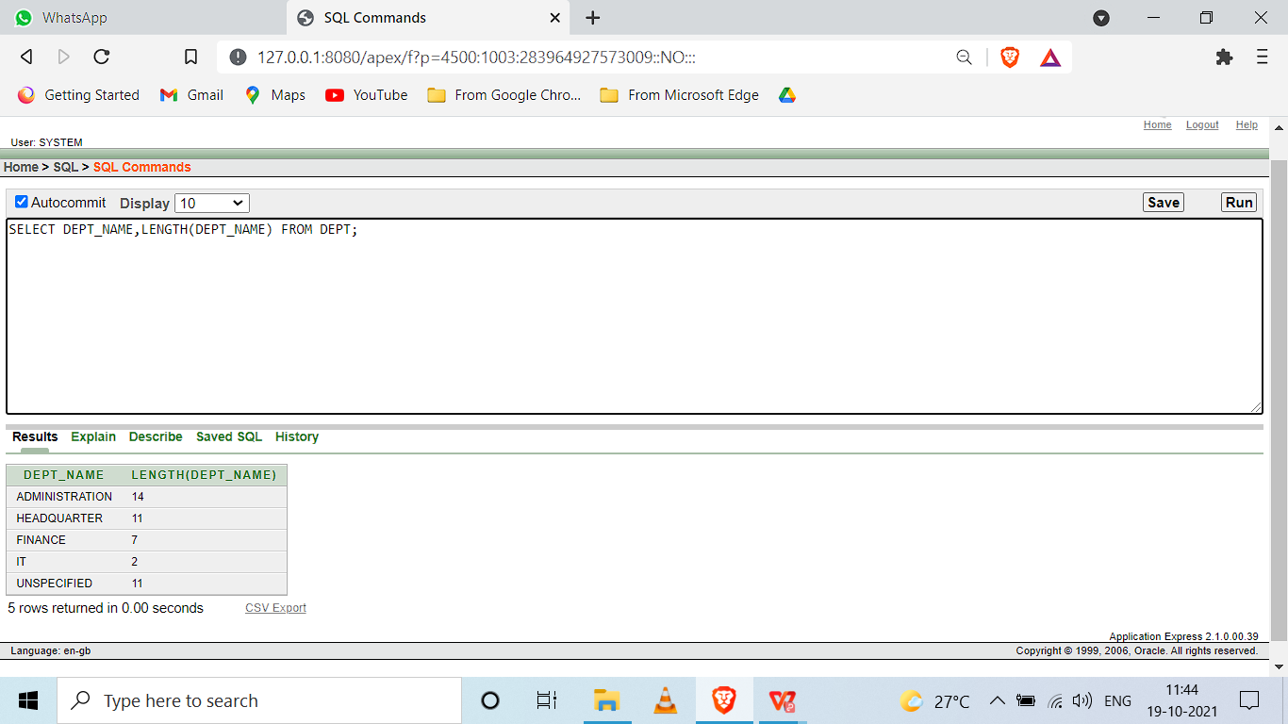

1. Display the date after 10 months from current date.

SELECT ADD_MONTHS(SYSDATE,10) FROM DUAL;

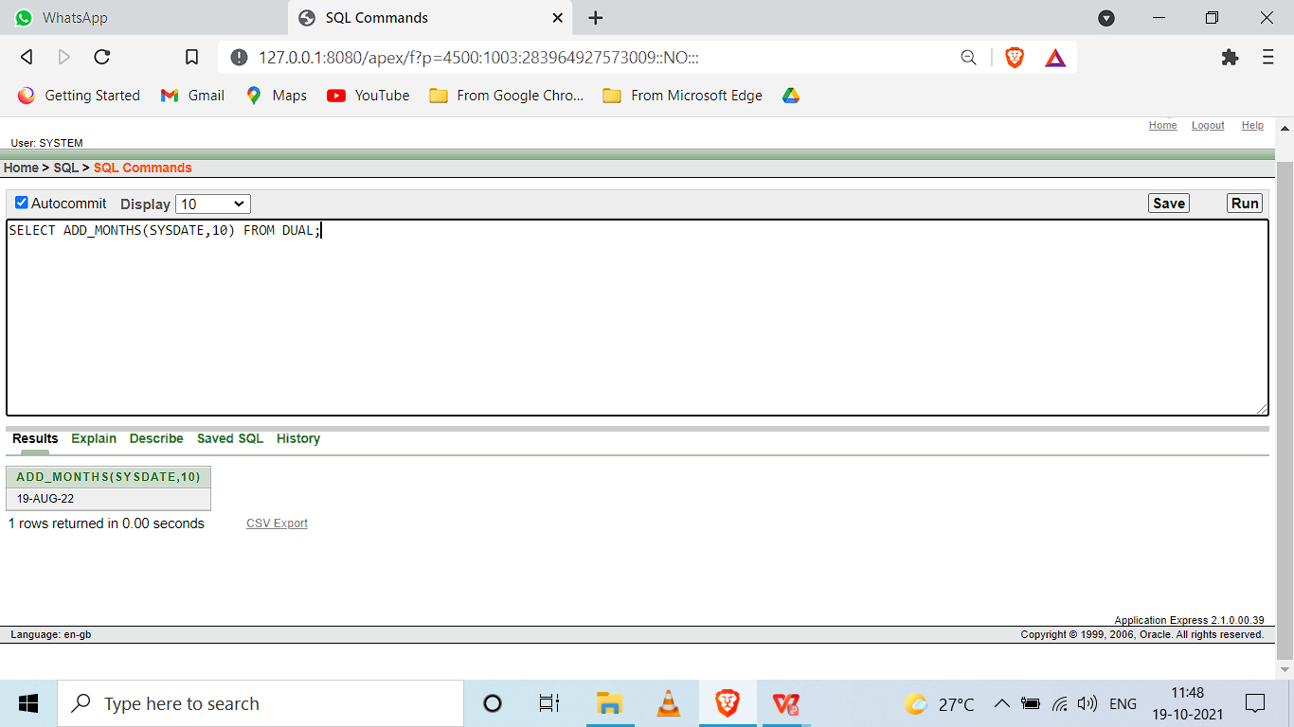

1. Display the next occurrence of Friday in this month.

SELECT NEXT_DAY(SYSDATE,'FRIDAY') FROM DUAL;

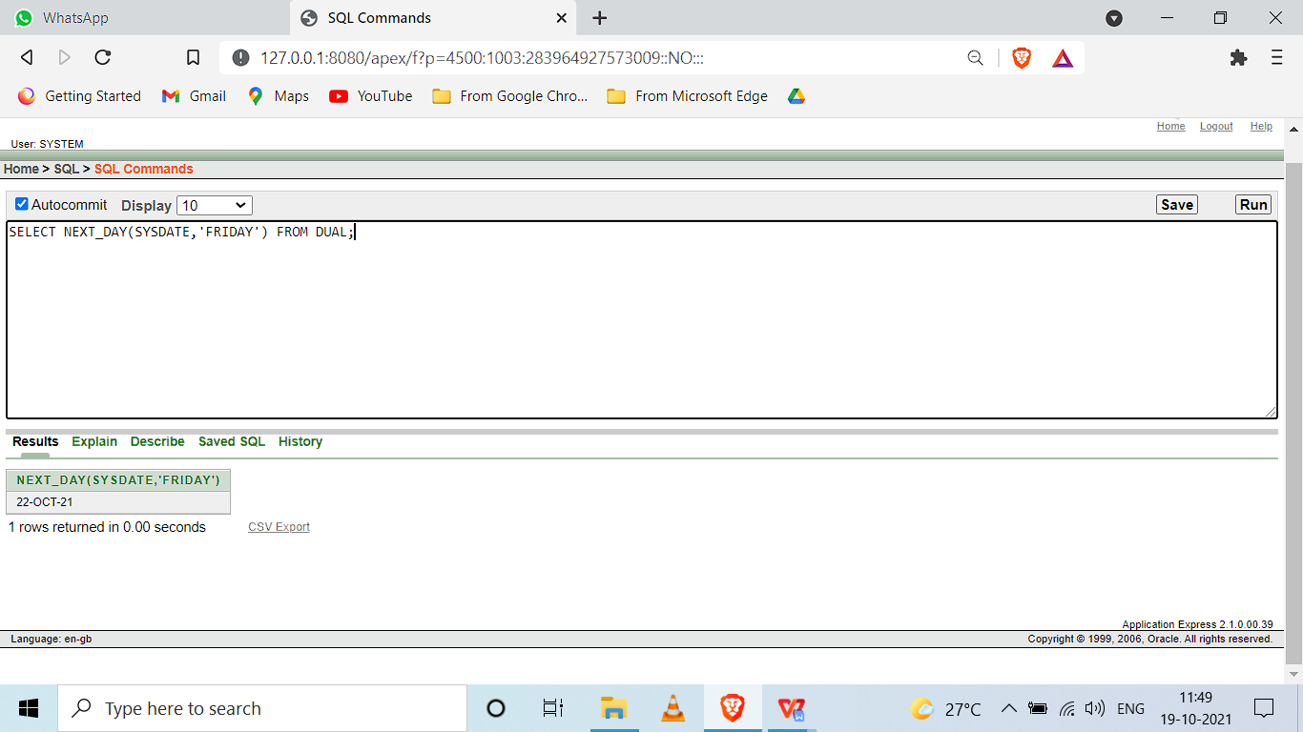

1. Display the project location padded with **** on left side.

select lpad(PROJECTLOCATION,15,'*') lpd from PROJECT;

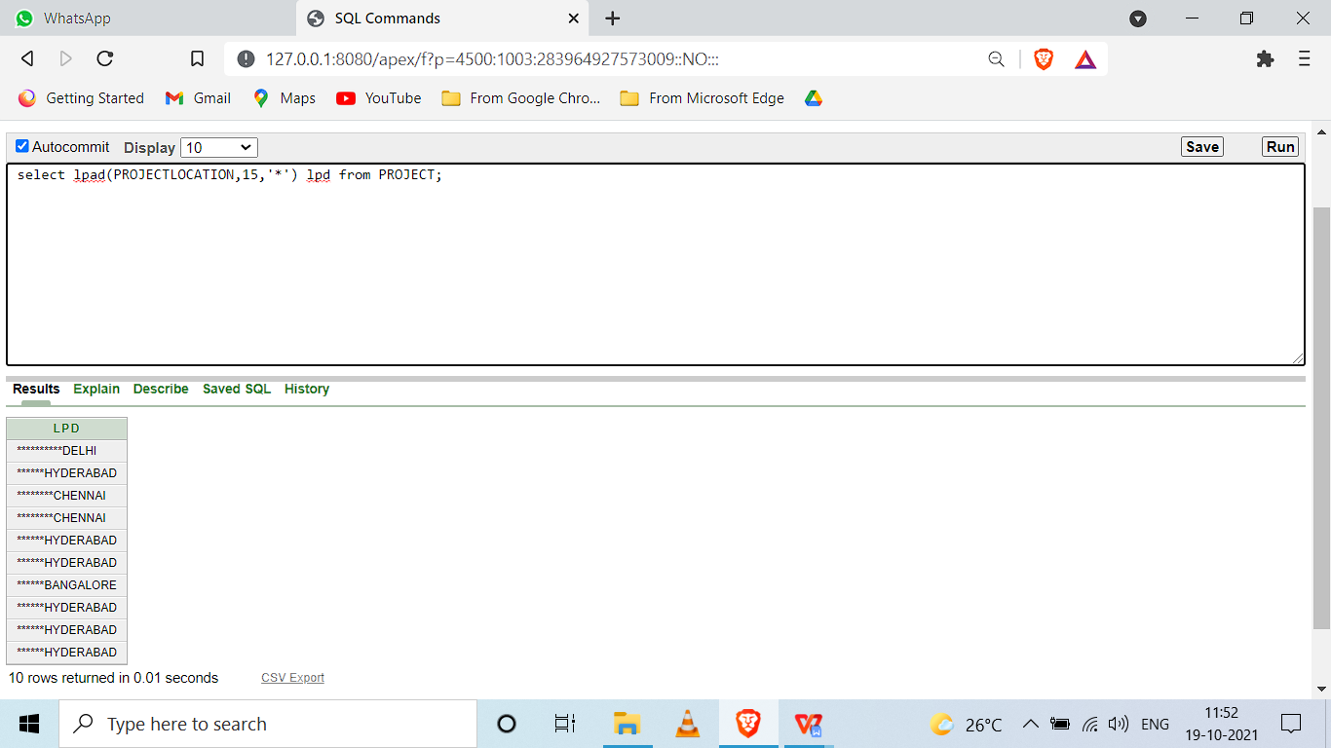

**Exercise: IV**

**Group Functions**

1. How many different departments are there in the ‘employee’ table

SELECT COUNT(*) FROM DEPT;

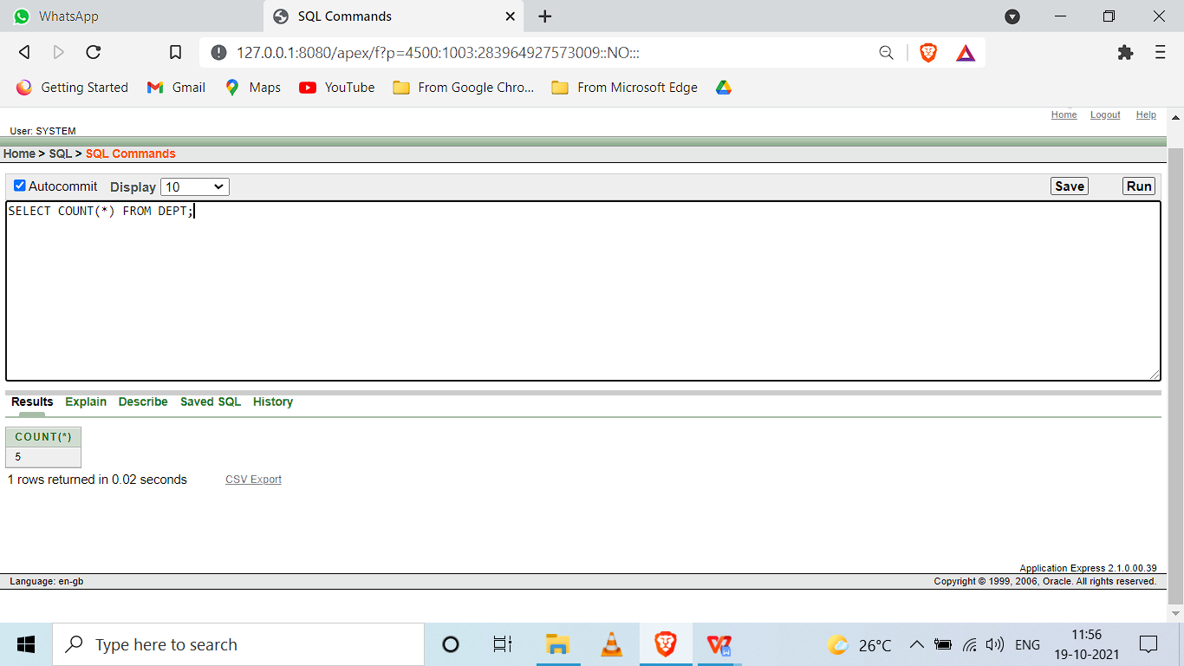

1. For each department display the minimum and maximum employee salaries

SELECT MIN(SALARY) FROM EMPLOYEE;

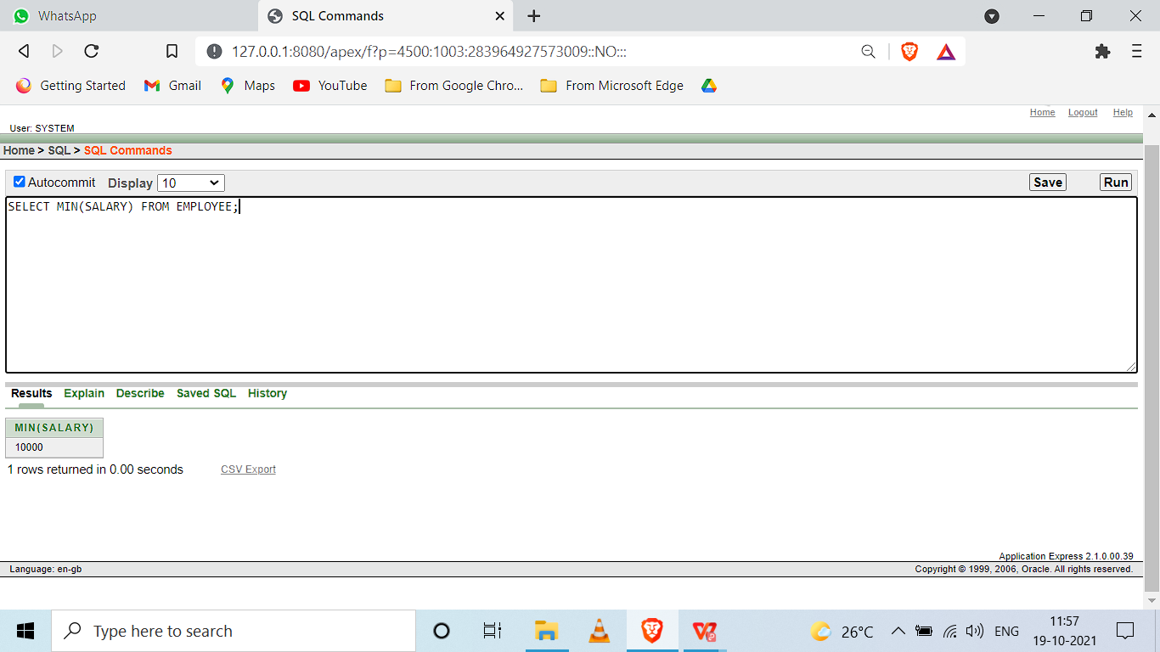

SELECT MAX(SALARY) FROM EMPLOYEE;

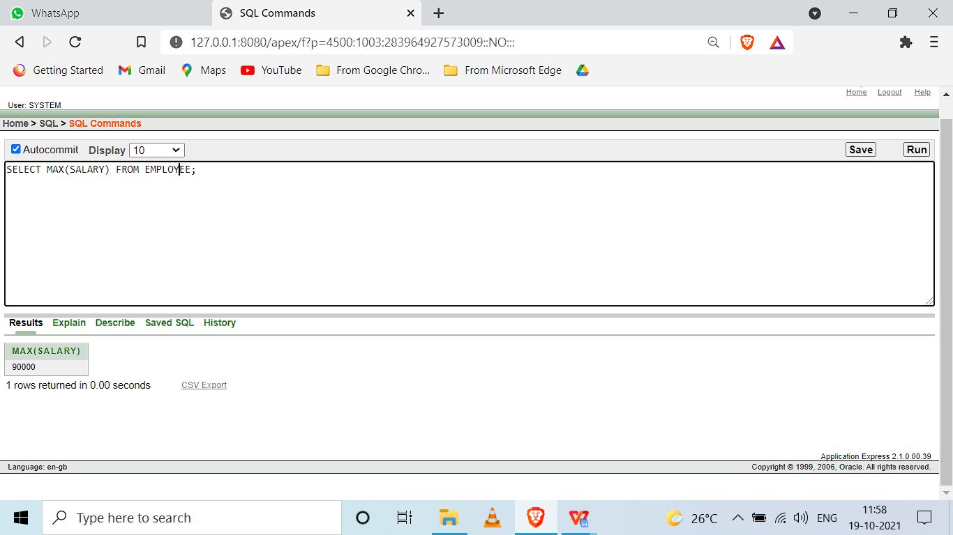

1. Print the average annual salary.

SELECT ROUND(AVG(SALARY)) FROM EMPLOYEE;

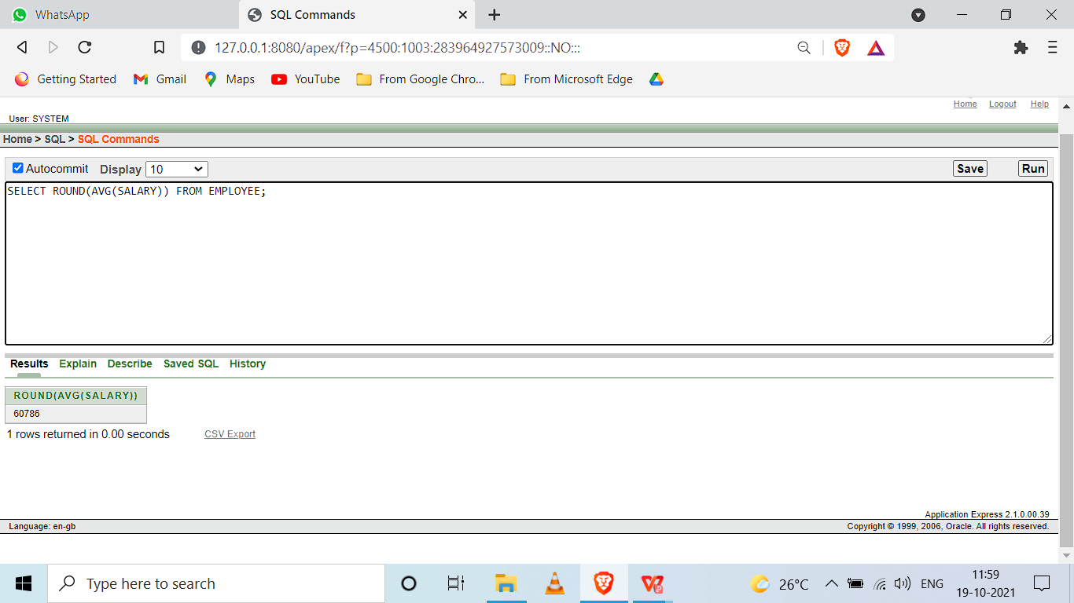

1. Count the number of employees over 30 age

select count(ssn_number) from employee where (abs(extract(year from sysdate)-(extract(year from birthday)))>30);

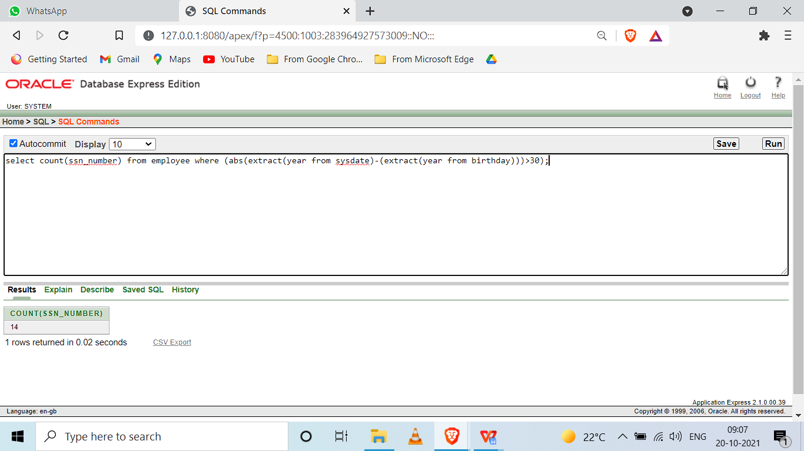

1. Print the Department name and average salary of each department

select dept_number, avg(salary) from employee group by dept_number;

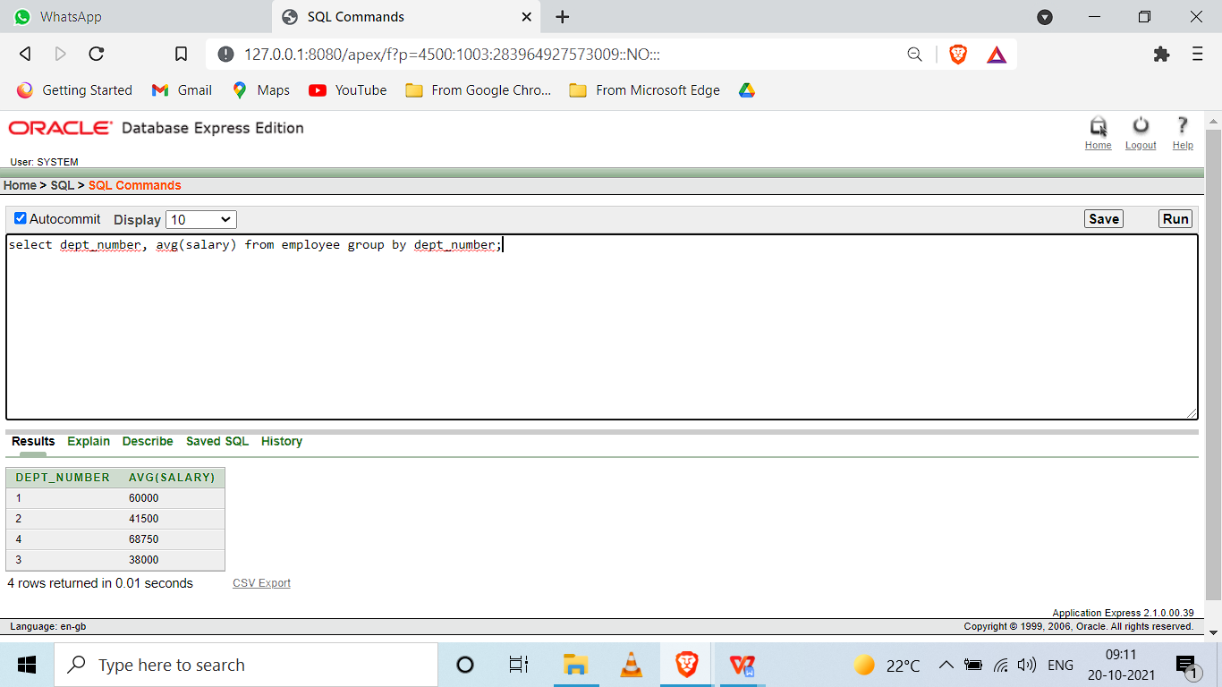

1. Display the department name which contains more than 2 employees.

select dept_name

from dept,employee

where dept.dept_no=employee.dept_number

group by(dept_name)

having count(ssn_number)>2;

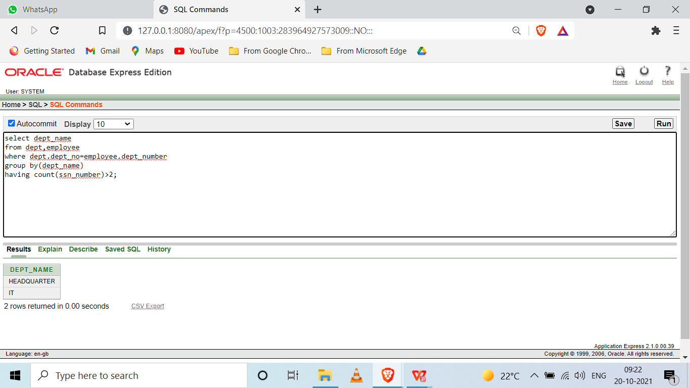

1. Calculate the average salary of employees by department and age

select distinct dept_number,months_between(sysdate,birthday)/12,avg(salary) from employee group by dept_number,months_between(sysdate,birthday)/12;

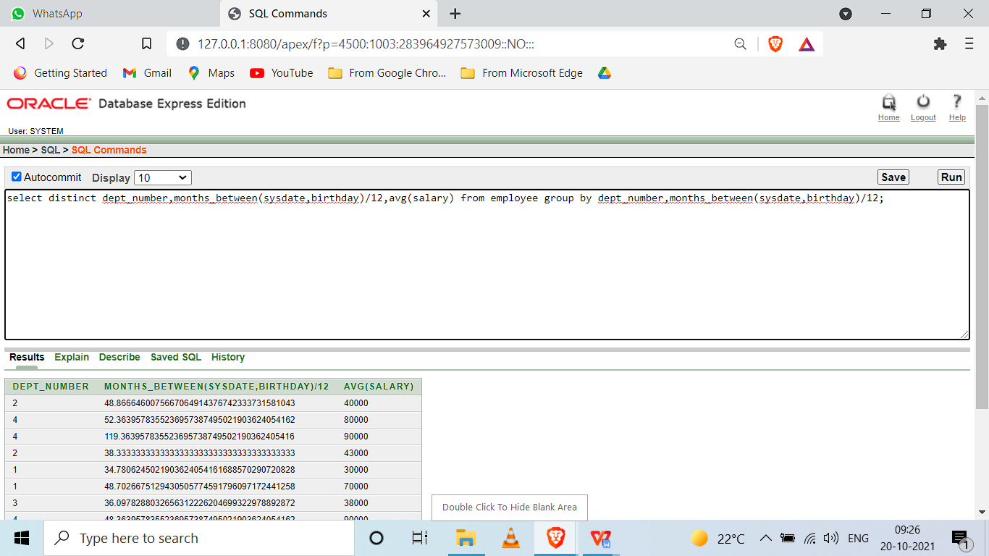

1. Count separately the number of employees in the finance and administration department.

select count(ssn_number) from employee where dept_number = (select dept_no from dept where dept_name='FINANCE');

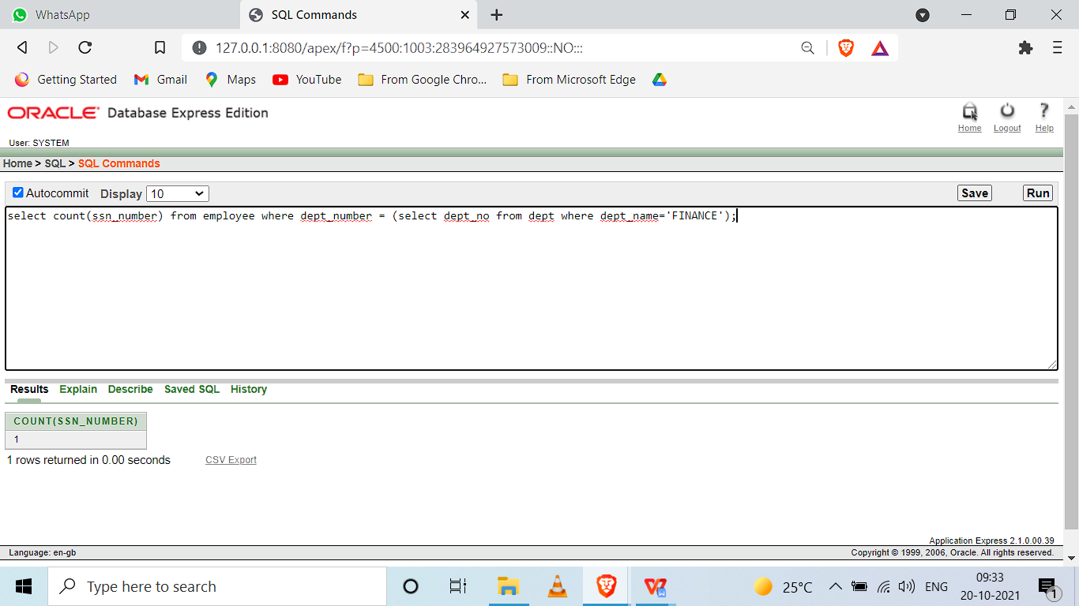

select count(ssn_number) from employee where dept_number = (select dept_no from dept where dept_name='ADMINISTRATION');

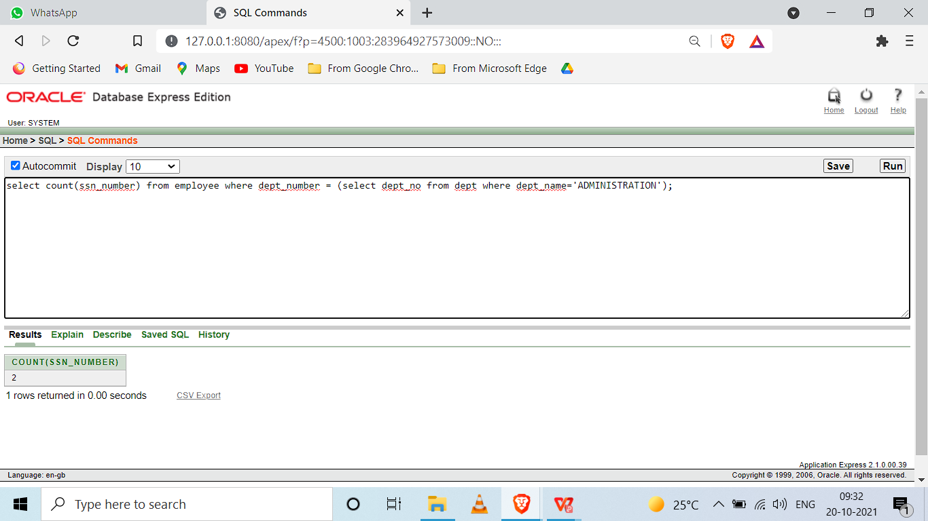

1. List out the employees based on their seniority.

select first_name,last_name,months_between(sysdate,birthday)/12 from employee order by months_between(sysdate,birthday)/12 desc;

