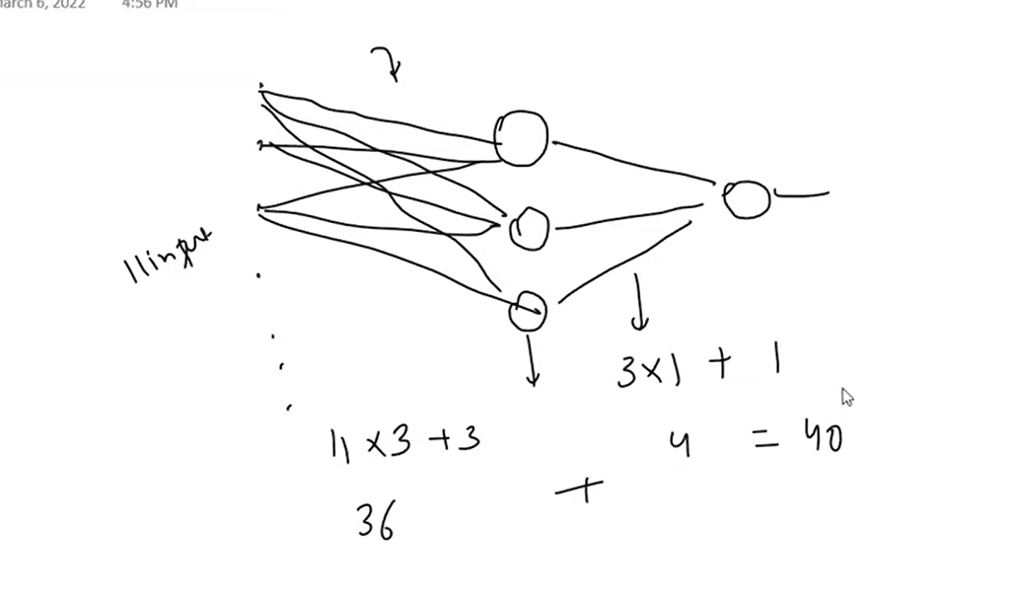

Neural Network has 3 layers

1. input layer

2.hidden layer

3.output layer