**PRACTICAL - 01**

**Aim: - A] Install and configure PHP, Web Server and MySQL database**

**Using XAMPP/WAMP/LAMP/MAMP.**

**STEP 1-** Open any web browser and visit <https://www.apachefriends.org/index.html>. On the home page, you can find the option to download XAMPP for three platforms- Windows, MAC, and [Linux](https://www.javatpoint.com/linux-tutorial). Click on **XAMPP for Windows**. The latest version available on the website is **7.4.5.**

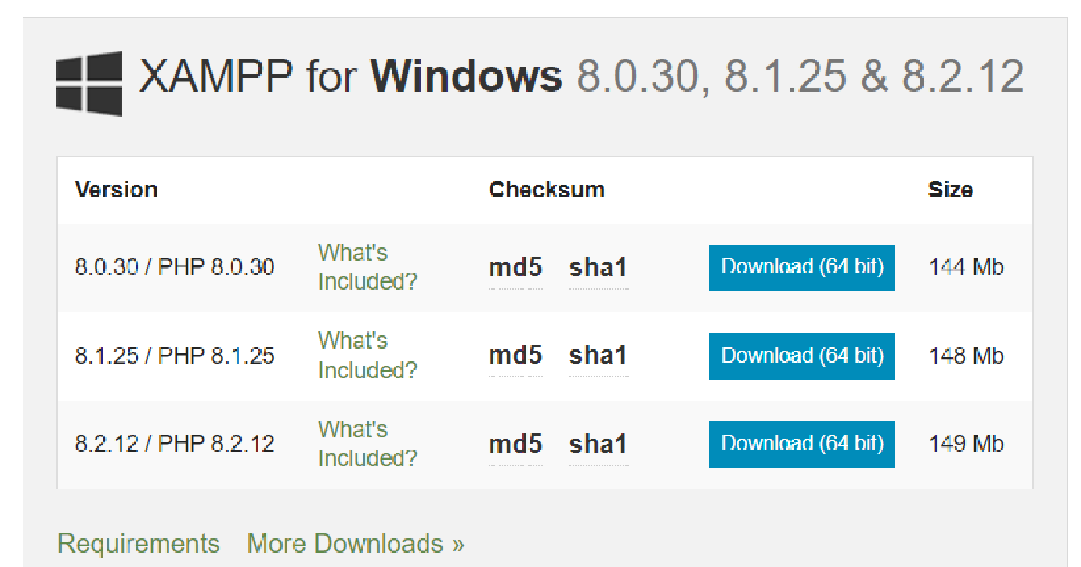

**STEP 2-** After the download is completed, double click the .exe extension file to start the process of installation.

**STEP 3-** A pop-up screen with the message asking you to allow making changes on your desktop appears. Click "YES" to continue the process.

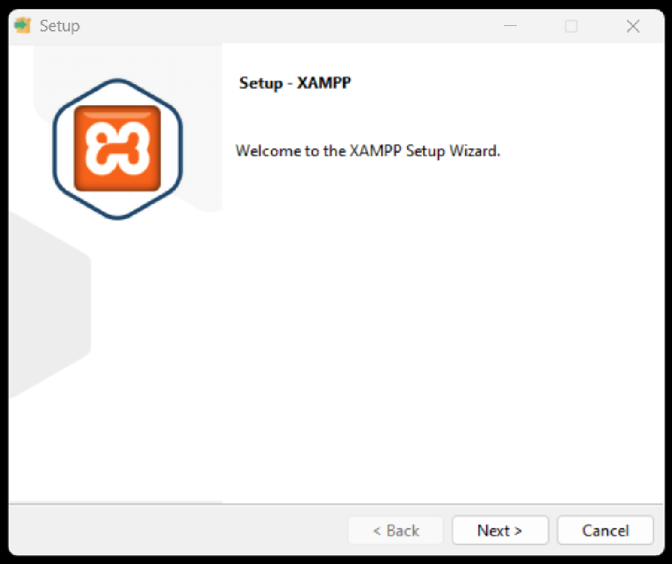

**STEP 4-** Click to **Allow access** or deactivate the firewall and any other antivirus software because it can hamper the process of installation. Thus, it is required to temporarily disable any antivirus software or security firewall till the time all the XAMPP components have been installed completely.

**STEP 5-** Just before the installation, a pop-up window appears with a warning to **disable UAC**. User Account Control (UAC) interrupts the XAMPP installation because it restricts the access to write to the C: drive. Therefore, it is suggested to disable it for the period of installation.

**STEP 6-** After clicking the .exe extension file, the XAMPP setup wizard opens spontaneously. Click on "NEXT" to start the configuration of the settings.

**STEP 7-** After that, a 'Select Components' panel appears, which gives you the liberty to choose amongst the separate components of the XAMPP software stack for the installation. To get a complete localhost server, it is recommended to install using the default options of containing all available components. Click "NEXT" to proceed further.

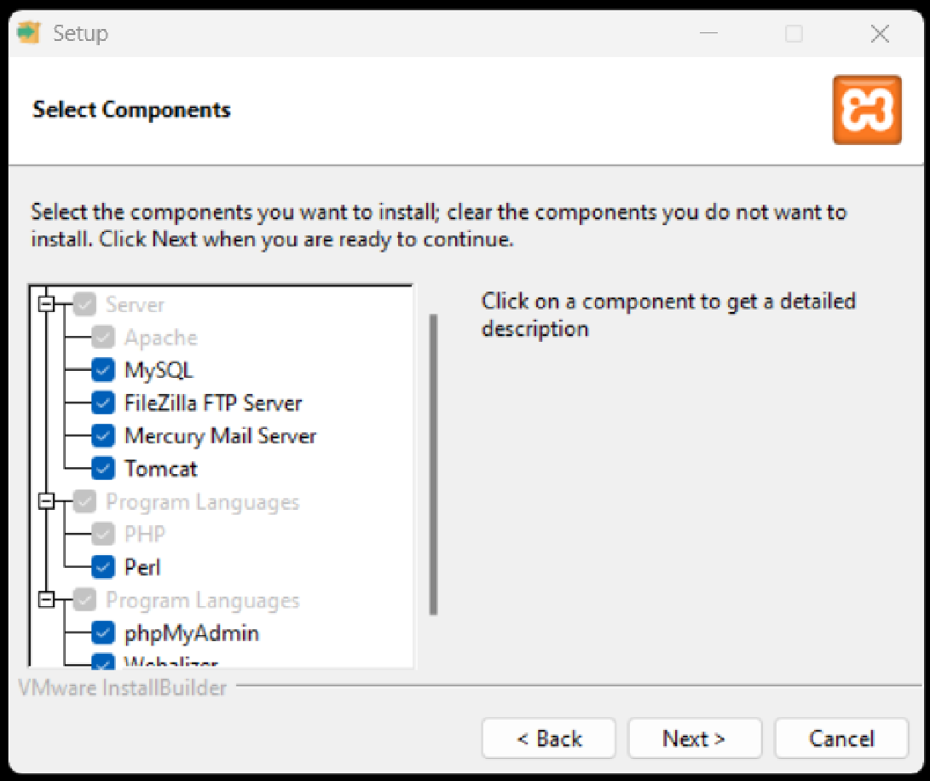

**STEP 8-** The setup is now ready to install, and a pop-up window showing the same appears on the screen. Click "NEXT" to take the process forward.

**STEP 9-** Select the location where the XAMPP software packet needs to be installed. The original setup creates a folder titled XAMPP under C:\ for you. After choosing a location, click "NEXT".

**STEP 11-** After the successful installation of the XAMPP setup on your desktop, press the "FINISH" button.

**Aim: - B] Create a web page that displays “Hello World.”**

**CODE: -**

<!DOCTYPE html>

<html>

<head>

<meta charset='utf-8'>

<meta http-equiv='X-UA-Compatible' content='IE=edge'>

<title>HELLO WORLD USING PHP</title>

<meta name='viewport' content='width=device-width, initial-scale=1'>

<style>

body

{

font-size: 28px;

text-align: center;

color: red;

}

</style>

</head>

<body>

<div class="container">

<?php echo "<h1>Hello World!</h1>"; ?>

</div>

</body>

</html>

**OUTPUT:-**

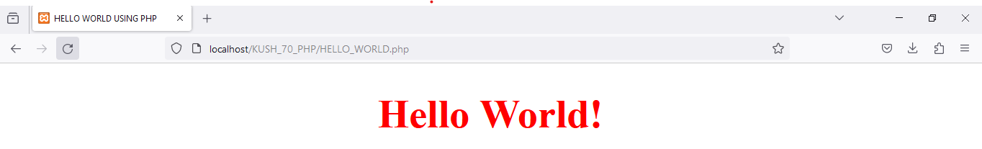

**PRACTICAL - 02**

**Aim: - Create a web page that collects user information using a form and displays it when the user clicks the submit button.**

**CODE:-**

<!DOCTYPE html>

<html>

<head>

<meta charset="UTF-8">

<meta http-equiv="X-UA-Compatible" content="IE=edge">

<meta name="viewport" content="width=device-width, initial-scale=1.0">

<title>USER INFORMATION FORM</title>

</head>

<body>

<div class="container">

<h1>User Information</h1>

<form action="" method = "POST" id="userForm">

<label for="name">Name:</label>

<input type="text" id="name" name="name" required placeholder = "Kush Amit Shah"><br>

<label for="age">Age:</label>

<input type="number" id="age" name="age" min="0" required placeholder = "17"><br>

<label for="age">Phone Number:</label>

<input type="number" id="pn" name="pn" min="0" required placeholder = "2260703070"><br>

<label for="age">Email:</label>

<input type="emial" id="email" name="email" required placeholder = "kush@bbit.ac.in"><br>

<label for="age">City:</label>

<input type="text" id="city" name="city" required placeholder = "Nadiad"><br>

<button type="submit">Submit</button>

</form>

<h2>KINDLY CHECK YOUR DETAILS:</h2>

<?PHP

if($_SERVER['REQUEST_METHOD'] == "POST"){

$name_final = filter_var($_POST['name']);

$age_final = filter_var($_POST['age'], FILTER_SANITIZE_NUMBER_INT);

$pn_final = filter_var($_POST['pn'], FILTER_SANITIZE_NUMBER_INT);

$email_final = filter_var($_POST['email'], FILTER_SANITIZE_EMAIL);

$city_final = filter_var($_POST['city']);

echo "<p>NAME : " .$name_final. " </p>";

echo "<p>AGE : " .$age_final. "</p>";

echo "<p>NAME : " .$pn_final. " </p>";

echo "<p>AGE : " .$email_final. "</p>";

echo "<p>CITY : " .$city_final. " </p>";

}

?></div></body></html>

**OUTPUT:-**

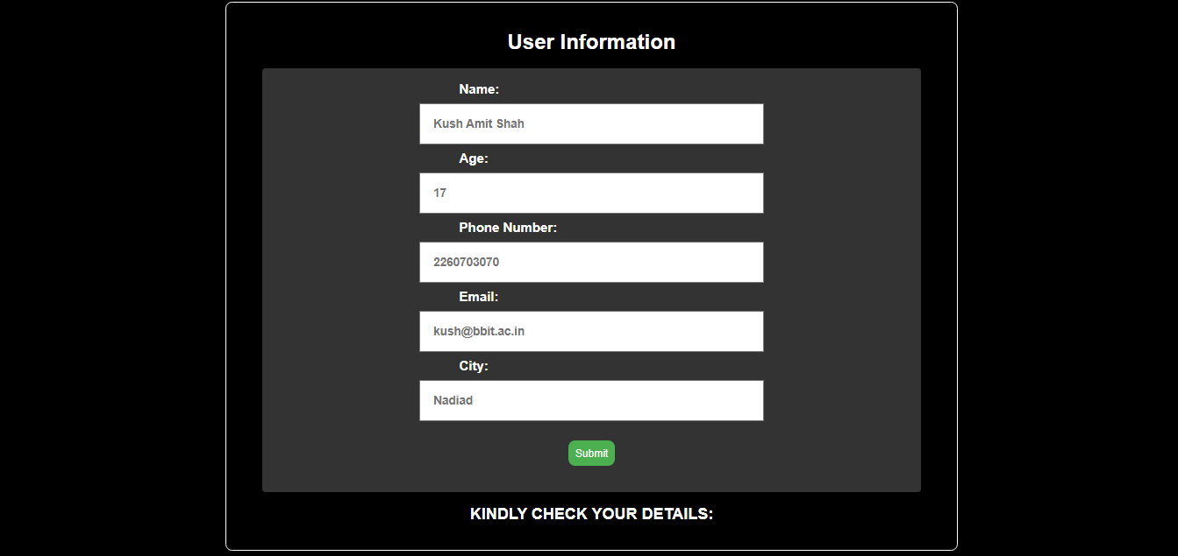



**PRACTICAL - 03**

**Aim: - A] Write a script to implement a simple calculator for mathematical operations.**

**CODE:-**

<!DOCTYPE html>

<html>

<head>

<meta charset="UTF-8">

<meta http-equiv="X-UA-Compatible" content="IE=edge">

<meta name="viewport" content="width=device-width, initial-scale=1.0">

<title>SIMPLE CALCULATOR</title>

<?php

$result = 0;

if(isset($_POST['var'])){

$num_1 = $_POST['num1'];

$num_2 = $_POST['num2'];

$operator = $_POST['var'];

if ($operator == "+") {

$result = $num_1 + $num_2;

}

else if ($operator == "-"){

$result = $num_1 - $num_2;

}

else if ($operator == "*"){

$result = $num_1 * $num_2;

}

else if ($operator == "/"){

$result = $num_1 / $num_2;

}

}

?>

</head>

<body>

<div class="container">

<form action="" method="POST">

<h1 style="color: red;">CALCULATOR</h1>

<label for="num1">ENTER THE FIRST NUMBER</label>

<input type="text" name="num1" placeholder="EG: 10" required><br>

<label for="num1">ENTER THE SECOND NUMBER</label>

<input type="text" name="num2" placeholder="EG: 20" required><br><br>

<button type="submit" name="var" value="+" required> + </button>

<button type="submit" name="var" value="-" required> - </button>

<button type="submit" name="var" value="*" required> * </button>

<button type="submit" name="var" value="/" required> / </button>

<h3>RESULT </h3><input type="text" value = "<?php echo $result ?>" readonly>

</form></div></body></html>

**OUTPUT:-**

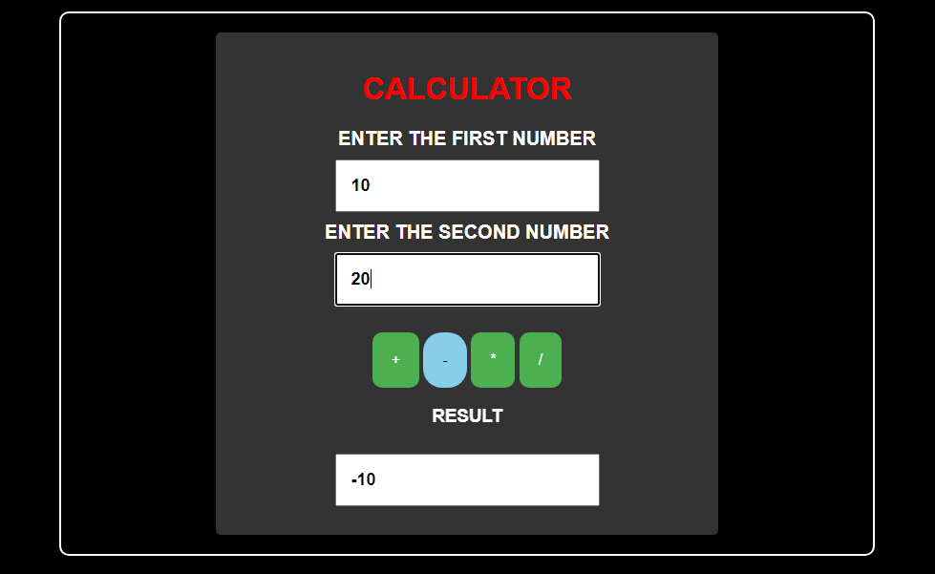

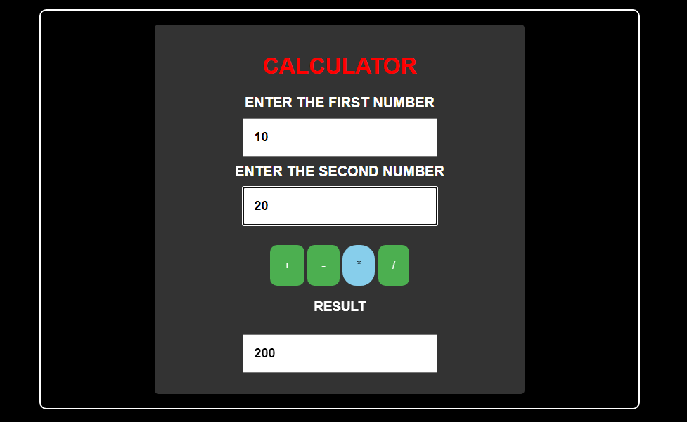

**Aim: - B] A company has following payment scheme for their staff:**

**a. Net Salary = Gross Salary – Deduction**

**b. Gross Salary = Basic pay + DA + HRA + Medical**

**c. Deduction = Insurance + PF**

**d. DA (Dearness Allowance) = 50% of Basic pay**

**e. HRA (House Rent Allowance) = 10% of Basic pay**

**f. Medical = 4% of Basic pay**

**g. Insurance = 7% of Gross salary**

**h. PF (Provident Fund) = 5% of Gross salary**

**Write a script to take the basic salary of an employee as input and calculate the net payment to any employee.**

**CODE:-**

<!DOCTYPE html>

<html>

<head>

<meta charset="UTF-8">

<meta http-equiv="X-UA-Compatible" content="IE=edge">

<meta name="viewport" content="width=device-width, initial-scale=1.0">

<title>SALARY CALCULATOR</title>

<?php

if (isset($_POST['SUB'])) {

$bs = $_POST['BS'];

$da = $hra = $med = $gs = $in = $pf = $ded = $fs = '';

$da = $bs * 0.50;

$hra = $bs * 0.10;

$med = $bs * 0.04;

$gs = $bs + $da + $hra + $med;

$in = $gs * 0.07;

$pf = $gs * 0.05;

$ded = $in + $pf;

$fs = $gs - $ded;

}

?>

</head>

<body>

<div class="container">

<form action="" method="POST">

<label for="age">BASIC SALARY (IN RUPEES):</label>

<input type="text" name="BS" placeholder="BASIC SALARY" value="<?php echo isset($bs) ? $bs : ''; ?>" required>

<button type="submit" name="SUB">CALCULATE</button>

</form>

</div>

<div class="container">

<label for="age">DEARNESS ALLOWANCE (IN RUPEES):</label>

<input type="text" name="DA" placeholder="DEARNESS ALLOWANCE" value="<?php echo isset($da) ? $da : ''; ?>" required>

<label for="age">HOUSE RENT ALLOWANCE (IN RUPEES):</label>

<input type="text" name="HRA" placeholder="HOUESE RENT ALLOWANCE" value="<?php echo isset($hra) ? $hra : ''; ?>" required>

<label for="age">MEDICAL ALLOWANCE (IN RUPEES):</label>

<input type="text" name="MED" placeholder="MEDICAL ALLOWANCE" value="<?php echo isset($med) ? $med : ''; ?>" required>

<label for="age">INSURANCE (IN RUPEES):</label>

<input type="text" name="IN" placeholder="INSURANCE" value="<?php echo isset($in) ? $in : ''; ?>" required>

<label for="age">PROVIDENT FUND (IN RUPEES):</label>

<input type="text" name="PF" placeholder="PROVIDENT FUND" value="<?php echo isset($pf) ? $pf : ''; ?>" required>

<label for="age">FINAL SALARY (IN RUPEES):</label>

<input type="text" name="FS" placeholder="FINAL SALARY" value="<?php echo isset($fs) ? $fs : ''; ?>" required>

</div></body></html>

**OUTPUT:-**

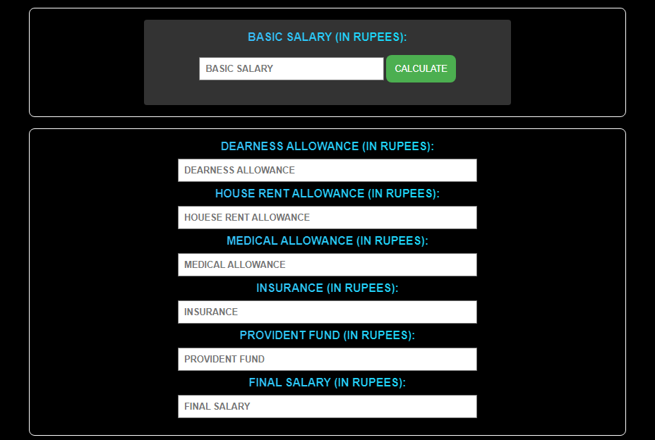

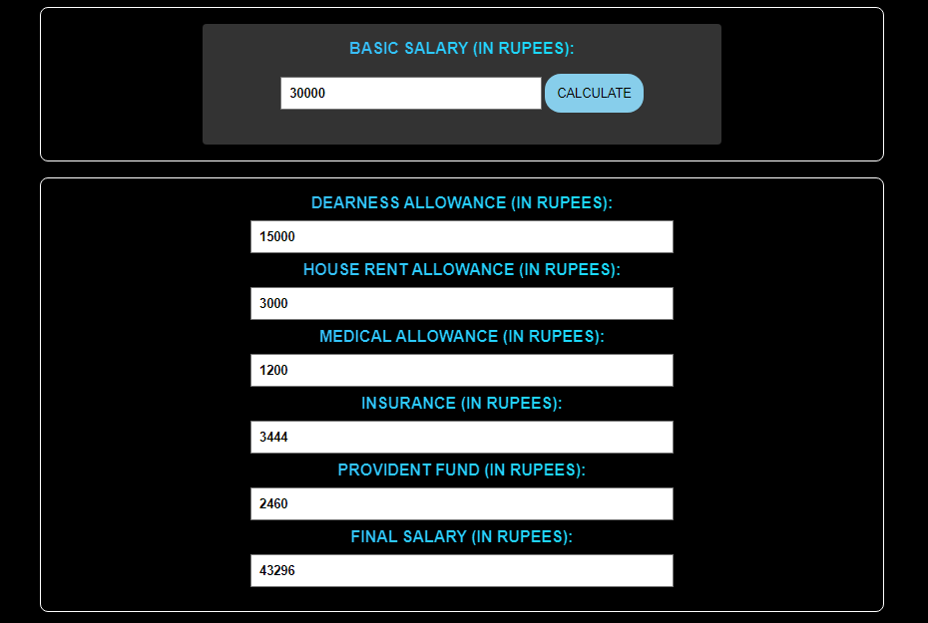

**PRACTICAL - 04**

**Aim: - A] Write a script that reads the name of the car and displays the name of the company the car belongs to as per the below table:**

|  |  |
| --- | --- |
| **Car** | **Company** |
| **Safari, Nexon, Tigor, Tiago** | **Tata** |
| **XUV700, XUV300, Bolero** | **Mahindra** |
| **i20, Verna, Venue, Creta** | **Hyundai** |
| **Swift, Alto, Baleno, Brezza** | **Suzuki** |

**CODE: -**

<!DOCTYPE html>

<html>

<head>

<meta charset="UTF-8">

<meta http-equiv="X-UA-Compatible" content="IE=edge">

<meta name="viewport" content="width=device-width, initial-scale=1.0">

<title>CAR COMPANY FINDER</title>

<?php

if (isset($_POST['car_name'])) {

$name = strtoupper($_POST['car_name']);

$comp = "";

$name = $_POST['car_name'];

if($name == "SAFARI" || $name == "NEXON" || $name == "TIGOR" || $name == "TIAGO") {

$comp = "TATA";

} else if($name == "XUV700" || $name == "XUV300" || $name == "BOLERO") {

$comp = "MAHINDRA";

} else if($name == "I20" || $name == "VERNA" || $name == "VENUE" || $name == "CRETA") {

$comp = "HYUNDAI";

} else if($name == "SWIFT" || $name == "ALTO" || $name == "BOLENO" || $name == "BREZZA") {

$comp = "SUZUKI";

} else {

$comp = "SORRY! NO DATA FOUND...";

}

}

?>

</head>

<body>

<form action = "" method = "POST">

<div class="container">

<label for="car">ENTER THE CAR NAME:</label>

<input type="text" name="car_name" placeholder="EG: MERCEDES" required>

<button type="submit" name="SUB">SUBMIT</button>

<label for="comp_name">COMPANY NAME:</label>

<input type="text" name="res" placeholder="COMPANY NAME" value="<?php echo isset($comp) ? $comp : ''; ?>" readonly>

</div>

</body>

</html>

**OUTPUT:-**

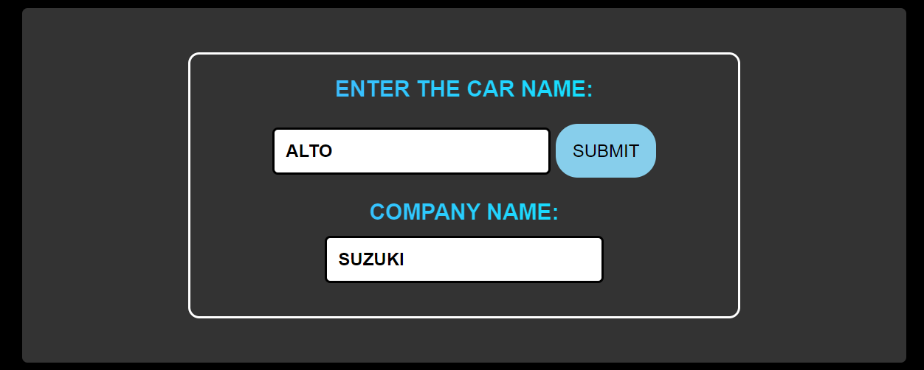

**Aim: - B] Write a script to read the marks of 4 subjects and display the result as per the below instructions:**

|  |  |
| --- | --- |
| **GTU GRADE** | **MARK-RANGE** |
| **AA** | **85-100** |
| **AB** | **75-84** |
| **BB** | **65-74** |
| **BC** | **55-64** |
| **CC** | **45-54** |
| **CD** | **40-44** |
| **DD** | **35-39** |
| **FF** | **<35 (FAIL)** |

**CODE: -**

<!DOCTYPE html>

<html lang="en">

<head>

<meta charset="UTF-8">

<meta http-equiv="X-UA-Compatible" content="IE=edge">

<meta name="viewport" content="width=device-width, initial-scale=1.0">

<title>GTU GRADE CALCULATOR</title>

<?php

if (isset($_POST['calculate'])) {

$subjects = array("ADVANCED OBJECT ORIENTED PROGRAMMING", "INTRODUCTION TO SOFTWARE ENGINEERING", "COMPUTER NETWORKING", "INTRODUCTION TO WEB DEVELOPMENT");

$marks = array($_POST['aoop'], $_POST['ise'], $_POST['cn'], $_POST['iwd']);

$grades = array();

echo "<h3>RESULT</h3>";

echo "<table>";

echo "<tr><th>SUBJECT</th><th>MARKS</th><th>GRADE</th></tr>";

for ($i = 0; $i < count($subjects); $i++) {

$mark = $marks[$i];

if ($mark >= 85) $grade = "AA";

elseif ($mark >= 75) $grade = "AB";

elseif ($mark >= 65) $grade = "BB";

elseif ($mark >= 55) $grade = "BC";

elseif ($mark >= 45) $grade = "CC";

elseif ($mark >= 40) $grade = "CD";

elseif ($mark >= 35) $grade = "DD";

else $grade = "FF";

echo "<tr><td>" . $subjects[$i] . "</td><td>" . $mark . "</td><td><input type='text' value='" . $grade . "' readonly></td></tr>";

}

echo "</table>";

$overallResult = "CONGRATULATIONS! YOU HAVE PASSED THE EXAM.";

$mark1 = $_POST['aoop'];

$mark2 = $_POST['ise'];

$mark3 = $_POST['cn'];

$mark4 = $_POST['iwd'];

if ($mark1 < 35 || $mark2 < 35 || $mark3 < 35 || $mark4 < 35) {

$overallResult = "NEEDS IMPROVEMENT";

}

echo "<h3>OVERALL RESULT: $overallResult</h3>";

}

?>

</head>

<body>

<form action="" method="post">

<table id="mainTable">

<tr>

<td><label for="aoop">ADVANCED OBJECT ORIENTED PROGRAMMING</label></td>

<td><input type="number" name="aoop" min="0" max="100" required></td>

</tr><tr>

<td><label for="ise">INTRODUCTION TO SOFTWARE ENGINEERING</label></td>

<td><input type="number" name="ise" min="0" max="100" required></td>tr>tr>

<td><label for="cn">COMPUTER NETWORKING</label></td>

<td><input type="number" name="cn" min="0" max="100" required></td></tr><tr>

<td><label for="iwd">INTRODUCTION TO WEB DEVELOPMENT</label></td>

td><input type="number" name="iwd" min="0" max="100" required></td></tr></table><br>

<button type="submit" name="calculate">CALCULATE RESULT</button></form>

</body>

</html>

**OUTPUT: -**

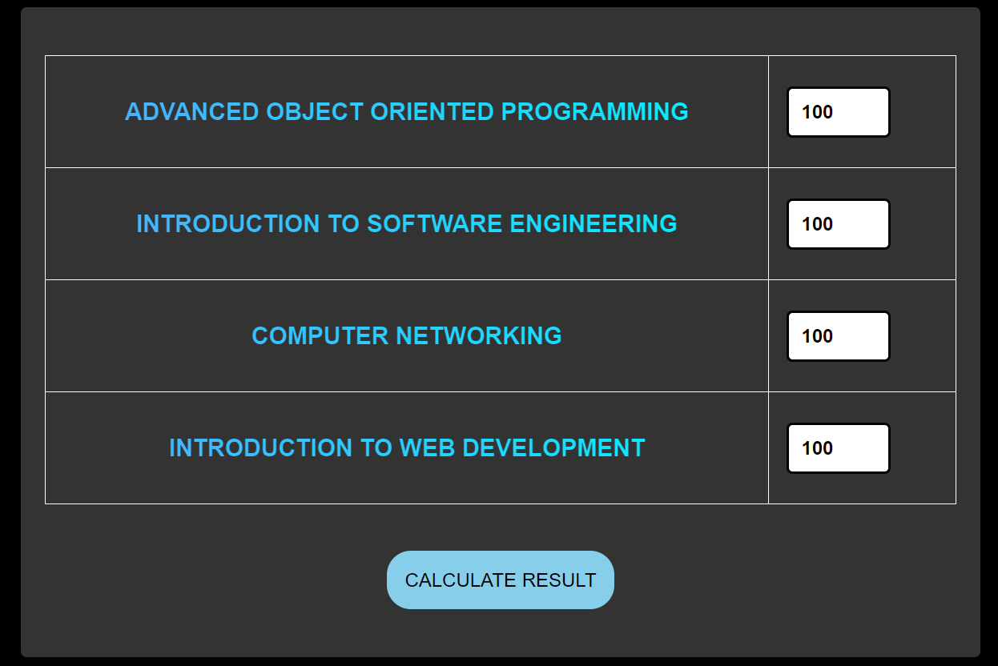

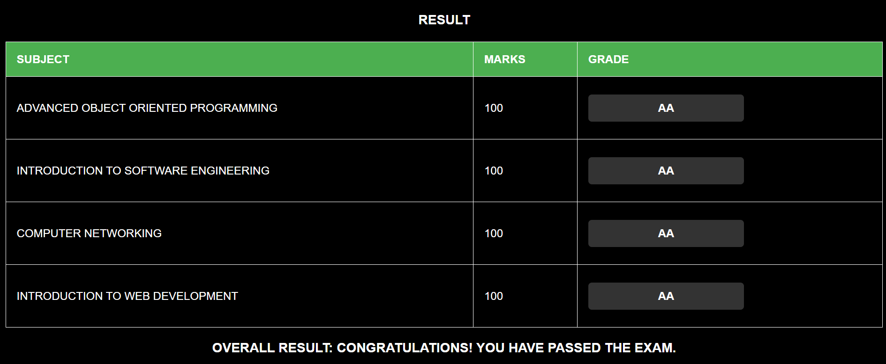

**Aim: - C] Write a script to display Fibonacci numbers up to a given term.**

**CODE: -**

<!DOCTYPE html>

<html lang="en">

<head>

<meta charset="UTF-8">

<meta name="viewport" content="width=device-width, initial-scale=1.0">

<title>FIBONACCI CREATOR</title>

<?php

$series = " ";

if (isset($_POST['size'])) {

$fibo = $_POST['size'];

$a = 0;

$b = 1;

$series = "";

$result = 0;

for($i = 0 ; $i <= $fibo ; $i++){

$series .= $a . " ";

$result = $a + $b;

$a = $b;

$b= $result;

}

}

?>

</head>

<body>

<form action = '' method = 'POST'>

<div class="container">

<label for = "size">ENTER THE NUMBER UPTO WHICH YOU WANT TO GENERATE FIBONACCI SERIES</label>

<input type = "number" name = "size" placeholder = " EG:- 10">

<button type="submit" name="SUB">SUBMIT</button>

</div>

<div class="container">

<label for = "size">RESULT</label>

<input type = "text" name = "res" readonly value = "<?php echo $series?>" placeholder = "RESULT">

</div>

</form>

</body>

</html>

**OUTPUT: -**

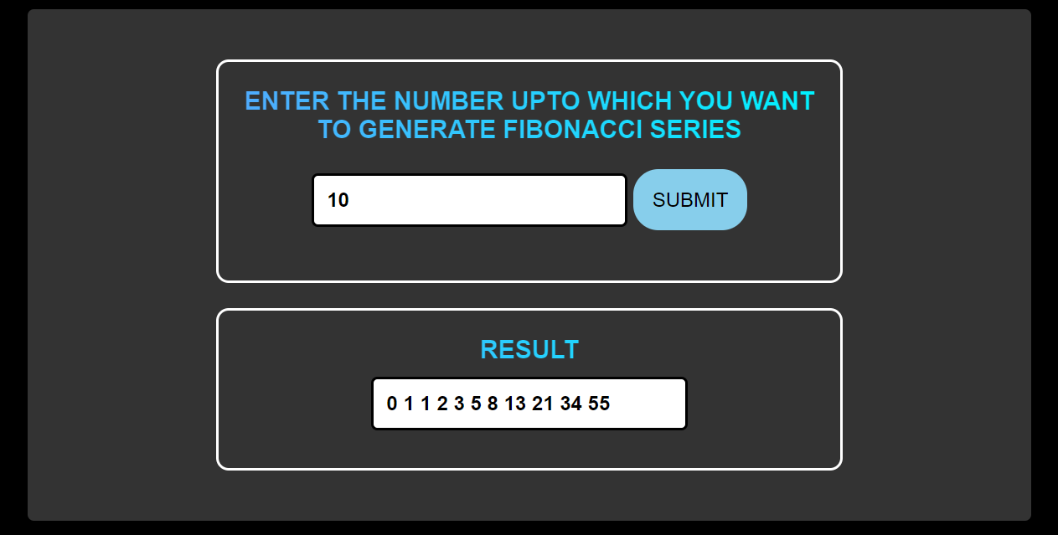

**Aim: - D] Write a script to display a multiplication table for the given number.**

**CODE: -**

<!DOCTYPE html>

<html lang="en">

<head>

<meta charset="UTF-8">

<meta name="viewport" content="width=device-width, initial-scale=1.0">

<title>MULTIPLICATION TABLE</title>

<?php

$series = " ";

if (isset($_POST['number'])) {

$num = $_POST['number'];

$result = 0;

for ($i = 1 ; $i <= 10 ; $i++) {

$result = $num * $i;

$series .= "$num * $i = $result".PHP_EOL;

}

}

?>

</head>

<body>

<form action = '' method = 'POST'>

<div class="container">

<label for = "size">ENTER THE NUMBER OF WHICH YOU WANT TO GENERATE MULTIPLICATION TABLE</label>

<input type = "number" name = "number" placeholder = " EG:- 10">

<button type="submit" name="SUB">SUBMIT</button>

</div>

<div class="container">

<label for = "size">MULTIPLICATION TABLE OF <?php echo $num?>:</label>

<textarea><?php echo $series;?> </textarea>

</div>

</form>

</body>

</html>

**OUTPUT: -**

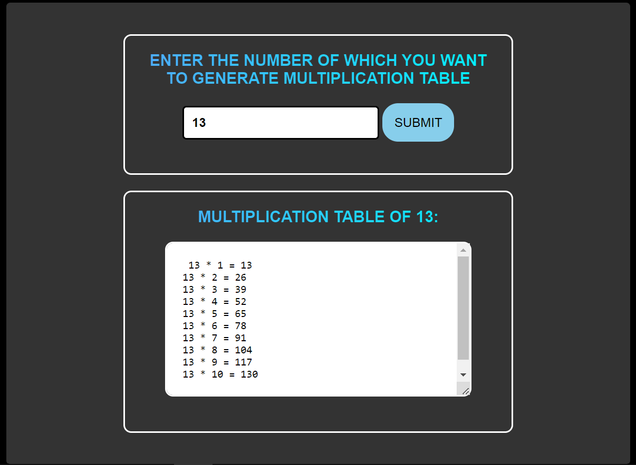

**PRACTICAL - 05**

**Aim: - A] Write a script to calculate the length of a string and count the number of words in the given string without using string functions.**

**CODE: -**

<!DOCTYPE html>

<html lang="en">

<head>

<meta charset="UTF-8">

<meta name="viewport" content="width=device-width, initial-scale=1.0">

<title>LENGTH AND WORDS COUNTER</title>

<?php

$length = 0;

$wordCount = 0;

if (isset($_POST['string'])) {

$string = $_POST['string'];

for ($i = 0; $i < strlen($string); $i++) {

if ($string[$i] != " ") {

$length++;

}

if ($string[$i] == " " && $string[$i-1] != " ") {

$wordCount++;

}

}

if ($length > 0 && $string[0] != " ") {

$wordCount++;

}

}

?>

</head>

<body>

<form action = "" method = "POST">

<div class="container">

<label for = "string">ENTER A STRING</label>

<input type = "text" name = "string" placeholder = " EG: KUSH SHAH">

<button type="submit" name="SUB">SUBMIT</button>

</div>

<div class="container">

<input type = "text" name = "length" value = "<?php echo $length?>" placeholder = " LENGTH" readonly>

<input type = "text" name = "wordcount" value = "<?php echo $wordCount?>" placeholder = " WORD COUNT" readonly>

</div>

</form>

</body>

</html>

**OUTPUT: -**

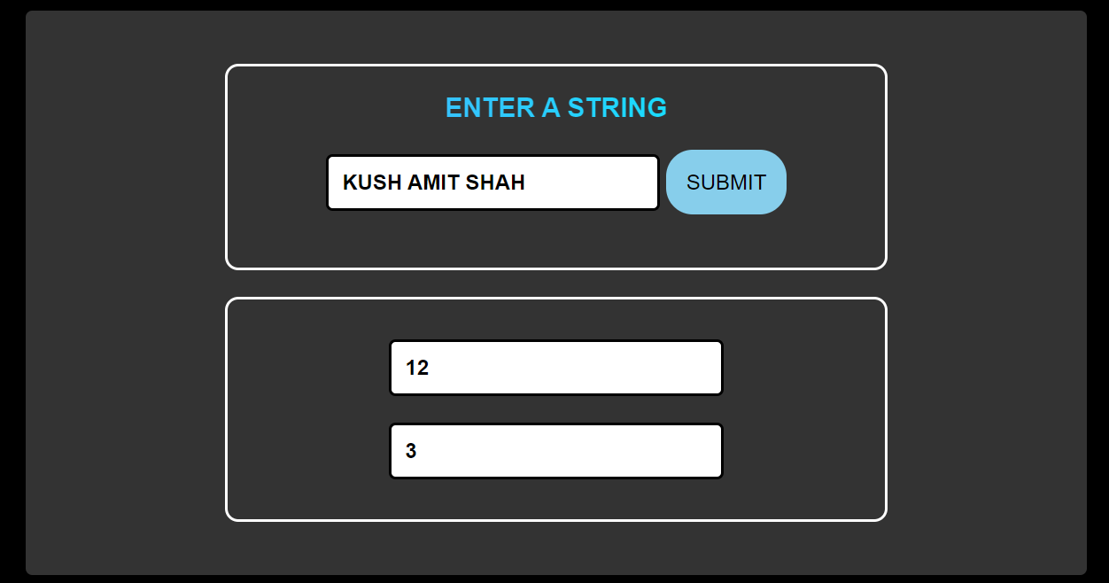

**Aim: - B] Write a script to sort a given indexed array.**

**CODE: -**

<!DOCTYPE html>

<html lang="en">

<head>

<meta charset="UTF-8">

<meta name="viewport" content="width=device-width, initial-scale=1.0">

<title>SORTING OF ARRAY</title>

<?php

$result = " ";

$array = array();

if (isset($_POST['SUB'])) {

$array = array(10, 30, 20, 50, 40, 70, 60, 90, 80, 100);

sort($array);

$result = implode(", ", $array);

}

?>

</head>

<body>

<form action = "" method = "POST">

<div class="container">

<label for="org">ORIGINAL ARRAY</label>

<textarea name = "org"><?php echo "10, 30, 20, 50, 40, 70, 60, 90, 80, 100";?></textarea>

<button type="submit" name="SUB">SUBMIT</button>

</div>

<div class="container">

<label for = "result">RESULTANT ARRAY</label>

<textarea name = "result"><?php echo $result;?></textarea>

</div>

</form>

</body>

</html>

**OUTPUT: -**

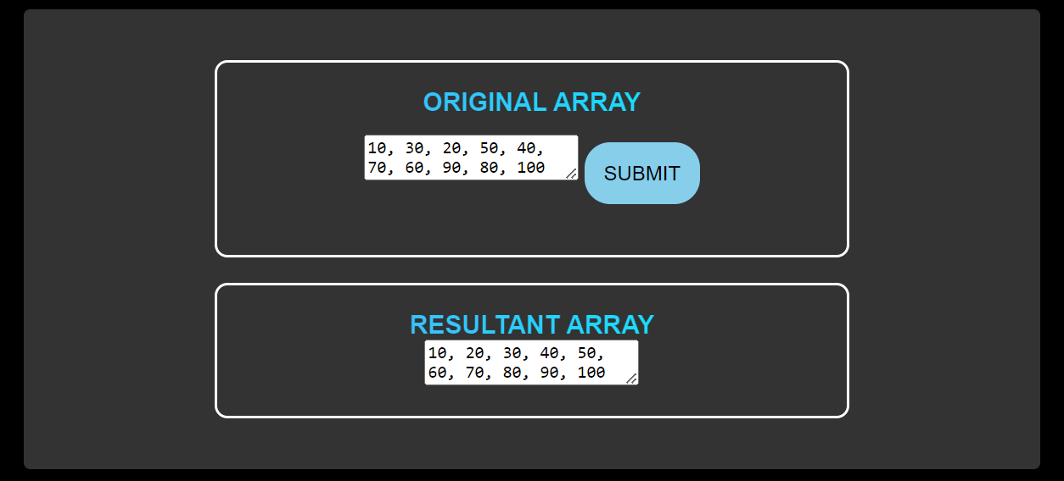

**Aim: - C] Write a script to perform 3 x 3 matrix Multiplication.**

**CODE: -**

<!DOCTYPE html>

<html lang="en">

<head>

<meta charset="UTF-8">

<meta name="viewport" content="width=device-width, initial-scale=1.0">

<title>3 X 3 MATRIX MULTIPLICATION</title>

<?php

$res = " ";

if (isset($_POST['SUB1'])) {

$arr1 = $_POST['arr1'];

$arr2 = $_POST['arr2'];

$result = array();

for ($i = 0; $i <= 2; $i++) {

for ($j = 0; $j <= 2; $j++) {

$result[$i][$j] = 0;

for ($k = 0; $k <= 2; $k++) {

$result[$i][$j] += $arr1[$i][$k] * $arr2[$k][$j];

}

}

}

echo "<table>";

for ($i = 0; $i <= 2; $i++) {

echo "<tr>";

for ($j = 0; $j <= 2; $j++) {

echo "<td><input type='text' value='" . $result[$i][$j] . "' readonly></td>";

}

echo "</tr>";

}

echo "</table>";

$res = json_encode($result);

}

?>

</head>

<body>

<form action="" method="POST">

<div class="container">

<table>

<th>MATRIX - 01</th>

<tr>

<td><input type="text" name="arr1[0][0]" placeholder="10" required></td>

<td><input type="text" name="arr1[0][1]" placeholder="20" required></td>

<td><input type="text" name="arr1[0][2]" placeholder="30" required></td>

</tr>

<tr>

<td><input type="text" name="arr1[1][0]" placeholder="10" required></td>

<td><input type="text" name="arr1[1][1]" placeholder="20" required></td>

<td><input type="text" name="arr1[1][2]" placeholder="30" required></td>

</tr>

<tr>

<td><input type="text" name="arr1[2][0]" placeholder="10" required></td>

<td><input type="text" name="arr1[2][1]" placeholder="20" required></td>

<td><input type="text" name="arr1[2][2]" placeholder="30" required></td>

</tr>

<tr>

<td>

<br>

<button type="submit" name="SUB1">SUBMIT</button>

</td>

</tr>

<th>MATRIX - 02</th>

<tr>

<td><input type="text" name="arr2[0][0]" placeholder="10" required></td>

<td><input type="text" name="arr2[0][1]" placeholder="20" required></td>

<td><input type="text" name="arr2[0][2]" placeholder="30" required></td>

</tr>

<tr>

<td><input type="text" name="arr2[1][0]" placeholder="10" required></td>

<td><input type="text" name="arr2[1][1]" placeholder="20" required></td>

<td><input type="text" name="arr2[1][2]" placeholder="30" required></td>

</tr>

<tr>

<td><input type="text" name="arr2[2][0]" placeholder="10" required></td>

<td><input type="text" name="arr2[2][1]" placeholder="20" required></td>

<td><input type="text" name="arr2[2][2]" placeholder="30" required></td>

</tr>

<tr>

<td>

<br>

<button type="submit" name="SUB">SUBMIT</button>

</td>

</tr>

</table>

</div>

</form>

</body>

</html>

**OUTPUT: -**

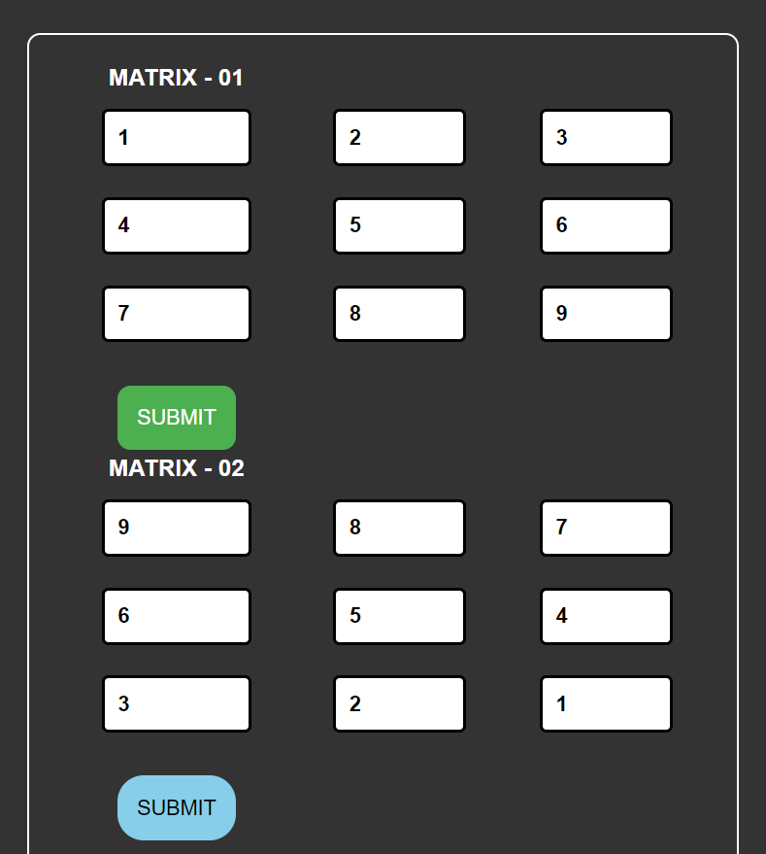

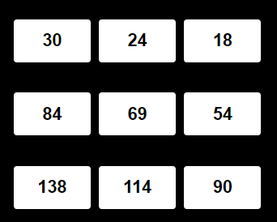

**Aim: - D] Write a script to encode a given message into equivalent Morse code.**

**CODE: -**

<!DOCTYPE html>

<html lang="en">

<head>

<meta charset="UTF-8">

<meta name="viewport" content="width=device-width, initial-scale=1.0">

<title>MORSE CODE GENERATOR</title>

<?php

$series = " ";

if (isset($_POST['submit']))

{

$string = $_POST["string"];

$string_main = strtolower($string);

$array1 = array(

"a"=>".-", "b"=>"-...", "c"=>"-.-.", "d"=>"-..", "e"=>".", "f"=>"..-.",

"g"=>"--.", "h"=>"....", "i"=>"..", "j"=>".---", "k"=>"-.-", "l"=>".-..",

"m"=>"--", "n"=>"-.", "o"=>"---", "p"=>".--.", "q"=>"--.-", "r"=>".-.",

"s"=>"...", "t"=>"-", "u"=>"..-", "v"=>"...-", "w"=>".--", "x"=>"-..-",

"y"=>"-.--", "z"=>"--..", "0"=>"-----","1"=>".----", "2"=>"..---", "3"=>"...--",

"4"=>"....-", "5"=>".....", "6"=>"-....", "7"=>"--...","8"=>"---..", "9"=>"----.",

"."=>".-.-.-",","=>"--..--","?"=>"..--..","/"=>"-..-."," "=>" ");

for($i=0;$i<strlen($string_main);$i++){

foreach($array1 as $letter => $code)

{

if($letter == $string_main[$i])

{

$series .= "$code";

}

}

}

}

?>

</head>

<body>

<form action = "" method = "POST">

<div class="container">

<label for = "string">ENTER THE STRING WHICH IS TO BE CONVERTED TO MORSE CODE:</label>

<input type = "text" name = "string" placeholder = "MISSION AI1" required>

<button type="submit" name="submit">SUBMIT</button>

</div>

<div class="container">

<label for = "res">(MORSE CODE)</label>

<input type = "text" value = "<?php echo $series?>" placeholder = "RESULT" readonly>

</div>

</form>

</body>

</html>

**OUTPUT: -**

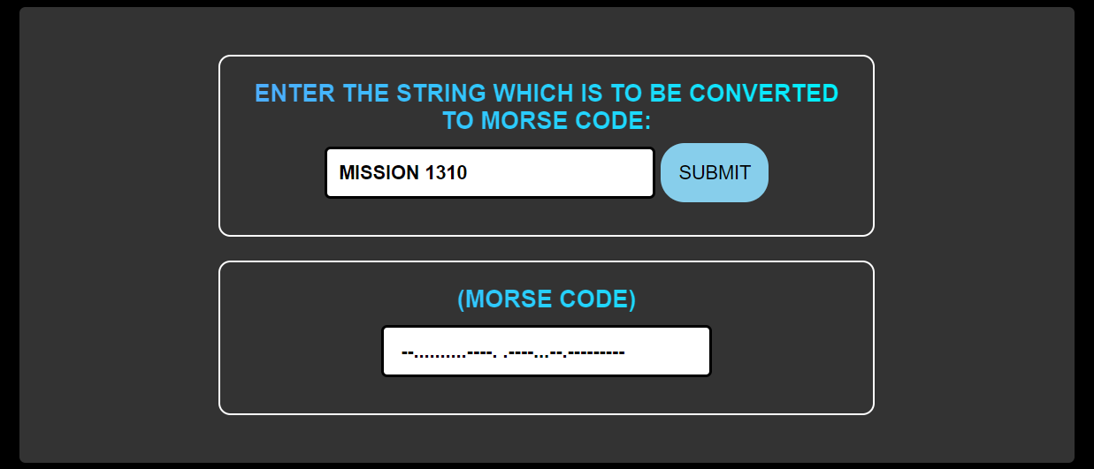

**PRACTICAL - 06**

**Aim: - A] Consider a currency system in which there are notes of 7 denominations, namely Rs. 1, Rs. 2, Rs. 5, Rs. 10, Rs. 20, Rs. 50 and Rs. 100. Write a function that computes the smallest number of notes that will combine for a given amount of money.**

**CODE: -**

<!DOCTYPE html>

<html lang="en">

<head>

<meta charset="UTF-8">

<meta name="viewport" content="width=device-width, initial-scale=1.0">

<title>NOTES CALCULATOR</title>

<?php

$ans = " ";

if (isset($_POST['submit'])){

$amt = $_POST['amt'];

function countnotes($amt){

$var = 1;

while ($var != 0){

if ($amt >= 100){

$temp = 100;

}else if ($amt >= 50){

$temp = 50;

}else if ($amt >= 20){

$temp = 20;

}else if ($amt >= 10){

$temp = 10;

}else if ($amt >= 5){

$temp = 5;

}else if ($amt >= 2){

$temp = 2;

}else if ($amt >= 1){

$temp = 1;

} else{

$ans .= $amt;

}

$amount = $amt / $temp;

$notes = floor(floatval($amount));

echo "<input type='text' name='res' value='USE OF $temp RS. NOTES: $notes' readonly>";

$amt = fmod($amt , $temp);

if ($amt == 0){

$var = 0;}}}

countnotes($amt);}

?>

</head>

<body>

<form action="" method="POST">

<div class="container">

<label for="amt">ENTER THE AMOUNT:</label>

<input type="text" name="amt" placeholder="1310" required>

<button type="submit" name="submit">SUBMIT</button>

</div>

</form>

</body>

</html>

**OUTPUT: -**

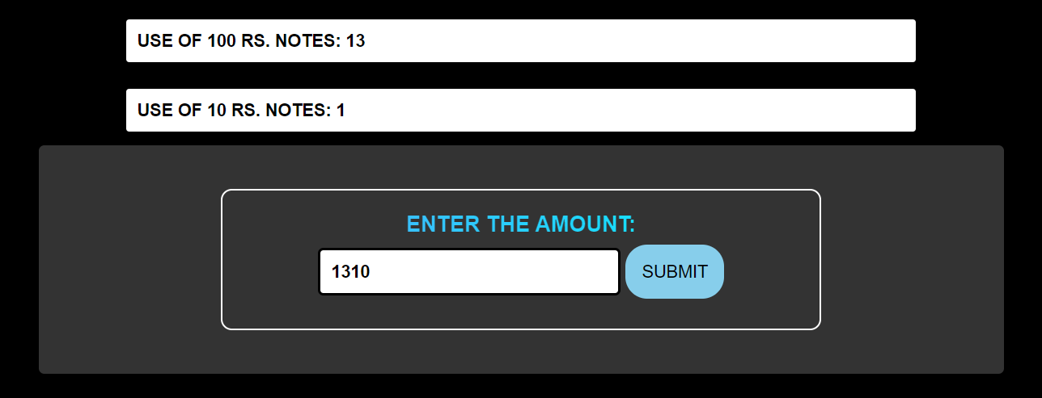

**Aim: - B]** **Write scripts using string functions:**

**a. to check if the given string is lowercase or not.**

**b. to reverse the given string.**

**c. to remove white spaces from the given string.**

**d. to replace the given word from the given string.**

**CODE: -**

<!DOCTYPE html>

<html lang="en">

<head>

<meta charset="UTF-8">

<meta name="viewport" content="width=device-width, initial-scale=1.0">

<title>STRING FUNCTIONS</title>

</head>

<body>

<form action = "" method = "POST">

<div class="container">

<label for = "string">ENTER A STRING</label>

<input type = "text" name = "string" placeholder = " EG: KUSH SHAH" required>

<button type="submit" name="SUB">SUBMIT</button>

</div>

</form>

</body>

<?php

$string_low = " ";

$string_rev = " ";

$string_trimmed = " ";

$string_before = "HELLO WORLD!";

$string_after = " ";

if (isset($_POST['string'])) {

$string = $_POST['string'];

$string_low = strtolower($string);

$string_rev = strrev($string);

$string_trimmed = trim($string);

$string_after = str_replace("WORLD" , "KUSH" , "HELLO WORLD!");

echo "<input type = 'text' name = 'org' value = 'ORIGINAL STRING IS: $string' readonly>";

if($string == $string_low){

echo "<input type = 'text' name = 'lower' value = 'THE STRING IS IN LOWERCASE.' readonly>";

}else{

echo "<input type = 'text' name = 'lower_not' value = 'THE STRING IS NOT IN LOWERCASE.' readonly>";

}

echo "<input type = 'text' name = 'reversed' value = 'THE REVERSED STRING IS: $string_rev' readonly>";

echo "<input type = 'text' name = 'trimmed' value = 'STRING AFTER REMOVING WHITESPACES IS: $string_trimmed' readonly>";

echo "<input type = 'text' name = 'before' value = 'STRING TO REPLACE: $string_before' readonly>";

echo "<input type = 'text' name = 'after' value = 'REPLACED STRING IS: $string_after' readonly>";

}

?>

</html>

**OUTPUT: -**

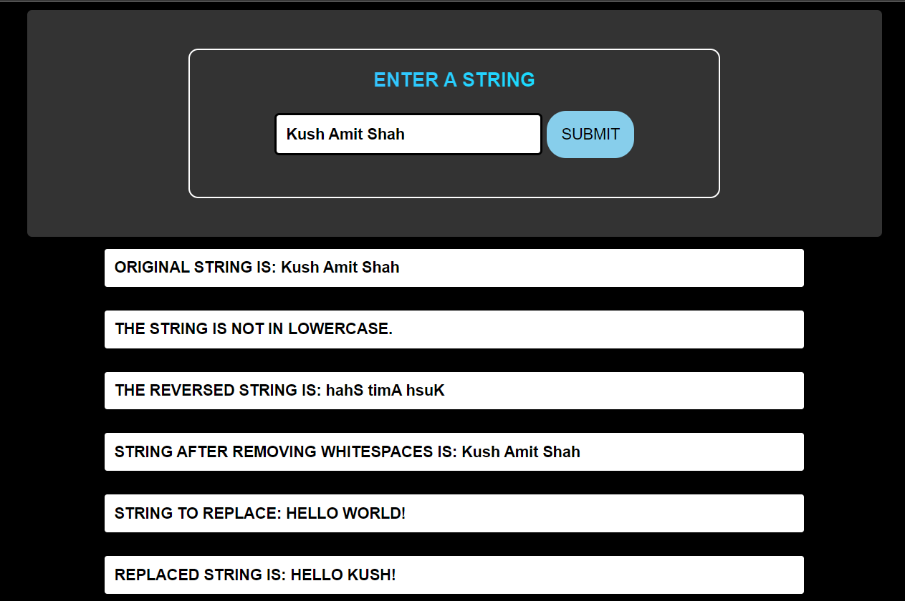

**Aim: - C]** **Write scripts using math functions:**

**a. to generate a random number between the given range.**

**b. to display the binary, octal and hexadecimal of a given decimal number.**

**c. to display the sin, cos and tan of the given angle.**

**CODE: -**

<!DOCTYPE html>

<html lang="en">

<head>

<meta charset="UTF-8">

<meta name="viewport" content="width=device-width, initial-scale=1.0">

<title>MATH FUNCTIONS</title>

</head>

<body>

<form action = "" method = "POST">

<label for = "n1">ENTER FIRST NUMBER</label>

<input type = "text" name = "n1" placeholder = "START RANGE" required>

<label for = "n2">ENTER SECOND NUMBER</label>

<input type = "text" name = "n2" placeholder = "END RANGE" required>

<label for = "num">ENTER A NUMBER</label>

<input type = "text" name = "num" placeholder = "DECIMAL NUMBER TO CONVERT" required>

<label for = "angle">ENTER AN ANGLE</label>

<input type = "text" name = "angle" placeholder = "EG: 80" required>

<br>

<button type="submit" name="SUB">SUBMIT</button>

</form>

</body>

<?php

if (isset($_POST['SUB'])) {

$num1 = $_POST['n1'];$num2 = $_POST['n2'];$num = $_POST['num'];

$angle = $_POST['angle'];

$random_num = rand($num1, $num2);

echo "<input type = 'text' name = 'random' value = 'RANDOM NUMBER GENERATED IS: $random_num' readonly>";

$num_bin = decbin($num); $num_oct = decoct($num); $num_hex = dechex($num);

echo "<input type = 'text' name = 'decbin' value = 'BINARY VALUE OF $num IS: $num_bin' readonly>";

echo "<input type = 'text' name = 'decoct' value = 'OCTAL VALUE OF $num IS: $num_oct' readonly>";

echo "<input type = 'text' name = 'dechex' value = 'HEXADECIMAL VALUE OF $num IS: $num_hex' readonly>";

$angle_sin = sin($angle); $angle_cos = cos($angle); $angle_tan = tan($angle);

echo "<input type = 'text' name = 'sin' value = 'SINE VALUE OF $angle IS: $angle_sin' readonly>";

echo "<input type = 'text' name = 'cos' value = 'OCTAL VALUE OF $angle IS: $angle_cos' readonly>";

echo "<input type = 'text' name = 'tan' value = 'HEXADECIMAL VALUE OF $angle IS: $angle_tan' readonly>";

}

?>

</html>

**OUTPUT: -**

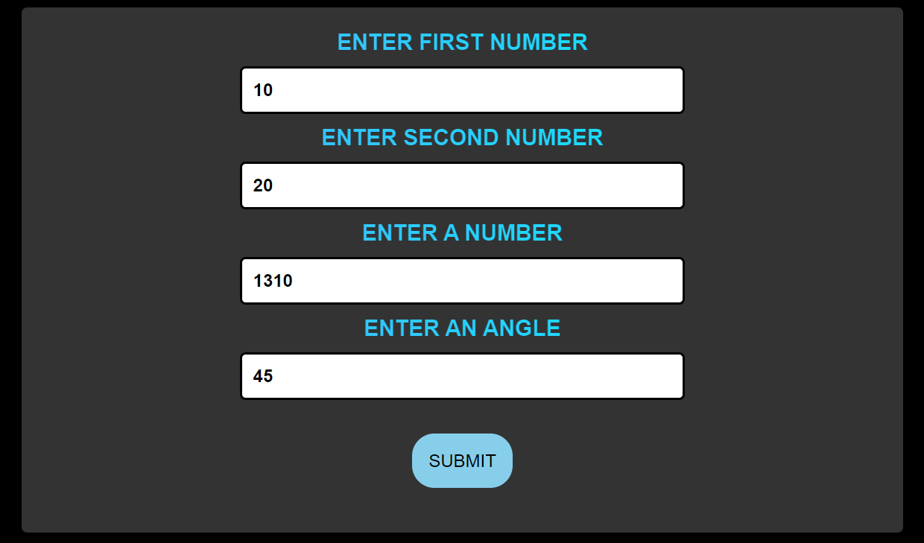

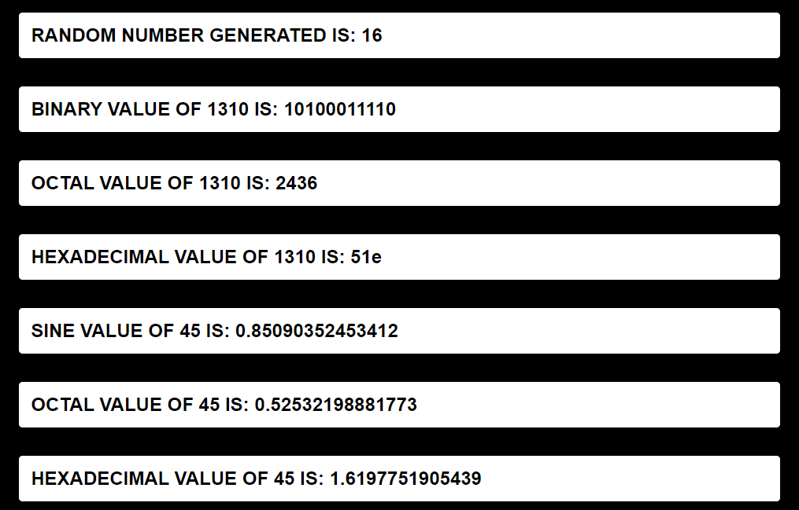

**Aim: - D]** **Write a script to display the current date and time in different formats.**

**CODE: -**

<!DOCTYPE html>

<html lang="en">

<head>

<meta charset="UTF-8">

<meta name="viewport" content="width=device-width, initial-scale=1.0">

<title>DATE FUNCTIONS</title>

</head>

<body>

<div class="container">

<h2>DATE TIME FUNCTIONS</h2>

</div>

<?php

$time = new DateTime();

$format_1 = $time->format('Y-m-d H:i:s');

$format_2 = $time->format('d-m-y');

$format_3 = $time->format('l, F j, Y g:i A');

$format_4 = $time->format('Y-m-d');

$format_5 = $time->format('d-D-M-y');

echo "<input type = 'text' value = 'DEFAULT FORMAT: $format_1' readonly>";

echo "<input type = 'text' value = 'CUSTOM FORMAT 1: $format_2' readonly>";

echo "<input type = 'text' value = 'CUSTOM FORMAT 2: $format_3' readonly>";

echo "<input type = 'text' value = 'CUSTOM FORMAT 3: $format_4' readonly>";

echo "<input type = 'text' value = 'CUSTOM FORMAT 4: $format_5' readonly>";

?>

</body>

</html>

**OUTPUT: -**

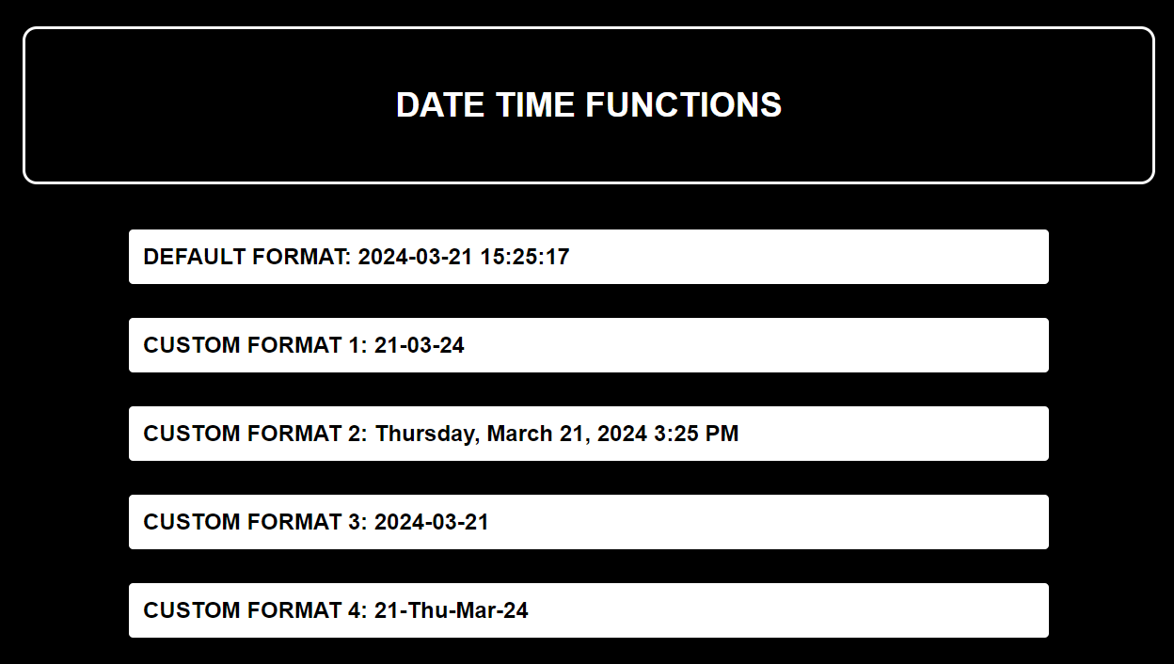

**PRACTICAL - 07**

**Aim: - A] Write a script to:**

**a. Define a class with constructor and destructor.**

**b. Create an object of a class and access its public properties and methods.**

**CODE: -**

<!DOCTYPE html>

<html lang="en">

<head>

<meta charset="UTF-8">

<meta name="viewport" content="width=device-width, initial-scale=1.0">

<title>CONSTRUCTOR AND DESTRUCTOR</title>

</head>

<body>

<div class="container">

<?php

class demo{

function add(){

$num1 = 10;

$num2 = 20;

$ans = $num1 + $num2;

echo "<input type = 'text' value = 'ADDITION OF $num1 AND $num2 IS: $ans' readonly>";

}

function __construct(){

echo "<input type = 'text' value = 'CONSTRUCTOR HERE!!!' readonly>";

}

function __destruct(){

echo "<input type = 'text' value = 'DESTRUCTOR HERE!!!' readonly>";

}

}

$ob = new demo();

$ob->add();

?>

</div>

</body>

</html>

**OUTPUT: -**



**Aim: - B] Write a script that uses the set attribute and get attribute methods to access a class’s private attributes of a class.**

**CODE: -**

<!DOCTYPE html>

<html lang="en">

<head>

<meta charset="UTF-8">

<meta name="viewport" content="width=device-width, initial-scale=1.0">

<title>SET AND GET ATTRIBUTES</title>

</head>

<body>

<?php

if ($_SERVER["REQUEST_METHOD"] == "POST") {

class privateattribute{

private $user;

function setUser($user){

$this->user = $user;

}

function getUser(){

echo $this->user;

}

}

$use = new privateattribute();

$user = $_POST["userName"];

$use->setUser($user);

}

?>

<div class="container">

<h1>Accessing Private Variables Using functions</h1>

<form action="" method="post">

<div class="form-group">

<label for="ans">Enter a Name :</label>

<input type="text" name="userName" required><br><br>

<button type="submit">Submit</button><br><br>

<label for="ans">Your Name is :</label>

<input type="text" name="displayUser" value="<?php $use->getUser(); ?>" readonly>

</div>

</form>

</body>

</html>

**OUTPUT: -**

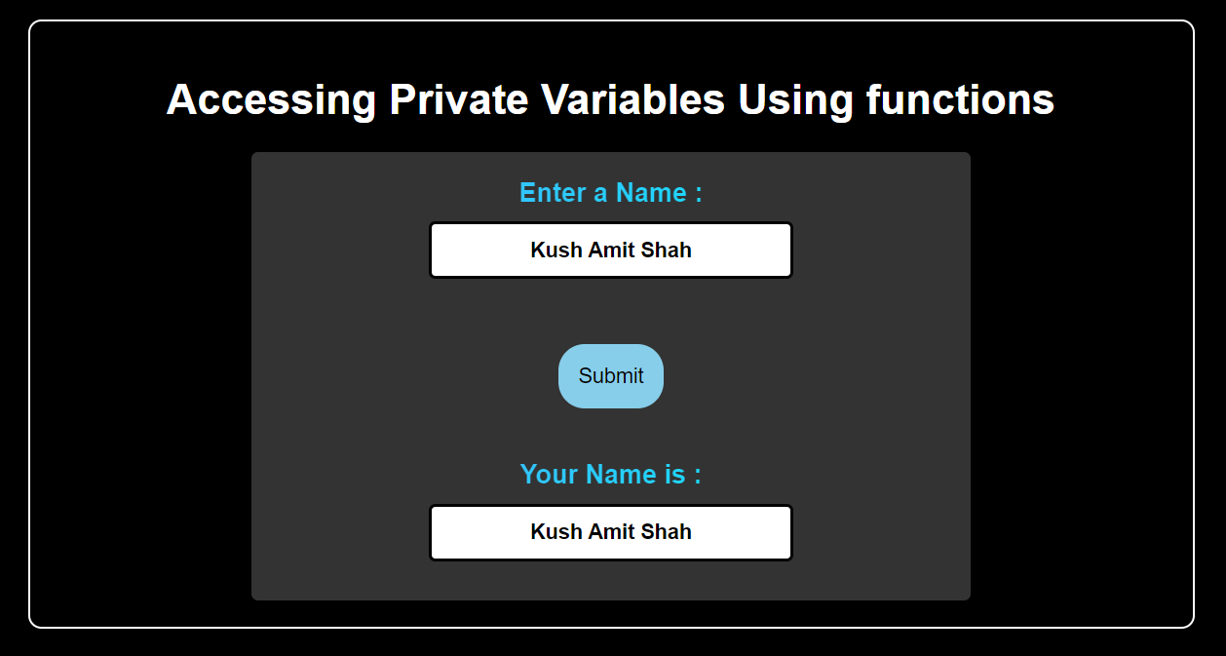

**Aim: - C] Write a script to demonstrate single inheritance.**

**CODE: -**

<!DOCTYPE html>

<html lang="en">

<head>

<meta charset="UTF-8">

<meta name="viewport" content="width=device-width, initial-scale=1.0">

<title>SINGLE INHERITANCE</title>

</head>

<body>

<form action = "" method = "POST">

<div class="container">

<input type = "text" name = "msg" value = "SINGLE INHERITANCE" readonly></div>

<div class="container">

<label for = "num1">ENTER FIRST NUMBER</label>

<input type = "number" name = "num1" required>

<label for = "num2">ENTER SECOND NUMBER</label>

<input type = "number" name = "num2" required><br>

<button type = "submit" name = "submit">SUBMIT</button><br>

<?php

if(isset($_POST['submit'])){

class base{

public $num1;

public $num2;

function __construct($num1, $num2){

$this->num1 = $num1;

$this->num2 = $num2;

}

function add(){

$ans1 = $this->num1 + $this->num2;

echo "ADDITION: " . $ans1;

}

}

class child extends base{

function sub(){

$ans2 = $this->num1 - $this->num2;

echo "SUBTRACTION: " . $ans2;}}

$ob = new child($_POST['num1'], $_POST['num2']);

}

?>

<input type = 'text' value = '<?php $ob->add();?>' readonly>

<input type = 'text' value = '<?php $ob->sub();?>' readonly>

</div>

</form>

</body>

</html>

**OUTPUT: -**

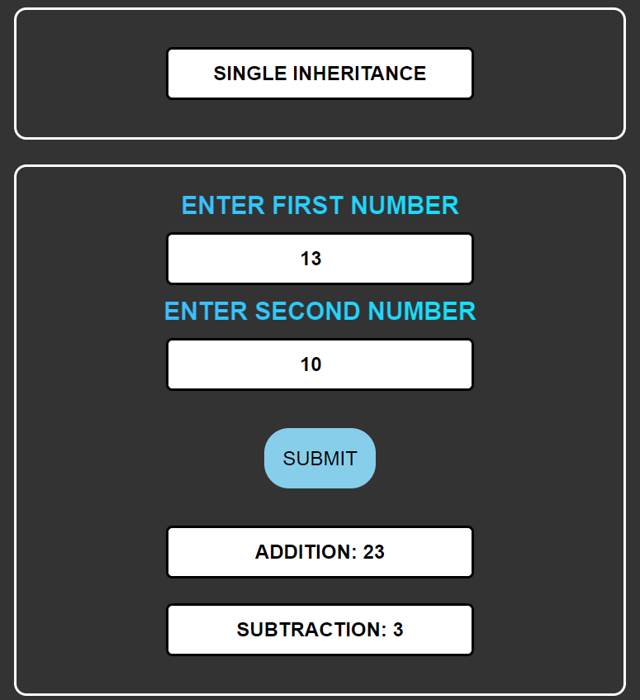

**Aim: - D] Write a script to demonstrate multiple inheritance.**

**CODE: -**

<!DOCTYPE html>

<html lang="en">

<head>

<meta charset="UTF-8">

<meta name="viewport" content="width=device-width, initial-scale=1.0">

<title>MULTIPLE INHERITANCE</title>

<body>

<?php

if ($_SERVER["REQUEST_METHOD"] == "POST") {

interface A{

function setUser($user);

}

interface B{

function getUser();

}

class Userinfo implements A,B{

public $user;

function setUser($user){

$this->user = $user;

}

function getUser(){

echo $this->user;

}

}

$use = new Userinfo();

$user = $_POST["userName"];

$use->setUser($user);

}

?>

<div class="container">

<h1>Multiple Inheritance</h1>

<form action="#" method="post">

<div class="form-group">

<label for="ans">Enter a Name :</label>

<input type="text" name="userName" required><br><br>

<button type="submit">Submit</button><br><br>

<label for="ans">Displaying User Name using Child Class Object :</label>

<input type="text" name="displayUser" value="<?php $use->getUser(); ?>" readonly>

</div>

</form>

</body>

</html>

**OUTPUT: -**

