 Invention Disclosure Format (IDF)-B | Document No. | 02-IPR-R003
 | Issue No/Date | 2/01.02.2024
 | Amd. No/Date | 0/00.00.0000

- Title of the invention:
Dynamic Health Insurance Premium Prediction Using a Combined Health and Financial Stress Score

- Field /Area of invention:
The invention discusses how a person's health changes over time. It also examines body vitals such as variable heart rate and unusual medical patterns. The proposed work takes financial habits and patterns into account. By observing these patterns and their intensity, the system detects signs of financial stress or lifestyle change. These patterns affect long-term health issues. Rather than finding prices based only on static characteristics like age and background, the system calculates health insurance premiums using health patterns and financial stress levels observed during certain time intervals. The system is designed to handle a large amount of data by processing information in multiple batches in a distributed system, making it possible to track changes over long periods with reduced latency. The invention uses different Machine Learning models for predictive modelling. By combining various characteristics, including personal financial details and stress data, it can reliably predict future healthcare costs and possible variations in insurance premiums.

The proposed work supports SDG 3 (Good Health and Well-Being) and SDG 9 (Industry, Innovation and Infrastructure) by connecting everyday financial stability and long-term health patterns to insurance risk modeling to . Instead of waiting for illness to occur, the proposed Health–Financial Stability (HFS) framework helps identify sustained stress and instability early, encouraging preventive awareness. At the same time, implementing the system using distributed Apache Spark demonstrates that the approach. In doing so, the work promotes reliable outcomes while contributing to innovation and modernization within the insurance sector

- Prior Patents and Publications from literature (provide a table summarizing the prior art)

Figure 1 Literature Survey
Sno. | Patent / Publication Title | Year | Summary of Technique | Limitation Addressed by Proposed System
1 | Big Data Analytics in Healthcare: Current Practices, Innovations, and Future Prospects | 2022 | Reviews how AI, ML, blockchain, and cloud are used in healthcare. | Only review-based. No predictive model, no financial-health link, no insurance premium logic.
2 | The Use of Big Data Analytics in Healthcare | 2022 | Studies how hospitals adopt big data for decisions. | Focuses on adoption, not prediction. No financial behavior or insurance pricing model.
3 | Leveraging Artificial Intelligence and Big Data in Healthcare Provider Systems: Enhancing Patient Care and Operational Efficiency | 2025 | Uses AI and Spark to improve hospital diagnostics and workflows. | Limited to hospital efficiency. No financial instability or insurance recalculation.
4 | Analysis of Financial Risk Early Warning Systems of High-Tech Enterprises under Big Data Framework | 2022 | Predicts corporate financial crisis using financial indicators. | Only corporate finance. No healthcare or physiological integration.
5 | Big Data: Deep Learning for Financial Sentiment Analysis | 2018 | Uses deep learning to predict stock sentiment. | Only stock market focus. No healthcare or insurance modelling.
6 | Predictive Modelling of Healthcare Insurance Costs Using Machine Learning | 2025 | Predicts insurance charges using regression on demographic data. | Static features only. No temporal behavior or financial stress factors.
7 | Health Insurance Cost Prediction using Machine Learning | 2022 | Uses Kaggle dataset to predict insurance cost. | Small dataset and static modelling. No financial stress or dynamic pricing.

- Summary and background of the invention (Address the gap / Novelty)

Traditional insurance premium systems rely on fixed attributes such as age, BMI, smoking status, and past medical history. Even when machine learning is used, most models treat risk as static and based on historical averages rather than ongoing behavioral changes.
Meanwhile, healthcare analytics focuses on hospital efficiency and diagnostics, and financial analytics concentrates on market or corporate risk prediction. These systems operate independently. However, growing evidence shows that financial stress can directly influence physiological health, including heart rate variability and abnormal medical indicators. Despite this connection, existing insurance models do not integrate financial instability with health data for dynamic risk assessment.
The core gap is the absence of a unified, time-aware system that measures instability rather than fixed characteristics. Current frameworks do not analyze short-term volatility, multi-horizon stress patterns, or continuously adjust premiums.
The proposed invention introduces a Health–Finance Stress (HFS) Score, a composite metric combining financial spending variability, physiological instability, and abnormal health indicators across 7-, 30-, and 90-day windows.
Conclusion
By shifting from static profiling to dynamic instability modeling, the invention enables real-time risk assessment and adaptive premium recalibration. This creates a more responsive, integrated, and forward-looking approach to predictive insurance analytics.

- Objective(s) of Invention

The aim of the current invention is to provide a unified Health-Financial Stability (HFS) measure that can quantitatively express the joint effects of financial behavior and physiological instability on health risk. The purpose of the current invention is to convert complex stress signals from multiple domains into a structured composite indicator reflecting real-world instability patterns
Another is to use the stress scores calculated over different time horizons to incorporate temporal variability in insurance risk modeling. The system will be able to capture both the short-term and long-term trends of risk instability by using the different time horizons, which include short-term (7 days), mid-term (30 days), and long-term (90 days).
Another objective of the invention is to prove that the time-dependent health/finance stress factor has a material effect on insurance premium computations, even if the base predictions of medical costs are kept unchanged. This is made possible by the introduction of HFS as a defined instability modifier.
The invention further seeks to prove the predictive and economic significance of HFS by performing a comparative analysis using machine learning. The models are trained on three settings: (i) without the HFS indicator, (ii) based on the raw temporal features in isolation, and (iii) based on the composite score of HFS. The comparison shows the benefit of compressing instability in a structured manner compared to the raw temporal features.
Finally, the aim of the invention is to provide a justification for the use of Apache Spark in batch-based temporal processing as a viable model for the insurance industry. Instead of the continuous recalculation of premiums in real-time, the system shows how periodic recalibration can be achieved through distributed batch processing.

6. Working principle of the invention (in brief)
Our invention is proceeding with four main steps:
We have mined steady features from the medical cost dataset and merged them with temporarily replicated physiological and financial processes over the time period. Our novel metric HFS is computed as the variance-based regulated components are aggregated to calculate the Health-Financial stability score across three window divisions, which are 7-day, 30-day and 90-day. We are using Ensemble regression models like XGboost and random forest models for machine learning prediction to estimate the predicted healthcare cost using collective attributes and HFS features. The datasets of different batches are processed in Apache Spark, which is a distributed environment to compute the dynamic insurance premium using HFS values changing with time across the three window divisions.
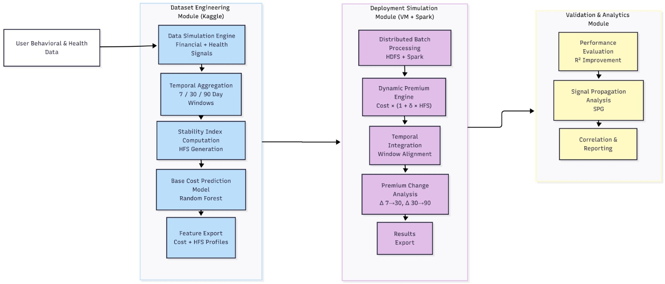
Figure 2 workflow diagram

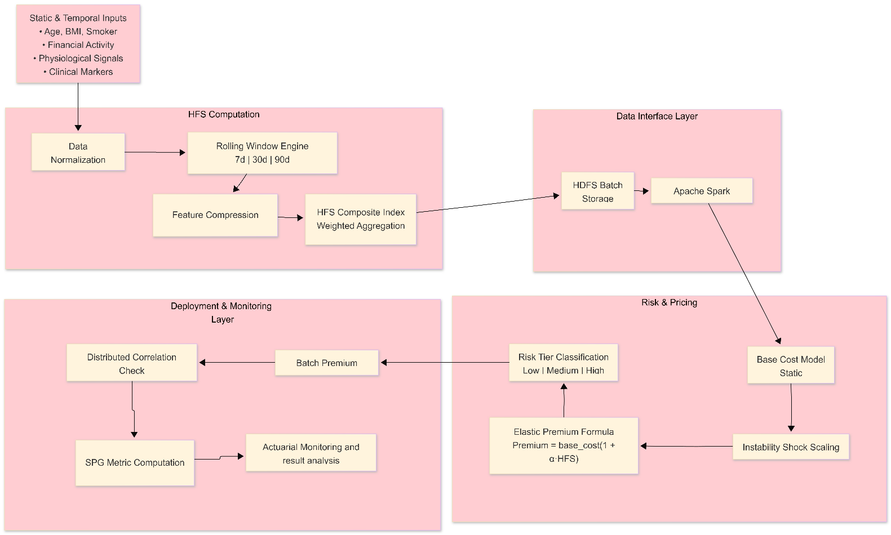
Figure 3 Architecture diagram

7. Description of the invention in detail (Include drawing and or photograph as needed)
The invention provides a distributed computational platform for dynamic insurance premium Readjustment based on health-financial instability modelling over time. We have achieved this with the use of a scalable big-data processing platform, i.e., Apache Spark, which processes large volumes of multi-domain data while following a parallel batch processing framework. The system proceeds with structured and semi-structured data such as indicators of physiological variability, behavioural data, financial transaction variability and abnormal event indicators. For instance, the simulated structured synthetic data is created using supervised distribution models to replicate real-world patterns of instability. All data is temporal to handle window segmentation based on time.
The incoming data is transmitted to a distributed storage system using virtual compute nodes and storage blocks to handle scalability, fault tolerance, and parallel processing readiness. The computational engine runs multi-window temporal divisions(short, mid, long), variance extraction, growth rate measures, and instability indexing. Before variance aggregation, the system performs data preprocessing, which includes noise filtering, missing value handling, and statistical normalisation. Risk thresholds may be predefined, actuarially calibrated, or dynamically learned from historical policy data.

A composite Health–Financial Stability (HFS) score is computed as:
HFS=α(HV)+β(FV)+γ(AV)
where HV represents health variability, FV represents financial volatility, AV represents abnormal signal indexing, and α, β, γ are adaptive weighting coefficients.
The weights (α, β, γ) are distributed unequally because financial stress causes the instability to rise, and physiological changes reflect the body’s response, and abnormal events confirm the outcome. Assigning different weights improves accuracy in modelling risk.
Cross-window variance gradients are analysed to detect temporal risk amplification.
If:
ΔVariance(t) >Threshold
- A risk intensification trigger is generated.

Based on the detection, a distributed premium recalculation engine reclassifies the policyholder into a new risk category and computes:
Premium(new)​=Premium(base)​×(1+λ⋅HFS)
where λ is an amplification sensitivity factor.
A continuous monitoring loop ensures that scores are updated in a fixed interval of time and premiums are adjusted dynamically. The architecture reduces delayed risk detection and enables dynamic premium adjustment compared to static insurance pricing systems.

8. Experimental validation results:

The experimental evaluation (in Figure 5) shows us how the HFS indicator significantly leads to improvement in predictive accuracy over the baseline model. For the different windows(7-day, 30-day, 90-day), the model with HFS has consistently shown us higher R² values, which showcase the improvements of around 8% to 15% compared to the baseline model. The maximum improvement can be noticed for the short window, which has shown better initial phase instability detection. Also, the correlation between premium and HFS (shown in Figure 4) shows improvement with increased aggregation over time, which confirms the effectiveness of variance modelling across multiple windows. Feature importance analysis
(in Figure 5) also confirms the effect of HFS integration. In the baseline model, the premium prediction task is dominated by the static base cost features. This shows a lack of sensitivity to dynamic changes. With the integration of HFS, the predictive importance gets slowly inclined towards instability -related features, which helps to avoid over-dependence on static features. This shows us the proposed framework, which helps to migrate the premium prediction task from static cost-centric models to a temporally adaptive variance-sensitive risk assessment system.
The graphs of premium distribution (in Figure 6) over 7-day,30-day, and 90-day windows are positively skewed, which implies that although most policyholders are distributed in moderate premium categories, some of them have higher premium adjustments due to high instability scores. The distributions are firm over windows, implying that the dynamic pricing system is stable while still permitting volatility. Stability of distribution over windows implies that the system is not introducing volatility but is instead maintaining proportional scaling on the basis of risk intensity. The premium change distribution period (30-90 days) is majorly concentrated around zero with a few extreme values, which implies that most premium adjustments are smooth instead of abrupt. The average premium evolution graph further strengthens this implication, which shows that there is little variation over windows without abrupt changes. All these findings collectively come to a conclusion that the dynamic premium system ensures smooth premium adjustments temporally while maintaining actuarial stability and permitting recalibration based on temporal health-financial instability.

For quantitatively evaluating the performance gain induced by the HFS metric, a new assessment metric called as Scaled Performance Gain(SPG) is proposed(Figure 8):

SPG=R²(HFS)- R²(BASE)/(1- R²(BASE))

This formulation calculates the percentage of the original unexplained variance(1- R²(Base)) that is explained within the HFS. In contrast to the direct difference in R² values, SPG scales the performance gain in terms of the remaining prediction error, which makes it a more
Informative performance amplification factor. Based on this calculation, the SPG values we have obtained are roughly 0.713(7-day), 0.708(30-day), and 0.684(90-day). These particular values show us how the HFS framework explains about 68-71% of the remaining prediction error left by the baseline model. These findings clearly show us that HFS enables more incremental gains and also effectively bridges the gap of unexplained variance, thus validating its efficacy as a performance amplification factor handled by temporal instability.

Figure 4 correlation between premium and HFS
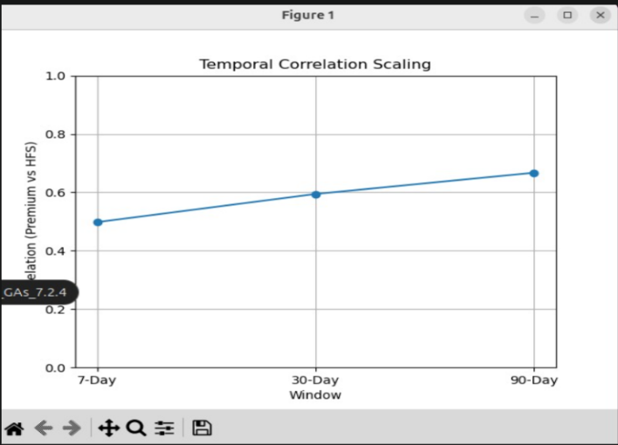

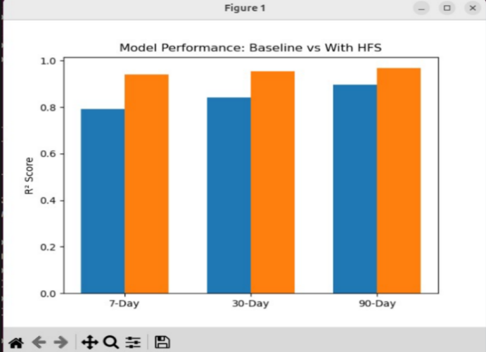
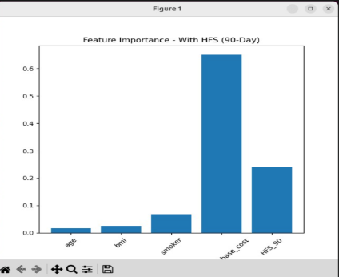
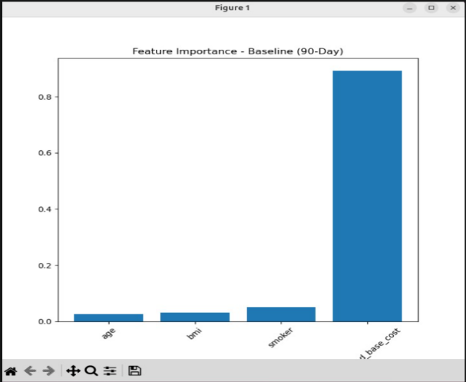
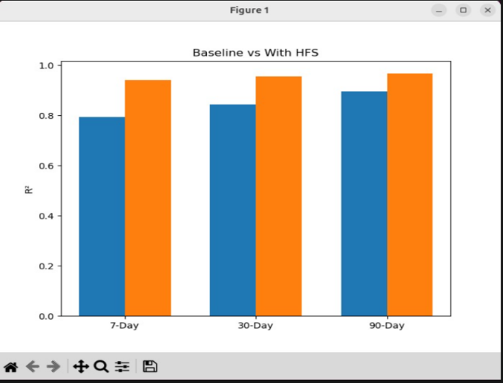
Figure 5 Comparative Model Validation and Feature Contribution Analysis for the Proposed Health–Financial Stability (HFS) Framework

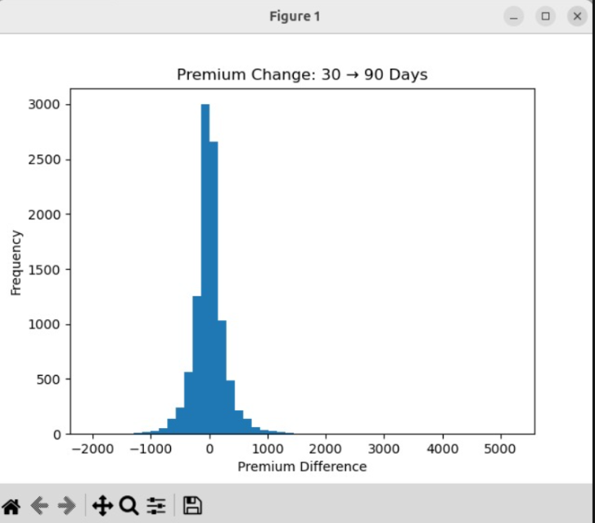
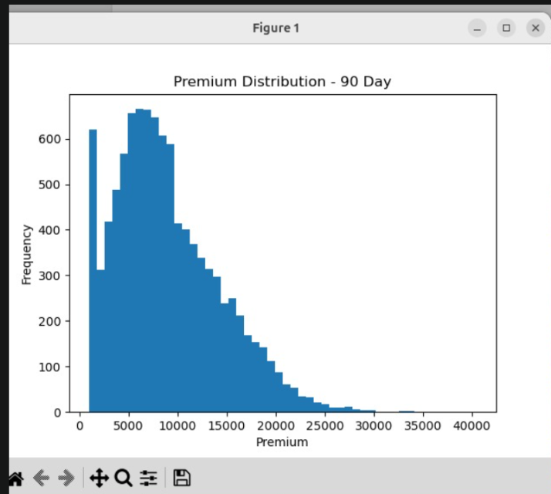
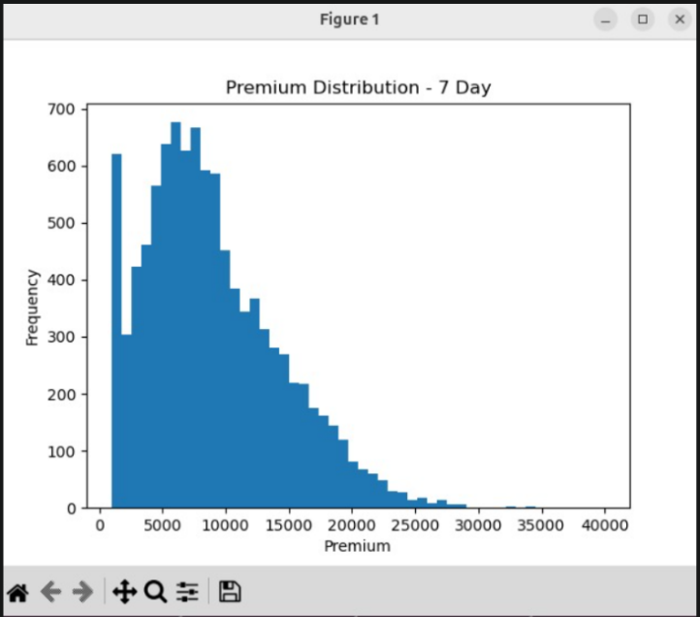
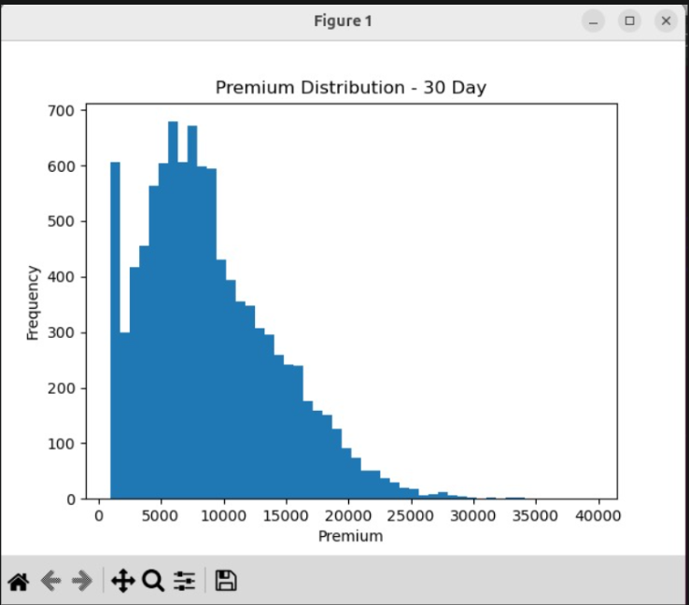
Figure 6 Multi-Horizon Premium Distribution and Temporal Adjustment Analysis Under the Proposed HFS-Based Dynamic Pricing Framework

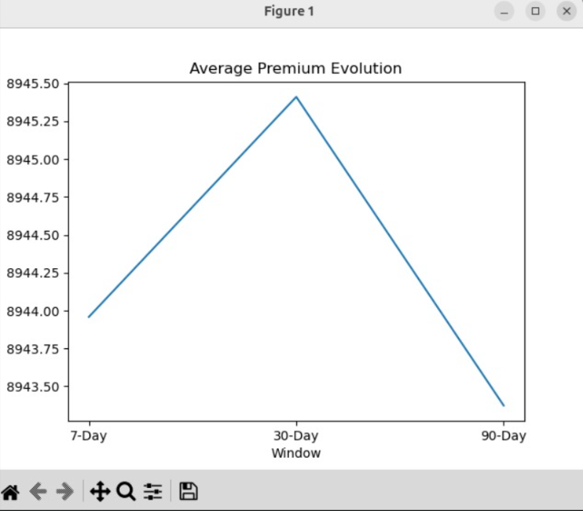
Figure 7 Average premium evolution
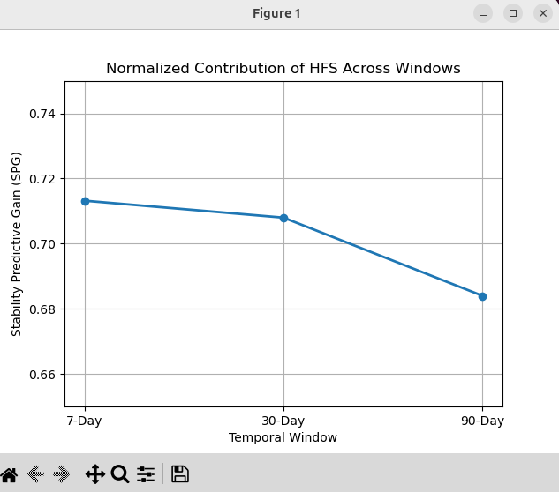
Figure 8 normalized contribution of HFS across temporal windows

9.What aspect(s) of the invention need(s) protection?

Protection is required for the health financial instability modelling framework, which smooths the dynamic insurance premium readjustment. Specifically, the multi-window segmentation, which is changing over time and the variance calculation mechanism require legal protection. The Health Financial Stability (HFS) scoring model, which combines health arbitrariness, financial volatility, and abnormal event measures using unequal weights, and the cross-window risk amplification detection logic is based on the changes in variance over time with the threshold escalation, and hence requires protection.

Additionally, the distributed premium recalculation framework, the dynamic premium adjustment formula, which is related to the calculated HFS score, the derived assessment metric Scaled Performance Gain(SPG), and the closed-loop adaptive monitoring system, which is processing the time-indexed data needs to be protected. Protection is also required for the system architecture and the corresponding computer-implemented method, which allows insurance premiums to change over time depending on variations in health and financial conditions.
 Invention Disclosure Format (IDF)-B | Document No. | 02-IPR-R003
 | Issue No/Date | 2/01.02.2024
 | Amd. No/Date | 0/00.00.0000

10.What is Technology readiness level of your invention? (Tick the appropriate TRL)

Research |  |  | Development |  |  | Deployment
TRL 1 | TRL 2 | TRL 3 | TRL 4 | TRL 5 | TRL 6 | TRL 7 | TRL 8 | TRL 9
Basic | Technology | Experimental | Technology | Technology | Technology | System | System | Actual system
Principles | concept | proof of | validated in | validated in a | demonstrated | prototype | complete | proven in an
observed | formulated | concept | a lab | relevant | in a relevant | demonstration | and | operational
 |  |  |  | environment | environment | in an | qualified | environment
 |  |  |  | (industrially | (industrially | operational |  | (competitive
 |  |  |  | relevant in | relevant in | environment |  | manufacturing
 |  |  |  | case of key | case of key |  |  | in case of key
 |  |  |  | enabling | enabling |  |  | enabling
 |  |  |  | technologies) | technologies) |  |  | technologies,
 |  |  |  |  |  |  |  | or in space )

----------------------END OF THE DOCUMENT-----------------------------

