* *

**

**

|  |
| --- |
| **CONTENTS**   1. **Introduction**    1. **OVERVIEW**    2. **Our Vision**    3. **Purpose**    4. **Abstract**    5. **Scope**    6. **Intended Audience** 2. **Over All Description**    1. **Product Perspective**    2. **Product Features**    3. **User classes and characteristics**    4. **Operating Environment**    5. **Design and Implementation Constraints**    6. **Assumptions and Dependencies** 3. **External Requirements**    1. **User Interface**    2. **Hardware Interface**    3. **Software Interface**    4. **Communication Interface** 4. **Software Features**    1. **Technical features**    2. **Database Design** 5. **Risk Management**    1. **Risk Identification**    2. **Risk Mitigation**    3. **Scheduling and Estimates** 6. **Non Functional Requirements**    1. **Performance Requirement**    2. **Safety Requirements**    3. **Security Requirements**    4. **Other Requirements**    5. **Software Quality Requirements** |

1. **INTRODUCTION**
   1. **OVERVIEW**

We are designing a web application named “***My Learnzia***”. It is a Learning Management System popularly known as LMS. We believe that the capacity to learn is a gift; the ability to learn is a skill; the willingness to learn is a choice.

Hence we bring in an application that will make learning easy and on your devices in our comfort zones. My Learnzia is a package as a whole that provides improved and better platform for the students to study.

* 1. **Our Vision**

We have chosen LMS as a project because we as scholars realize the importance of the learning management system and online learning. The whole idea behind the project is to fix the issues that that we have faced while using it. We are adding some important functionality as per our requirements. Moreover we are working on the user interface to make it a little attractive to study.

## Purpose

The purpose of this document is to define the requirements and design for a learning management system project  
 that can be used for the purpose of managing the learning or training in an organization. It contains the description   
 of all the modules, description and functionalities in detail.

## Abstract

The Learning Management System (LMS) is a web based application that is developed   
using the web technologies in JAVA, Spring Boot and Hibernate. The application is aimed to manage the learning and basic tasks related to learning of scholar in an organization. Based on the type of user it provides various required functionalities for Admin, scholar and Trainer. It facilitates administration, documentation, tracking, reporting, automation and delivery of training programs or learning and development programs.

## Scope

The LMS is a web application, with following functional requirements.

* 1. All the users will be able to login through same login page.
  2. User should be able to Change Password
  3. Admin can Create, Modify, View and Delete the users.
  4. The scholar will be able to access the content and phone directory, create and reply query, send emails and submit/view their assignments.
  5. Scholar should be able to view their query and its status.
  6. Scholar can view and edit their profile. They can also reply to queries created by other scholars and trainers.
  7. Trainer can View/Update/Reply the queries. Trainer can also mark attendance, send emails and access phone directory.
  8. The trainer can create/remove sessions, upload/edit/view assignment.
  9. Trainer can view their scholars and profile. They can also create/reply to queries.
  10. The Admin will insert/update/delete the calendar, study material, user profile, sessions, emails, queries.
  11. Admin should be able to approve the new request from scholar and should be able to monitor user activity and reports.
  12. **Intended Audience**

The main target o the application will be **Small to medium size training centres**, language schools, handcraft centres, ski academies, companies providing external training programs and organization that deliver effective and independent learning and development programs.

# 2. Overall Description

## 2.1. Product Perspective My Learnzia is a Learning Management System that is an enhanced version of the existing LMS. We have modified the LMS according to our requirements. We will try to add some colours to learning and make it fun so that it keeps the mind fresh and conscious.

## 2.2. Product Features The Product consists of many features:

1. The Dashboard consists of the application as a whole. We have different modules to study. The scholar can edit his profile, make notes in the notes panel, create a query to ask his doubts, view sessions and calendar, submit assignments, search contacts and send emails.
2. The trainer can edit his profile, add notes in the notes panel, create and reply to the queries asked by students, create and reply to sessions, view calendar, upload assignments, search contacts and send emails.
3. The admin has all the rights of the scholar and trainer. He can also create or restrict a user.
4. All the data will be stored in the databases and all the functionalities will be enabled post authentication from the database and admin.
5. The UI will be designed using Bootstrap, HTML, CSS.
6. The back end will be developed using JAVA, Hibernate and Database.

## 2.3. User Classes and Characteristics The product is basically designed for the organizations or institutions that provide an independent and effective learning program. This is a collective learning material that encourages easy learning along with additional features like notes making and clearing queries that helps the user to avoid pen and paper and it is easily accessible in your devices also.

## 2.4. Operating Environment

## Windows 2000

## Windows XP

## Windows Vista

## Windows 7

## Windows 8

## Windows 10

## Mac OS X

## 2.5. Design and Implementation Constraints My Learnzia is developed in Java, it uses Bootstrap for its visualization engine and is built on Eclipse IDE platfom. It uses a modular design where every feature is wrapped into a separate module and the modules depend on each other through well-written APIs. There are several APIs available to make plugin development easy. All the data is authenticated and stored in database.

## 2.6. Assumptions and Dependencies

My Learnzia is developed in Java and therefore requires Java to be installed on the user’s system.. This applies to Windows and Linux users. On Mac OS X, Java is bundles with the application.

# 3. External Interface Requirements

## 3.1. User Interface

1. LOGIN PAGE FOR MY LEARNZIA

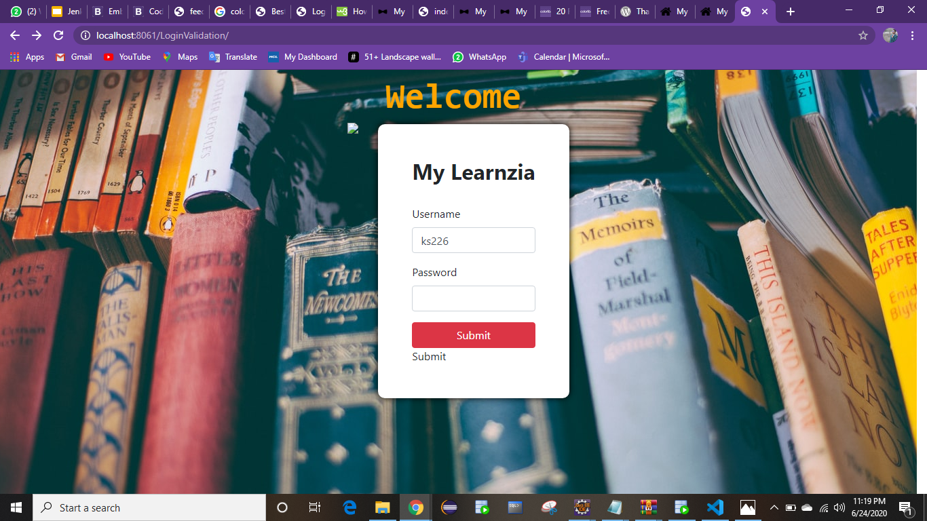

1. THE MAIN PAGE- THE DASHBOARD

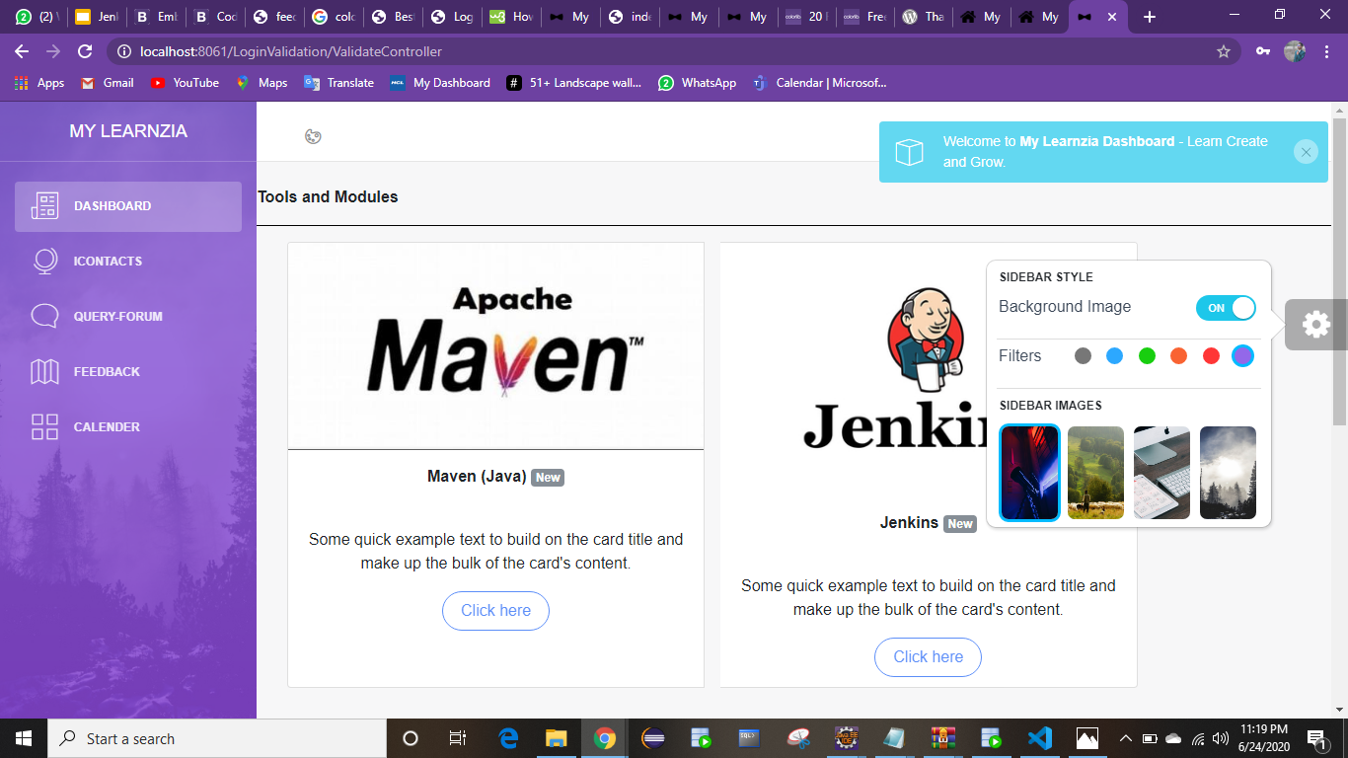

## 3.2. Hardware Interfaces

## The minimum hardware requirements of My Learnzia are a 500 Megahertz CPU and 128 megabytes of RAM. Also, because My Learnzia uses an Bootstrap to speed up graph visualization, a compatible graphics card is required. A system with these specifications can handle a Network of approximately 1000 edges and nodes.

## 3.3. Software Interfaces

As already stated in assumptions the latest version of java should be installed in the user’s system also we need oracle database to store data in tables and use the data for proper functioning of the site.

## 3.4. Communications Interfaces

My Learnzia requires an internet connection to install new plugins, update already installed ones and update some of its components. Also Oracle database is required.

**4. System Features**

This section demonstrates the most prominent features and explains how they can be used and the results they will give back to the user.

**4.1.** **System Features Description**

1. The Dashboard consists ofthe study material or slides.

2.We have icontacts that will provide us the name and email of the required person in the organization.

3. The query form will allow the users to create query or ask doubts and the trainers can respond to the queries.

4. We have a thought of the day section where new thought would be displayed everyday which will keep the user motivated and positive to study.

5. The calendar will display upcoming holidays.

6. The feedback portal will accept trainers name and post anonymous feedback from the user.

7. The trainer can upload assignments for the trainee.

8. The trainee will be able to view and submit assignments.

9. The trainer will create or delete sessions and scholar can view the sessions created.

10. The trainer and scholar both can write notes in the notes section.

**4.2. Database design**Users_Details:

|  |  |  |
| --- | --- | --- |
| Column name | Type | Size |
| Username | Varchar2 | 15 |
| Password | Varchar2 | 15 |
| Name | Varchar2 | 30 |
| DOB | Date |  |
| Gender | Varchar2 | 10 |
| E-Mail | Varchar2 | 20 |
| Mobile_No | Varchar2 | 13 |
| Address | Varchar2 | 40 |
| Date-Of-Joining | Date |  |

# Other Non-functional Requirements

## Performance Requirements

<If there are performance requirements for the product under various circumstances, state them here and explain their rationale, to help the developers understand the intent and make suitable design choices. Specify the timing relationships for real time systems. Make such requirements as specific as possible. You may need to state performance requirements for individual functional requirements or features.>

## Safety Requirements

<Specify those requirements that are concerned with possible loss, damage, or harm that could result from the use of the product. Define any safeguards or actions that must be taken, as well as actions that must be prevented. Refer to any external policies or regulations that state safety issues that affect the product’s design or use. Define any safety certifications that must be satisfied.>

least, clarify the relative preferences for various attributes, such as ease of use over ease of learning.>

# Other Requirements

<Define any other requirements not covered elsewhere in the SRS. This might include database requirements, internationalization requirements, legal requirements, reuse objectives for the project, and so on. Add any new sections that are pertinent to the project.>

### Query_table:

|  |  |  |
| --- | --- | --- |
| Column name | Type | Size |
| Query_id | int | 5 |
| Query | Varchar2 | 250 |
| Language_query | Varchar2 | 20 |

### Feedback_Table:

|  |  |  |
| --- | --- | --- |
| Column name | Type | Size |
| Trainer_Name | Varchar2 | 30 |
| Feedback | Varchar2 | 255 |

### Quote_Table:

|  |  |  |
| --- | --- | --- |
| Column name | Type | Size |
| Quote_ID | Int | 5 |
| Quote | Varchar2 | 50 |

### Session_Table :

|  |  |  |
| --- | --- | --- |
| Column name | Type | Size |
| Session_Id | Int | 10 |
| Start_Time | TIMESTAMP |  |
| End_Time | TIMESTAMP |  |
| Venue | Varchar2 | 25 |
| Trainer_Name | Varchar2 | 25 |
| Batch_Name | Varchar2 | 15 |

***5 Risk Management***

***5.1. Risk Identification***

The major threats and as follows:

1. Confidentiality and integrity violation: unauthorized access and tempering the assets.
2. Denial of services: prevention of legitimate users.
3. Illegitimate use: Exploitation of privileges by legitimate users.
4. The risks can be unintended, deliberate or natural.

***5.2. Risk Mitigation***

The threats can be avoided by following some simple steps:

1. Allowing only authorized users as the username will be provided by the admin only.
2. The details will be feed in the database and the server will ensure that the access is given to legitimate users.
3. The admin will have access to all the activities and the privileges which will be monitored with he database.
4. The support team will always be available to take actions whenever needed.

***5.3. Scheduling and Estimates***

***Milestone Description Release Date Release Iteration***

***M1 Application view and Design 23rd June R1***

***(Front-end development)***

***M2 Database for my application 24th June R1***

***(Back-end)***

***M3 Integrating views and designs 26th June R1***

***(Integrating front-end and back-end)***

***M4 Testing for initial release 27th June R2***

***M5 Issue resolving, user reviews, 28th June R2***

***web design integration***

***M6 Final release 29th June R2***

## 

1. **Non Functional Requirements**
   1. **Performance Requirement**

As mentioned earlier the application needs good quantity of Ram and java installation. Performance depends on Internet and space provided to the application.

* 1. **Safety Requirements**The Admin ensures that data is safe and secure and the integrity of the privileges given to the users is intact.

The team will also keep regular checks.

* 1. **Security Requirements**

My Learnzia allows only genuine users. Any new user is created by the admin and the privileges given to the scholar and trainer are different which are maintained by the admin itself

* 1. **Software Quality Requirements**My Learnzia provides the users with both simple and advanced features. Due to its well designed and easy to use interface it can be used by scholars and trainers for effective learning. However, only authenticated users from the organization can access the application.