Dear Sir,
As you are aware that GST is set to be implemented very soon. GST is not only tax reform but it is a complete business transformation. The GST implementation be the biggest step the country has taken in ensuring economic integration.
Please take note that our GST provisional ID and ARN No and Pan No as follows.
COMPANY NAME | INDIAN AGENCIES
ADDRESS | SANT KABIR ROAD, OPP. GEB OFFICE, BARANPURA NAKA, BARODA -390001. GUJARAT. INDIA
TELEPHONE | 0265-2412170/2432694
EMAIL | info@indianagencies.co.in / indian_agencies1975@yahoo.co.in
CONTACT PERSONS | MR. HEMANG P SHAH  MR. VISHAL P. SHAH
CONTACT NUB | 9427346354/ 9824919042
CST TIN NO | 24AAAFI7106D1ZZ
GST TIN NO | 24AAAFI7106D1ZZ
PAN NO | AAAFI7106D
GST PROVISIONAL ID | 24AAAFI7106D1ZZ
ARN NO | AA241216010107W
GOODS OFFER | AUTHORISED DEALER OF BOSCH POWER TOOLS, ESAB INDIA LTD, KPT LTD, DEALING IN ALL WELDING ACCESSORIES , CABLE, WELDING M/CS AND WELDING ROD AND FILLER WIRE.
BANK DETAILS :
1. | Bank Name | UNION BANK OF INDIA
2. | Branch Name & Address | SULTANPURA, VADODARA
3. | Account Type | CURRENT A/C
4. | Bank Account Number | 429304010019014
5. | IFSC code (For RTGS) | UBIN0542938
6. | IFSC code (For NEFT) | UBIN0542938
7. | MICR code | 390026005

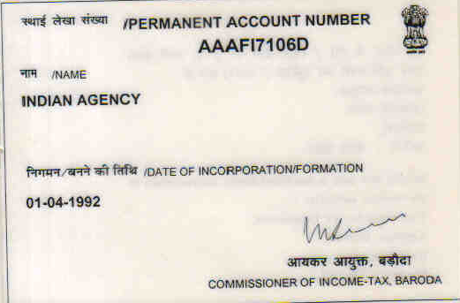
BANK DETAILS :
1. | Bank Name | HDFC BANK LTD
2. | Branch Name & Address | NYAY MANDIR, VADODARA
3. | Account Type | CURRENT A/C
4. | Bank Account Number | 50200042185976
5. | IFSC code (For RTGS) | HDFC0002443
6. | IFSC code (For NEFT) | HDFC0002443
7. | MICR code | 390240015

