**CHAPTER1**

**INTRODUCTION**

**CHAPTER 1**

**1.1 INTRODUCTION TO SYSTEM:**

The conversion of solar light into electrical energy represents one of the most promising and challenging energetic technologies, being clean, silent in continuous development, and reliable, with very low maintenance costs and minimal ecological impact. Solar energy is the thermal radiation of the sun, mainly called the sunlight in daily life. The average solar radiation intensity on the Earth's orbit is 1369w/m2. Earth's equatorial circumference of 40076 kilometers, and thus, we can calculate that the energy Earth get can be up to 173000TW. The standard peak intensity at sea level is 1kW/m2, and the annual average radiation intensity in 24hs from certain point on Earth's surface is 0.20kW/m2, equivalent of 102000TW energy. Although the energy that the sun radiates to the Earth's atmospheres is only one 2,200,000,000th of its total radiation energy, it has been up to 173,000TW, which means the energy from sun is as the equivalent of 5 million tons of Coal--499, 40,000,000Joule every second.

Solar energy from is free, practically inexhaustible, and involves nonpolluting residues or greenhouse gases emissions. The conversion principle of solar light into electricity, called PV conversion. The PV conversion is not very new, but the efficiency improvement of the equipment is still one of top priorities for many academic and/or industrial research groups all over the world. Light is combination of different colors. The light which we can see is called visible light and has colors from purple to red. These different colors of light have different wavelengths and energies. There is also a lot of light that our eyes can’t see! Light that is lower in energy than visible light we call Infrared or IR light. Your task is to determine what colors of light from a lamp and from sunlight work in a solar cell.

Along with decrease of fossil fuels, human beings are beginning to pay more attention on the new energy resource, and focusing on how to convert the new type of energy into electricity instead of fossil fuels. When it comes to the new energy, wind power, hydro power and solar power are known as most of people. Apparently, the sun is everlasting and powerful, which has very huge potential discovered by people. Compared with so many types of new energy, in recent years solar power also possesses the rapid development in both industrial and civil aspects. However, people only can convert and utilize 15% to 25% energy from solar power so far. It is a very low utilization. On the other hands, solar energy owns high cost, high occupied area by solar cell and unstable electric energy production in practical application. Thus, if people want to take good advantage of solar power, these issues must be solved in the further.

**1.2 LITERATURE SURVEY**

When it comes to traditional electricity, we can easily imagine fossil fuels such as coal, natural gas or petroleum, which leads to a quantity of sustainable issues and environmental problems. Therefore, in the future, using more sustainable ways instead of fossil fuel, for instance wind power, solar power and hydropower seems be a globe trend. Nowadays, lots of countries have begun the research and exploitation of solar energy. Here, we will mainly discuss solar energy, researching the power transmitted from sunlight in different ways, because it is so available that we can meet and collect in our daily life. In the same time, it contains a huge amount of potential for human beings to discover. However, normally sunlight is a kind of sense that we feel warm, bright and shining. As a star existing for several billion years, what we think the function of the sunshine is fertilizing the earth and lighting our world. Maybe there is a doubt in most of our minds why someone can link sunshine to electricity power. Sun and electricity, those two seems no any relation ostensibly. We know the sun is hot enough and powerful, but how the light converts into electricity? Also what helps and promotes the conversion? What type of electricity we can get from the sun? Before we solved above question people will face on serious problem it is how to convert the sunlight and then how track it, go through a several of years scientist found the best martial is silicon to convert the sunlight to electric energy, but the conversion rate is very low, only has 15-25%. Based on that reason, people try to consider how to improve the conversion rate. One way is from the chemistry, changing or developing material to research the new and high-conversion-rate material for solar panel.

Another way is that to find best way and fit factors for tracking the light sources. This thesis mainly discusses the physics way like circuit design, light scours tracking and physics factors analysis to improve the light conversion rate. When we try to track the sunlight and convert the energy from the sun, it always has the best factor such as angle, temperature and direction that can convert the maximum energy. When people configure the solar panel, they always want to obtain more energy transfer and utilize the sunlight as great as possible. Based on that reason, people need to research the inclination and azimuth angle that is the relationship between the earth and the sun.

Azimuth angle, it is a measurement method that can represent angular difference of the object on the plane. In general, the azimuth angle range is in 0 degree to 360 degree. The north is 0 degree, east is 90 degree, south is 180 degree and the west is 270 degrees o that people can calculate the angle between two objects on the plane with north point (zero point). And about inclination, it is the angle between two horizontal planes or one horizontal line with one horizontal plane. For application issue, two objects in the space, one is on the horizontal plane, the other one is perpendicular to this horizontal plane and connect these two objects in aline, the inclination between horizontal plane and this line. People can use azimuth, inclination and distance to determine an object on the ground relative the sun.

**1.3 PROBLEM STATEMENT:**

There are some problems with solar power technology at present development.

* Low conversion rate of solar power

The maximum conversion rate of solar power is 25%, which is so inefficient to be compared with other renewable energy. The solar cell, or photovoltaic cell (PV), is a device that converts light into electric current using the photoelectric effect. However, the efficiency of solar cells is only about 22%, which means the rest of the sunlight striking the panel is wasted as heat. More efficient photovoltaic cells have been discovered (up to 43% efficient – but are expensive to manufacture).

* Solar panels use expensive semiconductor material to generate electricity directly from sunlight. Semiconductor factories need 'clean' manufacturing environments, building and maintaining with high cost.

Most solar modules are currently produced by solar cells made from polycrystalline and monocrystalline silicon. More than 90 percent of worldwide PV production has been accounted containing crystalline silicon. However, when people produce crystalline for making solar cell, it will have a strong effect on our environment.

* Solar energy is not stable with weather changed

Along with the weather changing, the electricity is always variation with the light intensity. Like the clouds, seasons, day and night and extreme weather, all of these can affect the power from solar cells.

**CHAPTER 2**

**RENEWABLE ENERGY**

CHAPTER 2

2.1 SOLAR R ENERGY

The whole Earth, which has a cross section of 127,400,000 km2, approximately receives solar power of 1.740 × 1017 W and reflects about 30% of the power back to space. The annual incoming solar radiation at the top of the atmosphere is about 5.5 × 1024 J, and 60% of the energy reaches the surface. The total annual downward solar energy at the surface is about 3.3 × 1024 J, which is 6800 times more than the world's annual energy consumption. Even by excluding the water surface (70%) and assuming a solar energy conversion efficiency of 10% , the usage of solar energy over 0.5% of the land surface can meet the current global energy demand. The downward solar radiation at the surface depends on time, latitude, atmosphere, aerosols/clouds, and surface conditions.

Solar energy can be converted directly or indirectly into other forms of energy, such as heat and electricity. Through vegetation photosynthesis, solar radiation can transfer CO2 in the atmosphere into biodiesel. PV energy results from the conversion of sunlight into electricity through a PV cell, commonly called a solar cell. The PV cell uses a part of solar radiation for generating electricity. Only a photon having enough energy (its wavelength < 1120 nm) can free an electron from the silicon, generating current for electricity. Solar thermal technologies use concentrator systems because of the high temperatures needed for the working gas or fluid. A parabolic trough and solar dish are two examples of efficient concentrator systems .The world's largest parabolic trough facilities, located in the Mojave Desert near Barstow, California, produce 354 MW of power at peak output. In the solar energy plant, oil is used as the carrying medium to absorb solar thermal energy and goes through a heat exchanger to generate steam, which is in turn used to run a conventional power plant. We may consider an alternative model such as a combined natural gas/steam power plant as a solar energy plant. The combined natural gas/steam plant achieves a conversion (from thermal to electric energy) efficiency between 50% and 60% , which is higher than that of a single steam plant, which is between 30% and 40. The solar beam/steam plant would be the same as the conventional combined natural gas/steam plant except that the fuel gas for firing the combustion chamber will be replaced with solar heat.

Solar energy as a resource at high latitudes is poor. It is also low over the Amazon rainforest owing to the large absorption and scattering of clouds there. However, solar radiation over deserts and bare soils at low latitudes is rich. For example, the Qinghai-Tibet plateau may serve as a vast solar energy base for China. A number of locations in deserts and other non vegetated land regions have been proposed for potential solar energy applications .Additional factors, such as population, local energy demands, and the cost of energy transportation, need to be considered when selecting a location for a solar power plant. It needs to be pointed out that only a very small area of each proposed site is needed for the actual plant.

2.2 WIND ENERGY

Wind energy is the atmospheric kinetic energy determined by the mass and motion speed of air. The spatial gradients of the absorbed solar radiation by the Earth-atmospheric system are the primary source for driving atmospheric and oceanic flows and transferring heat from one part of the globe to another. This atmospheric motion contains huge kinetic energy that can be used to benefit mankind. The kinetic energy *K* for an air mass *m* with a wind speed *V* can be expressed as:

display math(1)

The air mass can be derived from the product of its density and volume. For a constant wind speed of *V* and normal section area of *A* during a given period of time *t*, the air mass can be expressed as:

display math(2)

and the kinetic energy of the air mass is:

display math(3)

The wind power density (power per area, W/m2) is:

display math(4)

The atmosphere approximately observes an ideal gas equation in which air density at the standard temperature (*T*0) of 288.15 K and at a sea-level pressure (*P*0) of 101,325 Pa is 1.225 kg/m3 .Therefore, the air density (kg/m3) for a temperature *T* and pressure *P* can be written as:

display math(5)

Using equations [(4)](http://onlinelibrary.wiley.com/doi/10.1002/2013EF000206/full#eft211-disp-0004) and [(5)](http://onlinelibrary.wiley.com/doi/10.1002/2013EF000206/full#eft211-disp-0005) we can derive the wind power density at a temperature *T* (in Kelvin) and at pressure *P* as:

display math(6)

Therefore, the wind power density is proportional to a cubic law of the wind speed. Because of the nonlinearity and the distribution function (e.g., Rayleigh distribution) describing the frequency of occurrence for the wind speed, an energy pattern factor (Epf) is applied when an averaged wind speed *V*a is used to compute the wind power density. That is

display math(7)

In this study, an energy pattern factor, Epf = 1.91 for a Rayleigh distribution is applied when an averaged wind speed is used to compute the wind power density.

**Terms Associated with Solar and Wind Energy:**

* Declination: The angular displacement of the sun from the plane of the earth’s equator.
* Inclination: The angle between the sun’s ray and the perpendicular (normal) to the horizontal plane.
* Azimuth angle: It is the angle on the horizontal plane, between the line due south and the projection of the sun’s ray on the horizontal plane.
* Tilt angle: It is the angle between the inclines surface under consideration and the horizontal.
* Incident angle: It is the angle between the sun’s ray incident on the plane surface(collector) and the normal to the surface.
* Anemometer: It is an instrument used to measure the velocity or speed of the wind.
* Angle of attack: The angle of relative air flow to a wind turbine blades.
* Availability Factor: The percentage of the time that a wind turbine is able to operate and is not out of commission due to maintenance or repairs.
* Cut-in speed: The wind speed at which turbine blades begin to rotate and produce electricity typically around 10 miles per hor.
* Cut-out Speed: The wind speed usually around 55to 65 miles per hour at which some wind turbines automatically stop the blades from turning and rotates out of the wind to avoid damage to the turbine.
* Hybrid System: The combination of multiple energy producing technologies such as photovoltaic solar electric systems combined with small wind turbine systems.

**CHAPTER 3**

**Principle of Design**

**3.1 PRINCIPLE:**

Solar electric systems use solar cells to convert the Sun's radiant energy into electricity. This is done using a principle known as the photovoltaic effect. The electricity produced is called direct current (DC) and can be used immediately or stored in a battery.

A wind turbine works on a simple principle. The energy in the wind turns two or three propeller-like blades around a rotor. The rotor is connected to the main shaft, which spins a generator to create electricity.

**3.2 BLOCK DIAGRAM:**

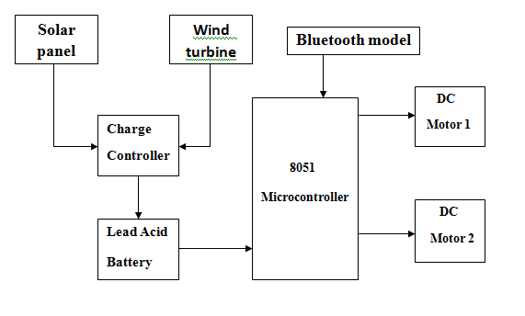

Fig2: Block Diagram of Hybrid Robot

**3.3 CIRCUIT DESCRIPTION:**

**3.4 WORKING:**

**CHAPTER 4**

**MODULES**

**4.1 SOLAR PANEL:**

A solar cell or photovoltaic cell, is an electrical device that converts the energy of light directly into electricity by the photovoltaic effect, which is a physical and chemical phenomenon.[1] It is a form of photoelectric cell, defined as a device whose electrical characteristics, such as current, voltage, or resistance, vary when exposed to light. Solar cells are the building blocks of photovoltaic modules, otherwise known as solar panels.

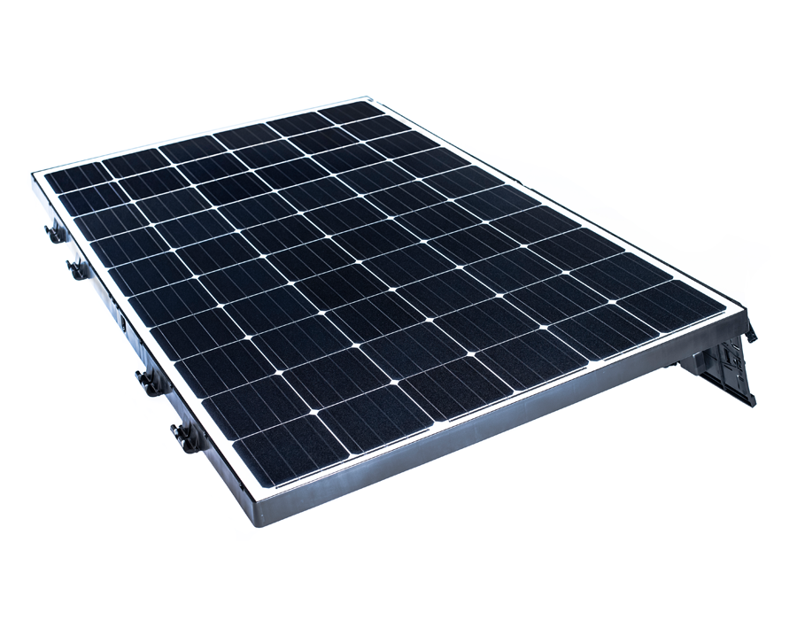

Fig4.1: Solar Panel

**Types of Solar Cell:**

Monocrystalline

Polycrystalline

Cast poly silicon

String ribbon silicon

Amorphous solar panel

**Construction and working:**

It essentially consists of silicon PN junction diode with a glass window on top surface layer P material is made extremely thin so that the incident light photons may easily reach the PN junction. When these photons collide with valence electrons they comport them sufficient energy as to leave their parent atoms. In this way free electrons and holes are generated on both sides of the junction. Due to these holes and electrons current is produced. The current is directly proportional to illumination and also depends on the size of the surface area being illuminated.

**4.2 WIND TURBINE:**

A wind turbine is a device that [converts](https://en.wikipedia.org/wiki/Wind_power) the wind's [kinetic energy](https://en.wikipedia.org/wiki/Kinetic_energy) into [electrical power](https://en.wikipedia.org/wiki/Electrical_power).  The wind turns the blades, which spin a shaft, which connects to a generator and makes electricity. There are two types of wind turbines. They are:

* **Horizontal Axis Wind Turbine**
* **Vertical Axis Wind Turbine**

Horizontal Axis Wind Turbine:

This is the standard type of wind turbine where the low-speed shaft that connects to the rotor is horizontal. There are various ways to construct this wind turbine but they all follow the same concept as outlined above. The rotor spins with the wind and the rotational kinetic energy is converted to electrical energy through a generator

**Vertical Axis Wind Turbine:**

This type of wind turbine is less common but has an advantage in that the rotor does not need to face into the wind. The shaft connecting to the rotor is vertical and the gearbox and generator are generally at the bottom of the tower. There are many types of vertical axis wind turbines all of which follow the same concept of force along the X-axis (parallel to the ground) as opposed to horizontal axis turbines which use force along the Y-axis (perpendicular to the ground).

**4.3 RELAY**

A relay is an electrically operated switch. Many relays use an electromagnet to operate a switching mechanism mechanically, but other operating principles are also used. Relays are used

where it is necessary to control a circuit by a low-power signal (with complete electrical isolation between control and controlled circuits), or where several circuits must be controlled by one signal.

A relay is an electrically operated switch. Current flowing through the coil of the relay creates a magnetic field which attracts a lever and changes the switch contacts. The coil current can be on or off so relays have two switch positions and most have double throw (changeover)

Switch contacts.

Relays allow one circuit to switch a second circuit which can be completely separate from the first. For example a low voltage battery circuit can use a relay to switch 230V AC mains circuit. There is no electrical connection inside the relay between the two circuits; the link is

Magnetic and mechanical.

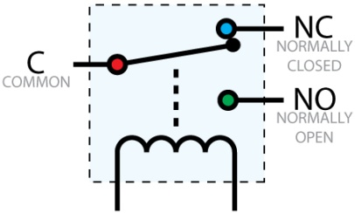

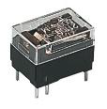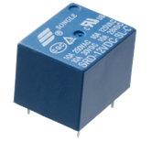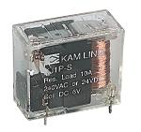

Fig : Relay

The coil of a relay passes a relatively large current, typically 30mA for a 12V relay, but it can

be as much as 100mA for relays designed to operate from lower voltages. Most ICs (chips)

cannot provide this current and a transistor is usually used to amplify the small IC current to the

larger value required for the relay coil. The maximum output current for the popular 555 timer

IC is 200mA so these devices can supply relay coils directly without amplification.

Relays are usually SPDT or DPDT but they can have many more sets of switch contacts, for

example relays with 4 sets of changeover contacts are readily available. For further information

about switch contacts and the terms used to describe them please see the page on switches.

Most relays are designed for PCB mounting but you can solder wires directly to the pins

providing you take care to avoid melting the plastic case of the relay.

The supplier's catalogue should show you the relay's connections. The coil will be obvious

and it may be connected either way round. Relay coils produce brief high voltage 'spikes' when

they are switched off and this can destroy transistors and ICs in the circuit. To prevent damage

you must connect a protection diode across the relay coil.

The figure shows a relay with its coil and switch contacts. You can see a lever on the left

being attracted by magnetism when the coil is switched on. This lever moves the switch contacts.

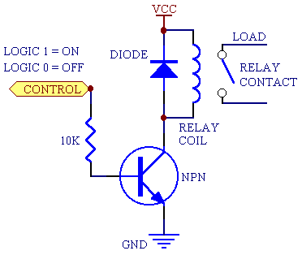

Operation of Relay

There is one set of contacts (SPDT) in the foreground and another behind them, making the

relay DPDT.

The relay's switch connections are usually labeled COM, NC and NO:

• COM = Common, always connect to this; it is the moving part of the switch.

• NC = Normally Closed, COM is connected to this when the relay coil is off.

• NO = Normally Open, COM is connected to this when the relay coil is on.

**Applications of relays**

Relays are used to and for:

• Control a high-voltage circuit with a low-voltage signal, as in some types of modems or

audio amplifiers.

• Control a high-current circuit with a low-current signal, as in the starter solenoid of an

automobile.

* Detect and isolate faults on transmission and distribution lines by opening and closing

circuit breakers.

Time delay functions. Relays can be modified to delay opening or delay closing a set of

contacts. A very short (a fraction of a second) delay would use a copper disk between the

armature and moving blade assembly. Current flowing in the disk maintains magnetic field for a

short time, lengthening release time. For a slightly longer (up to a minute) delay, a dashpot is

used. A dashpot is a piston filled with fluid that is allowed to escape slowly. The time period can

be varied by increasing or decreasing the flow rate. For longer time periods, a mechanical

clockwork timer is installed.

**4.4 PUSH BUTTON:**

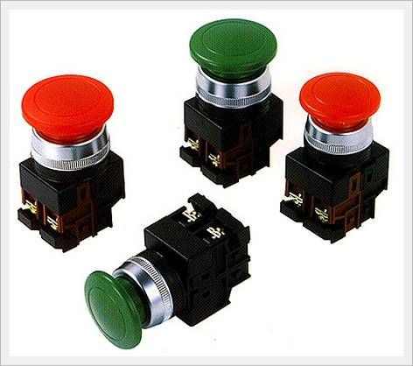

Fig :Push Button

A push-button (also spelled pushbutton) or simply button is a simple switch mechanism for

controlling some aspect of a machine or a process. Buttons are typically made out of hard

material, usually plastic or metal. The surface is usually flat or shaped to accommodate the

human finger or hand, so as to be easily depressed or pushed. Buttons are most often biased

switches, though even many un-biased buttons (due to their physical nature) require a spring to

return to their un-pushed state. Different people use different terms for the "pushing" of the

button, such as press, depress, mash, and punch.

**Uses:**

In industrial and commercial applications push buttons can be linked together by a

mechanical linkage so that the act of pushing one button causes the other button to be released.

In this way, a stop button can "force" a start button to be released. This method of linkage is usedin simple manual operations in which the machine or process have no electrical circuits forcontrol.

Pushbuttons are often color-coded to associate them with their function so that the operator

will not push the wrong button in error. Commonly used colors are red for stopping the machine

or process and green for starting the machine or process.

Red pushbuttons can also have large heads (mushroom shaped) for easy operation and to

facilitate the stopping of a machine. These pushbuttons are called emergency stop buttons and

are mandated by the electrical code in many jurisdictions for increased safety. This large

mushroom shape can also be found in buttons for use with operators who need to wear gloves for

their work and could not actuate a regular flush-mounted push button. As an aid for operators

and users in industrial or commercial applications, a pilot light is commonly added to draw the

attention of the user and to provide feedback if the button is pushed. Typically this light is

included into the center of the pushbutton and a lens replaces the pushbutton hard center disk.

**4.5 LED:**

LEDs are semiconductor devices. Like transistors, and other diodes, LEDs are made out of

silicon. What makes an LED give off light are the small amounts of chemical impurities that are

added to the silicon, such as gallium, arsenide, indium, and nitride.

When current passes through the LED, it emits photons as a byproduct. Normal light bulbs

produce light by heating a metal filament until it is white hot. LEDs produce photons directly

and not via heat, they are far more efficient than incandescent bulbs.

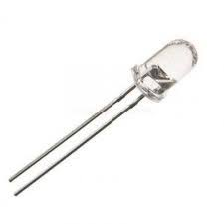 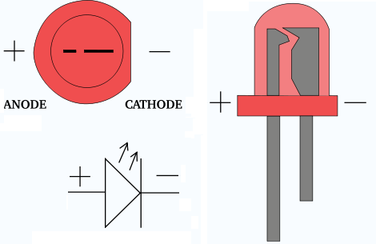 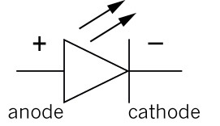

Fig: LED

Not long ago LEDs were only bright enough to be used as indicators on dashboards or electronic equipment. But recent advances have made LEDs bright enough to rival traditional lighting technologies. Modern LEDs can replace incandescent bulbs in almost any application.

**4.6 RESISTORS**

A resistor is a two-terminal electronic component designed to oppose an electric current by producing a voltage drop between its terminals in proportion to the current, that is, in accordance with Ohm's law:

V = IR

Resistors are used as part of electrical networks and electronic circuits. They are extremely

commonplace in most electronic equipment. Practical resistors can be made of various

compounds and films, as well as resistance wire (wire made of a high-resistivity alloy, such as

nickel/chrome).

The primary characteristics of resistors are their resistance and the power they can dissipate.

Other characteristics include temperature coefficient, noise, and inductance. Less well-known is

critical resistance, the value below which power dissipation limits the maximum permitted

current flow, and above which the limit is applied voltage. Critical resistance depends upon the

materials constituting the resistor as well as its physical dimensions; it's determined by design.

Resistors can be integrated into hybrid and printed circuits, as well as integrated circuits.

Size, and position of leads (or terminals) are relevant to equipment designers; resistors must be

physically large enough not to overheat when dissipating their power.



Fig :Resistors

A resistor is a two-terminal passive electronic component which implements electrical resistance as a circuit element. When a voltage V is applied across the terminals of a resistor, a current I will flow through the resistor in direct proportion to that voltage. The reciprocal of the constant of proportionality is known as the resistance R, since, with a given voltage V, a larger value of R further "resists" the flow of current I as given by Ohm's law:

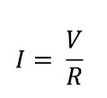

Resistors are common elements of electrical networks and electronic circuits and are

ubiquitous in most electronic equipment. Practical resistors can be made of various compounds

and films, as well as resistance wire (wire made of a high-resistivity alloy, such as nickel chrome). Resistors are also implemented within integrated circuits, particularly analog devices,

and can also be integrated into hybrid and printed circuits.

**4.7 CAPACITOR**

A capacitor or condenser is a passive electronic component consisting of a pair of conductors

separated by a dielectric. When a voltage potential difference exists between the conductors, an

electric field is present in the dielectric. This field stores energy and produces a mechanical force

between the plates. The effect is greatest between wide, flat, parallel, narrowly separated

conductors.

An ideal capacitor is characterized by a single constant value, capacitance, which is

measured in farads. This is the ratio of the electric charge on each conductor to the potential

difference between them. In practice, the dielectric between the plates passes a small amount of

leakage current. The conductors and leads introduce an equivalent series resistance and the

dielectric has an electric field strength limit resulting in a breakdown voltage.

The properties of capacitors in a circuit may determine the resonant frequency and quality

factor of a resonant circuit, power dissipation and operating frequency in a digital logic circuit,

energy capacity in a high-power system, and many other important aspects. 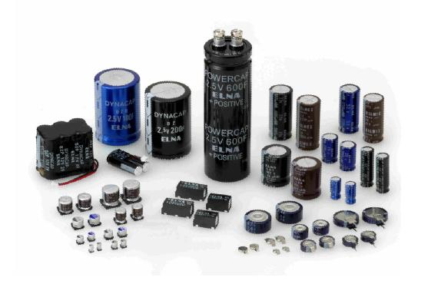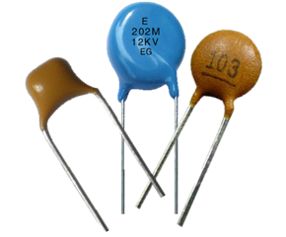

Fig: Electrolytic and Ceramic Capacitors

A capacitor (formerly known as condenser) is a device for storing electric charge. The forms

of practical capacitors vary widely, but all contain at least two conductors separated by a nonconductor.

Capacitors used as parts of electrical systems, for example, consist of metal foils

separated by a layer of insulating film.

Capacitors are widely used in electronic circuits for blocking direct current while allowing

alternating current to pass, in filter networks, for smoothing the output of power supplies, in the

resonant circuits that tune radios to particular frequencies and for many other purposes.

**4.8 MICROCONTROLLER(8051):**

A microcontroller is a self-contained system with peripherals, memory and a processor that can be used as an embedded system. Microcontroller is also called “Embedded Controller”.

Some of the features of the 8051microcontroller are:

* 4 KB on chip program memory.
* 128 bytes on chip data memory(RAM)
* 32 bytes devoted to register banks
* 16 bytes of bit-addressable memory
* 80 bytes of general-purpose memory
* 4 register banks.
* 128 user defined software flags.
* 8-bit data bus
* 16-bit address bus
* 16 bit timers (usually 2, but may have more, or less).
* 3 internal and 2 external interrupts.
* Bit as well as byte addressable RAM area of 16 bytes.
* Four 8-bit ports, (short models have two 8-bit ports).
* 16-bit program counter and data pointer.
* 1 Microsecond instruction cycle with 12 MHz Crystal.
* 8051 may also have a number of special features such as UARTs, ADC, Op-amp, etc.

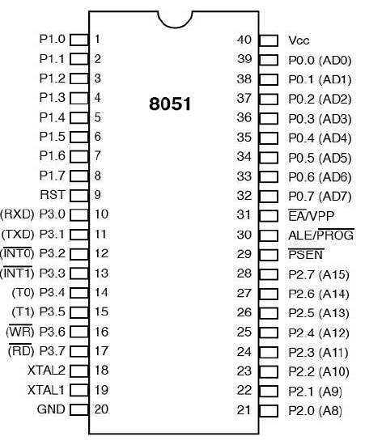

Fig: Pin Diagram of 8051

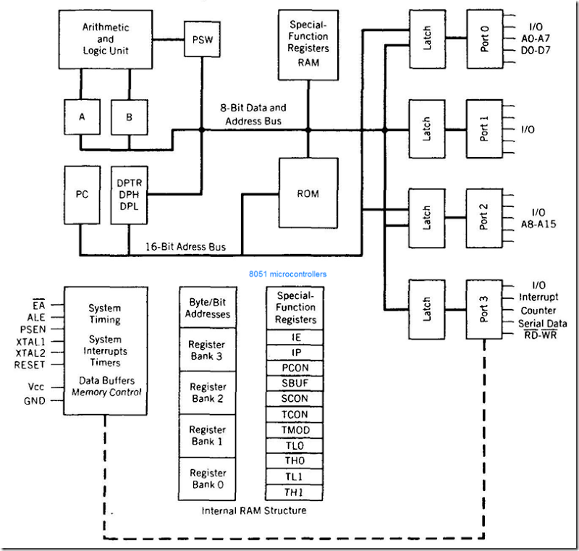

Fig: Internal Architecture of 8051 Microcontroller

**TMOD:**

* The TMOD register is used to select the operating mode and the timer/counter operation of the timers.

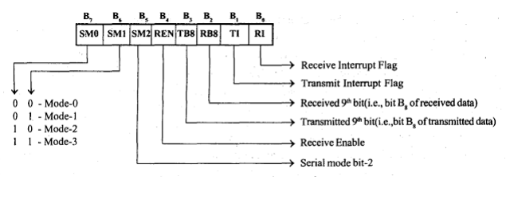

Fig: Tmod Register

* The lower four bits of TMOD register is used to control timer-0 and the upper four bits are used to control timer-1.
* The two timers can be independently program to operate in various modes.
* The TMOD register has two separate two bit field M0 and Ml to program the operating mode of timers. The operating modes of timers are mode-0, mode-1, mode-2 and mode-3. In all these operating modes the oscillator clock is divided by 12 and applied as input clock to timer.

**MODE-0**

* In mode-0 the timer register is configured as 13-bit register. o For timer-1 the 8 bits of TH1 and lower 5 bits of TL1 are used to form 13-bit register.
* For timer-0 the 8-bit of TH0 and lower 5 bits of TL0 are used to form 13-bit register. o The upper three bits of TL registers are ignored.
* For every clock input to timer the 13-bit timer register is incremented by one When the timer count rolls over from all 1’s to all 0’s, (i.e., 1 1111 1111 1111 to 0 0000 0000 0000) the timer interrupt flag in TCON register is set to one.

**Mode-1**

* The mode-1 is same as mode-0 except the size of the timer register. In mode-1 the TH and TL registers are cascaded to form 16-bit timer register.

**MODE-2**

* In mode-2, the timers function as 8-bit timer with automatic reload feature. The TL register will function as 8-bit timer count register and the TH register will hold an initial count value.
* When the timer is started, the initial value in TH is loaded to TL and for each clock input to timer the 8-bit timer count register is incremented by one.
* When the timer count rolls over from all 1’s to all 0’s (i.e., 1111 1111 to 0000 0000), the timer interrupt flag in TCON register is set to one and the content of TH register is reloaded in TL register and the count process starts again from this initial value.

**Mode-3**

* In mode-3, the timer-0 is configured as two separate 8-bit timers and the timer-1 is stopped. o In mode-3 the TL0 will function as 8-bit timer controlled by standard timer-0 control bits and the TH0 will function as 8-bit timer controlled by timer-1 control bits.
* While timer-0 is programmed in mode-3, the timer-0 can be programmed in mode-0, 1 or 2 and can be used for an application that does not require an interrupt.
* The C/T(Low) bit of TMOD register is used to program the counter or timer operation of the timer. When C/T bit is set to one, the timer will function as event counter. The C/T(Low) bit is programmed to zero for timer operation.
* The timer will run only if clock input is allowed.
* When GATE = 1, the clock input to timer is allowed only if the signal at pin is high and when GATE =0 the signal at INT (low) pin is ignored.

**SCON:**

|  |
| --- |
| **Serial Port Control Register (SCON)** |
| The serial port control and status register is the Special Function Register SCON. This register contains not only the mode selection bits, but also the 9th data bit for transmit and receive (TB8 and RB8), and the serial ports interrupt bits (TI and RI).  Capture1.PNG  Fig :SCON Register  Based on SM0 and SM1 various baud rates are selected as shown in the table below.  Capture.PNG  Table1   * SM0-SCON.7- Serial port mode specifier (Table-1) * SM1-SCON.6- Serial port mode specifier (Table-1) * SM2-SCON.5- Enable multiprocessor communication in modes 2/3. * REN-SCON.4- Set/clear by software to enable/disable reception * TB8-SCON.3- The 9th bit that will be transmitted in mode2/3, set/clear by software * RB8-SCON.2- In mode2/3, it is the 9th bit that was received. In mode 1, if SM2=0, RB8 is the stop bit that was received, in mode 0, it is not used. * TI-SCON.1- Transmit Interrupt flag, set by hardware at the end of 8th bit time in mode 0, at the beginning of the stop bit in the other modes, it must be cleared by software. * RI-SCON.0- receives Interrupt flag, set by hardware and must be cleared by software. |
|  |

**4.9 BLUETOOTH HC-05:**

HC-05 module is an easy to use Bluetooth SPP (Serial Port Protocol) module, designed for transparent wireless serial connection setup.

Serial port Bluetooth module is fully qualified Bluetooth V2.0+EDR (Enhanced Data Rate) 3Mbps Modulation with complete 2.4GHz radio transceiver and baseband. It uses CSR Bluecore 04-External single chip Bluetooth system with CMOS technology and with AFH(Adaptive Frequency Hopping Feature).

**Hardware Features**

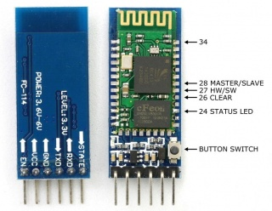

* Typical ‐80dBm sensitivity.
* Up to +4dBm RF transmit power.
* 3.3 to 5 V I/O.
* PIO(Programmable Input/Output) control.
* UART interface with programmable baud rate.
* With integrated antenna.
* With edge connector

**Software Features**

* Default Baud rate: 38400, Data bits:8, Stop bit:1,Parity:No parity, Data control: has.

Slave default Baud rate: 9600, Data bits:8, Stop bit:1,Parity:No parity

* Given a rising pulse in PIO0, device will be disconnected.
* Status instruction port PIO1: low-disconnected, high-connected;
* PIO10 and PIO11 can be connected to red and blue led separately. When master and slave are paired, red and blue led blinks 1time/2s in interval, while disconnected only blue led blinks 2times/s.
* Auto-connect to the last device on power as default.
* Permit pairing device to connect as default.
* Auto-pairing PINCODE:”0000” as default λ Auto-reconnect in 30 min when disconnected as a result of beyond the range of connection.
* Auto‐connect to the last device on power as default.
* Auto‐pairing PINCODE:”1234” as default.

**Pin Description:**

The HC-05 Bluetooth Module has 6pins. They are as follows:

* **ENABLE:**

When enable is pulled LOW, the module is disabled which means the module will not turn on and it fails to communicate. When enable is left open or connected to 3.3V, the module is enabled i.e the module remains on and communication also takes place.

* **Vcc:**

Supply Voltage 3.3V to 5V

* **GND:**

Ground pin

* **TXD & RXD:**

These two pins acts as an UART interface for communication

* **STATE:**

It acts as a status indicator. When the module is not connected to / paired with any other Bluetooth device, signal goes Low. At this low state, the led flashes continuously which denotes that the module is not paired with other device. When this module is connected to/paired with any other Bluetooth device, the signal goes high. At this high state, the led blinks with a constant delay say for example 2s delay which indicates that the module is paired.

* **BUTTON SWITCH:**

This is used to switch the module into AT command mode. To enable AT command mode, press the button switch for a second. With the help of AT commands, the user can change the parameters of this module but only when the module is not paired with any other BT device. If the module is connected to any other Bluetooth device, it starts to communicate with that device and fails to work in AT command mode.

**4.10 DC MOTOR:**

A DC motor is any of a class of rotary electrical machines that converts direct current electrical energy into mechanical energy.

The principle of working of a DC motor is that "*whenever a current carrying conductor is placed in a magnetic field, it experiences a mechanical force".* The direction of this force is given by Fleming's left hand rule and it's magnitude is given by F = BIL.

B = magnetic flux density

I = current

L = length of the conductor within the magnetic field.

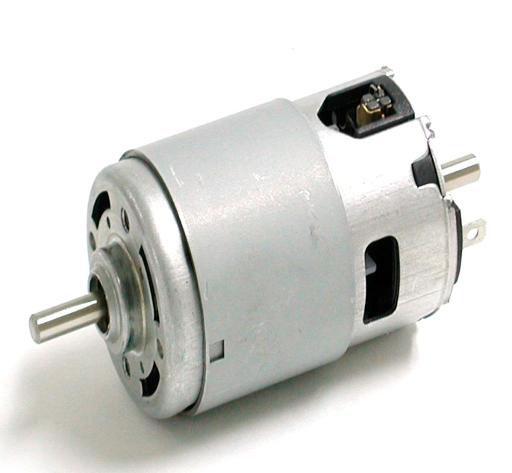

Fig: DC Motor

**Fleming's left hand rule** : If we stretch the first finger, second finger and thumb of our left hand to be perpendicular to each other AND direction of magnetic field is represented by the first finger, direction of the current is represented by second finger then the thumb represents the direction of the force experienced by the current carrying conductor.

When armature windings are connected to a DC supply, current sets up in the winding. Magnetic field may be provided by field winding (electromagnetism) or by using permanent magnets. In this case, current carrying armature conductors experience force due to the magnetic field, according to the principle stated above.

Commutator is made segmented to achieve unidirectional torque. Otherwise, the direction of force would have reversed every time when the direction of movement of conductor is reversed the magnetic field.

**4.11 DC MOTOR DRIVER CIRCUIT L293D:**

L293D is a typical Motor driver or Motor Driver IC which allows DC motor to drive on either direction. L293D is a 16-pin IC which can control a set of two DC motors simultaneously in any direction. It means that you can control two DC motor with a single L293D IC.

It works on the concept of H-bridge. H-bridge is a circuit which allows the voltage to be flown in either direction. As you know voltage need to change its direction for being able to rotate the motor in clockwise or anticlockwise direction, Hence H-bridge IC are ideal for driving a DC motor.

In a single L293D chip there are two h-Bridge circuit inside the IC which can rotate two dc motor independently. Due its size it is very much used in robotic application for controlling DC motors. Given below is the pin diagram of a L293D motor controller.

There are two Enable pins on l293d. Pin 1 and pin 9, for being able to drive the motor, the pin 1 and 9 need to be high. For driving the motor with left H-bridge you need to enable pin 1 to high. And for right H-Bridge you need to make the pin 9 to high. If anyone of the either pin1 or pin9 goes low then the motor in the corresponding section will suspend working. It’s like a switch.

**Pin Diagram:**

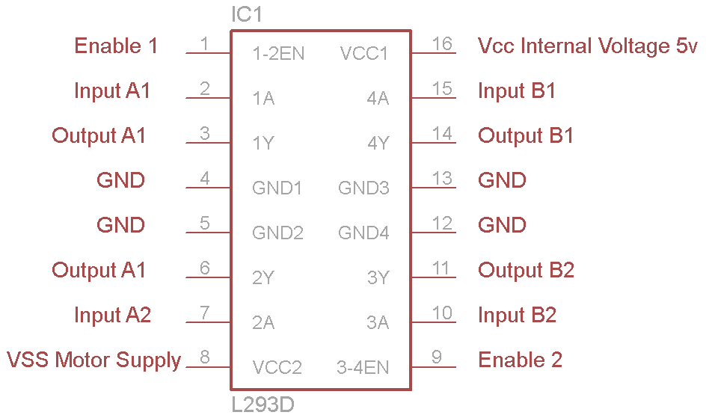

Fig: L293D Pin diagram

* Pin-1 (Enable 1-2):  When the enable pin is high, then the left part of the IC will work otherwise it won’t work. This pin is also called as a master control pin.
* Pin-2 (Input-1):  When the input pin is high, then the flow of current will be through output 1
* Pin-3 (Output-1): This output-1 pin must be connected to one of the terminals of the motor
* Pin4 &5: These pins are ground pins
* Pin-6 (Output-2):  This pin must be connected to one of the terminals of the motor.
* Pin-7 (Input-2): When this pin is HIGH then the flow of current will be though output 2
* Pin-8 (Vcc2): This is the voltage pin which is used to supply the voltage to the motor.
* Pin-16 (Vss): This pin is the power source to the integrated circuit.
* Pin-15 (Input-4): When this pin is high, then the flow of current will be through output-4.
* Pin-14 (Output-4): This pin must be connected to one of the terminals of the motor
* Pin-12 & 13: These pins are ground pins
* Pin-11 (Output-3): This pin must be connected to one of the terminals of the motor.
* Pin-10 (Input-3): When this pin is high, then the flow of current will through output-3
* Pin-9 (Enable3-4): When this pin is high, then the right part of the IC will work & when it is low the right part of the IC won’t work. This pin is also called as a master control pin for the right part of the IC.

**Working:**

There are 4 input pins for l293d, pin 2,7 on the left and pin 15 ,10 on the right as shown on the pin diagram. Left input pins will regulate the rotation of motor connected across left side and right input for motor on the right hand side. The motors are rotated on the basis of the inputs provided across the input pins as LOGIC 0 or LOGIC 1 i.e High or Low.

## L293D Logic Table:

Suppose you need to control the left motor which is connected to Pin3 and Pin6. As mentioned above, we require three pins to control this motor - Pin1 (E1), Pin2 and Pin7. Here is the truth table representing the functionality of this motor driver.

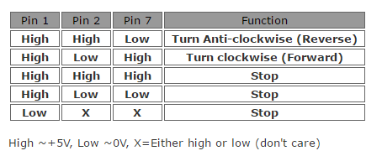

Fig: L293 Truth Table

In the above truth table you can observe that if Pin1 (E1) is low then the motor stops, irrespective of the states on Pin2 and Pin7. Hence it is essential to hold E1 high for the driver to function, or simply connect enable pins to positive 5 volts.

With Pin1 high, if Pin2 is set high and Pin7 are pulled low, then current flows from Pin2 to Pin7 driving the motor in anti-clockwise direction. If the states of Pin2 and Pin7 are flipped, then current flows from Pin7 to Pin2 driving the motor in clockwise direction.

The above concept holds true for other side of the IC too. Connect your motor to Pin11 and Pin14; Pin10 and Pin15 are input pins, and Pin9 (E2) enables the driver.

I guess we have already had too much of theory. In the next section, we will start building the board.

**Connection Diagram:**

The circuit shown to the right is the most basic implementation of L293D IC. There are 16 pins sticking out of this IC and we have to understand the functionality of each pin before implementing this in a circuit

1. Pin1 and Pin9 are "Enable" pins. They should be connected to +5V for the drivers to function. If they pulled low (GND), then the outputs will be turned off regardless of the input states, stopping the motors. If you have two spare pins in your microcontroller, connect these pins to the microcontroller, or just connect them to regulated positive 5 Volts.
2. Pin4, Pin5, Pin12 and Pin13 are ground pins which should ideally be connected to microcontroller's ground.
3. Pin2, Pin7, Pin10 and Pin15 are logic input pins. These are control pins which should be connected to microcontroller pins. Pin2 and Pin7 control the first motor (left); Pin10 and Pin15 control the second motor(right).
4. Pin3, Pin6, Pin11, and Pin14 are output pins. Tie Pin3 and Pin6 to the first motor, Pin11 and Pin14 to second motor
5. Pin16 powers the IC and it should be connected to regulated +5Volts
6. Pin8 powers the two motors and should be connected to positive lead of a secondary battery. As per the datasheet, supply voltage can be as high as 36 Volts.

[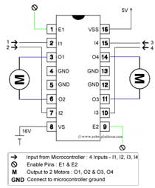](http://www.robotplatform.com/howto/L293/img_l/L293D_connections.jpg)

Fig: Connection Diagram of L293D

**4.12 SOLAR CHARGE CONTROLLER:**

A solar charge controller is basically a current or a voltage controller to charge the battery and to protect the cells from overcharging. It directs the current and voltage comes from the solar panels to charge the battery.

**Working:**

* Microcontroller is powered up with 5V regulated DC supply from the battery. Ones the microcontroller is powered ON, it continuously monitors the battery voltage with the help of ADC. A potential divider connected at the pin 2 of the ADC with resistor arrangement, scale down the voltage from 0V-20V to 0V-05V. Then these values are accordingly displayed on LCD display.
* This circuit is implemented with a parallel regulation technique which allows the charging current to flow into the battery and once the battery is fully charged it stops charging. By making this charging as pulsed, wasting of current as heat is reduced to keep the battery topped-up.
* Microcontroller continuously gets the input signals from dusk to dawn sensor and based on this input, it switches the load or charging relay. When this sensor gives the input to microcontroller upon solar voltage presence, then microcontroller drives the LCD to display the message as charging. Once battery is fully charged , then microcontroller interrupts the charging by energizing the relay through the MOSFET. At this time, microcontroller starts 5 minute timer and displays the message as Battery Full.
* After the timer elapsed, the relay reconnects the battery to solar panel. By this way solar charging current is pulsed as long as the solar voltage is present.
* Whenever the solar panel voltage falls below the zener diode voltage of the dusk-to-dawn sensor, then microcontroller receives it and activates the load through MOSFET and accordingly displays the message as Load ON. Similarly, when the voltage falls low then the dusk-to-dawn sensor then microcontroller turns OFF the load through this MOSFET.

By this way solar charging system charges the battery as well as protects the battery and loads from over and under voltages.

**CHAPTER 5**

**SOFTWARE**

**5.1 INTRODUCTION TO KEIL MICRO VISION (IDE)**

Keil an ARM Company makes C compilers, macro assemblers, real-time kernels, debuggers,

Simulators, integrated environments, evaluation boards, and emulators for ARM7/ARM9/Cortex-

M3, XC16x/C16x/ST10, 251, and 8051 MCU families.

Keil development tools for the 8051 Microcontroller Architecture support every level of

Software developer from the professional applications engineer to the student just learning about

Embedded software development. When starting a new project, simply select the microcontroller

You use from the Device Database and the μVision IDE sets all compiler, assembler, linker, and

Memory options for you.

Keil is a cross compiler. So first we have to understand the concept of compilers and cross

Compilers. After then we shall learn how to work with keil.

**5.2 CONCEPT OF COMPILER**

Compilers are programs used to convert a High Level Language to object code. Desktop

Compilers produce an output object code for the underlying microprocessor, but not for other

microprocessors. I.E the programs written in one of the HLL like ‘C’ will compile the code to

run on the system for a particular processor like x86 (underlying microprocessor in the

computer). For example compilers for Dos platform is different from the Compilers for Unix

platform. So if one wants to define a compiler then compiler is a program that translates source

code into object code.

The compiler derives its name from the way it works, looking at the entire piece of source

code and collecting and reorganizing the instruction. See there is a bit little difference between

compiler and an interpreter. Interpreter just interprets whole program at a time while compiler

analyses and execute each line of source code in succession, without looking at the entire

program.

The advantage of interpreters is that they can execute a program immediately. Secondly

programs produced by compilers run much faster than the same programs executed by an

interpreter. However compilers require some time before an executable program emerges. Now

as compilers translate source code into object code, which is unique for each type of computer,

many compilers are available for the same language.

**CHAPTER 6**

**ADVANTAGES AND DISADVANTAGES**

**6.1 ADVANTAGES**

**6.2 DISADVANTAGES**

**CHAPTER 7**

**PROGRAM**

**7.1 Program:**

**Main Function:**

#include<reg51.h>  
unsigned char y;  
  
void delay(int x)  
{  
int i,j;  
for(i=0;i<x;i++)  
  
for(j=0;j<=1275;j++);  
  
}  
  
  
main()  
{  
        serial_init();  
  
        {  
                bluetooth();  
  
        }  
  
}  
  
  
**Bluetooth Function**:

#include<reg51.h>  
#include"motor_fuction.h"  
#include"uart.h"  
  
void bluetooth()  
{  
c=rcv();  
  
if(c==f)  
{  
motor_front();  
}  
  
if(c==b)  
{  
motor_back();  
}  
if(c==l)  
{  
motor_left();  
}  
if(c==r)  
{  
motor_right();  
}  
if(c==s)  
{  
 motor_stop();  
}  
}  
  
**Uart Function:**

void serial_init()  
{  
        TMOD = 0x20;  
        SCON = 0x50;  
        TH1 = -3;  //9600  
        TR1 = 1;  
}  
void trans(unsigned char x)  
{  
        SBUF = x;  
        while(!TI);  
        {  
                TI =10;  
        }  
}  
unsigned char rcv()  
{  
        unsigned char b;  
        while(!RI);  
        b = SBUF;  
        RI = 10;  
        return b;  
  
}  
  
void rec_str00(char str[])  
{  
  int i=0;  
  
  while(1)  
  {  
   str[i] = rcv();  
        }  
  
**Motor Function:**  
#include<reg51.h>  
sbit motor1R=P0^0;//22  
sbit motor1L=P0^1;//23  
sbit motor2R=P0^2;//24  
sbit motor2L=P0^3;//25  
  
  
void motor_front()  
{  
motor1R=0x00;  //22  
motor1L=0x01;  //23  
motor2R=0x00;  //24  
motor2L=0x01;           //25  
}  
  
void motor_back()  
{  
motor1L=0x00;  //23  
motor1R=0x01;  //22  
motor2L=0x01;  //25  
motor2R=0x00;           //24  
}  
  
void motor_right()  
{  
motor1R=0x01;  
motor1L=0x00;  
motor2R=0x01;  
motor2L=0x00;  
}  
  
void motor_left()  
{  
motor1R=0x00;  
motor1L=0x01;  
motor2L=0x01;  
motor2R=0x00;  
}  
 void motor_stop()  
{  
motor1R=0x00;  
motor1L=0x00;  
motor2R=0x00;  
motor2L=0x00;  
}

**CHAPTER 8**

**RESULTS AND DISCUSSON**

**8.1 CONCLUSION**

**8.2 SCOPE OF FUTURE**

**8.3 BIBLIOGRAPHY**

# APPENDIX