Data Preparation Report
Smoking & Drinking Detection — Class-Balanced YOLOv8 Dataset
At a glance
Task: Object detection — two classes: smoking (0), drinking (1)
Source: 1 Roboflow project (case1-dmyty/eating-drinking-mobile-smoking, v1), YOLOv8 format
Raw images downloaded: 8,333
Clean target instances: 4,809 boxes across 4,069 images
After dedup + balancing: 3,704 images (smoking 2,010 / drinking 1,694)
Final split: train 2,963 · val 370 · test 371 images
Exported dataset: 3,704 originals + 5,921 augmented train images (726.2 MB zip)

1 Objective & Pipeline
The goal of this notebook is to build a clean, reproducible, training-ready object-detection dataset for two behaviours — smoking and drinking — and hand off an Ultralytics YOLOv8 package (a data.yaml plus images/ and labels/ folders). No model training is performed here; the notebook covers only the data side.
A central design decision distinguishes this version from an earlier one. The earlier pipeline corrected class imbalance by augmenting the minority class up to roughly 17×, which encourages overfitting and poor generalization. This version fixes imbalance at the source and sampling level instead: it starts from a Roboflow project that already contains both classes, caps the majority class down to real images after cleaning, and keeps augmentation light and hard-capped.

Processing stages
The dataset flows through the following ordered stages, each of which is audited before the next begins:
- Download every configured Roboflow project in YOLOv8 format.
- Harmonize by class name — each source's data.yaml names are remapped onto a unified schema, so mismatched index orders cannot corrupt labels.
- Validate & quarantine — corrupt images, missing / malformed labels, out-of-range coordinates and unmapped classes are set aside before any analysis.
- EDA — class balance, scene crowding, box geometry, spatial prior, and per-source comparison.
- Deduplicate perceptually, then balance with real images, then split (image-grouped, stratified), then augment train only and export.
The whole run is reproducible via a single global seed (SEED = 42). Environment: Albumentations 2.0.8 with OpenCV 4.10.0.

2 Dataset
The dataset is pulled directly from Roboflow via the API in YOLOv8 format (normalized .txt labels) — no manual uploads or Drive mounts. The active source is the project case1-dmyty / eating-drinking-mobile-smoking (version 1), a large set of 8,333 images whose annotations cover four action classes.

Source classes and the unified schema
Only smoking and drinking are targets. The name-based harmonizer reads the source's declared classes and maps each onto the unified schema; anything that is not a smoking or drinking synonym is dropped rather than remapped, so it can never masquerade as a target.
Source class (id) | Declared name | Mapped to | Unified id
0 | cigarette | smoking | 0
1 | drinking | drinking | 1
2 | eating | DROP | —
3 | mobile | DROP | —
Table 1 · Name-based class harmonization. The eating and mobile classes are discarded; cigarette is folded into smoking.
As a result of dropping non-target boxes, 5,939 non-target boxes were removed during indexing. Images whose boxes were all non-target become negatives; with KEEP_NEGATIVES = False the pipeline retains only images that contain at least one smoking or drinking box.

3 Preprocessing

3.1 · Integrity validation & quarantine
Every unique image is checked for decodability (PIL can open and verify the pixels), label presence (missing vs. empty vs. malformed), coordinate sanity (values normalized to [0,1] with non-zero box size), and unmapped classes (an id in a label file absent from the source data.yaml). The results were exceptionally clean:
Quality check | Count
Corrupt / undecodable images | 0
Missing labels | 0
Malformed labels | 0
Bad coordinates | 0
Unmapped classes | 0
Empty (negative) labels | 794
Dropped non-target-only images | 3,470
Table 2 · Data-quality report. No images were quarantined for defects; the 794 empty and 3,470 non-target-only images are intentional exclusions, not errors.
Images quarantined for any defect: 0. The intentionally dropped non-target and empty images are not counted as errors.

3.2 · Building the clean instance table
After quarantine, only real smoking / drinking boxes are kept and derived box geometry (area and aspect ratio in normalized units) is computed. This produces the trustworthy per-box table used by every chart and by the export:
- Clean target instances: 4,809 boxes across 4,069 images.
- Instances per class: smoking 2,149 · drinking 2,660.

3.3 · Deduplication
Merged detection datasets frequently share frames, and a duplicate that lands on both sides of the split leaks information. Every image is perceptual-hashed (pHash) and one representative is kept per hash cluster. This found 348 duplicate clusters and dropped 365 images, leaving 3,704 target images before balancing.

3.4 · Balancing with real images
Rather than inflating the minority class with heavy augmentation, the majority class is capped downward using real data. Each image is assigned a dominant class, and the majority class is limited to at most MAX_IMBALANCE_RATIO × the minority-class image count (ratio = 1.25). This runs after dedup and before the split, so the balance is real and duplicate-free.
Dominant class | Images before | Images after | Cap
smoking | 2,010 | 2,010 | ≤ 2,118
drinking (minority) | 1,694 | 1,694 | —
Table 3 · Real-image balancing. Both classes already sat inside the 1.25× cap, so no images had to be discarded; the image-level imbalance ratio is 1.19×.
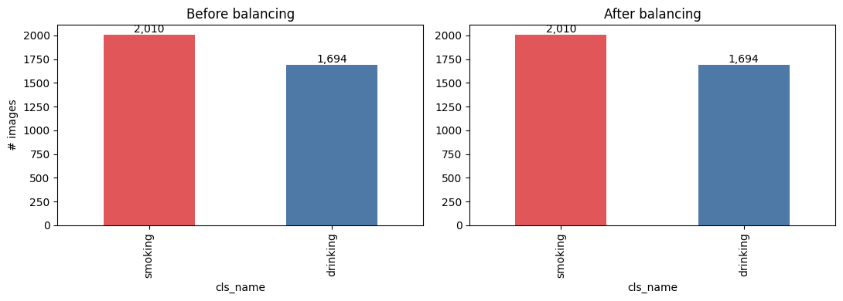
Figure 1 · Images per dominant class before and after balancing — essentially unchanged because the source is already balanced.

4 Exploratory Data Analysis
The EDA is organized around the questions that most influence detector behaviour: class balance, scene crowding, box geometry, spatial prior, and cross-dataset agreement.

4.1 · Class balance
Counted at the instance level, drinking is slightly more common than smoking, with an imbalance ratio of only 1.24× (max/min) — well within a healthy range and a direct consequence of choosing a source that carries both behaviours.
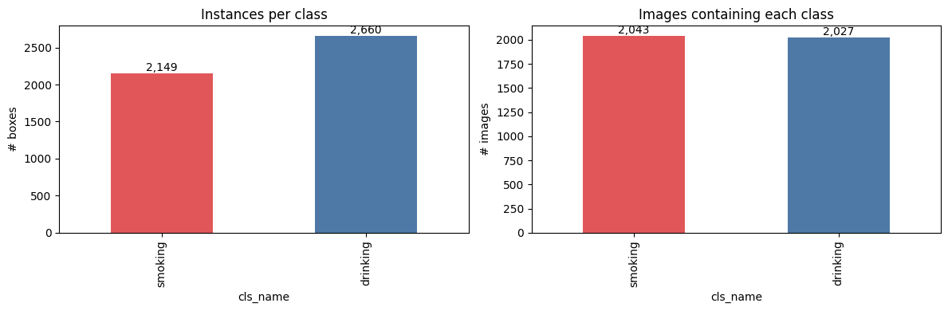
Figure 2 · Instances per class (left) and images containing each class (right).

4.2 · Objects per image
Scenes are overwhelmingly single-object: the mean is 1.18 boxes per image, the median is 1, and the 75th percentile is still 1, with a long thin tail up to 8 boxes in the busiest frame. Detectors will rarely have to resolve crowded, overlapping instances.
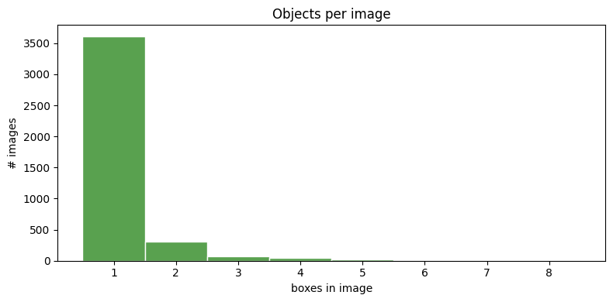
Figure 3 · Distribution of the number of boxes per image (count 4,069; mean 1.18; max 8).

4.3 · Box geometry & small objects
Box width, height and aspect ratio were profiled and each box bucketed by its area as a fraction of the image. The small-object share matters because tiny boxes are the hardest for a detector to see at low resolution.
Size bucket (area of image) | drinking | smoking
tiny (<1%) | 339 | 738
small (1–5%) | 1,508 | 1,242
medium (5–15%) | 656 | 163
large (>15%) | 157 | 6
Table 4 · Instance counts by object size. Smoking boxes skew much smaller (cigarettes) while drinking boxes are larger (bottles / cups).
Roughly 22.4% of all boxes are tiny (<1% of the image), concentrated in the smoking class. The notebook's recommendation follows directly: prefer a larger training image size (e.g. imgsz 832–960) and avoid heavy downscaling.
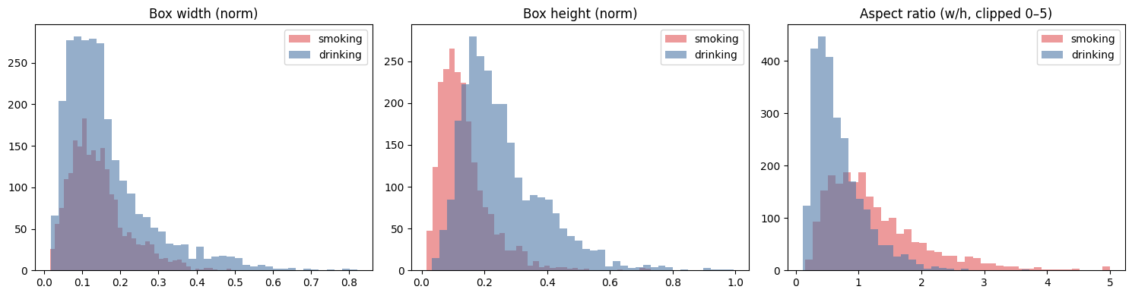
Figure 4 · Normalized box width, height, and aspect ratio by class.

4.4 · Spatial prior
Heatmaps of box centres show where each behaviour tends to appear in the frame. Both classes cluster toward the centre and lower-centre of the image — consistent with hand-to-mouth actions framed on a subject — with drinking sitting marginally lower and wider than smoking.
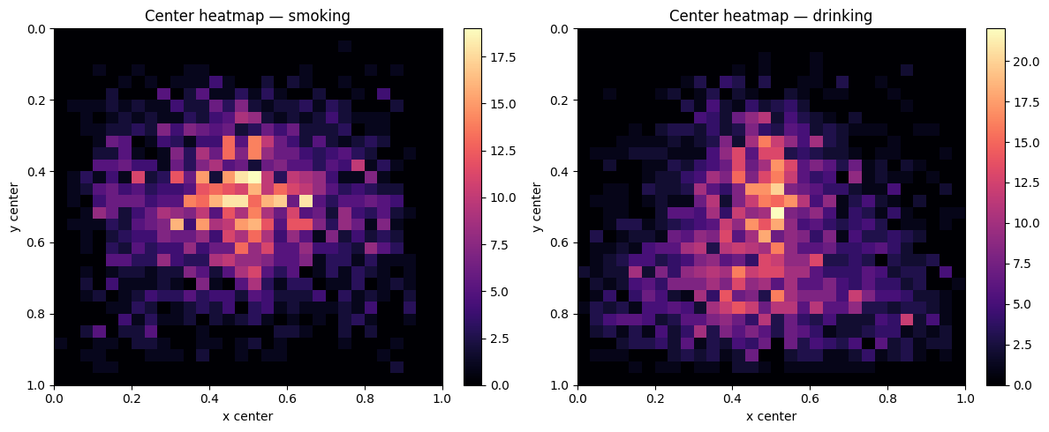
Figure 5 · Object-centre heatmaps for smoking and drinking.

4.5 · Visual sanity check
Drawing boxes back onto sample images is the most direct confirmation that harmonization worked: every drawn box is genuinely a smoking or drinking action, with no non-target classes leaking through under a target label.
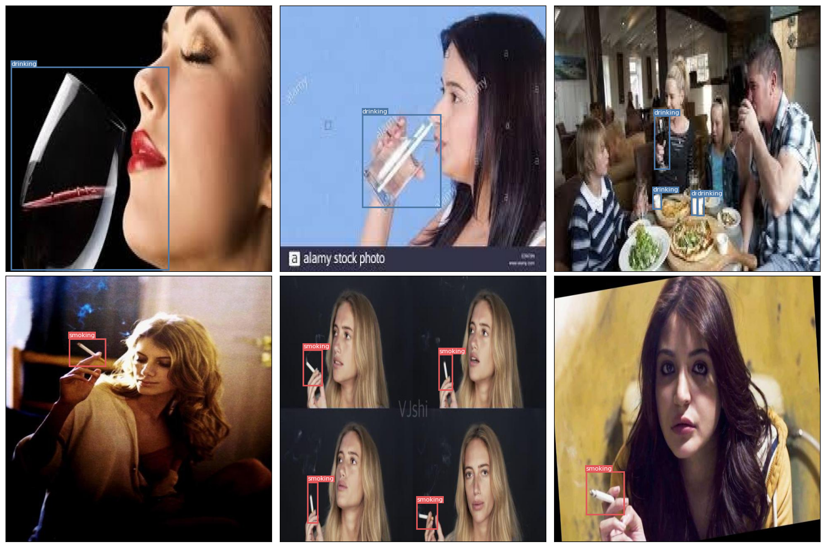
Figure 6 · Sample images with their smoking (red) and drinking (blue) boxes drawn.
Because there is a single source, the per-dataset comparison collapses to one domain — the class share within the source is drinking 55.3% / smoking 44.7% — so no cross-source domain-shift correction is required. Adding more Roboflow projects later would re-activate that check automatically.

5 Split, Augmentation & Export

5.1 · Train / val / test split
The split is performed at the image level so that every box of an image stays together, and is stratified by each image's dominant class. It is deterministic under the global seed.
Split | Images | smoking boxes | drinking boxes
train | 2,963 | 1,685 | 1,813
val | 370 | 214 | 217
test | 371 | 214 | 231
Table 5 · Image and per-class instance counts by split (≈ 80 / 10 / 10). Class balance is preserved within every split.

5.2 · Augmentation — train only
Augmentation is applied to the training split only, using Albumentations so that bounding boxes transform together with the pixels. Only label-preserving operations are used: horizontal flips, mild affine (scale, translate, small rotation and shear), brightness / contrast and hue-saturation jitter, occasional blur or noise, and light CLAHE. Vertical flips are excluded.
Because Section 3.4 already balanced the classes with real data, augmentation is light and uniform: 2 augmented copies per training image, with any residual minority top-up hard-capped by MAX_MINORITY_EXTRA. Here the residual gap was 0, so no extra minority copies were added. The maximum number of copies of any single image is therefore 3× (original + 2), versus the ~18× ceiling of the earlier approach.

5.3 · Export
Originals are copied byte-for-byte with no re-encoding; augmented variants are written as JPEG into the train split only. The final YOLOv8 package uses relative paths in data.yaml so it works wherever it is unzipped.
Export artefact | Value
Original images written | 3,704
Augmented train images written | 5,921
Archive size | 726.2 MB
Format | Ultralytics YOLOv8 (data.yaml + images/ + labels/)
Table 6 · Final exported dataset.

6 Summary & Handoff Notes
The pipeline delivers a clean, duplicate-free, class-balanced YOLOv8 dataset for smoking and drinking detection, built entirely from a single Roboflow source and reproducible from one config cell.
- Balance is achieved with real data, not heavy augmentation. The source carries both classes, the majority class is capped to a 1.25× ratio, and augmentation is uniform and hard-capped — final instance imbalance is only ~1.24×.
- Labels are trustworthy. Name-based harmonization plus a full integrity pass produced zero quarantined images and dropped 5,939 non-target boxes so they cannot pollute the target classes.
- Metrics will reflect real generalization. Perceptual dedup runs before the split, and val / test are augmentation-free and duplicate-free.
- Training guidance. With ~22% tiny boxes (mostly cigarettes), train at a larger image size (imgsz 832–960) and avoid heavy downscaling.
- Extensibility. Additional drinking-action Roboflow sources can be added in the config cell; the pipeline merges them by name and re-balances automatically. Face-state "drunk/sober" datasets should be avoided, as they detect intoxication rather than the act of drinking.

