Objective

Reference

Soft skills

projects

Education

|  |  |  |  |
| --- | --- | --- | --- |
| qualification | Instiute | Year of passing | CGPA/Percent |
|  |  |  |  |
|  |  |  |  |
|  |  |  |  |

Skills

Programming Language: - C, C++ and Python.

C and C++ 4 stars in HackerRank.

Competitiev coder, participated in many coding competition.

Kushagra Sharma

Linkedin

Address

B-14, Patrakarpuram, RaptiNagar, Phase-3, Gorakhpur, pin-273003 Uttarpradesh.

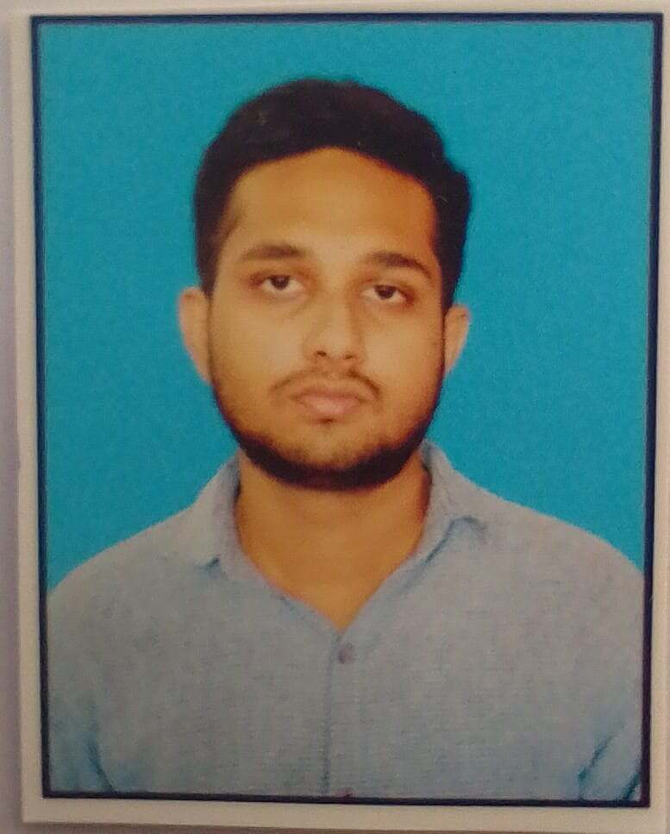

Contact Number

+91 123456789

EMAIL

Kushman9111@gmail.com