# Project Schedule

## 

## Major Project Milestones

|  |  |  |  |  |  |
| --- | --- | --- | --- | --- | --- |
| **Milestone** | **Estimated Start Date** | **Estimated Completion Date** | **Estimated Hours** | **Number of Resources** | **Number of Days** |
| **Software Requirements Specification** | **22/01/2015** | **12/02/2015** | **60** | **3** | **20** |
| **Software Design** | **13/02/2015** | **27/02/2015** | **60** | **3** | **14** |
| **Detailed Design** | **28/02/2015** | **12/03/2015** | **20** | **3** | **12** |
| **Coding** | **13/03/2015** | **26/03/2015** | **100** | **6** | **13** |
| **Unit Testing** | **27/03/2015** | **16/04/2015** | **60** | **3** | **20** |
| **Integration Testing** | **17/04/2015** | **23/04/2015** | **20** | **3** | **6** |
| **System Testing** | **24/04/2015** | **29/04/2015** | **30** | **3** | **5** |
| **Project Demo** | **30/04/2015** | **30/04/2015** | **2** | **3** | **1** |
| **Total Hours** | | | **352** | | |

## 

## Gantt chart For Project

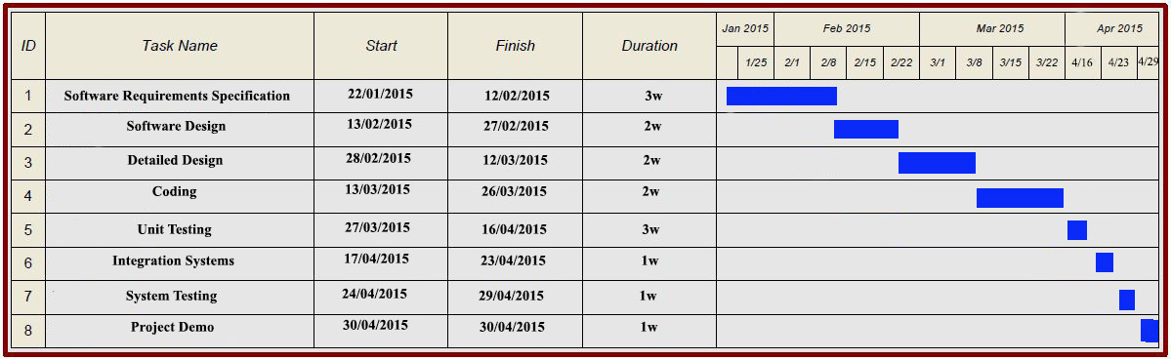

## PERT Chart for Project

## 

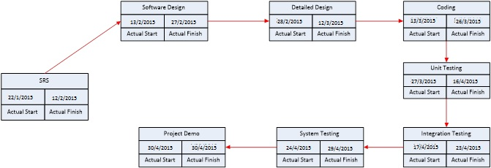

**Project Time Line Chart**

