**Date 9/9/21**

**Activity1 To work with operators**

Data Sets used Samples(Product, Transaction)

* **Aggregate** operator into the process. Connect it to the output of **Join**.
* Click **Aggregate** to select. Make the following changes in the **Parameters** panel:
* Click on **aggregation attributes**.
* Select *Customer ID* in the left box and set **function** to *count* in the right box.
* Stay in this dialog and add another entry *Product Name* with **function** set to *mode*. Click **Apply**.
* Click on **group by attributes**. Then, select the *Product ID* by moving it to the right. Click **Apply**.
* Connect **Aggregate** to the result port on the right.
* Press **Run** to execute the process.

Statistics

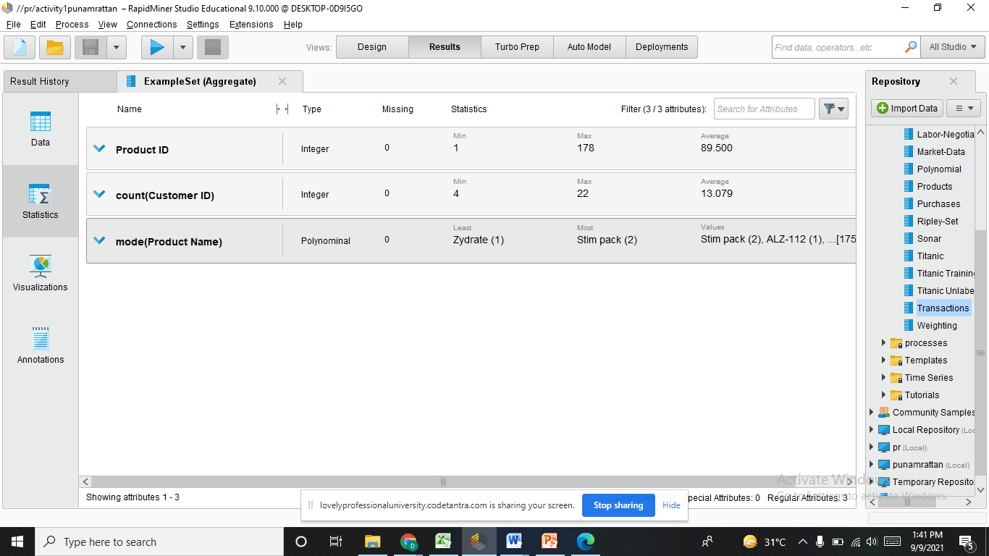

Visualization

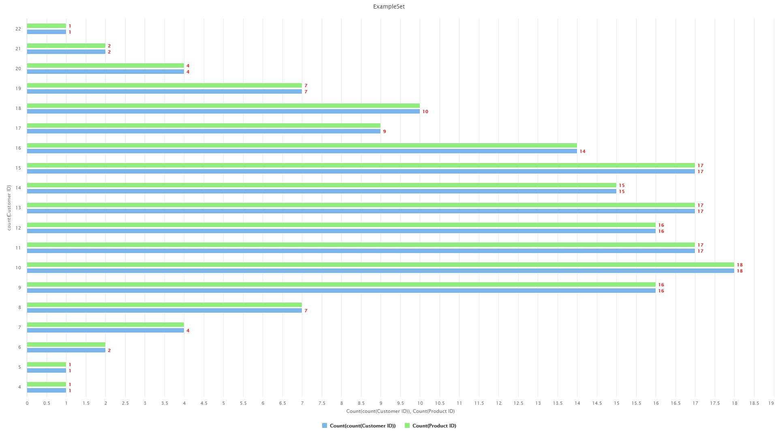

Interpretation