Why Git?

On the most used Version Control. Its is free and open source. It helps you to manage your repository and keep the track of it in form of commits.

Advantages:

* It’s a Distributed version control
* Branch Tree can be seen locally

There are other version controls like SVN, Mercurial.

What Is GitHub?

Github is a web-hosting service for your Git repository. In Github we can Store our Repository to store our source code and Collaborate with different users that’s why it is known as an open source tool.

# Submodules in Github

Subdirectory in a directory or Github repo inside a another repository.

Like using a another project form within it.

To add a Submodule:

Command:

Step-1: git submodule add <https://github.com/kushagra67414/a3.git>



Step-2: Run Command : git diff –-cached –-submodule

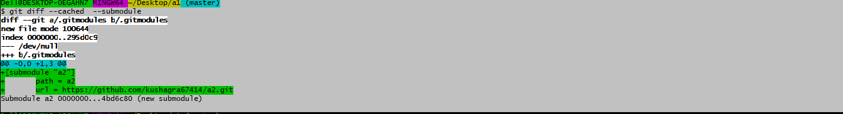

Important =>

Git sees it as a submodule and doesn’t track its contents when you’re not in that directory. Aslo

it count it as a commit of your present repository.

Step-3 : git add . (add all changes file to staging area) OR

Git add <filename> (to add a specific file at staging area)



Step-4:

Git commit –m “comment” [create a snapshot at central ]

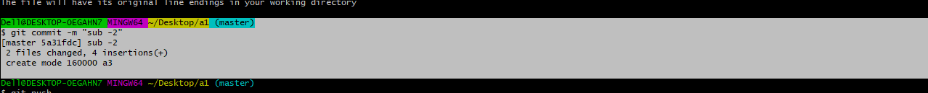

16000 in this ss implies that you’re recording a commit as a directory entry rather than a subdirectory or a file

Step-5: git push ( to push changes locally to remotely )

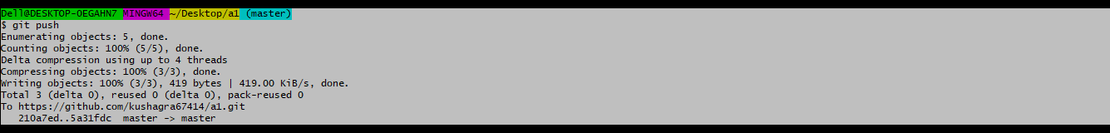

NOTE:

One Question Arise if we clone a repo having submodules in it will it clone submodules files/data too??

Answer => yes, as we know git count it as a commit of the present repository.

***UPDATING YOUR SUBMODULES =>***

Yes, Submodules are not automatically updated we need to fetch the data first and initialize our local configurations file.

Method- 1

We Add a file in repository a2 on github

Now a2 is a submodule at repo a1

Step-1 Go to repo a1 and then at submodule at a2

Comand run : a. cd a1

b. cd a2

now we are under a2 repo [ a submodule of repo a1 ]

Step-2: Pull the changes done remotely

Command run : git pull

Step-3: now file will come at locally at your submodule folder a2

Remember one thing file is fetch at submodule a2 and changes at a1 repo have to done.

Because when direct to submodule it acts as a repository.

Step-4: Check the status of repo a1.

Command run: git status

You will see Changes made in your a1 repo is unstaged stage it and commit it to have a snapshot of a repo

Step-5: Command run: git add .

Command run: git commit –m “comment”

Step-6: git push

Refresh your github you will see the changes

a.



b.

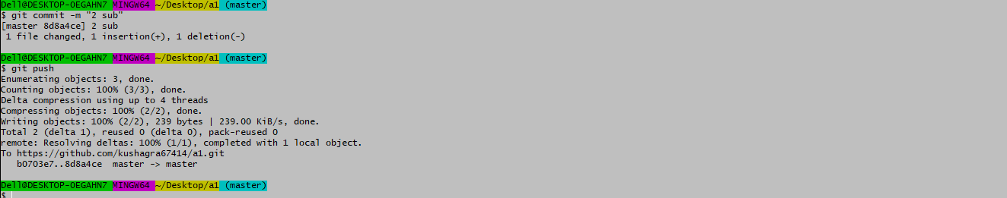

## **Cloning a Project with Submodules**

Sometimes when we clone the project with submodules, the submodules can be empty

To fetch the data use the below command.

***METHOD-1***

Sometimes when we clone the project with submodules, the submodules can be empty

To fetch the data use the below command.

Open your repo at git bash

Step-1 : Run Command : git submodule init

This is used to initialize your local configuration file,

Step-2 : Run command : git submodule update

It’s function is to fetch the data from the project

METHOD-2

Instead of using above method, we can use a single command

Run: git clone –recurse-submodules <https://github.com/kushagra67414/a1.git>

* Advantage of this method:

It fetch and update submodules inside the submodule

i.e nested submodule