***AWS AMI with Terraform***

By: Kushagra Bansal

DevOps Enthusiast

STEP-1: Create IAM user and provide ADMINISTRATOR ACCESS [imp ]

A

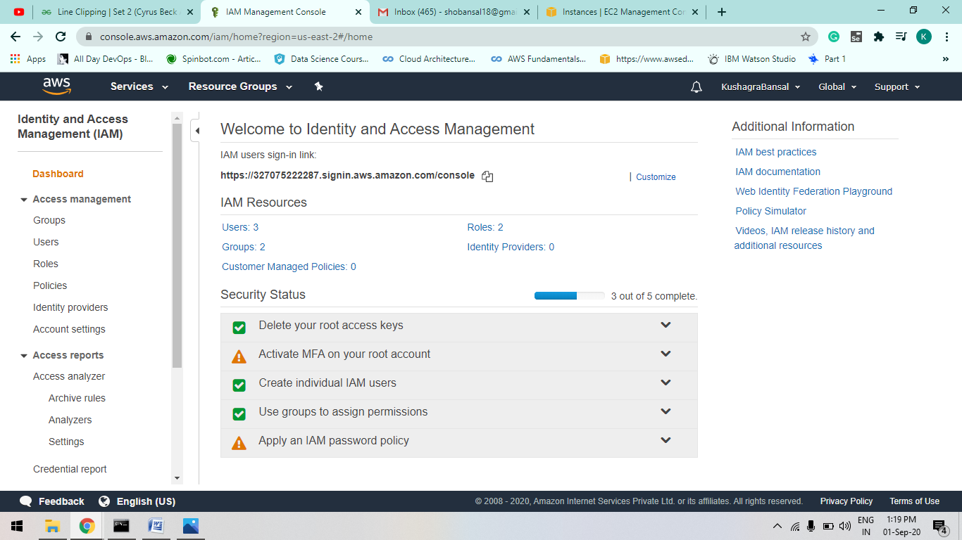

B

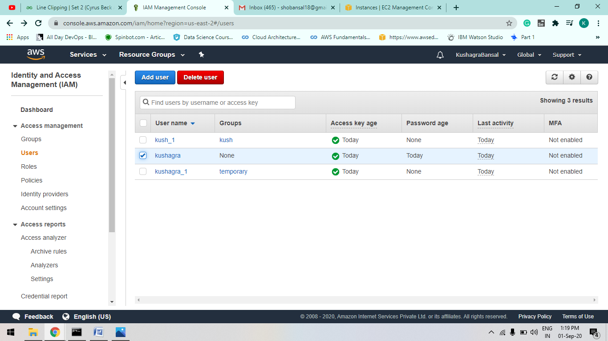

C

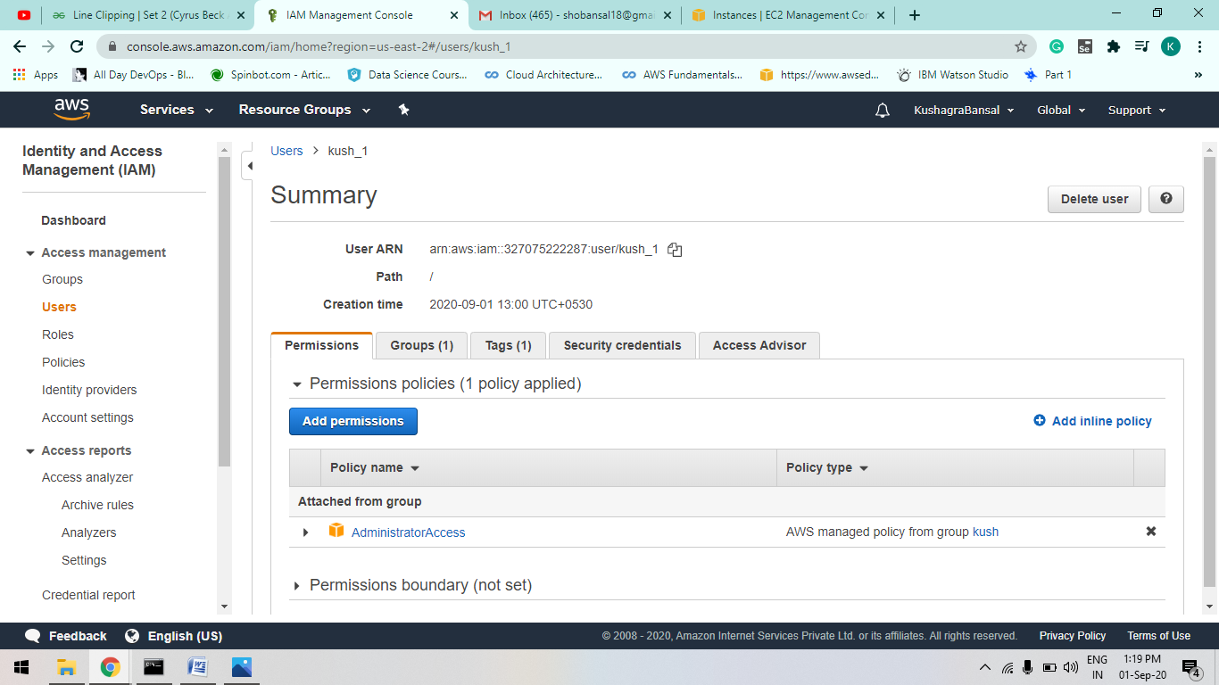

D

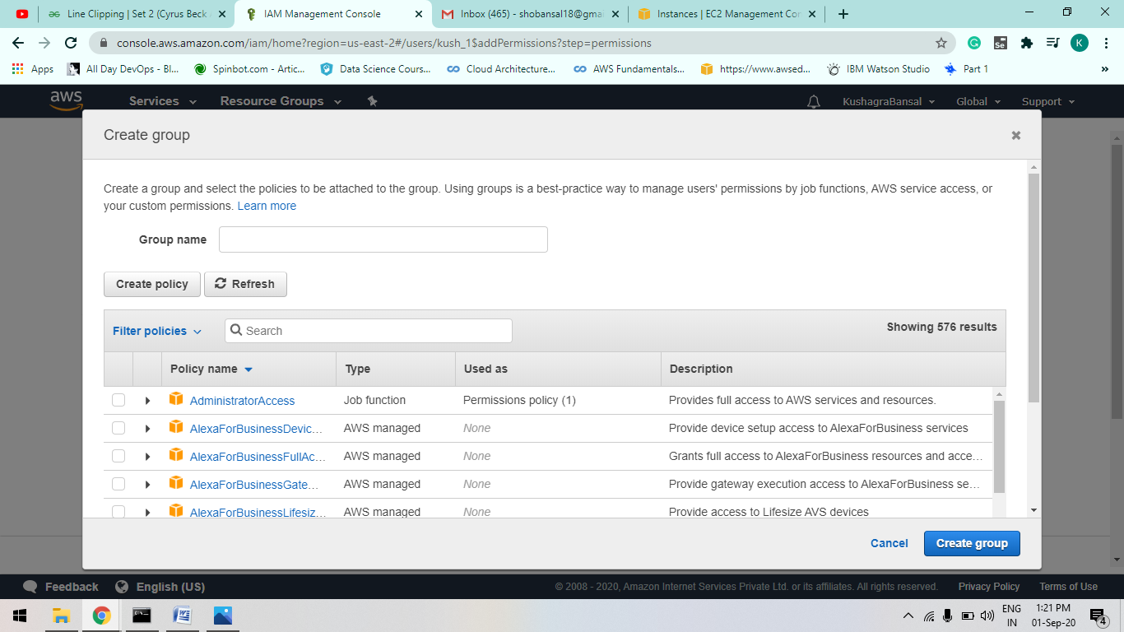

STEP-2: create xyz.tf file and configure it.. such as add security key and access key.

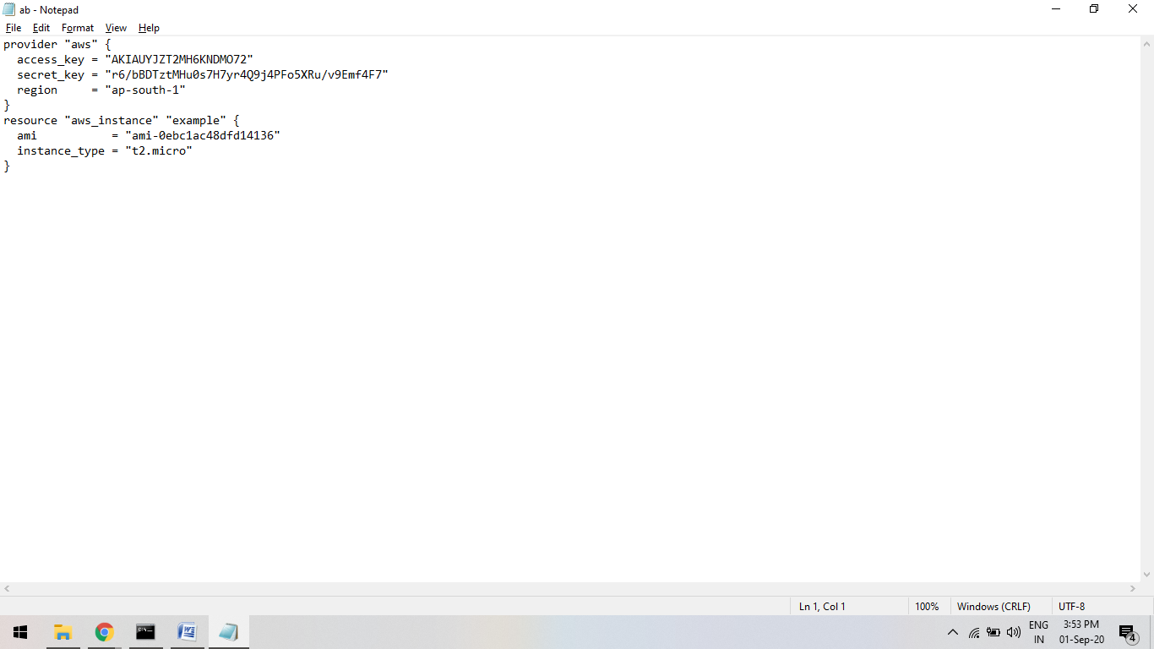

STEP-3:

Now run Command : “terraform plan”

Basically it create an aws_instance of which u give ami id while configuring your ab.tf file

[remember it must be in terraform folder ]

The terraform plan command is used to create an execution plan. Terraform performs a refresh, unless explicitly disabled, and then determines what actions are necessary to achieve the desired state specified in the configuration files.

A

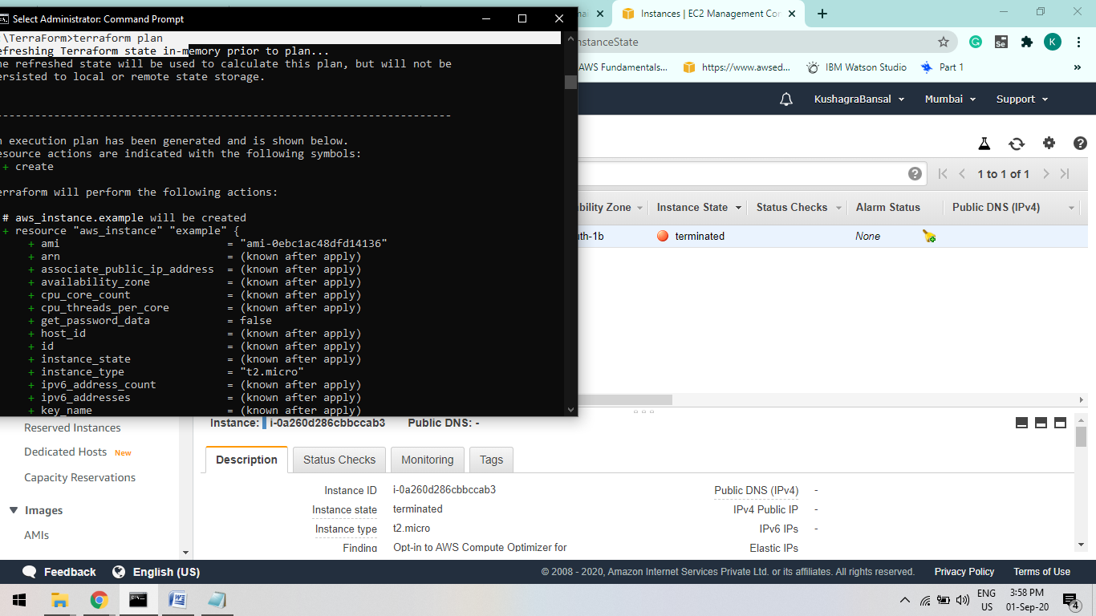

B

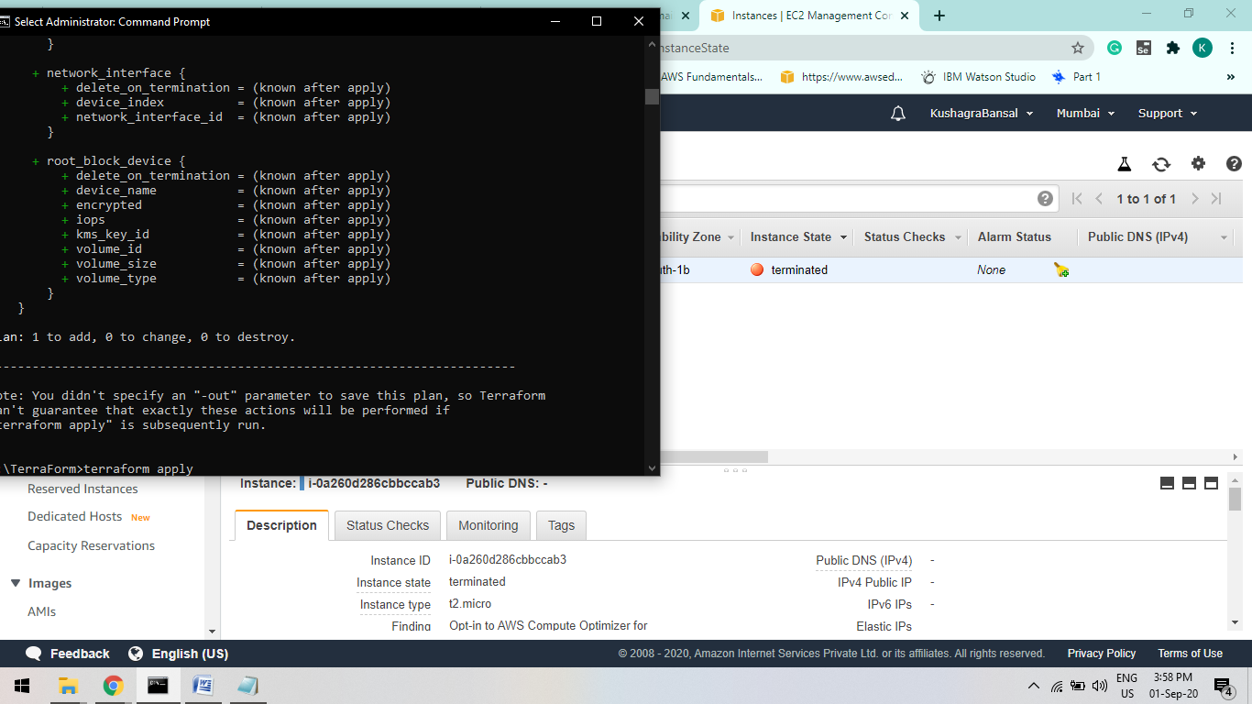

STEP-4:

Now run “terraform apply ”

he **terraform apply** command is used to **apply** the changes required to reach the desired state of the configuration, or the pre-determined set of actions generated by a **terraform plan** execution **plan**.

A

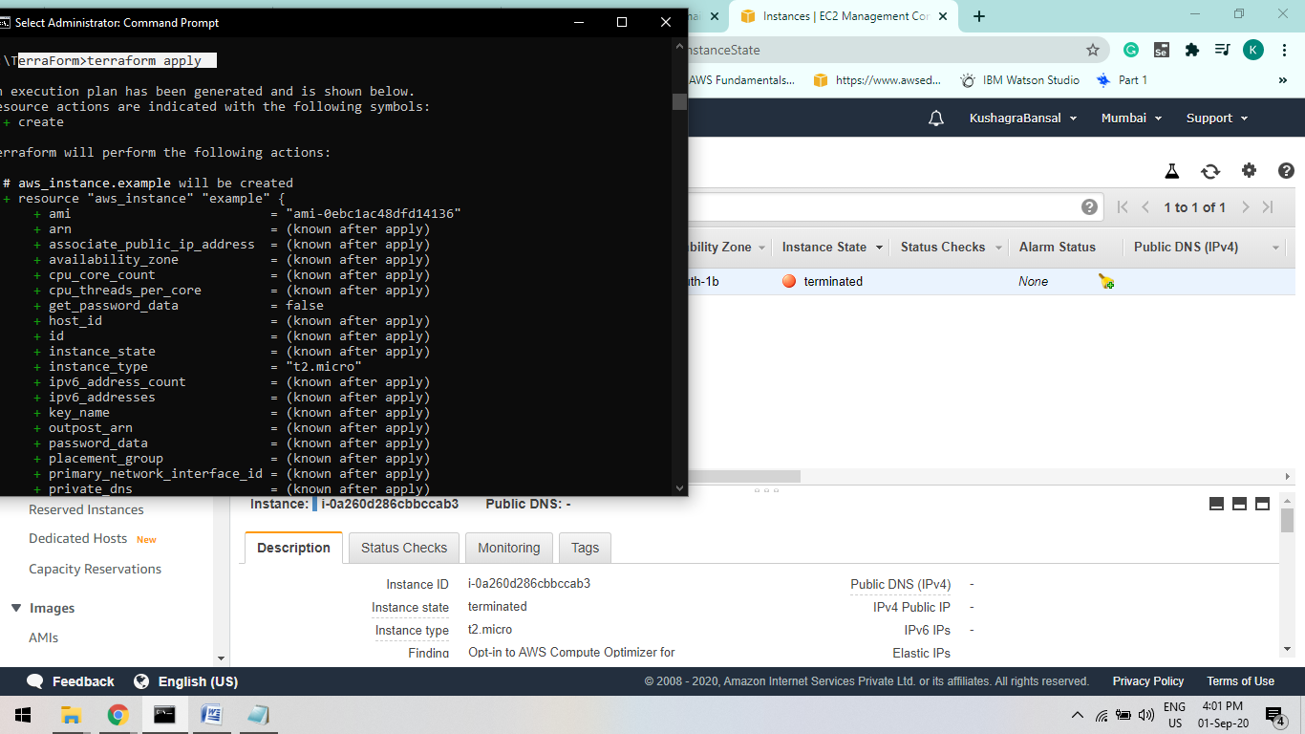

B

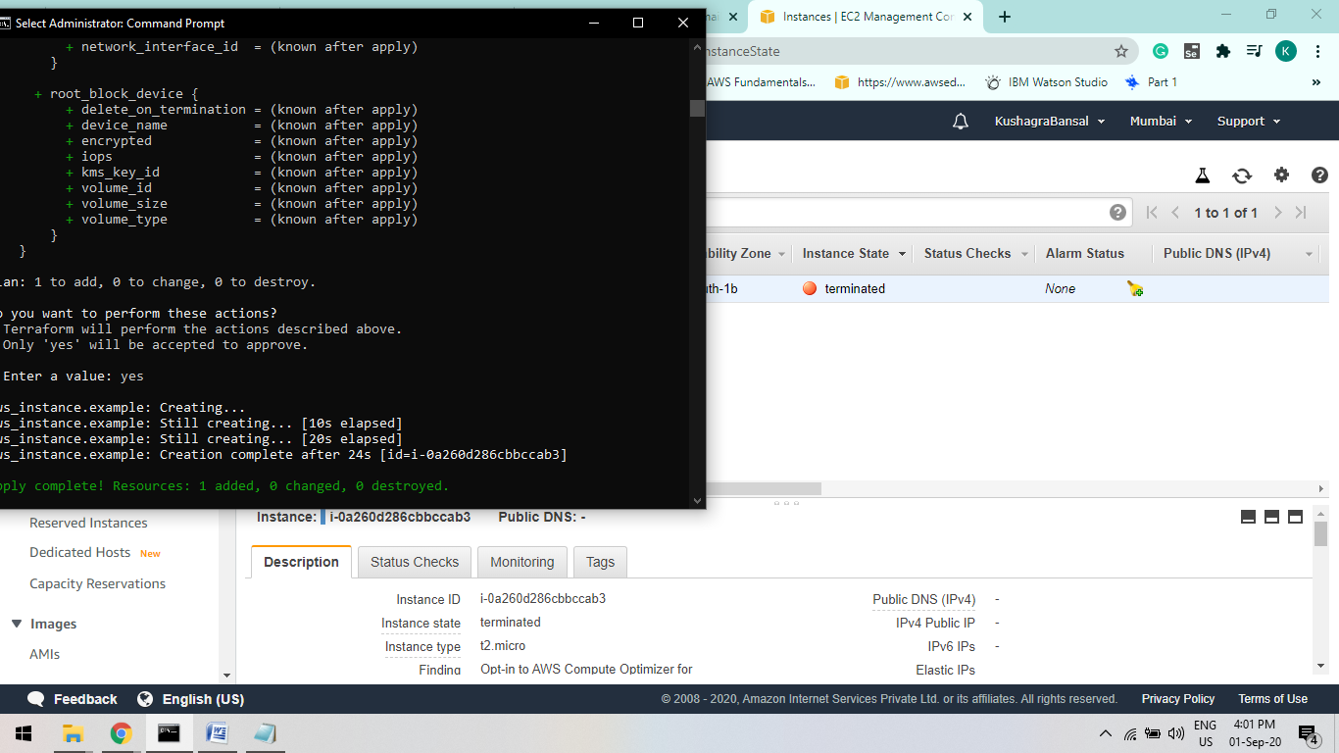

STEP-5:

Infrastructure managed by Terraform will be destroyed. This will ask for confirmation before destroying.

Run: “terraform destroy ”

a.

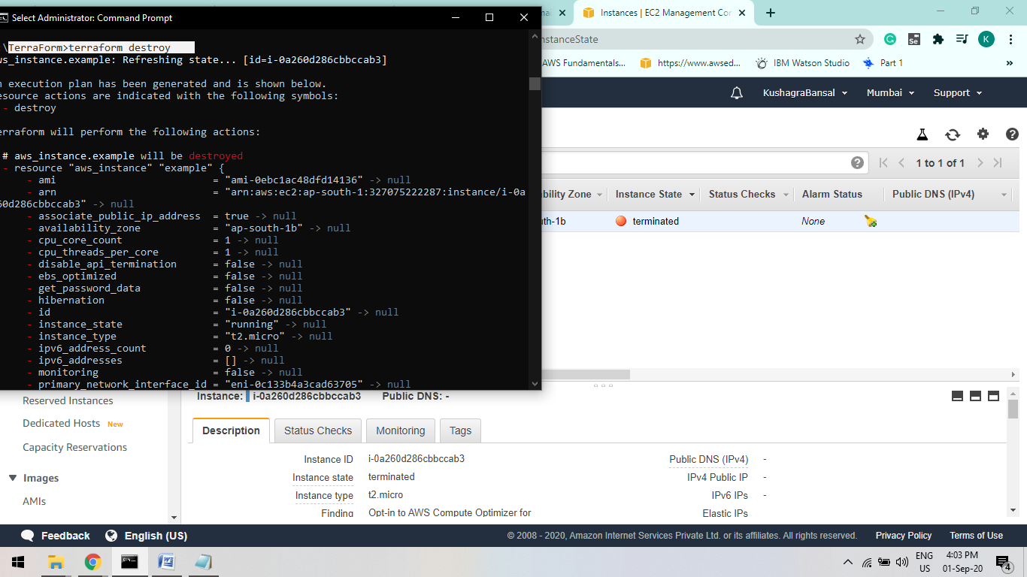

b.



STEP_6:

Refresh your aws webpage

It will take a few minute.

You will First it show “SHUTTING DOWN” After Few Minutes “TERMINATED”.

A.

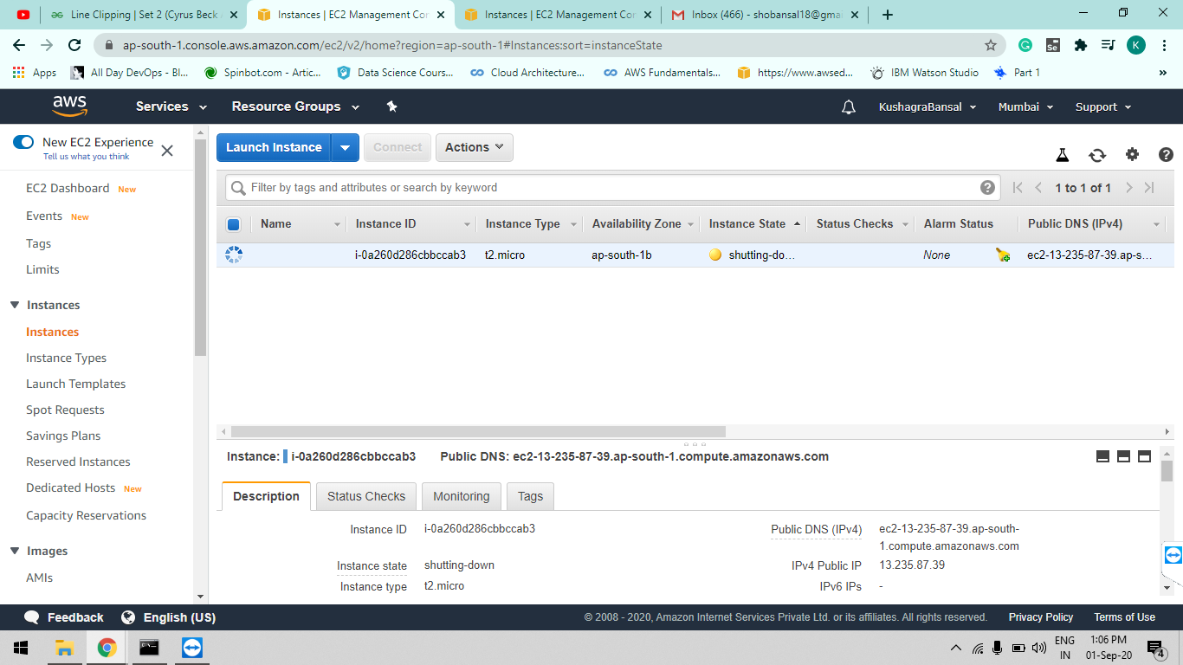

B.

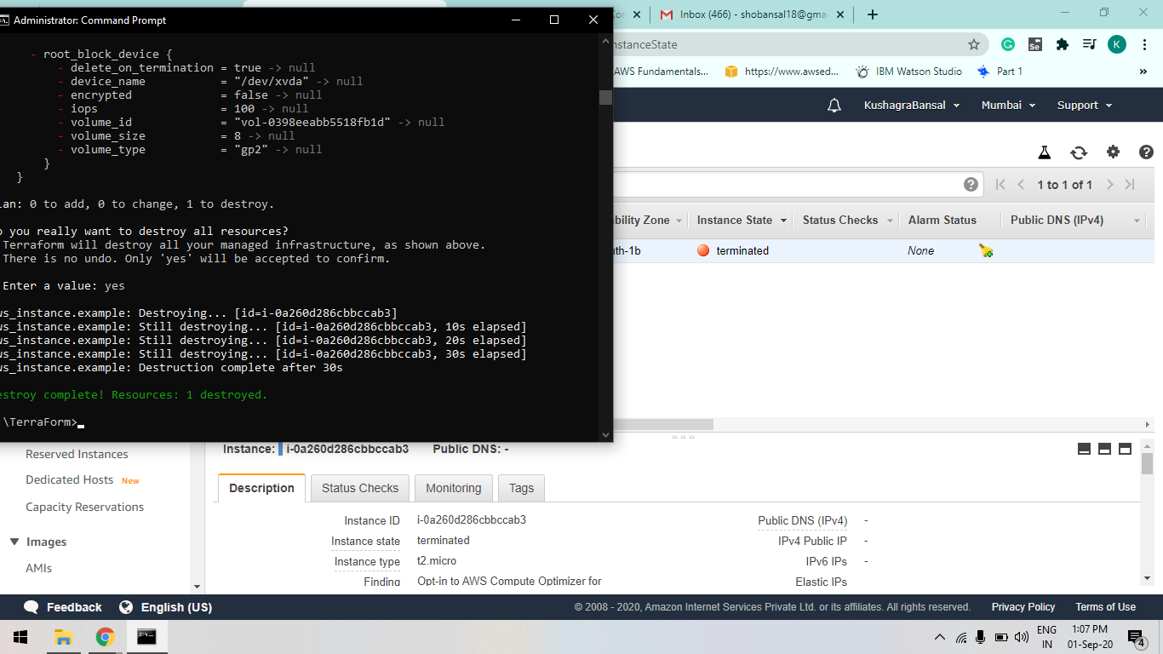

THANK YOU !!!!!!