How to use IntelliJ IDEA with AWS Java SDK

1. Install latest Amazon Java SDK from [here](https://sdk-for-java.amazonwebservices.com/latest/aws-java-sdk.zip)
2. Extract the .zip file downloaded

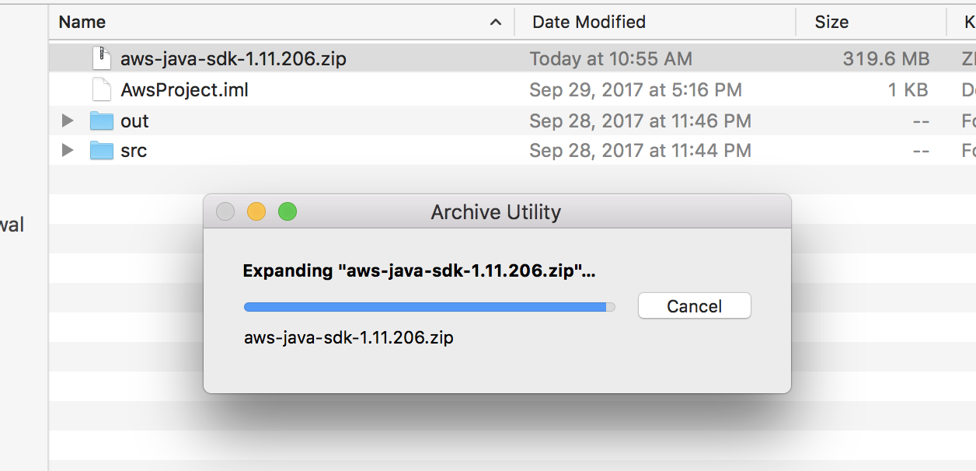

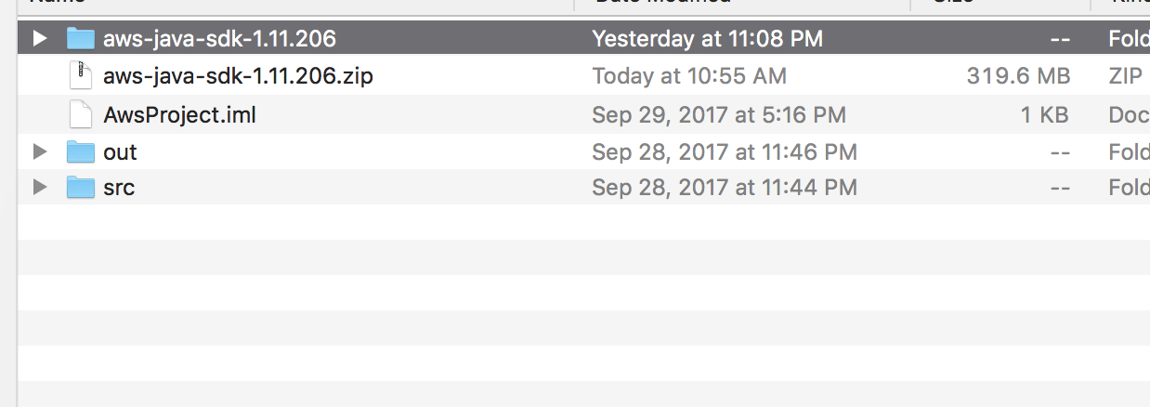

1. Now create a Java project with IntelliJ
2. Now move your unzipped AWS sdk to the project folder

The unzipped folder **aws-java-sdk-1.11.206,** should appear in your Project in IntelliJ like this

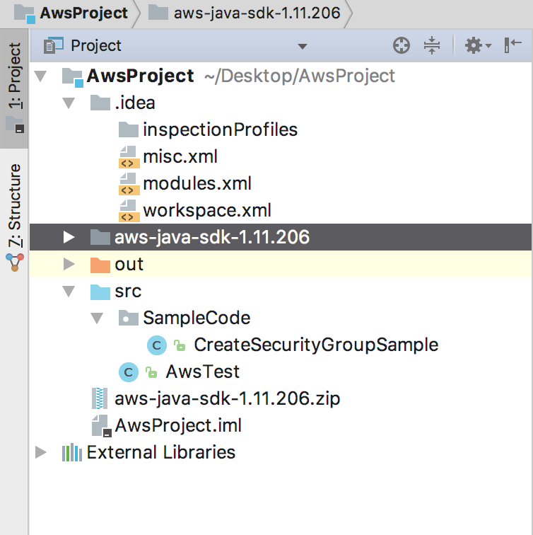

1. Now open Project Structure, <cmd+;> on Mac

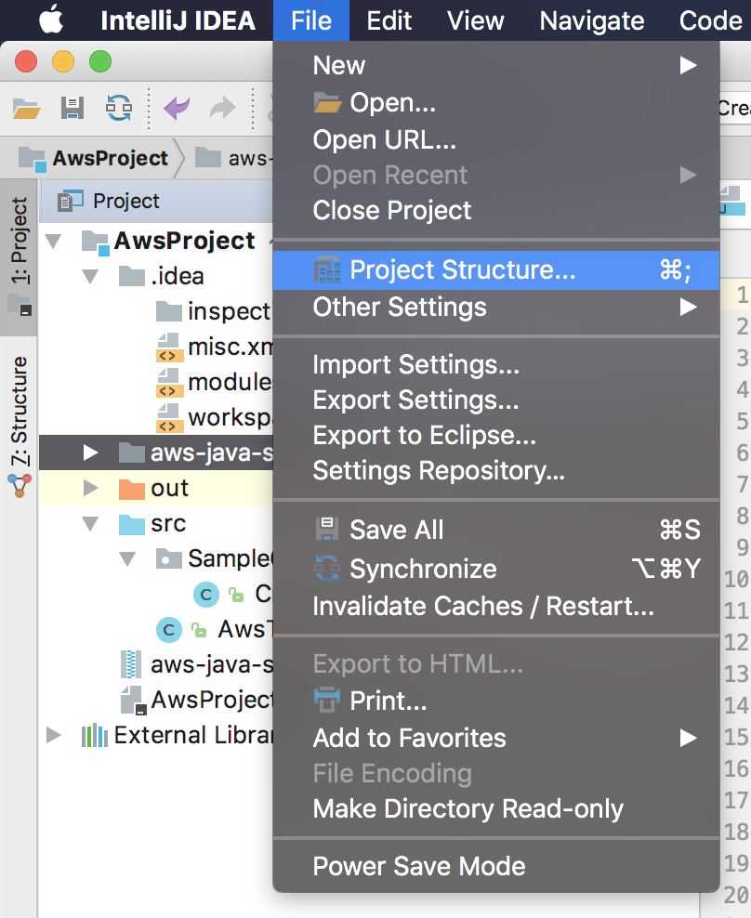

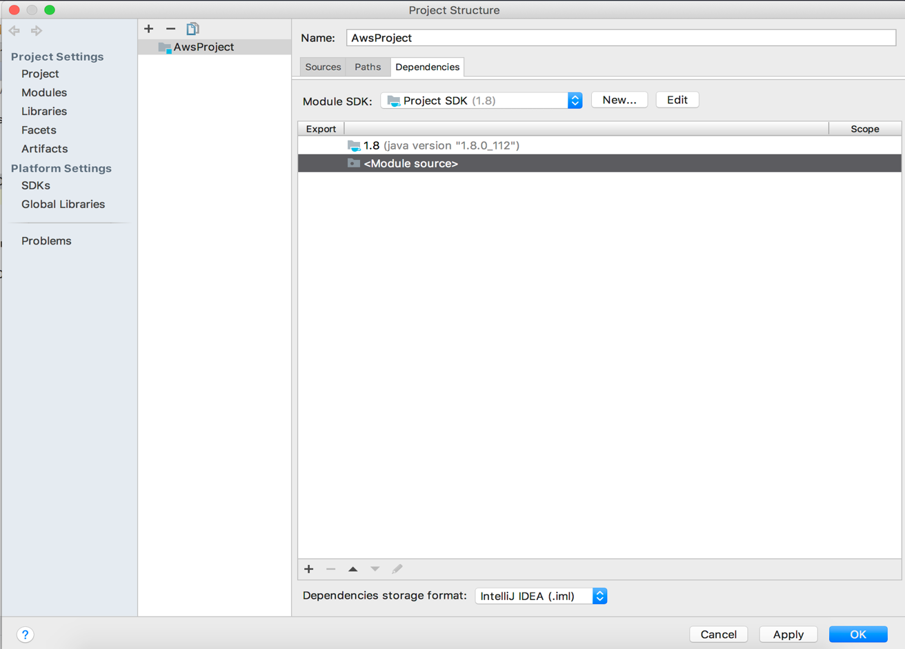

1. Now go to Module-> Dependencies

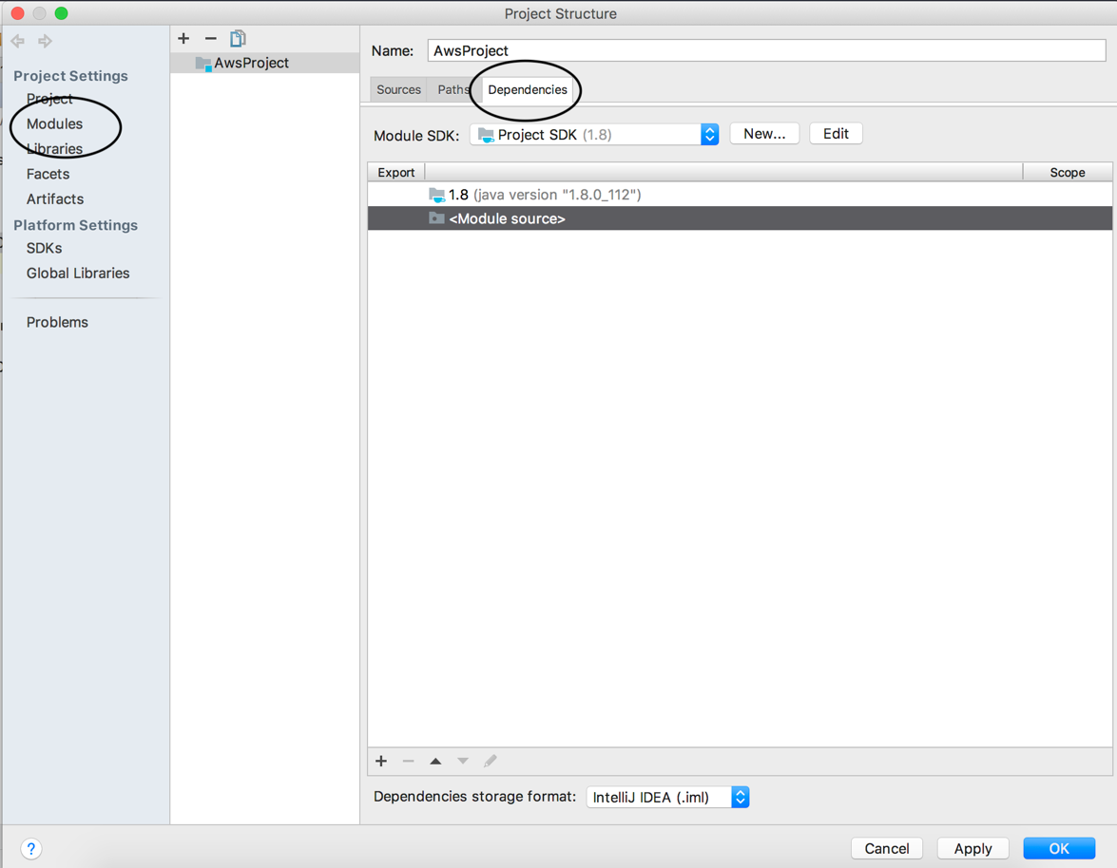

1. Now click on Add

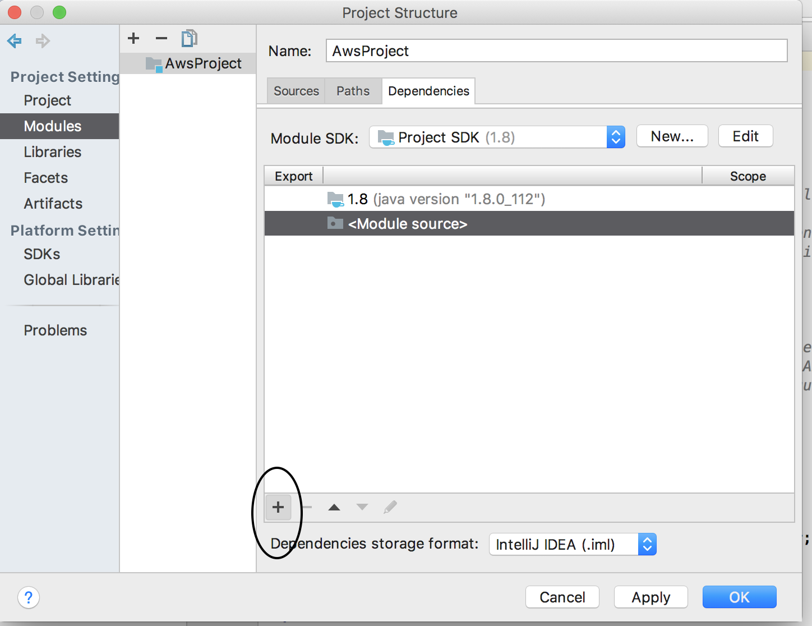

1. Open Jars or Directories, 1st option, from the menu

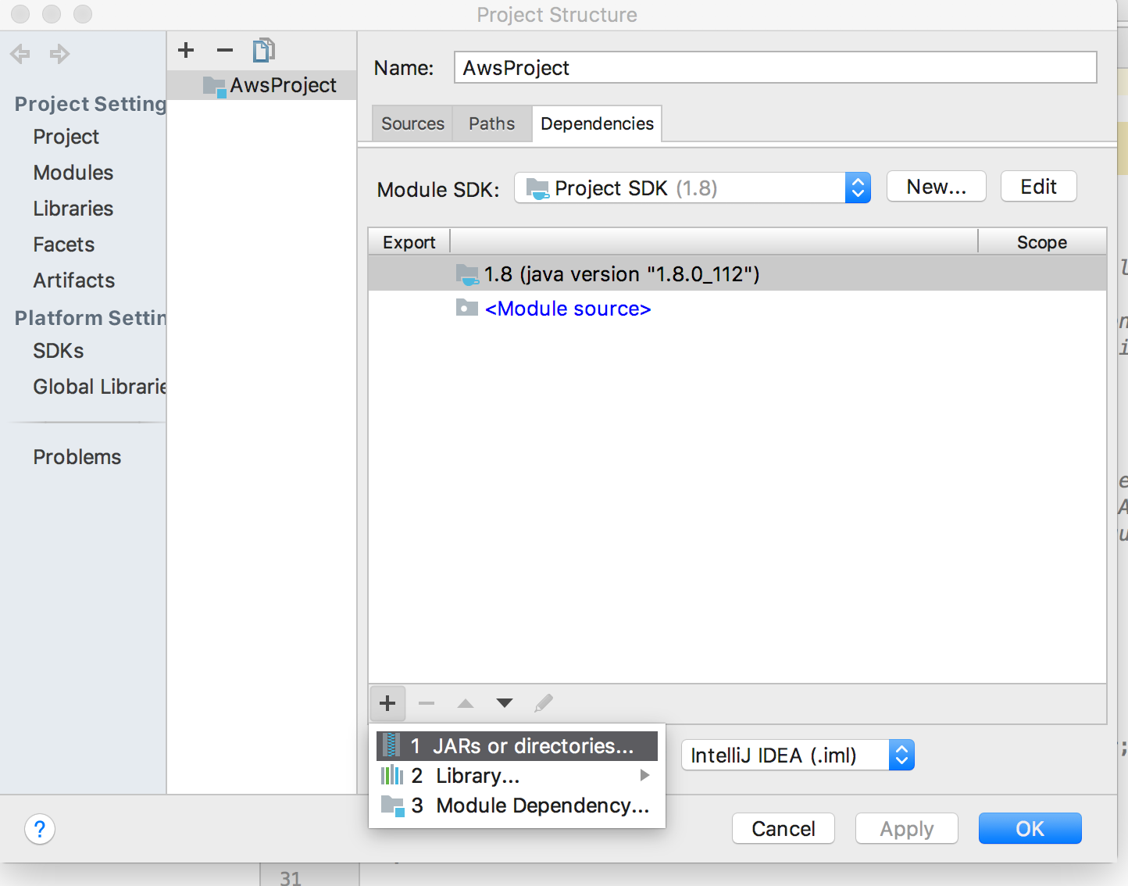

1. Now add the **lib**s folders present in the sdk folder which we have unzipped in the step 2

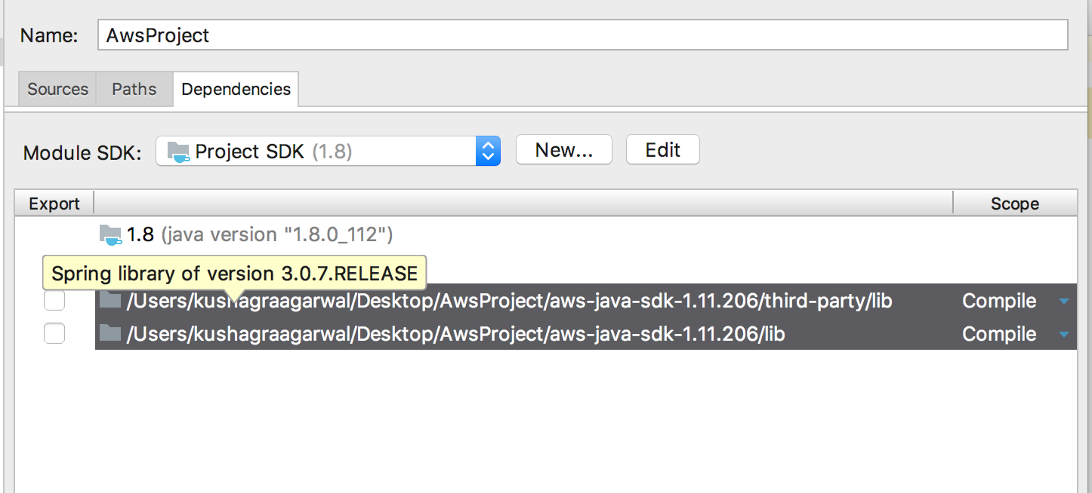

1. Click on OK and then wait till the indexing finishes

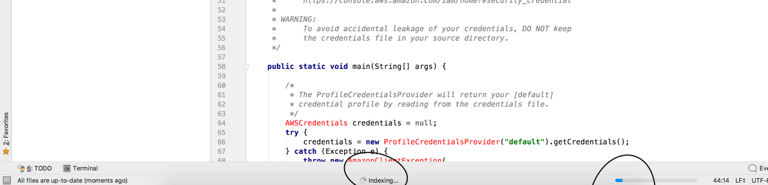

1. After that you’ll be able to run your project ☺

Please let me know if you have some doubts in running it as well!