
A




Examination Paper | Semester-1
Fundamentals of
with
Total Marks : 25 Marks Time : 1 hour

ANSWER KEY

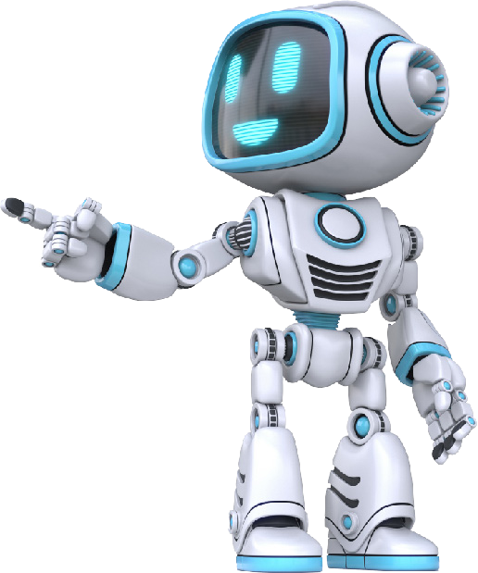




Section 1: Multiple Choice Questions (2 marks each)
(Green color box is the correct answer)

1
2
Which of the following is NOT one of the 4Cs?
How does creativity help in everyday life?

- It makes school more difficult
A. CREATIVITY
D. Playing online games
C. Learning coding languages
B.Expressing concepts using visual content such as posters, videos, animations, etc.
C. Sharing projects for feedback
D. Playing multiplayer games
D. No use outside of artistic field
B. Helps in solving problems and thinking differently
C. Works when you are doing art
D. Making communication only about fun and games
C. No important role in communication
B. Improving how we communicate and present ideas
- Limiting our ability to communicate
5
How does Adobe Express help us share and engage with ideas in the digital world?
B. Creating infographics and videos
- Ready to use templets
4
Which of these is not a feature of Adobe express?
3
A. Solving math problems
What is the main use of Adobe express in the classroom?
D. COMMUNICATION
C. CALCULATION
B. COLLABORATION

Section 2- Hands-On-Projects (10-Marks each)

Remove the background on the image by clicking on the link and using Adobe express.
6

Use the remixable template-https://tinyurl.com/removethebackgroundsem-1

PASTE THE FINAL LINK
Marks will be awarded to students based on the work they have submitted

Create an awareness/ notification poster for a tree plantation drive at school. Paste the final output.
7

Use the remixable template: https://tinyurl.com/Plantationdrivesem-1
PASTE THE FINAL LINK

Marks will be awarded to students based on the work they have submitted

